Table of Contents

UNITED STATES

SECURITIES AND EXCHANGE COMMISSION
Washington, D.C. 20549

SCHEDULE 14A INFORMATION

Proxy Statement Pursuant to Section 14(a) of the Securities Exchange Act of 1934

(Amendment No. )

Filed by the Registrant ☒ Filed by a Party other than the Registrant ☐

Check the appropriate box:

- Preliminary Proxy Statement

- Confidential, for Use of the Commission Only (as permitted by Rule 14a-6(e)(2))

- Definitive Proxy Statement

- Definitive Additional Materials

- Soliciting Material Pursuant to §240.14a-12

Applied Materials, Inc.

(Name of Registrant as Specified In Its Charter)

(Name of Person(s) Filing Proxy Statement, if other than the Registrant)

Payment of Filing Fee (Check the appropriate box):

- No fee required.

- Fee computed on table below per Exchange Act Rules 14a-6(i)(1) and 0-11.

  - Title of each class of securities to which transaction applies:

  - Aggregate number of securities to which transaction applies:

  - Per unit price or other underlying value of transaction computed pursuant to Exchange Act Rule 0-11 (set forth the amount on which the filing fee is calculated and state how it was determined):

  - Proposed maximum aggregate value of transaction:

  - Total fee paid:

- Fee paid previously with preliminary materials:

- Check box if any part of the fee is offset as provided by Exchange Act Rule 0-11(a)(2) and identify the filing for which the offsetting fee was paid previously. Identify the previous filing by registration statement number, or the Form or Schedule and the date of its filing.

  - Amount Previously Paid:

  - Form, Schedule or Registration Statement No.:

  - Filing Party:

  - Date Filed:

Table of Contents

Table of Contents


January 28, 2021

Dear Fellow Shareholders:

On behalf of the Board of Directors, we are pleased to invite you to attend Applied Materials’ 2021 Annual Meeting of Shareholders, which will be held on Thursday, March 11, 2021, at 11:00 a.m. Pacific Time. This year’s Annual Meeting will be conducted virtually due to the public health concerns resulting from the COVID-19 pandemic and to support the health and well-being of our shareholders, employees and community. The Annual Meeting will be held online at www.virtualshareholdermeeting.com/AMAT2021, via a virtual annual meeting platform that will allow shareholders to participate and submit questions.

We encourage you to read this Proxy Statement because it contains important information for voting your shares and sets forth how the Board oversaw your investment over the past year. This year’s Proxy Statement reflects our continued focus on our business strategy, an engaged and effective Board, sound corporate governance and executive compensation practices, our Environmental, Social and Governance strategy and our regular dialogue with and responsiveness to our shareholders.

Financial Performance and Business Strategy

Despite the unprecedented global challenges created by the COVID-19 pandemic, Applied Materials delivered record performance in fiscal 2020. Our revenues and earnings per share increased 18% and 37% year-over-year, respectively, and we generated record annual cash flows from operations. We also continued to make strategic investments in new technologies and products to address the industry’s highest value problems and position the company for sustained long-term success.

As we look ahead to the next decade, we remain very positive about our growth opportunities. The convergence of technologies, including the Internet of Things and AI, are poised to transform nearly every industry – from medicine and healthcare to retail, energy and transportation. The advances in the technology needed to unlock the potential of AI have created tremendous opportunities for Applied Materials. We have aligned our strategy and investments around this vision for the future, and we are uniquely positioned to accelerate innovations that deliver improvements in the power, performance, area, cost and time-to-market of next-generation semiconductor devices.

Shareholder Engagement and Demonstrated Responsiveness

We are committed to effective corporate governance that is informed by our shareholders, promotes the long-term interests of our shareholders, and strengthens the Board’s and management’s accountability.

We have a robust shareholder outreach program that focuses on governance, compensation, environmental and sustainability issues of interest to our shareholders. The outreach is a recurring, year-round effort, led by a cross-functional team that includes members of our Investor Relations, Global Rewards, ESG, Diversity and Inclusion, Environmental Health and Safety and Legal functions, with participation of independent directors where appropriate. Shareholder feedback directly informs the Board’s decision-making on a variety of matters. For example, in response to extensive shareholder feedback on the topic and after careful consideration, at last year’s annual meeting the Board submitted and our shareholders approved an amendment and restatement of our Certificate of Incorporation to allow shareholder action by written consent.

Thank you for your continued investment in and support of Applied Materials.

Sincerely,
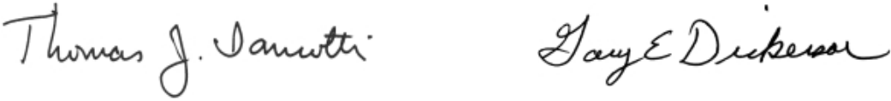

Thomas J. Iannotti Gary E. Dickerson

Chairman of the Board President and Chief Executive Officer

3050 Bowers Avenue Mailing Address:

Santa Clara, California 95054 Applied Materials, Inc.

Phone: (408) 727-5555 3050 Bowers Avenue

P.O. Box 58039

Santa Clara, California 95052-8039

Table of Contents

NOTICE OF

2021 ANNUAL MEETING OF SHAREHOLDERS

Thursday, March 11, 2021

at 11:00 a.m. Pacific Time

The 2021 Annual Meeting of Shareholders of Applied Materials, Inc. will be held on Thursday, March 11, 2021, at 11:00 a.m. Pacific Time. Due to the public health concerns resulting from the COVID-19 pandemic and to support the health and well-being of our shareholders, employees and community, the Annual Meeting will be a virtual meeting held online at www.virtualshareholdermeeting.com/AMAT2021 via a live webcast. You will be able to vote and submit questions online through the virtual meeting platform during the Annual Meeting. You will not be able to attend the Annual Meeting in person. Please see “Virtual Annual Meeting” on page v for additional information.

Items of Business

- To elect ten directors to serve for a one-year term and until their successors have been duly elected and qualified.

- To approve, on an advisory basis, the compensation of our named executive officers for fiscal year 2020.

- To ratify the appointment of KPMG LLP as our independent registered public accounting firm for fiscal year 2021.

- To approve the amended and restated Employee Stock Incentive Plan.

- To approve the Omnibus Employees’ Stock Purchase Plan.

- To consider two shareholder proposals, if properly presented at the Annual Meeting.

- To transact any other business that may properly come before the Annual Meeting or any adjournment or postponement of the Annual Meeting.

Your vote is important to us. You may vote via the Internet or by telephone, or if you requested to receive printed proxy materials, by signing, dating and returning your proxy card. If you are voting via the Internet or by telephone, your vote must be received by 11:59 p.m. Eastern Time on Wednesday, March 10, 2021. For specific voting instructions, please refer to the information provided in the following Proxy Statement, together with your proxy card or the voting instructions you receive by e-mail or that are provided via the Internet.

If you received a Notice of Internet Availability of Proxy Materials on how to access the proxy materials via the Internet, a proxy card was not sent to you, and you may vote only via the Internet, unless you have requested a paper copy of the proxy materials, in which case, you may also vote by telephone or by signing, dating and returning your proxy card. Shares cannot be voted by marking, writing on and returning the Notice of Internet Availability. Any Notices of Internet Availability that are returned will not be counted as votes. Instructions for requesting a paper copy of the proxy materials are set forth on the Notice of Internet Availability.

By Order of the Board of Directors

Teri A. Little

Senior Vice President, Chief Legal Officer and

Corporate Secretary

Santa Clara, California

January 28, 2021

Important Notice Regarding the Availability of Proxy Materials for the Shareholder Meeting to be held on March 11, 2021: The Proxy Statement and Annual Report to Shareholders are available at www.proxyvote.com.

Table of Contents

TABLE OF CONTENTS

 |  |  |  |  |  |  |  |  |  | Page
 | 2021 Proxy Statement Summary |  |  |  |  |  |  |  |  | i
 | Annual Meeting of Shareholders |  |  |  |  |  |  |  |  | i
 | Proposals and Board Recommendations |  |  |  |  |  |  |  |  | i
 | Director Nominees |  |  |  |  |  |  |  |  | ii
 | Board Practices and Composition |  |  |  |  |  |  |  |  | iii
 | Corporate Governance |  |  |  |  |  |  |  |  | iv
 | Virtual Annual Meeting |  |  |  |  |  |  |  |  | v
 | Executive Compensation |  |  |  |  |  |  |  |  | v
 | Our Commitment to ESG |  |  |  |  |  |  |  |  | xii
 | Proposal 1—Election of Directors |  |  |  |  |  |  |  |  | 1
 | Nominees |  |  |  |  |  |  |  |  | 1
 | Board and Corporate Governance Practices |  |  |  |  |  |  |  |  | 7
 | Board Composition and Nominee Considerations |  |  |  |  |  |  |  |  | 7
 |  |  | Nominee Skills and Experience |  |  |  |  |  |  | 7
 |  |  | Board Composition and Refreshment |  |  |  |  |  |  | 8
 | Corporate Governance |  |  |  |  |  |  |  |  | 10
 |  |  | Corporate Governance Guidelines |  |  |  |  |  |  | 10
 |  |  | Board Leadership |  |  |  |  |  |  | 10
 |  |  | Director Onboarding and Education |  |  |  |  |  |  | 10
 |  |  | Board and Committee Evaluations |  |  |  |  |  |  | 10
 |  |  | Board’s Role in Risk Oversight |  |  |  |  |  |  | 11
 |  |  | Management Succession Planning |  |  |  |  |  |  | 12
 |  |  | Shareholder Rights |  |  |  |  |  |  | 12
 |  |  | Shareholder Engagement |  |  |  |  |  |  | 13
 |  |  | Shareholder Communications |  |  |  |  |  |  | 14
 |  |  | Stock Ownership Guidelines |  |  |  |  |  |  | 14
 |  |  | Standards of Business Conduct |  |  |  |  |  |  | 14
 | Board Meetings and Committees |  |  |  |  |  |  |  |  | 14
 | Director Compensation |  |  |  |  |  |  |  |  | 16
 | Compensation Program for Directors |  |  |  |  |  |  |  |  | 16
 | Director Compensation for Fiscal 2020 |  |  |  |  |  |  |  |  | 17
 | Stock Ownership Information |  |  |  |  |  |  |  |  | 18
 | Principal Shareholders |  |  |  |  |  |  |  |  | 18
 | Directors and Executive Officers |  |  |  |  |  |  |  |  | 19
 | Proposal 2—Approval, on an Advisory Basis, of the
 | Compensation of Our Named Executive Officers |  |  |  |  |  |  |  |  | 20
 | Compensation Discussion and Analysis |  |  |  |  |  |  |  |  | 21
 | Executive Summary |  |  |  |  |  |  |  |  | 21
 | Compensation Governance and Decision-Making |  |  |  |  |  |  |  |  | 28
 |  |  | Framework |  |  |  |  |  |  | 28
 |  |  |  |  |  |  |  |  |  | 29
 |  |  | Components of Total Direct Compensation |  |  |  |  |  |  | 29
 | Additional Compensation Programs and Policies |  |  |  |  |  |  |  |  | 41
 | Human Resources and
 | Compensation Committee Report |  |  |  |  |  |  |  |  | 43
 | Executive Compensation |  |  |  |  |  |  |  |  | 44
 |  | Summary Compensation Table for Fiscal 2020, 2019 and |  |  |  |  |  |  |  | 44
 |  | 2018 |  | of Plan-Based Awards for Fiscal 2020 |  |  |  |  |  | 44
 |  |  |  |  |  |  |  |  |  | 45
 | Grants |  |  |  |  |  |  |  |  | 45

Cautionary Note Regarding Forward-Looking Statements

Outstanding Equity Awards at Fiscal 2020 Year-End |  |  |  |  |  |  |  |  |  |  |  |  |  |  |  |  |  |  |  |  |  |  |  | Page
 |  |  |  |  |  |  |  |  |  |  |  |  |  |  |  |  |  |  |  |  |  |  |  | 46
Option Exercises and Stock Vested for Fiscal 2020 |  |  |  |  |  |  |  |  |  |  |  |  |  |  |  |  |  |  |  |  |  |  |  | 47
Non-Qualified Deferred Compensation |  |  |  |  |  |  |  |  |  |  |  |  |  |  |  |  |  |  |  |  |  |  |  | 47
Employment Agreement |  |  |  |  |  |  |  |  |  |  |  |  |  |  |  |  |  |  |  |  |  |  |  | 48
Potential Payments Upon Termination or Change of Control |  |  |  |  |  |  |  |  |  |  |  |  |  |  |  |  |  |  |  |  |  |  |  | 49
CEO Pay Ratio |  |  |  |  |  |  |  |  |  |  |  |  |  |  |  |  |  |  |  |  |  |  |  | 49
Equity Compensation Plan Information |  |  |  |  |  |  |  |  |  |  |  |  |  |  |  |  |  |  |  |  |  |  |  | 50
Certain Relationships and Related Transactions |  |  |  |  |  |  |  |  |  |  |  |  |  |  |  |  |  |  |  |  |  |  |  | 51
Proposal 3—Ratification of the Appointment of Independent
Registered Public Accounting Firm |  |  |  |  |  |  |  |  |  |  |  |  |  |  |  |  |  |  |  |  |  |  |  | 52
Fees Paid to KPMG LLP |  |  |  |  |  |  |  |  |  |  |  |  |  |  |  |  |  |  |  |  |  |  |  | 52
Policy on Audit Committee’s Pre-Approval of Audit and
 |  |  | Permissible Non-Audit Services of |  |  |  |  |  |  |  |  |  |  |  |  |  |  |  |  |  |  |  |  | 53
 |  |  | Independent Registered Public Accounting Firm |  |  |  |  |  |  |  |  |  |  |  |  |  |  |  |  |  |  |  |  | 53
Audit Committee Report |  |  |  |  |  |  |  |  |  |  |  |  |  |  |  |  |  |  |  |  |  |  |  | 53
Proposal 4—Approval of Amended and Restated Employee
Stock Incentive Plan |  |  |  |  |  |  |  |  |  |  |  |  |  |  |  |  |  |  |  |  |  |  |  | 54
Proposal 5—Approval of Omnibus Employees’ Stock
Purchase Plan |  |  |  |  |  |  |  |  |  |  |  |  |  |  |  |  |  |  |  |  |  |  |  | 61
Proposal 6—Shareholder Proposal Regarding Independent
Chair Policy |  |  |  |  |  |  |  |  |  |  |  |  |  |  |  |  |  |  |  |  |  |  |  | 64
Shareholder Proposal |  |  |  |  |  |  |  |  |  |  |  |  |  |  |  |  |  |  |  |  |  |  |  | 64
Board of Directors Statement in Opposition |  |  |  |  |  |  |  |  |  |  |  |  |  |  |  |  |  |  |  |  |  |  |  | 64
Proposal 7—Shareholder Proposal Regarding Executive
Compensation Program and Policy |  |  |  |  |  |  |  |  |  |  |  |  |  |  |  |  |  |  |  |  |  |  |  | 67
Shareholder Proposal |  |  |  |  |  |  |  |  |  |  |  |  |  |  |  |  |  |  |  |  |  |  |  | 67
Board of Directors Statement in Opposition |  |  |  |  |  |  |  |  |  |  |  |  |  |  |  |  |  |  |  |  |  |  |  | 67
Questions and Answers About the Proxy Statement and Our
2021 Annual Meeting |  |  |  |  |  |  |  |  |  |  |  |  |  |  |  |  |  |  |  |  |  |  |  | 69
Other Matters |  |  |  |  |  |  |  |  |  |  |  |  |  |  |  |  |  |  |  |  |  |  |  | 74
Shareholder Proposals or Nominations for 2022 Annual |  |  |  |  |  |  |  |  |  |  |  |  |  |  |  |  |  |  |  |  |  |  |  | 74
 |  |  | Meeting |  |  |  |  |  |  |  |  |  |  |  |  |  |  |  |  |  |  |  |  | 74
No |  |  |  |  |  |  |  |  |  |  |  |  |  |  |  |  |  |  |  |  |  |  |  | 74
 |  |  | Incorporation by Reference |  |  |  |  |  |  |  |  |  |  |  |  |  |  |  |  |  |  |  |  | 74
Appendix A: Unaudited Reconciliation of Non-GAAP
Adjusted Financial Measures |  |  |  |  |  |  |  |  |  |  |  |  |  |  |  |  |  |  |  |  |  |  |  | A-1
Appendix B: Proposed Amended and Restated Employee
Stock Incentive Plan |  |  |  |  |  |  |  |  |  |  |  |  |  |  |  |  |  |  |  |  |  |  |  | B-1
Appendix C: Proposed Omnibus Employees’ Stock Purchase
Plan |  |  |  |  |  |  |  |  |  |  |  |  |  |  |  |  |  |  |  |  |  |  |  | C-1

Reconciliation of non-GAAP adjusted financial measures used in the Compensation Discussion and Analysis section and elsewhere in this Proxy Statement, other than as part of disclosure of target levels, can be found in Appendix A.

This Proxy Statement contains forward-looking statements, including those regarding anticipated growth and trends in our businesses and markets, industry outlooks, market share, technology transitions, our business, strategies and financial performance, our development of new products, technologies and capabilities, and other statements that are not historical fact, and actual results could differ materially. Risk factors that could cause actual results to differ are set forth in the “Risk Factors” section of, and elsewhere in, our 2020 Annual Report on Form 10-K and other filings with the Securities and Exchange Commission. All forward-looking statements are based on management’s estimates, projections and assumptions as of the date hereof, and Applied Materials undertakes no obligation to update any such statements.

Table of Contents

2021 PROXY STATEMENT SUMMARY


2021 PROXY STATEMENT SUMMARY

Your proxy is being solicited on behalf of the Board of Directors of Applied Materials, Inc. We are making this Proxy Statement available to shareholders beginning on January 28, 2021. This summary highlights information contained elsewhere in this Proxy Statement. We encourage you to read the entire Proxy Statement for more information prior to voting.

Annual Meeting of Shareholders

Date and Time:

March 11, 2021, 11:00 a.m. Pacific Time

Location:

The Annual Meeting will be held online at www.virtualshareholdermeeting.com/AMAT2021 via a live webcast. You will not be able to attend the Annual Meeting in person. Please see “Virtual Annual Meeting” on the page v for additional information.

Record Date:

January 14, 2021

Voting:

Shareholders as of the record date are entitled to vote. Each share of common stock is entitled to one vote for each director nominee and one vote for each of the proposals to be voted on.

Attendance:

Shareholders and their duly appointed proxies may attend the meeting.

Proposals and Board Recommendations

 |  |  |  | For More Information | Board Recommendation
 | Proposal 1 – Election of Directors |  |  | Pages 1 to 6 | ✓ FOR each Nominee
 | Rani Borkar | Gary E. Dickerson | Yvonne McGill
 | Judy Bruner | Thomas J. Iannotti | Scott A. McGregor
 | Xun (Eric) Chen | Alexander A. Karsner
 | Aart J. de Geus | Adrianna C. Ma
Proposal 2 – Executive Compensation |  |  |  | Page 20 | ✓ FOR
 | Approval, on an advisory basis, of the compensation of our named executive officers for
 | fiscal year 2020
Proposal 3 – Ratification of Registered Accounting Firm |  |  |  | Page 52 | ✓ FOR
 | Ratification of the appointment of KPMG LLP as our independent registered public
 | accounting firm for fiscal year 2021
Proposal 4 – Approval of the Amended and Restated Employee Stock Incentive Plan |  |  |  | Pages 54 to 60 | ✓ FOR
 | Approval of the amendment and restatement of the Employee Stock Incentive Plan to,
 | among other changes, increase the number of shares of our common stock available for
 | issuance under the plan by 10 million
Proposal 5 – Approval of the Omnibus Employees’ Stock Purchase Plan |  |  |  | Pages 61 to 63 | ✓ FOR
 | Approval of the amendment and restatement of the Employees’ Stock Purchase Plan to,
 | among other changes, increase the number of shares of our common stock available for
 | issuance under the plan by 11.3 million shares and rename the plan the Omnibus
 | Employees’ Stock Purchase Plan
 |  |  |  |  | Applied Materials, Inc. i

Table of Contents

 |  |  | For More Information |  | Board Recommendation
 | Proposal 6 – Shareholder Proposal Regarding Independent Chair Policy |  | Pages 64 to 66 |  | × AGAINST
 | Shareholder proposal to adopt a policy, and amend our governing documents as
 | necessary, to require the Chairman of the Board to be independent whenever possible
 | including the next Chairman of the Board transition
 | Proposal 7 – Shareholder Proposal Regarding Executive Compensation Program and Pages 67 to 68 |  |  |  | × AGAINST
 | Policy
 | Shareholder proposal to improve the executive compensation program and policy to
 | include CEO pay ratio and other factors
Director Nominees
 | Name and Occupation | Age | Director Since | Independent | Committees
 | Rani Borkar | 59 | 2020 | ✓ | Strategy and Investment
 | Corporate Vice President, Azure Hardware Systems and
 | Infrastructure, Microsoft Corporation
 | Judy Bruner | 62 | 2016 | ✓ | Audit (Chair)
 | Executive Vice President, Administration and Chief |  |  |  | Governance (Chair)
 | Financial Officer, SanDisk Corporation (retired)
 | Xun (Eric) Chen | 51 | 2015 | ✓ | Compensation
 | Managing Partner, SB Investment Advisers (US), Inc. |  |  |  | Strategy and Investment
 | Aart J. de Geus | 66 | 2007 | ✓ | Strategy and Investment
 | Chairman of the Board of Directors, Co-Chief Executive
 | Officer, Synopsys, Inc.
 | Gary E. Dickerson | 63 | 2013
 | President and Chief Executive Officer, Applied Materials, Inc.
 | Thomas J. Iannotti | 64 | 2005 | ✓ | Compensation (Chair)
 | Senior Vice President and General Manager, Enterprise
 | Services, Hewlett-Packard Company (retired)
 | Alexander A. Karsner | 53 | 2008 | ✓ | Compensation
 | Senior Strategist, X |  |  |  | Governance
 | Adrianna C. Ma | 47 | 2015 | ✓ | Audit
 | Chief Operating Officer, Index Ventures |  |  |  | Strategy and Investment
 | Yvonne McGill | 53 | 2019 | ✓ | Audit
 | Corporate Controller and Infrastructure Solutions Group |  |  |  | Governance
 | Chief Financial Officer, Dell Technologies
 | Scott A. McGregor | 64 | 2018 | ✓ | Strategy and Investment
 | President and Chief Executive Officer, Broadcom |  |  |  | (Chair)
 | Corporation (retired) |  |  |  | Audit

ii 2021 Proxy Statement

Table of Contents

2021 PROXY STATEMENT SUMMARY
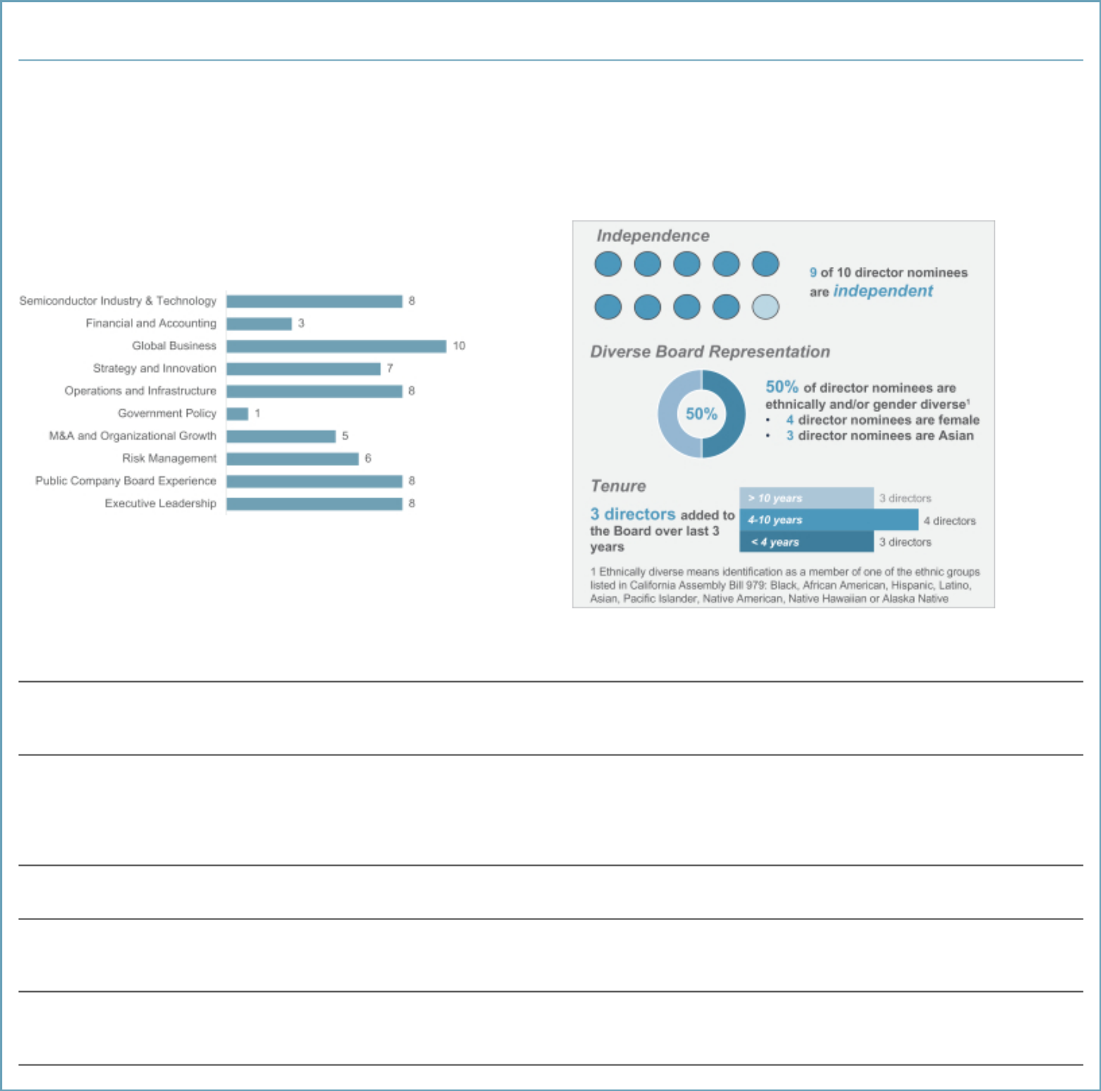

Board Practices and Composition

Ensuring the Board is composed of directors who possess a wide variety of relevant skills, professional experience and backgrounds, bring diverse viewpoints and perspectives, and effectively represent the long-term interests of shareholders is a top priority of the Board and the Corporate Governance and Nominating Committee. Our Board composition reflects strong Board practices that support regular refreshment based on board needs and proactive succession planning.

Director Nominee Expertise Key Attributes

Board Practices Support Thoughtful Board Composition

Board Composition to Support Company Strategy

The Board and the Corporate Governance and Nominating Committee regularly evaluate the size and composition of the Board to ensure appropriate alignment with the Company’s evolving business and strategic needs.

Policy on Board Diversity

The Board is committed to having a Board that reflects diverse perspectives, including those based on gender, ethnicity, skills, experience at policy-making levels in areas that are relevant to the Company’s global activities, and functional, geographic or cultural background. The Board has adopted a Policy on Board Diversity as part of its Corporate Governance Guidelines, which highlights its commitment to actively seek out women and ethnically diverse director candidates.

Annual Board Evaluations

The Board conducts an annual self-assessment of the Board, Board Committees and individual directors to evaluate effectiveness.

Board Refreshment

The Board believes the fresh perspectives brought by new directors are critical to a forward-looking and strategic Board when appropriately balanced by the deep understanding of Applied’s business provided by longer-serving directors.

Director Succession Planning

The Corporate Governance and Nominating Committee reviews the short- and long-term strategies and interests of Applied to determine what current and future skills and experience are required of the Board in exercising its oversight function.

Applied Materials, Inc. iii

Table of Contents


Corporate Governance

We are committed to effective corporate governance that is informed by our shareholders, promotes the long-term interests of our shareholders, and strengthens Board and management accountability.

Governance Highlights

✓ Annual Election of Directors | ✓ Shareholder Right to Act by Written Consent
✓ Independent Chairman of the Board | ✓ Shareholder Proxy Access
✓ Highly Independent Board (9 of 10 Director nominees) and | ✓ No Poison Pill
Committees
✓ Annual Board, Committee and Individual Evaluations | ✓ No Supermajority Vote Requirements
✓ Robust Board Succession Planning | ✓ Majority Voting for Directors
✓ Policy on Board Diversity | ✓ Regular Executive Sessions of Independent Directors
✓ Active Shareholder Engagement Practices | ✓ Stock Ownership Guidelines for Directors and Executives
✓ Shareholder Right to Call a Special Meeting | ✓ Clawback Policy for Annual and Long-Term Incentive Plans

Shareholder Engagement

We believe that strong corporate governance should include regular engagement with our shareholders to enable us to understand and respond to shareholder concerns. We have a robust shareholder outreach program led by a cross-functional team that includes members of our Investor Relations, Global Rewards, ESG, Diversity and Inclusion, Environmental Health and Safety and Legal functions. Independent members of our Board are also involved, as appropriate. In the fall, we solicit feedback on our executive compensation program, corporate governance practices, and sustainability and diversity and inclusion initiatives, as well as any matters voted on at our prior annual meeting. After the filing of our proxy statement, we engage again with our shareholders about important topics to be addressed at our annual meeting. Following our annual meeting, we review the results of the meeting and investor feedback, as well as evaluate emerging trends in corporate governance and other areas. We share feedback we receive from our shareholders with the Human Resources and Compensation Committee, Corporate Governance and Nominating Committee, and the full Board. See “Shareholder Engagement” on page 13 for more information.

- 2021 Proxy Statement

Table of Contents

2021 PROXY STATEMENT SUMMARY


Virtual Annual Meeting

This year’s Annual Meeting will be held in a virtual format through a live webcast. You are entitled to participate in the Annual Meeting if you were a shareholder as of the close of business on January 14, 2021, the record date, or hold a valid proxy for the meeting. To be admitted to the Annual Meeting at www.virtualshareholdermeeting.com/AMAT2021, you must enter the 16-digit control number found next to the label “Control Number” on your Notice of Internet Availability, proxy card, or the voting instructions you receive by email. The meeting webcast will begin promptly at 11:00 a.m., Pacific Time, on March 11, 2021. We encourage you to access the webcast prior to the scheduled start time of the Annual Meeting. If you encounter any difficulties accessing the virtual Annual Meeting, please call the technical support number that will be posted on the virtual shareholder meeting log in page. For information on how to vote your shares, please see “Questions and Answers about the Proxy Statement and our 2021 Annual Meeting” on page 69 of this Proxy Statement.

We are committed to ensuring that shareholders will be afforded the same rights and opportunities to participate as they would at an in-person meeting. Our directors and members of our management team will join the virtual meeting and be available for questions, and we are committed to answering all relevant questions we receive during the meeting. Shareholders may submit questions during the meeting through the virtual meeting platform at www.virtualshareholdermeeting.com/AMAT2021. We will address as many questions during the meeting as time permits, but if there are any questions that cannot be addressed due to time constraints or for any other reason, we will post answers to such questions on our website following the meeting. If we receive substantially similar questions, we may group them together and provide a single response to avoid repetition. Only questions that are relevant to the purpose of the Annual Meeting or our business will be answered.

Executive Compensation

Company Overview

Applied Materials is the leader in the materials engineering solutions used to produce virtually every new chip and advanced display in the world. Our expertise in modifying materials at atomic levels and on an industrial scale enables customers to transform possibilities into reality. At Applied Materials, our innovations make possible the technology shaping the future.

We develop, design, produce and service semiconductor and display equipment for manufacturers that sell into highly competitive and rapidly changing end markets. Our competitive positioning is driven by our ability to identify major technology inflections early, and to develop highly differentiated materials engineering solutions for our customers to enable those technology inflections. Through our broad portfolio of products, technologies and services, innovation leadership and focused investments in research and development, we are enabling our customers’ success and creating significant value for our shareholders.

In addition to our other accomplishments, we’ve laid out a new 10-year road map for environmental and social responsibility with detailed actions behind our vision to make possible a better future. Our 1x, 100x and 10,000x sustainability framework refers to the holistic goals and commitments we’ve set for our operations, how we work with customers and suppliers, and how our technology can be used to advance sustainability on a global scale.

Applied Materials, Inc. v

Table of Contents
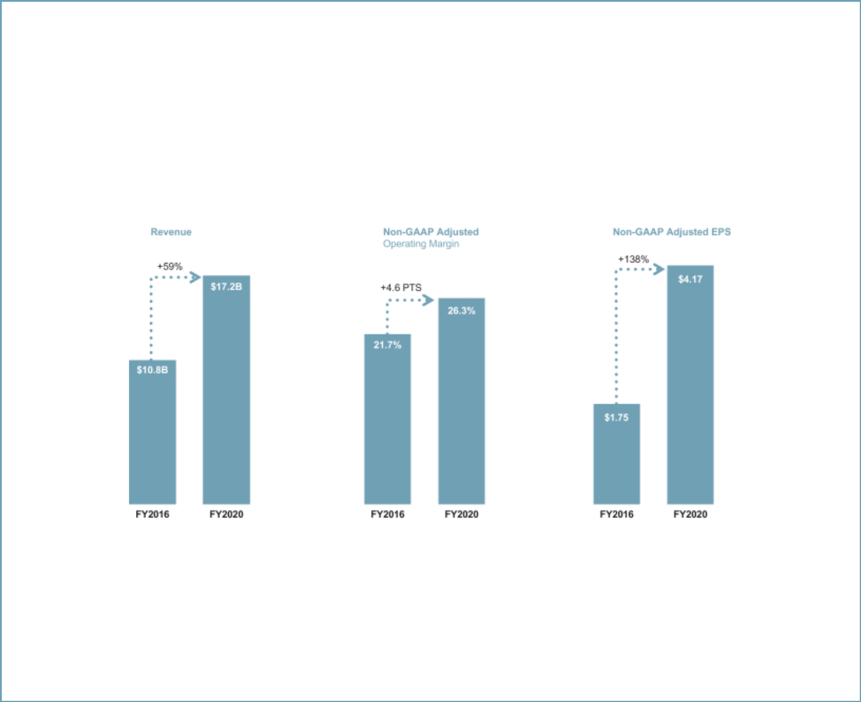

2020 Performance Highlights

Over the past several years, our broad portfolio of products and services has made Applied a more resilient company that can perform well in a variety of market environments. In 2020, we delivered strong performance despite the challenges of navigating the global COVID-19 pandemic. Key highlights include:

- Revenue of $17.2 billion;

- Operating income of $4.4 billion, resulting in GAAP EPS of $3.92, and non-GAAP adjusted operating income of $4.5 billion, resulting in non-GAAP adjusted EPS of $4.17 (see Appendix A for a reconciliation of non-GAAP adjusted measures); and

- Delivered record operating cash flow of $3.8 billion, equal to 22% of revenue.

Highlights of five-year performance achievements across key financial measures

Non-GAAP adjusted operating margin and non-GAAP adjusted EPS are performance targets under our long-term incentive and bonus plans. See Appendix A for non-GAAP reconciliations.

Key financial highlights for our reporting segments in fiscal 2020 include the following:

  - Semiconductor Systems segment: we delivered record annual revenue of $11.4 billion with broad-based strength across products and device types.

  - Applied Global Services segment: we grew revenue to a record $4.2 billion and increased the number of installed base tools covered by long-term service agreements – providing a recurring revenue stream – by 13% year-over-year.

  - Display and Adjacent Markets segment: we delivered revenue of $1.6 billion and maintained profitability during an industry down cycle.

- 2021 Proxy Statement

Table of Contents

2021 PROXY STATEMENT SUMMARY
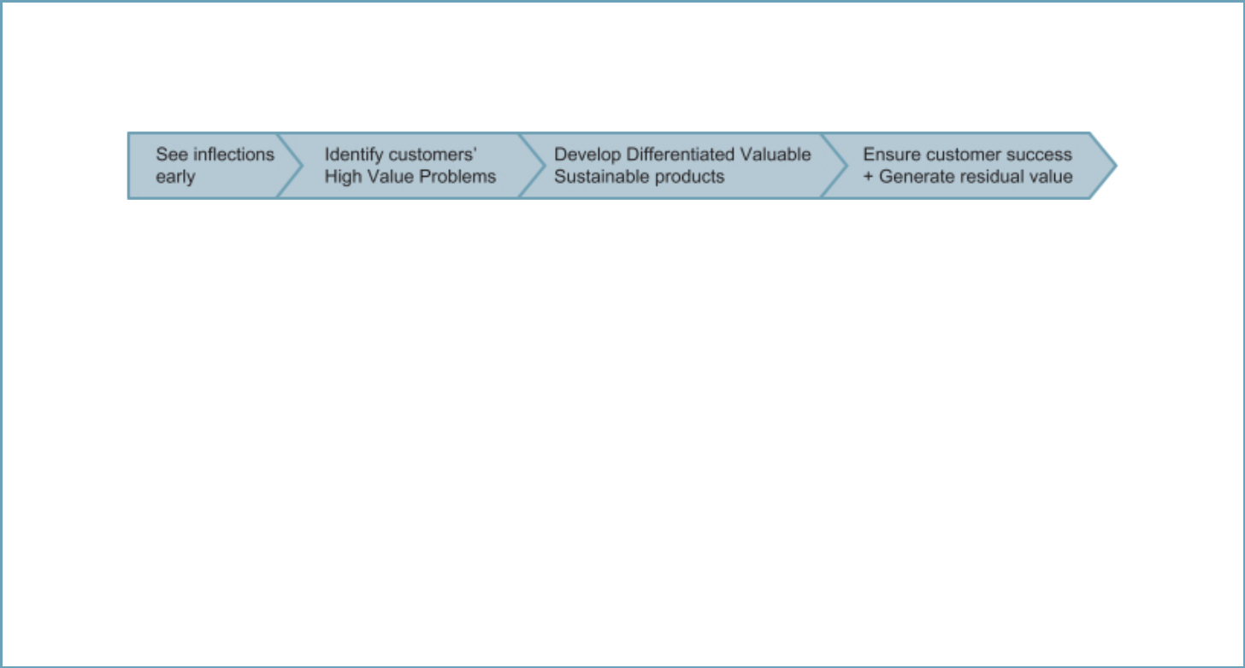

Strategic and Operational Highlights

Applied’s strategy is to deliver highly differentiated materials engineering products and services that enable major technology inflections and drive our customers’ success.

The world is relying on semiconductors more than ever as societies adapt to the challenges of COVID-19 and prepare for the post-pandemic era. Megatrends including the Internet of Things (IoT), big data and artificial intelligence (AI) are poised to transform nearly every industry in the years ahead. Applied Materials has aligned its strategy and investments around this vision for the future, and we are uniquely positioned to accelerate innovations that deliver improvements in the power, performance, area, cost and time-to-market of next-generation semiconductor devices. Key highlights for accomplishments during fiscal 2020 include:

- We continued to prioritize our operating expenses towards R&D to solve major technology challenges for our customers and drive our long-term growth strategy.

- We outperformed the wafer fabrication equipment market, growing revenues 18% and non-GAAP adjusted EPS 37%.

- Our inspection business delivered record performance as systems revenue increased 46%. Revenue for our metals deposition business grew 42% and we achieved record revenue in our packaging business. We gained share in conductor etch with new applications in DRAM and foundry-logic.

- In our services business, we increased the number of tools covered by long-term service agreements by 13%. As a result, 60% of our service and spare parts business now comes from these more predictable recurring revenue streams.

- We announced our 10-year roadmap for environmental and social responsibility, and set several challenging new goals and commitments related to our own operations, how we work with customers and suppliers and how our technology can be used to advance sustainability on a global scale.

Applied Materials, Inc. vii

Table of Contents
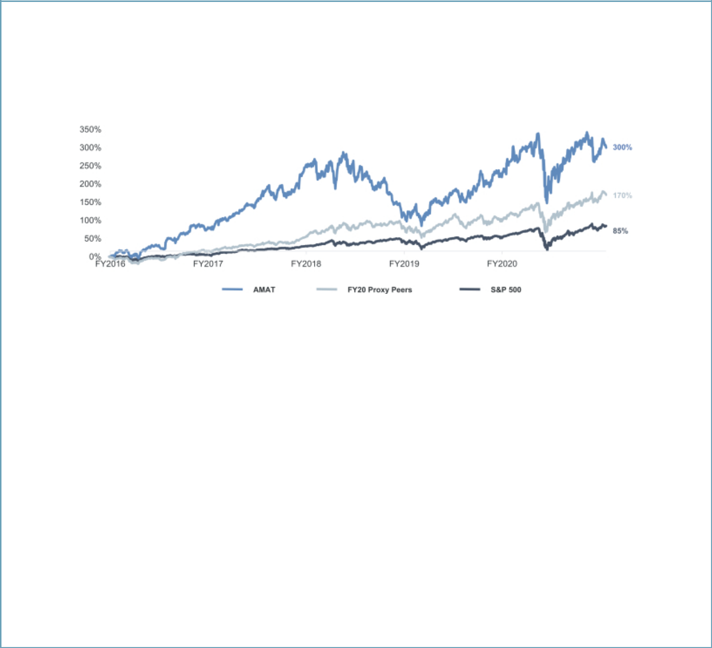

Stock Price Performance

In fiscal 2020, our stock price performance reflected increasing strength in the semiconductor markets, particularly in the second half of the year, as the industry began to adapt to the challenges created by the COVID-19 pandemic. Over the past five years, Applied has significantly outperformed the S&P 500 Index and our peer group, as shown below. In addition, from the close of market on the last trading day of fiscal 2020 through the close of market on December 31, 2020, Applied’s stock price increased by approximately 42%.

Fiscal 2016 – Fiscal 2020 Total Shareholder Return vs. S&P 500 and Proxy Peers¹

- Sourced from S&P Capital IQ. Proxy peer data reflects companies set forth on page 29, weighted by market capitalization.

Key Compensation Actions

Performance-Based Compensation Decisions. The Board’s Human Resources and Compensation Committee (the “HRCC”) approved an aggressive set of scorecard targets for the executive officers for fiscal 2020, including financial targets above any levels that Applied had achieved in the past, as well as equally challenging operational targets. During fiscal 2020, Applied delivered very strong financial and operational performance in a challenging environment and made meaningful progress towards our long-term strategic goals that are focused on enabling strong longer-term revenue and EPS growth.

As part of our multi-year incentive program, for the period of 2018 through 2020, the HRCC approved aggressive goals for non-GAAP adjusted operating margin and water fabrication equipment (“WFE”) market share. The results for this three-year performance period exceeded target, resulting in above-target vesting of performance share unit awards for our executive officers.

CEO Compensation Mix Rebalance. The HRCC has consistently focused on aligning Mr. Dickerson’s compensation with Applied’s long-term results. As a result, as part of its annual review of the executive compensation program in early fiscal 2020, the HRCC reduced Mr. Dickerson’s annual incentive bonus target amount while increasing the size of his annual long-term incentive award.

Chief Legal Officer Transition. In June 2020, we welcomed a new Chief Legal Officer, Teri A. Little, who brings significant experience and knowledge of our industry and is leading our legal organization to further accelerate the execution of our strategy. In connection with hiring Ms. Little, the HRCC approved a new-hire compensation package that was appropriate in the context of providing appropriate incentives for Ms. Little to join Applied but is not intended to represent ongoing compensation for her role.

Value Creation Awards. In early fiscal 2021, and after a number of months of careful deliberation of award design, the HRCC approved long-term value creation awards for Mr. Dickerson, Mr. Durn and Dr. Raja (the “Value Creation Awards”). These awards are entirely performance-based, have a longer vesting requirement than the annual long-term incentive awards, and will only deliver value to the recipients if Applied’s stock price significantly exceeds the Company’s all-time high on the grant date. The HRCC does not expect to grant similar awards to these executives in the coming years. For additional information regarding the Value Creation Awards, please see page 37.

- 2021 Proxy Statement

Table of Contents

2021 PROXY STATEMENT SUMMARY
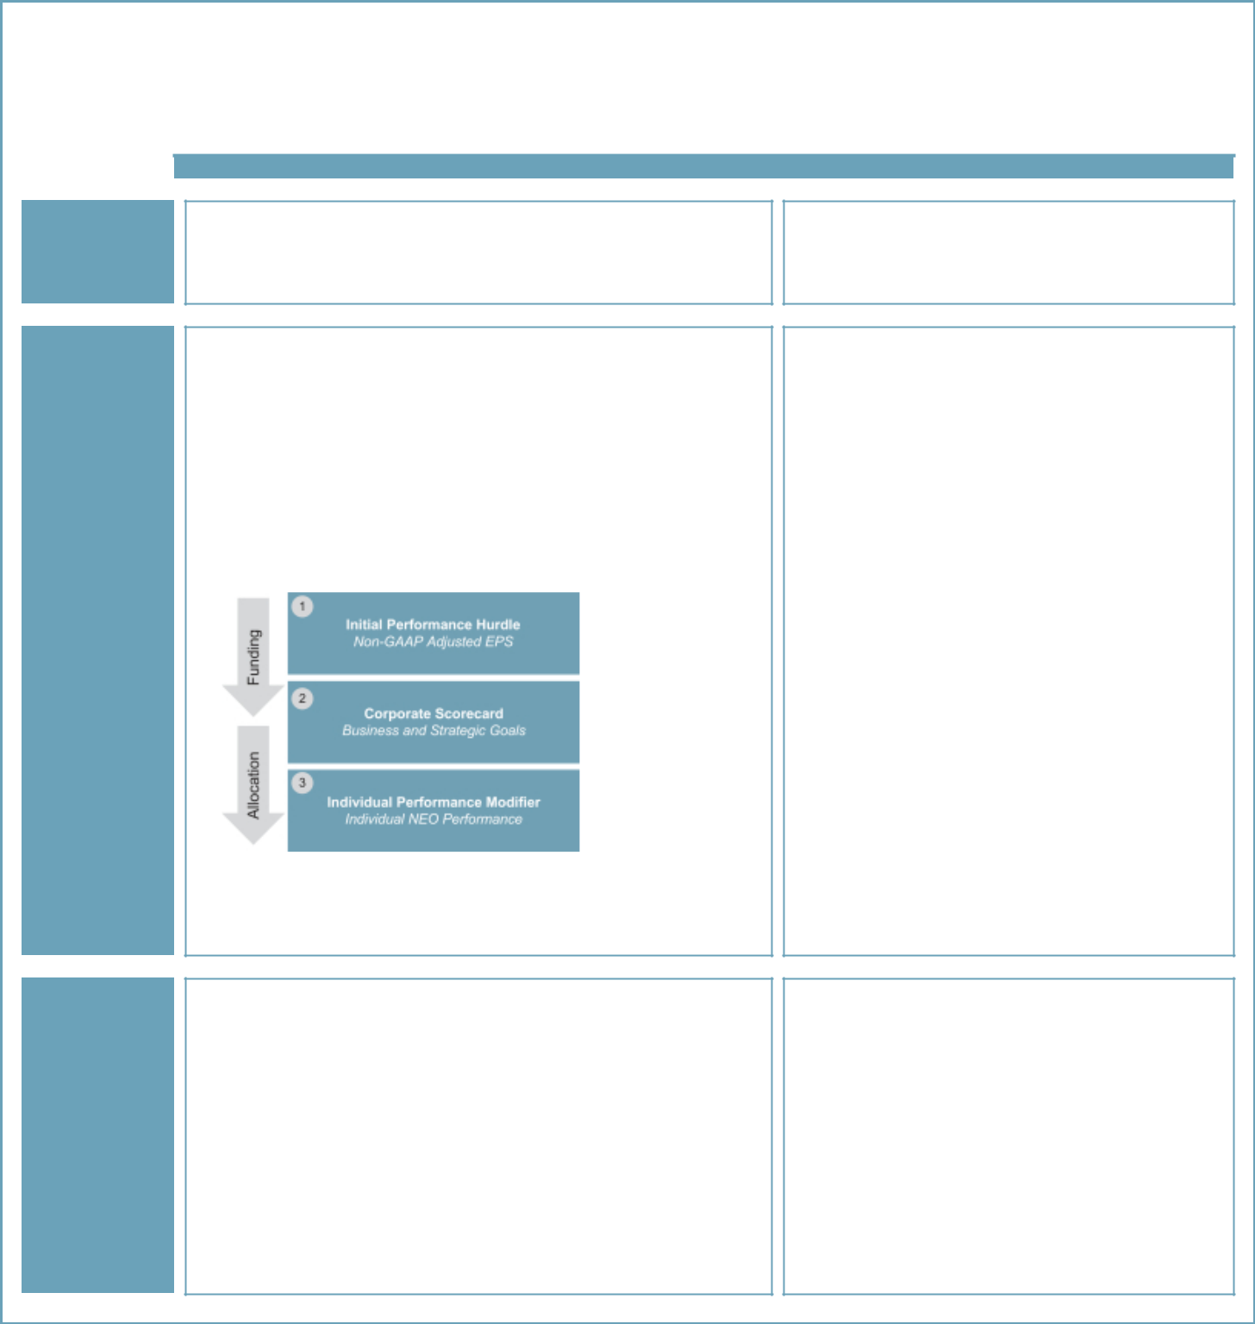

Primary Compensation Elements and Executive Compensation Highlights for Fiscal 2020

The primary elements of our compensation program consist of base salary, annual incentive bonuses and long-term incentive awards. Other elements of compensation include a 401(k) savings plan, deferred compensation benefits and other benefits programs that are generally available to all employees. Primary elements and highlights of our fiscal 2020 compensation program were as follows:

Element of Pay | Structure

Highlights

Base Salary

(see page 29)

Annual Incentive Bonuses (see page 29)

Long-Term Incentives (see page 35)

- Fixed cash compensation for expected day-to-day responsibilities

- Reviewed annually and adjusted when appropriate, based on scope of responsibility, performance, time in role, experience, and competitive market for executive talent

- Variable compensation paid in cash

- Based on performance against pre-established financial, operational, strategic and individual performance measures

- Financial and non-financial metrics provide a comprehensive assessment of executive performance

Performance metrics evaluated annually for alignment with strategy
- and market trends

NEO annual incentives determined through a three-step performance
- measurement process:

- Performance share units (“PSUs”) to establish rigorous long-term performance alignment

- Restricted stock units (“RSUs”) to provide link to shareholder value creation and retention value

PSUs vest based on achievement of 3-year non-GAAP adjusted
- operating margin and 3-year Total Shareholder Return (“TSR”) measured against the S&P 500

PSUs vests at end of 3-year performance period, based on
- achievement of performance goals; RSUs vest ratably over 3 years

- No change in salary from fiscal 2019 to fiscal 2020 for any of the named executive officers (“NEOs”)

- No increase in target bonus as a percentage of base salary from fiscal 2019 to fiscal 2020 for any of the NEOs

- A portion of Mr. Dickerson’s target bonus opportunity was re-allocated to his annual long-term incentive award value

- The initial performance hurdle non-GAAP adjusted EPS goal for fiscal 2020 was $3.25 – above Applied’s actual result for fiscal 2019. The Company achieved an actual result of $4.17 for

- fiscal 2020

As the initial performance hurdle was achieved, the annual bonuses were based on the performance of the Company’s objective and quantifiable business and strategic goals in the
- corporate scorecard for each NEO

Based on achievement compared to goals, fiscal 2020 actual annual bonuses ranged from 92% to 121% of target for our NEOs

— Achievement against the corporate scorecard ranged from 0.835x to 0.965x target (see corporate scorecard information on pages 32 and 33)

— Based on an assessment of individual performance results and the impact against both quantitative and strategic objectives, the NEOs received IPF ranging from 1.0x to
1.25x (see individual performance highlights on page 34)

- The target vehicle mix of the equity awards consists of 75% PSUs and 25% RSUs for the CEO and 50% PSUs and 50% RSUs for the other NEOs

- Non-GAAP adjusted operating margin is a key measure of our Company’s long-term success

- Prior to fiscal 2019, a portion of the PSU payout was based on the Company’s WFE market share. Starting in fiscal 2019, that metric was replaced with relative TSR, which better reflects our business mix, and incentivizes management to outperform the market in any business environment. The fiscal 2018 PSUs, which vested following the end of fiscal 2020, represent the last award with a portion of the performance based on the WFE market share metric.

Applied Materials, Inc. ix

Table of Contents
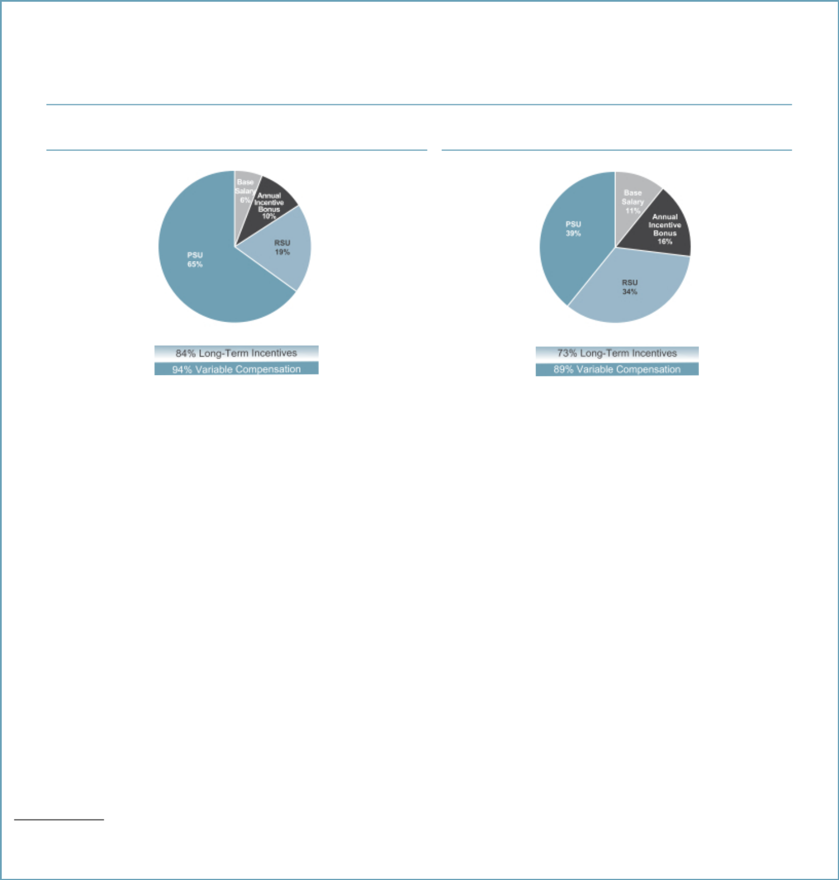

Pay Mix

In fiscal 2020, a significant portion of our executive compensation consisted of variable compensation and long-term incentives. As illustrated below, 94% of CEO compensation for fiscal 2020 consisted of variable compensation elements, and 84% of CEO compensation was delivered in equity with multi-year vesting.

Fiscal 2020 Compensation Mix1

CEO All Other NEOs²

- Represents total direct compensation for fiscal 2020, including the grant date fair value of annual equity awards. Does not include the Value Creation Awards, which were granted in fiscal 2021.

² All Other NEO chart excludes Ms. Little, whose fiscal 2020 compensation is not representative of the expected ongoing mix or level for her role.

Summary of 2020 Total Direct Compensation

The following table summarizes elements of annual total direct compensation for our NEOs for fiscal 2020, consisting of (1) base salary, (2) annual incentive bonus and (3) long-term incentive awards (the grant date fair value of stock awards). This table excludes amounts not considered by the HRCC to be annual total direct compensation, such as certain other amounts required by the SEC to be reported in the Summary Compensation Table (see page 44 of this Proxy Statement).

 |  |  | Annual
 |  | Annual | Long-Term
 |  | Incentive | Incentive
 | Salary | Bonus | Award | Total
Name and Principal Position | ($) | ($) | ($) | ($)
Gary E. Dickerson | 1,030,000 | 1,786,406 | 14,299,176 | 17,115,582
President and Chief Executive Officer
Daniel J. Durn | 625,000 | 975,586 | 4,459,552 | 6,060,138
Senior Vice President, Chief Financial Officer
Ali Salehpour | 625,000 | 774,984 | 4,247,422 | 5,647,406
Senior Vice President, Services, Display and Flexible Technology
Prabu G. Raja | 567,000 | 923,324 | 3,359,304 | 4,849,628
Senior Vice President, Semiconductor Products Group
Teri A. Little¹ | 198,077 | 200,655 | — | 398,732
Senior Vice President, Chief Legal Officer and Corporate Secretary

  - Ms. Little joined Applied in June 2020. The base salary and annual incentive bonus shown for Ms. Little are prorated based on her service during fiscal 2020. Ms. Little did not receive an annual long-term incentive award in fiscal 2020. Amounts for Ms. Little exclude the value of a sign-on bonus, a stock replacement cash payment and a new-hire equity award, all of which are reported in the Summary Compensation Table.

x 2021 Proxy Statement

Table of Contents

2021 PROXY STATEMENT SUMMARY
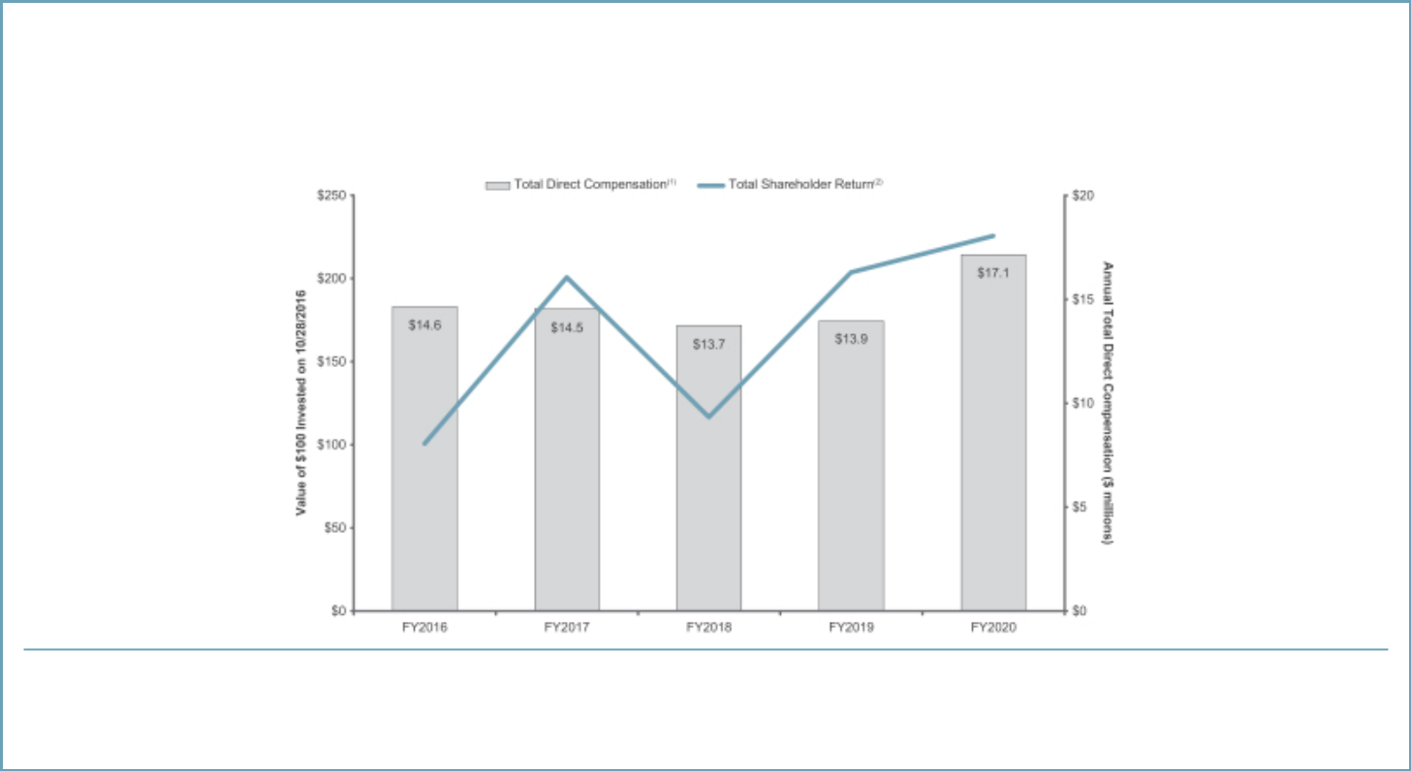

Pay and Performance

The HRCC approves aggressive performance goals for the CEO, as well as for the entire executive leadership team. As a result, despite outstanding TSR growth from fiscal 2016 through 2020, our CEO’s total direct compensation has remained within a comparable range over the same period.

- Total direct compensation consists of annual base salary, annual incentive bonus and long-term incentive award (grant date fair value of annual equity awards). Total direct compensation shown above excludes other amounts required by the SEC to be reported in the Summary Compensation Table.
- TSR line illustrates the total shareholder return on our common stock during the period from October 28, 2016 through October 23, 2020 (the last business day of fiscal 2020), assuming $100 was invested on October 28, 2016 and assuming reinvestment of dividends.

Applied Materials, Inc. xi

Table of Contents
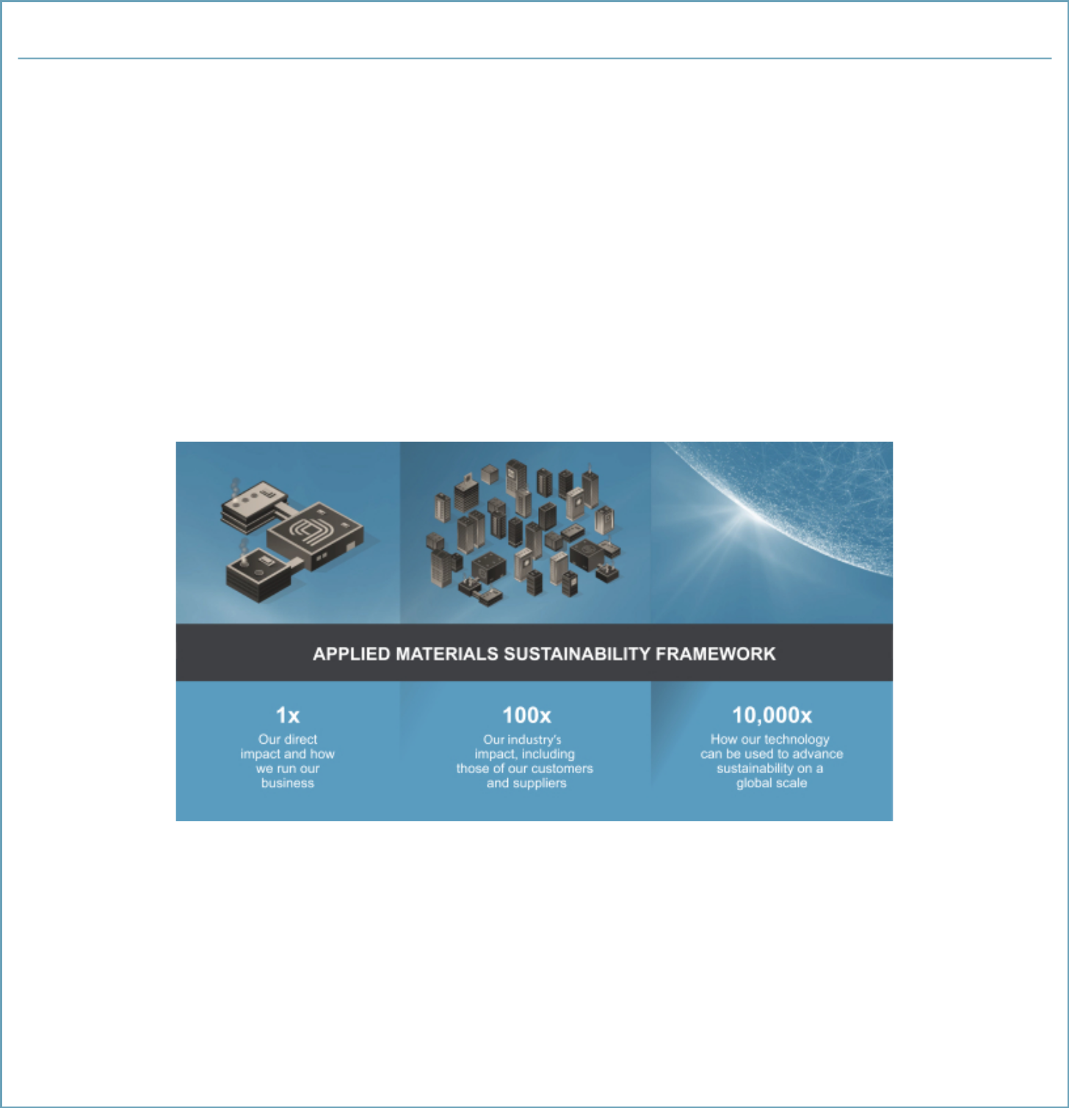

Our Commitment to ESG

Our Approach

Applied is committed to growing its business in a sustainable and socially responsible manner. We are focusing our resources and capabilities on addressing the sweeping technological challenges in the era of Artificial Intelligence and big data, and working with our customers to build a safer, more equitable and sustainable future.

At the heart of Applied’s values is a commitment to operate with responsibility and integrity while making a positive contribution to our industry and the world around us. To drive change and innovation, we are making investments in our research and development, operations, supply chain and interactions with our local communities. We are committed to advancing sustainability, not only through improvements in our own operations but also through investing in technological innovation. We are also committed to transparency and are aligning our disclosures and objectives with the United Nations Sustainable Development Goals and leading Environmental, Social and Governance (“ESG”) reporting frameworks such as those developed by the Sustainability Accounting Standards Board (“SASB”) and Global Reporting Initiative (“GRI”).

New Sustainability Framework

In 2020, as we sharpen our ESG focus, we launched a new sustainability framework and integrated strategy to build upon our ongoing ESG work. As part of this effort, we conducted our first comprehensive ESG materiality assessment to inform our sustainability framework and to help focus our efforts on issues that are most important to Applied and our key stakeholders. Our new sustainability framework is called 1x, 100x, 10,000x, and covers our direct impact, the impact of our value chain (customers and suppliers), as well as how we can advance sustainability on a global scale.

Our Sustainability Commitments

We have recently announced renewed sustainability commitments for the next decade that we believe will dramatically reduce our environmental impact. Although these goals are aggressive, we believe them to be achievable:

  - First, we aim to move to 100% renewable energy in our U.S. operations by 2022

  - Second, we aim to move to 100% renewable energy in our global operations by 2030

  - Third, we intend to achieve a 50% reduction in our Scope 1 and 2 CO2 emissions by 2030 compared to our 2019 baseline

  - In addition, we plan to establish science-based targets and will report our Scope 3 emissions within 24 months

  - Finally, we are committed to report in line with the Task Force on Climate-Related Financial Disclosures (“TCFD”)

- 2021 Proxy Statement

Table of Contents

2021 PROXY STATEMENT SUMMARY


Furthermore, we are committed to building a culture of inclusion with a focus on leadership, promoting diversity and inclusion, and eliminating systemic barriers to inclusion. We are currently working on promoting ongoing career development for employees to encourage innovation and engagement.

Sustainability and Corporate Social Responsibility Governance

Our Board and management oversee sustainability matters to foster accountability. We have established executive leadership of a company-wide strategy on ESG matters and reporting, and are focused on integrating sustainability into our operations and company culture through initiatives aligned to company strategy that address a broad set of stakeholders, including shareholders, customers, employees, suppliers, governments and our local communities. In 2020, we announced the appointment of a Director of ESG, Corporate Sustainability, and Reporting to lead ESG efforts across our business, and the Director of ESG now reports to the Board’s Corporate Governance and Nominating Committee (the “Governance Committee”) on a regular basis throughout the year.

Our Environmental, Health and Safety & Sustainability (“EHS&S”) organization is dedicated to maintaining a safe and healthful working environment, demonstrating environmental leadership, and meeting or exceeding regulatory compliance. The Head of EHS&S reports directly to the Governance Committee on a quarterly basis. We have a team fully dedicated to supporting our work in designing a culture of inclusion, and the Board’s Human Resources and Compensation Committee (the “HRCC”) oversees our corporate culture and human capital management programs, including our diversity and inclusion practices and initiatives. The HRCC approved ESG objectives for our annual bonus program to incentivize our leadership to improve employee safety, engagement and learning and development, to promote a culture of inclusion and to accelerate the representation of women and underrepresented minorities in our workforce. For the fiscal 2021 Corporate scorecard, we have added an ESG objective to demonstrate Applied’s commitment to driving sustainability throughout our business and to provide a discrete incentive for management to execute on our new ESG strategy. Further details and data on our sustainability and corporate social responsibility practices and accomplishments can be found in our annually published Sustainability Report, which can be accessed here: https://www.appliedmaterials.com/news/citizenship_report.html.

Key ESG Initiatives that Support our Long-Term Strategy

Climate Change & Environment

Fighting climate change means bringing all our skills and

technology innovations to bear

- GHG Emissions. We set new targets to reduce Scope 1 and 2 carbon emissions 50% by 2030 and announced our intention to set science-based targets and report Scope 3 emissions

- Renewable Energy. We set a target of sourcing 100% renewable power in our U.S. operations by 2022 and in our global operations by 2030

- Innovation and Product Stewardship. We introduced new industry-scaled focus on how our technology can advance sustainability globally and modified our product design process to incorporate ESG criteria from the earliest stages. We call this program and set of goals 3x30: on a per-wafer basis, a 30% reduction in equivalent energy consumption, a 30% reduction in chemical consumption, and a 30% increase in throughput density, all by 2030

Diversity and Inclusion

Cultivating a Culture of Inclusion, diversity, and engagement to become a destination employer

- Transparency. We disclosed our 2016–2018 EEO-1 reports and diversity data at three levels: executives, managers, and professionals, and continue to provide transparency of our diversity data, goals and progress

- Commitment. We continue to build a culture of inclusion and accelerate progress towards meeting our goals of increasing women’s representation in our U.S. workforce and globally, and underrepresented minorities in our U.S. workforce. We promote the next generation of diverse technology leaders by supporting STEM education programs

- Engagement. We are integrating our emphasis on diversity and inclusion into new-hire orientation and employee development programs, supporting employee resource groups, and measuring inclusion and engagement in our annual employee survey

Applied Materials, Inc. xiii

Table of Contents


Supply Chain

Driving sustainability across our business means forging a new level of partnership with our suppliers.

- Industry Coalition. We are a member of the Responsible Business Alliance (formerly EICC) and have adopted its Code of Conduct, to promote safe working conditions in our supply chains and environmentally responsible, sustainable and ethical business operations

- Commitment to High Standards. We developed a shared 10-year roadmap called SuCCESS2030 to help us better partner with our supply chain. We will require all companies in our global supply chain to implement the Responsible Business Alliance’s Code of Conduct and Applied’s Standards of Business Conduct

Ethics

Ethical business conduct is ingrained in our values and reflected in our employees’ actions, every day

- Human Rights. Our Standards of Business Conduct include several important provisions on human rights, including prohibitions on the use of child labor or forced, bonded or indentured labor in our operations

- Conflict Minerals. We are committed to responsible sourcing of minerals for our products. We do not directly purchase conflict minerals or have any direct relationship with mines or smelters that process these minerals. We are involved in the Conflict-Free Sourcing Initiative (CFSI)

- Governance. We appointed a director of ESG, Corporate Sustainability, and Reporting to oversee our ESG program. The Board receives regular in-depth updates on our ESG programs and topics related to climate, human capital, and health and safety

- 2021 Proxy Statement

Table of Contents

PROPOSAL 1—ELECTION OF DIRECTORS

PROXY STATEMENT

PROPOSAL 1—ELECTION OF DIRECTORS

Nominees

Applied’s Board of Directors is elected each year at the Annual Meeting of Shareholders. Applied currently has 11 directors. Stephen R. Forrest is retiring from the Board, and his service on our Board will end upon completion of his current term in March 2021. The Board has authorized a reduction in the size of the Board from 11 to 10 directors, effective upon the election of directors at the Annual Meeting. Upon the recommendation of the Corporate Governance and Nominating Committee, the Board has nominated the ten individuals listed below for election at the Annual Meeting, each of whom currently serves as a director of Applied. These nominees bring a wide variety of relevant skills, professional experience and backgrounds, as well as diverse viewpoints and perspectives to represent the long-term interests of shareholders, and to fulfill the leadership and oversight responsibilities of the Board.

If any nominee listed below becomes unable to stand for election at the Annual Meeting, the persons named as proxies may vote for any person designated by the Board to replace the nominee. Alternatively, the proxies may vote for the remaining nominees and leave a vacancy that the Board may fill later, or the Board may reduce the authorized number of directors. As of the date of this Proxy Statement, the Board is not aware of any nominee who is unable or will decline to serve as a director.

Each director elected at the Annual Meeting will serve until Applied’s 2022 Annual Meeting of Shareholders and until he or she is succeeded by another qualified director who has been elected, or, if earlier, until his or her death, resignation or removal.

- THE BOARD RECOMMENDS THAT YOU VOTE FOR EACH OF THE FOLLOWING DIRECTOR NOMINEES

Rani Borkar


Corporate Vice President, Azure Hardware Systems and Infrastructure, Microsoft Corporation

Rani Borkar has served as Corporate Vice President, Azure Hardware Systems and Infrastructure, at

Microsoft Corporation, a global technology provider, since June 2019. Ms. Borkar also served as Microsoft’s Corporate Vice President, Microsoft Cloud Capacity, Supply Chain and Provisioning, from September 2017 to June 2019. From 2016 to 2017, Ms. Borkar was Vice President, OpenPOWER Development at IBM Corporation, a global technology and consulting company. Prior to IBM, Ms. Borkar worked at Intel Corporation for 27 years, most recently as Intel’s Corporate Vice President and General Manager, Product Development Group. Ms. Borkar is a member of the board for the Global Semiconductor Alliance, and she serves as the Chair of the Board of Trustees at Oregon State University to help guide the State of Oregon’s effort to advance economic development and innovation.

Independent Director

Director since 2020

Age 59

Board Committees:

- Strategy and Investment

Key Qualifications and Expertise:

- Executive leadership and management experience

- Semiconductor industry leadership

- Global business, industry and operational experience

- Semiconductor design and computing systems development expertise

- Strategy and innovation

Applied Materials, Inc. 1

Table of Contents

Judy Bruner


Executive Vice President, Administration and Chief Financial Officer, SanDisk Corporation (retired)

Judy Bruner served as Executive Vice President,

Administration and Chief Financial Officer of SanDisk Corporation, a supplier of flash storage products, from June 2004 until its acquisition by Western Digital in May 2016. Previously, she was Senior Vice President and Chief Financial Officer of Palm, Inc., a provider of handheld computing and communications solutions, from September 1999 until June 2004. Prior to Palm, Inc., Ms. Bruner held financial management positions at 3Com Corporation, Ridge Computers and Hewlett-Packard Company. She currently serves as a member of the boards of directors of Rapid7, Inc., Seagate Technology plc and Varian Medical Systems, Inc. Ms. Bruner previously served as a member of the board of directors of Brocade Communications Systems, Inc., from 2009 until its acquisition in November 2017.

Independent Director

Director since 2016

Age 62

Board Committees:

- Audit (Chair)

- Corporate Governance and Nominating (Chair)

Other Current Public Boards:

- Rapid7, Inc.

- Seagate Technology plc

- Varian Medical Systems, Inc.

Key Qualifications and Expertise:

- Executive leadership and management experience

- Semiconductor industry leadership

- Accounting principles, financial controls, financial reporting rules and regulations, and audit procedures

- Global business, industry, finance, information technology and operational experience

- Risk management and controls

- Strategy and innovation

- Mergers and acquisitions

- Public company board experience

Xun (Eric) Chen

Managing Partner,
SB Investments Advisers (US), Inc.

Eric Chen has been a Managing Partner of SB

Investment Advisers (US), Inc. (“SBIA”), an investment adviser focused on investments in the technology sector, since March 2018. Prior to joining SBIA, Dr. Chen was the Chief Executive Officer and Co-Founder of BaseBit Technologies, Inc., a technology company in Silicon Valley. He served as CEO of BaseBit Technologies since it was founded in October 2015, except from March 2016 until December 2017, when BaseBit was a portfolio company of Team Curis Group, a group of integrated biotechnology and data technology companies and laboratories, during which time Dr. Chen served as CEO of Team Curis Group. From 2008 to 2015, Dr. Chen served as a managing director of Silver Lake, a leading private investment firm focused on technology-enabled and related growth industries. Prior to Silver Lake, Dr. Chen was a senior vice president and served on the executive committee of ASML Holding N.V. He joined ASML following its 2007 acquisition of Brion Technologies, Inc., a company he co-founded in 2002 and served as Chief Executive Officer. Prior to Brion Technologies, Dr. Chen was a senior vice president at J.P. Morgan. He served as a member of the boards of directors of Qihoo 360 Technology Co. Ltd. from 2014 to July 2016 and of Varian Semiconductor Equipment Associates, Inc. (“Varian”) from 2004 until its acquisition by Applied in 2011. Dr. Chen also currently serves as a member of the board of directors of Che Hao Duo Group.

- 2021 Proxy Statement

Independent Director

Director since 2015

Age 51

Board Committees:

- Human Resources and Compensation

- Strategy and Investment

Key Qualifications and Expertise:

- Executive leadership and management experience

- Semiconductor industry leadership

- Global business, industry and operational experience in the technology and information sector

- Mergers and acquisitions, capital markets

- Strategy and innovation

- Public company board experience

product development
challenges
leadership
experience
● Expertise in driving strategy, innovation and
● Understanding of complex industry and global
● Extensive engineering and technological
of the Board of Directors of Applied since September 2013. Mr. Dickerson joined Applied
following its acquisition in November 2011 of Varian Semiconductor Equipment Associates, ● Global business, industry and operational Inc., a supplier of semiconductor manufacturing equipment. Mr. Dickerson had served as
Chief Executive Officer and a director of Varian since 2004. Prior to joining Varian in 2004, Mr. Dickerson served 18 years with KLA-Tencor Corporation, a supplier of process control and yield management solutions for the semiconductor and related industries, where he held a variety of operations and product development roles, including President and Chief Operating Officer. Mr. Dickerson started his semiconductor career in manufacturing and engineering management at General Motors’ Delco Electronics Division and then AT&T, Inc.
Table of Contents

PROPOSAL 1—ELECTION OF DIRECTORS

Aart J. de Geus


Chairman and Co-Chief Executive Officer,

Synopsys, Inc.

Aart J. de Geus is a co-founder of Synopsys, Inc., a

provider of electronic design automation software and related services for semiconductor design companies, and currently serves as its Chairman of the Board of Directors and Co-Chief Executive Officer. Since 1986, Dr. de Geus has held various positions at Synopsys, including President, Senior Vice President of Engineering and Senior Vice President of Marketing, and has served as a member of its board of directors. From 1982 to 1986, Dr. de Geus was employed by the General Electric Company, a global power, renewable energy, aviation, healthcare and finance company, where he was the Manager of the Advanced Computer-Aided Engineering Group.

Independent Director

Director since 2007

Age 66

Board Committees:

- Strategy and Investment

Other Current Public Boards:

- Synopsys, Inc.

Key Qualifications and Expertise:

- Executive leadership and global management experience

- Semiconductor industry leadership

- Innovation, management development and

understanding of global challenges and

opportunities

- Navigating a company from start-up through various stages of growth

- Mergers and acquisitions

- Cybersecurity

- Risk management and controls

- Public company board experience

Gary E. Dickerson


President and Chief Executive Officer, Applied Materials, Inc.

Gary E. Dickerson has been President of Applied since June 2012 and Chief Executive Officer and a member

Director since 2013

Age 63

Key Qualifications and Expertise:

- Executive leadership and management experience

- Semiconductor industry leadership

Applied Materials, Inc. 3

Table of Contents

Thomas J. Iannotti


Senior Vice President and General Manager, Enterprise Services, Hewlett-Packard Company (retired)

Thomas J. Iannotti served as Senior Vice President

and General Manager, Enterprise Services, for Hewlett-Packard Company, a technology solutions provider to consumers, businesses and institutions globally, from February 2009 until his retirement in October 2011. From 2002 to January 2009,

Mr. Iannotti held various executive positions at Hewlett-Packard, including Senior Vice President and Managing Director, Enterprise Business Group, Americas. From 1978 to 2002, Mr. Iannotti worked at Digital Equipment Corporation, a vendor of computer systems and software, and at Compaq Computer Corporation, a supplier of personal computing systems, after its acquisition of Digital Equipment Corporation. Mr. Iannotti currently serves as lead director of the board of directors of Atento S.A.

Chairman of the Board

Independent Director

Director since 2005

Age 64

Board Committees:

- Human Resources and Compensation (Chair)

Other Current Public Boards:

- Atento S.A.

Key Qualifications and Expertise:

- Service management for technology companies on a global, regional and country level

- Senior leadership and management experience

- Global business, industry and operational experience

- International strategic and business development

- Public company board experience

Alexander A. Karsner


Senior Strategist, X

Alexander A. Karsner is Senior Strategist at X, the innovation lab of

Alphabet Inc. Mr. Karsner is also Executive Chairman of Elemental

Labs, which pursues

market transformation through nature-based solutions. From January 2016 to July 2019, Mr. Karsner served as Managing Partner of Emerson Collective, an investment platform funding non-profit, philanthropic and for-profit portfolios advancing education, immigration, the environment and other social innovation initiatives. Prior to that, Mr. Karsner was the Founder and CEO of Manifest Energy Inc., an energy technology development and investment firm, since July 2009, and has served as its Executive Chairman since January 2013. From March 2006 to August 2008, he served as Assistant Secretary for Energy Efficiency and Renewable Energy at the U.S. Department of Energy. From August 2002 to March 2006, Mr. Karsner was Founder and Managing Director of Enercorp, a private company involved in international project development, management and financing of energy infrastructure.

- 2021 Proxy Statement

Independent Director

Director since 2008

Age 53

Board Committees:

- Corporate Governance and Nominating

- Human Resources and Compensation

Key Qualifications and Expertise:

- Expertise in public policy and government relations

- Domestic and international trade, development and investment markets

- Cybersecurity

- Environment and sustainability, including renewable energy policy, technologies and commercialization

- Entrepreneurial leadership

- Strategy and innovation

- Public company board experience

Table of Contents

PROPOSAL 1—ELECTION OF DIRECTORS

Adrianna C. Ma


Chief Operating Officer, Index Ventures

Adrianna C. Ma has served as Chief Operating Officer of Index Ventures, a venture capital firm, since September 2020. Prior to joining Index Ventures,
Ms. Ma was Managing Partner of Haleakala Holdings LLC, her personal investment firm, since July 2019. From May 2015 to June 2019, she was a Managing Partner at the Fremont Group, a private investment company where she was responsible for a portfolio of funds, including its investment strategy, asset allocation, manager selection and risk management. From 2005 to April 2015, Ms. Ma served as a Managing Director at General Atlantic LLC, a global growth equity firm, where she invested in and served on the boards of directors of technology-enabled growth companies around the world. Prior to joining General Atlantic, Ms. Ma worked at Morgan Stanley & Co. Incorporated as an investment banker in the Mergers, Acquisitions and Restructuring Department. Ms. Ma previously served as a member of the board of directors of Jagged Peak Energy Inc. from 2019 to 2020 and C&J Energy Services, Inc. from 2013 to 2015.

Independent Director

Director since 2015

Age 47

Board Committees:

- Audit

- Strategy and Investment

Key Qualifications and Expertise:

- Broad experience with technology companies

- Expertise in global growth investment

- Financial and accounting expertise

- Global business and operational experience

- Mergers and acquisitions, capital markets

- Board experience with technology-enabled growth companies

Yvonne McGill


Corporate Controller and Infrastructure Solutions Group Chief
Financial Officer
Dell Technologies, Inc.

Yvonne McGill has been Corporate Controller and Infrastructure Solutions Group Chief Financial Officer since February 2020, and previously was Chief Financial Officer and Senior Vice President, Infrastructure Solutions Group since March 2018 and Senior Vice President, Global Financial Planning and Analysis since August 2015 at Dell Technologies, Inc., a leading global end-to-end technology provider, with a comprehensive portfolio of IT hardware, software and service solutions spanning both traditional infrastructure and emerging, multi-cloud technologies. Ms. McGill served in various other finance leadership roles since joining Dell in 1997. Prior to Dell, Ms. McGill worked at ManTech International Corporation and Price Waterhouse. She is a Certified Public Accountant (inactive). Ms. McGill also currently serves on the Susan G. Komen Greater and Central Texas Foundation Board.

Independent Director

Director since 2019

Age 53

Board Committees:

- Audit

- Corporate Governance and Nominating

Key Qualifications and Expertise:

- Executive leadership and management experience

- Accounting principles, financial controls, financial reporting rules and regulations, and audit procedures

- Global business, industry and operational experience in the technology sector

Applied Materials, Inc. 5

Table of Contents

Scott A. McGregor


President and Chief Executive Officer, Broadcom Corporation (retired)

Scott A. McGregor served as President and Chief

Executive Officer and as a member of the board of directors of Broadcom Corporation, a world leader in wireless connectivity, broadband, automotive and networking infrastructure, from 2005 until the company was acquired by Avago Technologies Limited in February 2016. Mr. McGregor joined Broadcom from Philips Semiconductors (now NXP Semiconductors), where he was President and Chief Executive Officer. He previously served in a range of senior management positions at Santa Cruz Operation Inc., Digital Equipment Corporation (now part of HP), Xerox PARC and Microsoft, where he was the architect and development team leader for Windows 1.0. Mr. McGregor currently serves as a member of the board of directors of Equifax Inc., and Luminar Technologies. He previously served as a member of the boards of directors of Ingram Micro Inc., TSMC, and Xactly Corporation.

Chairman Emeritus

Independent Director

Director since 2018

Age 64

Board Committees:

- Audit

- Strategy and Investment (Chair)

Other Current Public Boards:

- Equifax Inc. (since October 2017)

- Luminar Technologies, Inc.

Key Qualifications and Expertise:

- Executive leadership and management experience

- Semiconductor industry leadership

- Global business, industry and operational experience

- Strategy, innovation, management development and understanding of global challenges and opportunities

- Cybersecurity

- Public company board leadership

James C. Morgan became Chairman Emeritus in March 2009, following his retirement as our director and Chairman of the Board. Mr. Morgan spent more than 31 years as a director and employee of Applied, including over 20 years as Chairman of the Board.

- 2021 Proxy Statement

Mr. Morgan first joined Applied in 1976 and served as Chief Executive Officer from 1977 to 2003. As Chairman Emeritus, Mr. Morgan does not attend any Board or Committee meetings, has no voting rights and receives no retainer or meeting fees.

Table of Contents

BOARD AND CORPORATE GOVERNANCE PRACTICES

BOARD AND CORPORATE GOVERNANCE PRACTICES

Board Composition and Nominee Considerations

Nominee Skills and Experience

Our director nominees have a wide variety of relevant skills, professional experience and backgrounds, and collectively bring to our Board diverse viewpoints and perspectives that
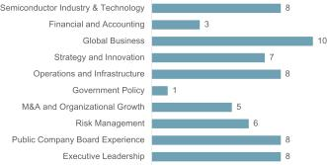

strengthen its ability to represent the long-term interests of shareholders. The chart below illustrates broad categories of skills and expertise that our director nominees offer that we believe contribute to the effective leadership and exercise of oversight responsibilities by the Board.
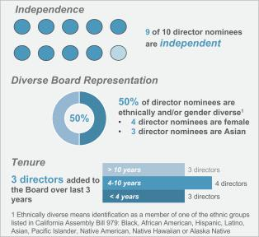

Diversity. Our Board values having a Board that reflects diverse perspectives, including those based on gender, ethnicity, skills, experience at policy-making levels in areas that are relevant to the Company’s global activities, and functional, geographic or cultural backgrounds. Our Board has adopted a Policy on Board Diversity within our Corporate Governance Guidelines, which reflects the Board’s commitment to actively seek out women and ethnically diverse director candidates and to consider the factors above, among others, in the context of the current composition of the Board and needs of the Company when identifying and evaluating director candidates.

The ten director nominees for election at our 2021 Annual Meeting bring to our Board a variety of different backgrounds, skills, professional and industry experience and other attributes and perspectives that contribute to the overall diversity of our Board.

Independence. The Governance Committee expects each non-employee director to be free of relationships, interests or affiliations that could give rise to conflicts of interest or interfere with the director’s exercise of independent judgment. Applied’s Corporate Governance Guidelines require that a majority of our directors must be independent, and that our

Audit, Human Resources and Compensation, and Governance Committees must consist solely of independent directors.

Director independence is determined under Nasdaq listing standards and SEC rules. The Board has affirmatively determined that, other than
Mr. Dickerson, our Chief Executive Officer, all members of the Board who served during 2020 and all director nominees are independent under applicable Nasdaq listing standards and SEC rules.

Tenure. The Board believes that new ideas and perspectives are critical to a forward-looking and strategic Board, as are the valuable experiences and deep understanding of Applied’s business and industries that longer-serving directors offer. Our Governance Guidelines do not impose a term limit on Board service, but our directors are not typically nominated for re-election after they reach the age of 70. Feedback from the annual Board evaluations and individual discussions between each non-employee director and our Chairman are an important determinant of Board tenure. As a result of our ongoing Board refreshment efforts, we have added three new directors to the Board over the last three years, which has resulted in a balanced range of tenures, ensuring both continuity and fresh perspectives among our director nominees.

Applied Materials, Inc. 7

Table of Contents

Our nominees have an average tenure of seven years, which is lower than the average tenure of other S&P 500 companies, and we have added three new directors to the Board over the last three years.
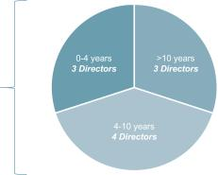

Regular

refreshment

resulting in

average director

tenure of 7 years

Board Composition and Refreshment

Identification of New Director Candidates. Identifying and recommending individuals for nomination and election to our Board is a principal responsibility of our Governance Committee, which performs this function through an ongoing, year-round process.

The Governance Committee regularly considers the size and composition of the Board and assesses whether the composition appropriately aligns with the Company’s evolving business and strategic needs. The focus is on ensuring that the Board is composed of directors who possess a wide variety of relevant skills, professional experience and backgrounds, bring diverse viewpoints and perspectives, and effectively represent the long-term interests of shareholders. In accordance with the Policy on Board Diversity, including our commitment to having a Board that reflects diverse perspectives, the Governance Committee actively seeks out women and ethnically diverse director candidates, as well as candidates diverse in skills, experience at policy-making levels in areas that are relevant to our global activities, and functional, geographic or cultural background.

In its consideration of potential director candidates, the Governance Committee reviews the short- and long-term strategies and interests of the Company to determine what current and future skills and experiences are required of the Board in exercising its oversight function. Specific search criteria evolve over time to reflect the Company’s dynamic business and strategic needs and the changing composition of the Board, and may include such factors as:

- Operating experience or thought leadership in key markets, industries, technologies or business models that are aligned with the Company’s strategic growth plans;

- Business or cultural background in regions where the Company does significant business;

- Senior executive leadership and management experience; and

- Subject matter expertise in such areas as corporate finance and financial reporting, governance, compensation, risk management and marketing.

The Governance Committee also considers succession planning in light of anticipated retirements, and for Board and Committee Chair roles, to maintain relevant expertise and depth of experience.

In addition, all director candidates are also expected to possess or demonstrate:

- Sound judgment, analytical and inquisitive perspective, and practical wisdom;

- Strategic mindset and engaged and collaborative approach;

- Independence, personal and professional ethics, integrity and values; and

- Commitment to representing the long-term interests of Applied’s shareholders.

The Governance Committee may retain a search firm to assist in identifying and evaluating new candidates for director nominees and may also consider referrals from directors, shareholders or other sources. Ms. Borkar, who joined our Board in December 2020, was identified and vetted as a potential candidate by a third-party search firm for consideration by the Governance Committee. The Governance Committee evaluates and interviews potential Board candidates and makes appointment recommendations to the full Board. All members of the Board may interview candidates.

Recent Board Refreshment. As a result of the foregoing process, the Board has added three new directors over the last three years, each of whom have brought valuable and

- 2021 Proxy Statement

Table of Contents

diverse backgrounds and perspectives to the overall composition of the Board. The most recent appointment was Ms. Borkar in December 2020. Ms. Borkar is Corporate Vice President, Azure Hardware Systems and Infrastructure at Microsoft Corporation. In this role, she leads the core organizations building Microsoft’s cloud computing platform, including silicon, systems and supply chain. Ms. Borkar has extensive experience in semiconductor design, having served in engineering and executive roles at IBM Corporation and Intel Corporation. Ms. Borkar brings to our Board experience in the semiconductor industry, chip design and cloud computing, as well as leadership and management experience.

Regular Review of Board Composition

Drives Refreshment
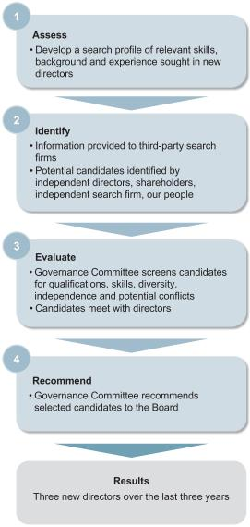

BOARD AND CORPORATE GOVERNANCE PRACTICES

Re-nomination of Directors for Election at Annual Meeting. In considering whether to recommend re-nomination of a director for election at our Annual Meeting, the Governance Committee considers factors such as:

- The extent to which the director’s skills, qualifications and experience continue to contribute to the success of our Board, taking into account current core competencies of the Board, the mix of skills and experience desired;

- Feedback from the annual Board evaluations and individual discussions between each non-employee director and our Chairman;

- Attendance and participation at, and preparation for, Board and Committee meetings;

- Shareholder feedback, including the support received by director nominees elected at our 2020 Annual Meeting;

- Outside board and other affiliations, including any actual or perceived conflicts of interest; and

- Considerations under the Board’s Policy on Board Diversity and the extent to which the director continues to contribute to the diversity of our Board.

Based on the Governance Committee’s recommendation, the Board selects director nominees and recommends them for election by Applied’s shareholders.

Shareholder Recommendations or Nominations. The evaluation procedures described above apply to all candidates for director nomination, including candidates submitted by shareholders. Shareholders wishing to recommend a candidate for consideration by the Governance Committee should submit the candidate’s name, biographical data and a description of his or her qualifications in light of the criteria listed above to Teri A. Little, Corporate Secretary, Applied Materials, Inc., 3225 Oakmead Village Drive, M/S 1268, P.O. Box 58039, Santa Clara, CA 95052, or by e-mail at corporatesecretary@amat.com.

Shareholders wishing to nominate a director should follow the specific procedures set forth in our Bylaws.

Applied Materials, Inc. 9

Table of Contents

Corporate Governance

Corporate Governance Guidelines

Applied’s Corporate Governance Guidelines establish the governance framework within which the Board conducts its business and fulfills its responsibilities. These guidelines and other important governance materials are available on our

website at: http://www.appliedmaterials.com/company/investor-relations/governance-documents. The Board regularly reviews our Corporate Governance Guidelines in light of legal and regulatory requirements, evolving best practices and other developments.

Board Leadership

Our corporate governance framework provides the Board flexibility to determine the appropriate leadership structure for the Company, and whether the roles of Chairman and CEO should be separated or combined. In making this determination, the Board considers many factors, including the needs of the business, the Board’s assessment of its leadership needs from time to time and the best interests of shareholders. If the role of Chairman is filled by a director who does not qualify as an independent director, the Board will designate a Lead Independent Director.

The Board believes that it is currently appropriate to separate the roles of Chairman and CEO. The CEO is responsible for setting our strategic direction and the day-to-day leadership of our business, while the Chairman, along with the rest of our independent directors, ensures that the Board’s time and attention are focused on effective oversight of the matters most critical to Applied. Mr. Iannotti, an independent director, currently serves as the Chairman of the Board. Mr. Iannotti has significant experience and knowledge of Applied, including working with two CEOs and different management teams at Applied, and the Board believes that his deep knowledge of the Company and industry, as well as his strong leadership and governance experience, enable him to lead the Board effectively and independently.

Director Onboarding and Education

When new directors join our Board, they participate in a comprehensive onboarding program to learn about our industry, business, strategies and policies. The multi-day onboarding program includes meetings with senior executives to discuss our businesses, strategy, operations and our corporate functions such as finance, technology, information systems and legal, and a tour of the Maydan Technology Center, our state-of-the-art R&D facility. New directors also meet with the executives and staff supporting the Committees on which they sit, as well as the Committees’ external consultants and advisors. Each new director is also partnered

with an experienced fellow director “mentor” to facilitate the integration of the new director to the Board.

For continued education regarding our business and industry, we provide presentations by internal and external experts during Board meetings on topics such as technology inflections, industry trends, changes in the geopolitical and macroeconomic landscape, and the ESG landscape, with particular focus on the implications and impact to the Company. Our Board and Committees also regularly review developments in corporate governance to continue enhancing the Board’s effectiveness. We encourage directors to participate in external continuing director education programs and provide reimbursement for expenses associated with this participation. Throughout the year, Board members also attend Company events, including Analyst Day, our Engineering and Technology (ET) Conference, and Diversity Day. These interactions, along with meetings with leaders below the CEO Executive Staff level throughout the year, give directors additional visibility to provide oversight of the Company’s culture, strategies and operations.

Board and Committee Evaluations

Our Board recognizes that a thorough, constructive evaluation process enhances our Board’s effectiveness and is an essential element of good corporate governance. Each year, the Governance Committee, in consultation with our independent Board Chairman, reviews and determines the design, scope, content and execution of the evaluation process, including whether to engage a third party to facilitate the evaluation.

The evaluation process consists of assessments of the Board, each standing committee of the Board, and individual directors. Written questionnaires solicit feedback on a range of issues, including Board and Committee structure and composition; meeting process and dynamics; execution of key responsibilities; interaction with management; and information and resources.

Following completion of the written questionnaires, aggregated results, including all written comments, together with data analyzing results compared to the prior year, are provided to the Chairman, who meets with each director individually to discuss additional input on these topics and to provide individual feedback. Committee chairs lead a discussion of evaluation results for their respective Committees, and a summary of Board and Committee evaluation results is discussed with the full Board, including suggestions for updating policies and practices per evaluation results. Director suggestions for improvements to the evaluation questionnaires and process are considered for incorporation for the following year.

- 2021 Proxy Statement

Table of Contents

BOARD AND CORPORATE GOVERNANCE PRACTICES

2020 Board Evaluation Process
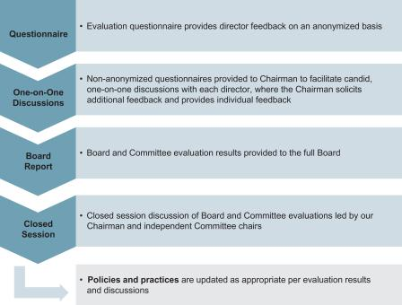

Board’s Role in Risk Oversight

One of the Board’s most important functions is overseeing risk management for the Company. Applied’s risk oversight framework illustrated below shows the close interaction between the full Board, individual committees and senior management.
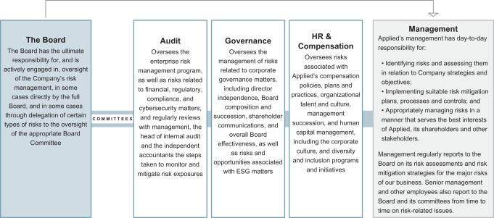

Applied has implemented an enterprise risk management (“ERM”) program, overseen by the Audit Committee, which provides an enterprise-wide perspective on Applied’s risks. The risks identified are reported to the Board, with a focus on the most significant risks facing the Company, including

strategic, operational, financial, and legal and compliance risks. Oversight responsibility for a particular risk may fall within an area of responsibility and expertise of one of the Board Committees. Management reviews the ERM program activities regularly with the Audit Committee, presents an

Applied Materials, Inc. 11

Table of Contents

analysis of risk mitigation strategies to the Board or the respective Committee with oversight responsibility for the risk, and provides annual risk mitigation updates to the full Board.

Risk Assessment of Compensation Programs. We have assessed our compensation policies, plans and practices, and determined that they do not create risks that are reasonably likely to have a material adverse effect on Applied. To make this determination, our management reviewed Applied’s compensation policies, plans and practices, and assessed the following aspects: design, payment methodology, potential payment volatility, relationship to our financial results, length of performance period, risk-mitigating features, performance measures and goals, oversight and controls, and plan features and values compared to market practices. Management reviewed its analysis with the Human Resources and Compensation Committee, which agreed with this determination. Applied also has in place various controls to mitigate risks relating to compensation policies, plans and practices, such as executive stock ownership guidelines and a clawback policy that enables the recovery of certain incentive compensation payments in certain circumstances.

Management Succession Planning

The Board and the Human Resources and Compensation Committee (“HRCC”) recognize that developing the capabilities of Applied’s executives is vital to our ability to capitalize on our opportunities and increase long-term shareholder value. Accordingly, the HRCC’s most important goal is to oversee the Company’s programs that foster executive capability and retention, with emphasis on leadership development, management capabilities and succession plans.

We build our leadership capability using a multi-step approach to succession planning for our most critical roles, including CEO, executive and technology leadership positions. Our executive succession planning process is a carefully designed, thoughtful, and long-term approach overseen by the HRCC and the Board. With the guidance of the HRCC, the Board also maintains a CEO emergency succession plan. We plan, and prepare as many years in advance as possible, for anticipated transitions to ensure leadership continuity and positive outcomes for the Company. Another key component of succession planning is leadership assessment and development of potential successors, including moving leaders into new, increasingly complex roles that complement their professional development. In addition, diversity of our succession pipelines is a priority of our Board and the Company, and we strive to ensure a diverse succession slate.

Management updates the HRCC on executive leadership developments every quarter and reports to the full Board on succession planning annually. The HRCC regularly discusses

- 2021 Proxy Statement

and reports to the Board with respect to succession and development programs for the CEO and other senior executives, with an eye toward ensuring development of the talent needed to lead Applied today and in the future and readiness of succession candidates who can assume top management positions without undue interruption. Board members have opportunities throughout the year to engage with members of senior management and other high-potential leaders in a variety of formal and informal settings, including Board meetings and events, preparatory meetings, analyst meetings and internal and external business and technology conferences. The HRCC and Board also regularly discuss individual executive transitions as the need arises over the course of the year. The Board’s goal is to have a long-term and continuing process for effective senior leadership capability, development and succession, and to ensure that there are ready choices available when the time is right.

Shareholder Rights

In addition to direct engagement through our recurring shareholder engagement program discussed below, we have instituted a number of mechanisms that allow shareholders to advance their points of view, including:

Right to Call a Special Meeting. Our Bylaws permit shareholders holding at least 20% of our outstanding shares of common stock to call a special meeting.

Right to Act by Written Consent. Our Certificate of Incorporation permits shareholders holding at least 20% of our outstanding shares of common stock to initiate the process for shareholders to take action by written consent without a meeting.

Proxy Access. Our Bylaws permit proxy access. Any shareholder (or group of up to 20 shareholders) owning 3% or more of Applied’s common stock continuously for at least three years may nominate up to two individuals or 20% of our Board, whichever is greater, as director candidates for election to the Board, and require us to include such nominees in our annual meeting proxy statement.

Majority Voting. Under our Bylaws, in any uncontested election of directors (an election in which the number of nominees does not exceed the number of directors to be elected), any nominee who receives a greater number of votes cast “for” his or her election than votes cast “against” his or her election will be elected.

Our Bylaws provide that in the event an incumbent director receives more “against” than “for” votes, he or she shall tender his or her resignation after certification of the shareholder vote. Our Governance Committee, composed entirely of independent directors, will consider the offer of resignation, taking into consideration all factors it deems relevant, and recommend to the Board the action to be taken. The Board must take action on the recommendation within 90

Table of Contents

BOARD AND CORPORATE GOVERNANCE PRACTICES

days following certification of the shareholder vote. No director who tenders an offer of resignation may participate in the vote on the Governance Committee’s recommendation or the Board’s determination of whether to accept the resignation offer. Applied will publicly disclose the Board’s decision, including, if applicable, the reasons for rejecting an offer to resign.

Shareholder Engagement

We believe that strong corporate governance should include regular engagement with our shareholders to enable us to understand and respond to shareholder concerns.

Investor Relations. Our senior management team, including our CEO, CFO and members of our Investor Relations team,

maintain regular contact with a broad base of investors, including through quarterly earnings calls, individual meetings and other channels for communication, to understand their concerns. In 2020, senior management participated in over 368 meetings with investors, including more than 179 meetings with the CFO and more than 20 with our CEO.

Shareholder Outreach Program. In addition, we have a robust shareholder outreach program, which is a recurring, year-round effort, led by a cross-functional team that includes members of our Investor Relations, Global Rewards, ESG, Culture of Inclusion, EHS and Sustainability, and Legal functions, with participation of our independent directors, where appropriate. This engagement enables us to build meaningful relationships over time with our shareholders.
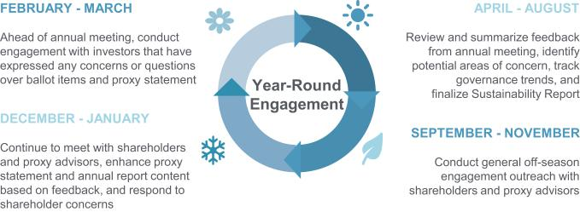

 | Key Themes Discussed with Shareholders in 2020 and 2021
COVID-19 Response | ● Applied’s response to the COVID-19 pandemic, including the prioritization of the health and safety of employees,
 | customers and community
ESG | ● Shareholders’ particular ESG focus areas and Applied’s strategy, initiatives and Board oversight related to ESG
 | matters
 | ● Alignment of sustainability initiatives with corporate strategy; Applied’s commitment to diversity and inclusion
Executive Compensation | ● Compensation program, metrics, and link between pay and performance
Risk Oversight | ● Framework for the Board’s oversight of risk, particularly around the COVID-19 pandemic, human capital
 | management, culture and sustainability
Board Refreshment and | ● Applied’s commitment to Board diversity, including gender, race/ethnicity and tenure
Composition | ● Thoughtful Board processes for refreshment and succession planning
Corporate Governance | ● Governance structure, including current shareholder rights and board leadership structure


We engage with a significant cross-section of our shareholder base, including large institutional investors, pension funds, and other investors. Topics of discussion include key

business, Board, governance, executive compensation, environmental, sustainability and diversity and inclusion matters, as well as other subjects of interest to our

Applied Materials, Inc. 13

Table of Contents

shareholders. Based on feedback from shareholders, we have over the last few years adopted proxy access, a special meeting right, and the right for shareholders to act by written consent, and implemented changes to our executive compensation programs. During the fall of 2020 and winter of 2021, we contacted the holders of approximately 62% of our outstanding shares, and engaged in active discussions on these topics with investors who requested meetings, representing approximately 39% of our shares outstanding.

Disclosure of Diversity Data. In 2020 we disclosed diversity data for the gender and ethnic composition of our workforce by three levels (executives, managers and professionals) and continued to publish the percentage of women in engineering roles. This was the first time we disclosed our diversity data at this level of detail in order to provide additional transparency on our progress towards our Culture of Inclusion goals. We also disclosed our EEO-1 data for the first time in 2020, which is a comprehensive breakdown of our workforce by race and gender according to ten employment categories. We continue to disclose additional key diversity data along with our goals for increasing our global diversity and ensuring we have an inclusive work environment, which include increasing the representation of women and underrepresented minorities in our workforce. These disclosures reflect not only the importance of this issue to Applied, but also the input that we received from our shareholders. Shareholder feedback on this information has been positive, with the view that it demonstrated our commitment to diversity and inclusion, transparency in disclosing data and accountability in working towards our goals. All of these disclosures aim to communicate the progress we are making towards our Culture of Inclusion goals.

A. Little, Corporate Secretary, Applied Materials, Inc., 3225 Oakmead Village Drive, M/S 1268, P.O. Box 58039, Santa Clara, CA 95052, or by e-mail at corporatesecretary@amat.com. The Board has instructed the Corporate Secretary to review correspondence directed to the Board and, at the Corporate Secretary’s discretion, forward items that she deems appropriate for the Board’s consideration.

Stock Ownership Guidelines

The Board has adopted stock ownership guidelines to align the interests of our directors and executive officers with those of our shareholders. The guidelines provide that non-employee directors should each own Applied stock with a value of at least five times the annual base retainer for non-employee directors. Applied’s Chief Executive Officer should own Applied stock with a value of at least six times his annual base salary. Each Section 16 officer on the CEO Executive Staff should own Applied stock with a value of at least three times his or her annual base salary. As of December 31, 2020, all of our directors and executive officers were in compliance with the stock ownership guidelines.

Standards of Business Conduct

Applied’s Standards of Business Conduct embody our commitment to ethical and legal business practices. The Board expects Applied’s directors, officers and all other members of its workforce to act ethically at all times and to acknowledge their commitment to Applied’s Standards of Business Conduct. The Standards of Business Conduct are available on our website at: http://www.appliedmaterials.com/company/investor-relations/governance-documents.

Shareholder Communications

Any shareholder wishing to communicate with any of our directors

regarding Applied may write to the director, c/o Teri

Board Meetings and Committees

The Board met six times in fiscal 2020. Each director attended over 75% of all Board and applicable committee meetings held during fiscal 2020. Directors are strongly encouraged to attend the Annual Meeting of Shareholders, and all of the directors serving on our Board at the time, except for Dr. Chen and Mr. McGregor, attended our 2020 Annual Meeting of Shareholders.

The Board has three principal committees performing the functions required by applicable SEC rules and Nasdaq listing standards to be performed by independent directors: the Audit Committee, the Human Resources and Compensation Committee, and the Corporate Governance and Nominating Committee. Each of these committees meets regularly and has a written charter approved by the Board that is reviewed

annually by the respective committee and by the Board. The Board also has a Strategy and Investment Committee, which was formed in March 2020 when the Board combined its former Strategy Committee and former Investment Committee.

At each regularly-scheduled Board meeting, the Chair of each committee reports on any significant matters addressed by the committee since the last Board meeting. Each director who serves on the Audit Committee, Human Resources and Compensation Committee, or Corporate Governance and Nominating Committee is an independent director under applicable Nasdaq listing standards and SEC rules.

Copies of the current charters for the Audit, Human Resources and Compensation, and Corporate Governance

- 2021 Proxy Statement

Table of Contents

and Nominating Committees can be found on our website at: http://www.appliedmaterials.com/company/investor-relations/governance-documents. The role and responsibilities of the

BOARD AND CORPORATE GOVERNANCE PRACTICES

Strategy and Investment Committee are described in Applied’s Corporate Governance Guidelines.

Audit Committee

Members:

Judy Bruner, Chair* Stephen R. Forrest Adrianna C. Ma* Yvonne McGill* Scott A. McGregor*

- Audit Committee Financial Expert

Primary responsibilities:

- Oversee financial statements, internal control over financial reporting and auditing, accounting and financial reporting processes

- Oversee the qualifications, independence, performance and engagement of our independent registered public accounting firm

- Oversee disclosure controls and procedures, and internal audit function

- Review and pre-approve audit and permissible non-audit services and fees

- Oversee tax, legal, regulatory and ethical compliance

- Review and approve related-person transactions

- Oversee financial-related risks, enterprise risk management program and cybersecurity

Meetings in Fiscal 2020: 16

Human Resources and Compensation Committee

Members:

Thomas J. Iannotti, Chair
Xun (Eric) Chen Alexander A. Karsner

Primary responsibilities:

- Oversee human resources, compensation and employee benefits programs, policies and plans

- Review and advise on management succession planning and executive organizational development

- Determine compensation policies for executive officers and employees

- Review the performance, and determine the compensation, of executive officers

- Approve and oversee equity-related incentive plans and executive bonus plans

- Review compensation policies and practices as they relate to risk management practices

- Approve the compensation program for Board members

- Oversee human capital management, including the Company’s culture and diversity and inclusion programs and initiatives

Meetings in Fiscal 2020: 5

Corporate Governance and Nominating Committee

Members:

Judy Bruner, Chair
Alexander A. Karsner Yvonne McGill

Primary responsibilities:

- Oversee the composition, structure and evaluation of the Board and its committees

- Identify and recommend qualified candidates for election to the Board

- Establish procedures for director candidate nomination and evaluation

- Oversee corporate governance policies and practices, including Corporate Governance Guidelines

- Review and approve director service on the board of directors of other companies and oversee director education

- Review shareholder proposals and recommend to the Board actions to be taken in response to each proposal

- Review strategy, policies, performance and reporting related to the Company’s management of environmental, social and governance (ESG) issues

- Review conflict of interest matters for the Board

Meetings in Fiscal 2020: 10

Applied Materials, Inc. 15

Table of Contents

DIRECTOR COMPENSATION

Compensation Program for Directors

We compensate our non-employee directors for their service on the Board with a combination of cash and equity awards. Directors who are employees of Applied do not receive any compensation for their service as directors. In March 2020, the Human Resources and Compensation Committee, comprised solely of independent directors, approved changes to the compensation program for non-employee directors after consideration of market data and based on the recommendation of its independent compensation consultant. These changes, which were effective beginning with the second fiscal quarter of 2020, included increasing the annual base retainer from $70,000 to $80,000. Prior to these changes, the compensation for our non-employee directors had not changed since fiscal 2017.

 | Effective | Effective
 | through |  | as of
 | Q1 FY |  | Q2 FY
 | 2020 |  | 2020
Corporate Governance and
Nominating Committee Chair | $ 12,500 | $ | 12,500
Strategy and Investment
Committee Chair | $ 12,500 | $ | 12,500
Transactions Subcommittee
Chair | N/A | $ | 7,500

Retainer and Meeting Fees

Each non-employee director receives an annual cash retainer for his or her service on the Board, as well as additional cash retainers if he or she serves as the Chairman of the Board, as a member of a committee or as the chair of a committee. Annual retainers are paid quarterly and are prorated based on the director’s service during the fiscal year. The following table sets forth cash compensation for non-employee directors in effect during fiscal 2020.

 |  | Effective |  | Effective
 |  | through |  | as of
 |  | Q1 FY |  | Q2 FY
 |  | 2020 |  | 2020
Annual Base Retainer (prorated and paid
quarterly) | $ | 70,000 | $ | 80,000
Additional Annual Retainers for Committee
Service (prorated and paid quarterly):
Audit Committee | $ | 25,000 | $ | 25,000
Human Resources and
Compensation Committee | $ | 12,500 | $ | 12,500
Corporate Governance and
Nominating Committee | $ | 10,000 | $ | 10,000
Strategy and Investment
Committee | $ | 10,000 | $ | 10,000
Additional Annual Retainers for Chairman
and Committee Chairs (prorated and paid
quarterly):
Chairman of the Board | $ | 150,000 | $ | 150,000
Audit Committee Chair | $ | 25,000 | $ | 25,000
Human Resources and
Compensation Committee Chair | $ | 20,000 | $ | 20,000

In addition, non-employee directors receive $2,000 per meeting for service on the Transactions Subcommittee of the Strategy and Investment Committee. Non-employee directors are reimbursed for travel and other reasonable out-of-pocket expenses related to attendance at Board and committee meetings, business events on behalf of Applied, and seminars and programs on subjects related to their Board responsibilities.

Equity Compensation

Initial Grant. Upon initial appointment (by the Board) or election (by the shareholders) to the Board other than at an annual meeting of shareholders, a non-employee director receives a non-discretionary grant of restricted stock units with respect to a number of shares of Applied common stock with a fair market value on the date of grant equal to $225,000 (rounded down to the nearest whole share), pro-rated based on the period starting on the day of initial appointment or election and ending on the day of the next scheduled annual meeting of shareholders.

Annual Grant. Each non-employee director elected at an annual meeting receives on that date a non-discretionary grant of restricted stock units with respect to a number of shares of Applied common stock with a fair market value on the date of grant equal to $225,000 (rounded down to the nearest whole share). A non-employee director who is initially appointed or elected to the Board on the day of an annual meeting of shareholders receives only an annual grant. Each of our non-employee directors re-elected at the

2020 Annual Meeting received a grant of 4,987 restricted stock units on that date.

Vesting. Grants made to our non-employee directors vest in full on the earlier of March 1 of the year following the date of grant or the date of the next annual meeting, provided the non-employee director remains on the Board through the scheduled vesting date. Vesting of these grants is accelerated in full upon a non-employee director’s earlier

- 2021 Proxy Statement

Table of Contents

termination of service on the Board due to disability or death, or upon a change of control of Applied if the director ceases to be a non-employee director (and does not become a member of the board of directors of any successor corporation or its parent). Non-employee directors may elect in advance to defer receipt of vested shares until their termination of service on the Board.

Limit on Awards. Under our amended and restated Employee Stock Incentive Plan, grants of equity awards to any individual non-employee director may not exceed a fair market value totaling more than $400,000 in any fiscal year.

DIRECTOR COMPENSATION

Charitable Matching Contributions

Non-employee directors are eligible to participate in The Applied Materials Foundation Matching Gift Program, under which the Foundation will match up to $5,000 of a non-employee director’s donations during fiscal 2020 to eligible non-profit and educational organizations, as well as matching an unlimited amount of donations to our annual food drive. In addition, non-employee directors are eligible to participate in a matching program under the Applied Materials, Inc. Political Action Committee, under which the Company annually will match up to $2,500 of a non-employee director’s contributions for the benefit of eligible non-profit organizations and kindergarten to 12th grade public and non-profit private schools in the U.S. These maximum matching amounts and other terms are the same as those that apply to Applied’s employees.

Director Compensation for Fiscal 2020

 | Fees Earned
 | or Paid in | Stock | All Other
 | Cash | Awards | Compensation | Total
Name | ($) | _{($)}(1)(2) | _{($)}(3) | ($)
Judy Bruner | 140,659 | 220,824 | 5,000 | 366,483
Xun (Eric) Chen | 100,000 | 220,824 | — | 320,824
Aart J. de Geus | 94,205 | 220,824 | — | 315,029
Stephen R. Forrest | 114,500 | 220,824 | — | 335,324
Thomas J. Iannotti | 260,000 | 220,824 | 5,500 | 486,324
Alexander A. Karsner | 100,000 | 220,824 | — | 320,824
Adrianna C. Ma | 120,177 | 220,824 | 1,030 | 342,031
Yvonne McGill | 108,736 | 220,824 | — | 329,560
Scott A. McGregor | 120,295 | 220,824 | 5,000 | 346,119
Dennis D. Powell⁽⁴⁾ | 51,808 | — | — | 51,808

- Amounts shown do not reflect compensation actually received by the directors. Instead, these amounts represent the grant date fair value of stock awards granted in fiscal 2020 (consisting of 4,987 restricted stock units granted to each director on March 12, 2020), as determined pursuant to FASB Accounting Standards Codification 718 (“ASC 718”). The assumptions used to calculate the value of stock awards are set forth in Note 13 of the Notes to Consolidated Financial Statements included in Applied’s Annual Report on Form 10-K for fiscal 2020 filed with the SEC on December 11, 2020.

- Each director, except for Mr. Powell, had 4,987 restricted stock units outstanding at the end of fiscal 2020. In addition, certain directors had restricted stock units that had vested in previous years and for which settlement was deferred until the date of his or her termination of service from the Board, as follows: Dr. Chen, 14,467 units; and Ms. Ma, 26,669 units.
- Amounts shown represent The Applied Materials Foundation’s and/or the Company’s matching contribution of the director’s donations/contributions to eligible non-profit organizations.
- Mr. Powell’s term of office expired upon the election of directors at the 2020 annual meeting of shareholders on March 12, 2020 and so he did not receive a stock award in fiscal 2020.

Ms. Borkar was appointed to the Board in fiscal 2021 and so did not receive any compensation as a non-employee director in fiscal 2020.

Applied Materials, Inc. 17

Table of Contents

STOCK OWNERSHIP INFORMATION

Principal Shareholders

The following table shows the number of shares of our common stock beneficially owned as of December 31, 2020 by each person known by Applied to own 5% or more of our common stock. In general, “beneficial ownership” refers to shares that an entity or individual had the power to vote or the power to dispose of, and shares that such entity or individual had the right to acquire within 60 days after December 31, 2020.

Name | Shares Beneficially Owned
Name | Number | Percent⁽¹⁾
The Vanguard Group
100 Vanguard Blvd. | 73,500,283⁽²⁾
Malvern, PA 19355 | 73,500,283⁽²⁾ | 8.04%
BlackRock, Inc.
55 East 52nd Street | 69,069,636⁽³⁾
New York, NY 10055 | 69,069,636⁽³⁾ | 7.55%
T. Rowe Price Associates, Inc.
100 E. Pratt Street | 47,820,595⁽⁴⁾
Baltimore, MD 21202 | 47,820,595⁽⁴⁾ | 5.23%
State Street Corporation
One Lincoln Street | 46,243,762⁽⁵⁾
Boston, MA 02111 | 46,243,762⁽⁵⁾ | 5.06%
- Percentage ownership is calculated by dividing the number of shares beneficially owned by such person or group by 914,711,241 shares of common stock outstanding as of December 31, 2020.
- The amended Schedule 13G filed with the SEC by The Vanguard Group (“Vanguard”) on February 12, 2020 indicates that as of December 31, 2019, Vanguard had sole dispositive power over 71,922,476 shares, shared dispositive power over 1,577,807 shares, sole voting power over 1,402,250 shares, and shared voting power over 259,829 shares.
- The amended Schedule 13G filed with the SEC by BlackRock, Inc. (“BlackRock”) on February 5, 2020 indicates that as of December 31, 2019, BlackRock had sole dispositive power over 69,069,636 shares and sole voting power over 58,530,265 shares.
- The Schedule 13G filed with the SEC by T. Rowe Price Associates, Inc. (“T. Rowe”) on February 14, 2020, indicates that as December 31, 2019, T. Rowe had sole dispositive power over 47,760,775 shares and sole voting power over 21,198,227 shares.

- The Schedule 13G filed with the SEC by State Street Corporation (“State Street”) on February 13, 2020 indicates that as of December 31, 2019, State Street had shared dispositive power over 44,410,424 shares and shared voting power over 41,432,776 shares.

- 2021 Proxy Statement

Table of Contents

STOCK OWNERSHIP INFORMATION

Directors and Executive Officers

The following table shows the number of shares of our common stock beneficially owned as of December 31, 2020 by: (1) each director and director nominee, (2) each NEO and (3) the current directors and executive officers as a group. In general, “beneficial ownership” refers to shares that a director or executive officer had the power to vote or the power to dispose of, and shares that such individual had the right to acquire within 60 days after December 31, 2020.

Name | Shares Beneficially Owned
Name | Number⁽¹⁾ | Percent⁽²⁾
Directors, not including the CEO:
Rani Borkar | 599⁽³⁾ | *
Judy Bruner | 25,541⁽⁴⁾ | *
Xun (Eric) Chen | 35,698⁽⁵⁾ | *
Aart J. de Geus | 152,442⁽⁴⁾ | *
Stephen R. Forrest | 75,942⁽⁴⁾ | *
Thomas J. Iannotti | 69,942⁽⁴⁾ | *
Alexander A. Karsner | 7,508⁽⁴⁾ | *
Adrianna C. Ma | 34,428⁽⁶⁾ | *
Yvonne McGill | 7,981⁽⁴⁾ | *
Scott A. McGregor | 15,236⁽⁴⁾ | *
Named Executive Officers:
Gary E. Dickerson | 1,689,274 | *
Daniel J. Durn | 145,908 | *
Ali Salehpour | 365,648 | *
Prabu G. Raja | 279,884 | *
Teri A. Little | — | *
Current Directors and Executive Officers, as a Group (18 persons) | 3,384,417⁽⁷⁾ | *
- Less than 1%

- Except as subject to applicable community property laws, the persons named in the table have sole voting and investment power with respect to all of their shares of common stock.
- Percentage ownership is calculated by dividing the number of shares beneficially owned by such person or group by the sum of 914,711,241 shares of common stock outstanding as of December 31, 2020, plus the number of shares of common stock that such person or group had the right to acquire within 60 days after December 31, 2020.
- Consists of 599 restricted stock units that are scheduled to vest within 60 days after December 31, 2020.
- Includes 4,987 restricted stock units that are scheduled to vest within 60 days after December 31, 2020.
- Includes (a) 14,612 restricted stock units that have vested and which, pursuant to Dr. Chen’s election to defer, will be converted to shares of Applied common stock and paid to him on the date of his termination of service from the Applied Board and (b) 4,987 restricted stock units that are scheduled to vest within 60 days after December 31, 2020 and which, pursuant to Dr. Chen’s election to defer, will be converted to shares of Applied common stock and paid to him on the date of his termination of service from the Applied Board.

- Includes (a) 26,923 restricted stock units that have vested and which, pursuant to Ms. Ma’s election to defer, will be converted to shares of Applied common stock and paid to her on the date of her termination of service from the Applied Board and (b) 4,987 restricted stock units that are scheduled to vest within 60 days after December 31, 2020 and which, pursuant to Ms. Ma’s election to defer, will be converted to shares of Applied common stock and paid to her on the date of her termination of service from the Applied Board.

- Includes (a) 45,482 restricted stock units that are scheduled to vest within 60 days after December 31, 2020 and (b) 41,535 restricted stock units that have vested and which, pursuant to each director’s election to defer, will be converted to shares of Applied common stock and paid to the director on the date of the director’s termination of service from the Applied Board.

Applied Materials, Inc. 19

Table of Contents

PROPOSAL 2—APPROVAL, ON AN ADVISORY BASIS, OF THE COMPENSATION OF OUR NAMED EXECUTIVE OFFICERS

Pursuant to Section 14A of the Securities Exchange Act of 1934 (the “Exchange Act”), we are asking shareholders to approve, on a non-binding, advisory basis, the compensation of our NEOs, as described in this Proxy Statement. We seek this approval each year. Our annual “say-on-pay” proposals have been supported by our shareholders each year since we began providing this vote in 2011, and received the support of 96% of votes cast in 2020.

Our Board of Directors believes that our compensation policies and practices promote a performance-based culture and align our executives’ interests with those of our shareholders through a strong emphasis on at-risk compensation tied to the achievement of performance objectives and shareholder value. Our executive compensation program is also designed to attract and retain highly-talented executives who are critical to the successful implementation of Applied’s strategic plan.

Pay and Performance. We align compensation with our business objectives, performance and shareholder interests. See pages 26 and 35 for charts illustrating the connection between key financial and Company performance metrics and the compensation paid to our CEO during the last five fiscal years.

Significant Portion of CEO Pay Consists of Variable Compensation and Long-Term Incentives. In fiscal 2020, 94% of our CEO’s compensation comprised variable compensation elements, and 84% of his overall

compensation was delivered in equity with multi-year vesting. Performance objectives include financial and market objectives relating to adjusted operating margin, relative TSR, adjusted gross margin and wafer fabrication equipment market share, as well as other strategic and operational objectives, as described on pages 32 and 33.

Please see the “Compensation Discussion and Analysis” section for further discussion of our executive compensation program and the fiscal 2020 compensation of our NEOs.

We are asking our shareholders to approve the compensation of our NEOs as described in this Proxy Statement by voting in favor of the following resolution:

“RESOLVED, that the shareholders approve, on a non-binding, advisory basis, the compensation paid to the Company’s named executive officers as disclosed in the Company’s Proxy Statement for the 2021 Annual Meeting of Shareholders pursuant to Item 402 of Regulation S-K, including the Compensation Discussion and Analysis section, the Summary Compensation Table, other compensation tables, narrative discussion and related disclosure.”

Even though this say-on-pay vote is advisory and therefore will not be binding on the Company, the HRCC and the Board value the opinions of our shareholders, and will consider the results of the vote when making future compensation decisions for our NEOs.

- THE BOARD RECOMMENDS THAT YOU VOTE FOR THE APPROVAL, ON AN ADVISORY BASIS, OF THE COMPENSATION OF OUR NAMED EXECUTIVE OFFICERS FOR FISCAL YEAR 2020, AS DISCLOSED IN THIS PROXY STATEMENT

- 2021 Proxy Statement

Table of Contents

COMPENSATION DISCUSSION AND ANALYSIS
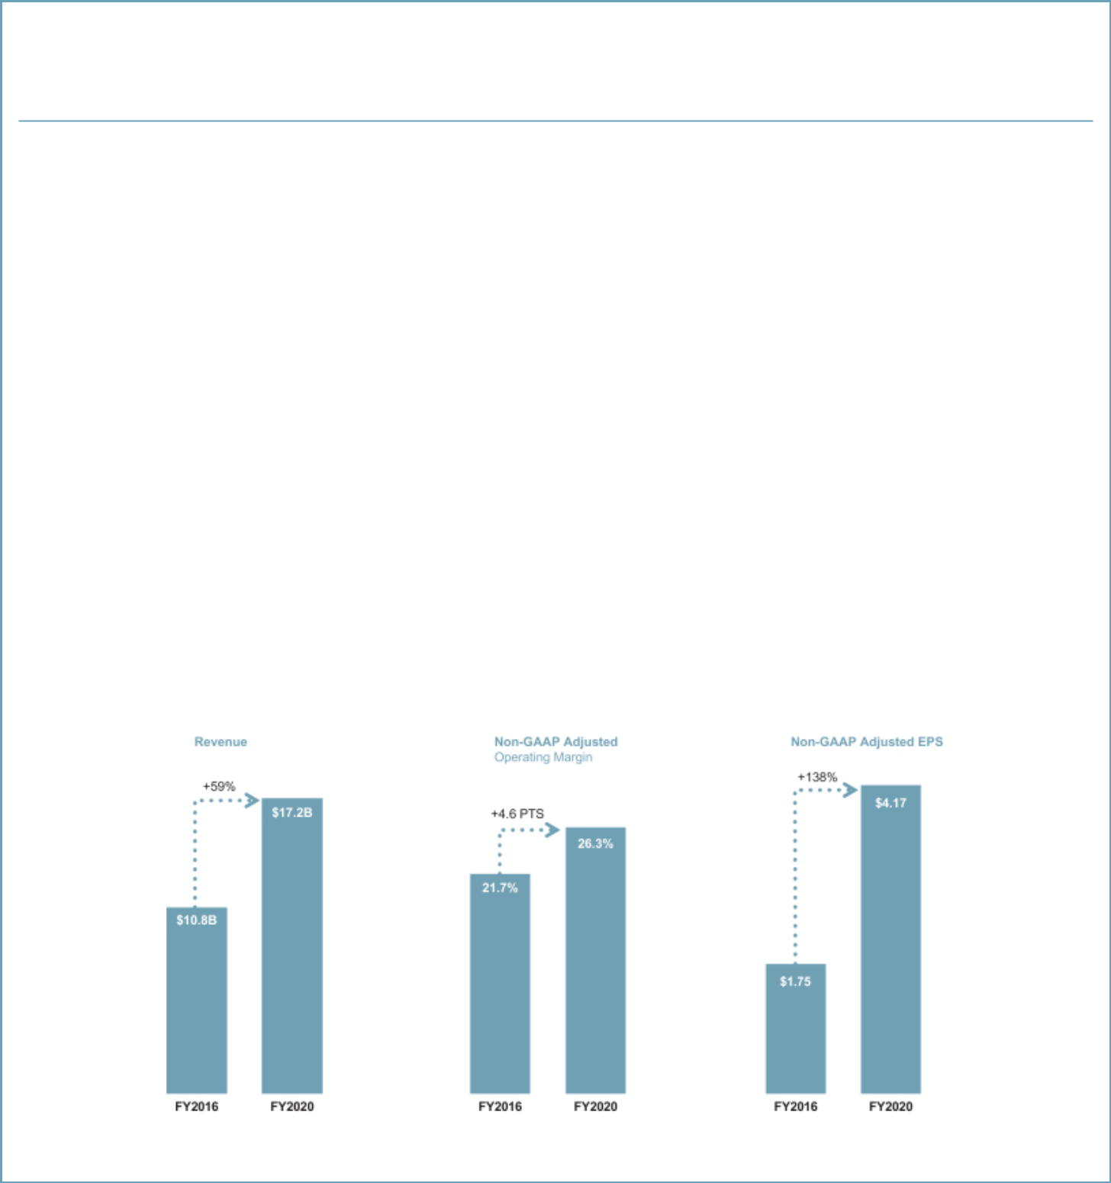

COMPENSATION DISCUSSION AND ANALYSIS

Executive Summary

Our Business and Strategy

Applied Materials is the leader in the materials engineering solutions used to produce virtually every new chip and advanced display in the world. Our expertise in modifying materials at atomic levels and on an industrial scale enables customers to transform possibilities into reality. At Applied Materials, our innovations make possible the technology shaping the future.

We develop, design, produce and service semiconductor and display equipment for manufacturers that sell into highly competitive and rapidly changing end markets. Our competitive positioning is driven by our ability to identify major technology inflections early, and to develop highly differentiated materials engineering solutions for our customers to enable those technology inflections. Through our broad portfolio of products, technologies and services, innovation leadership and focused investments in research and development, we are enabling our customers’ success and creating significant value for our shareholders.

In addition to our other accomplishments, we’ve laid out a new 10-year road map for environmental and social responsibility with detailed actions behind our vision to make possible a better future. Our 1x, 100x and 10,000x sustainability framework refers to the holistic goals and commitments we’ve set for our operations, how we work with customers and suppliers, and how our technology can be used to advance sustainability on a global scale.

Our Performance Highlights

Over the past several years, our broad portfolio of products and services has made Applied a more resilient company that can perform well in a variety of market environments. In 2020, we delivered strong performance despite the challenges of navigating the global COVID-19 pandemic. Key highlights include:

- Revenue of $17.2 billion;

- Operating income of $4.4 billion, resulting in GAAP EPS of $3.92, and non-GAAP adjusted operating income of $4.5 billion, resulting in non-GAAP adjusted EPS of $4.17 (see Appendix A for a reconciliation of non-GAAP adjusted measures); and

- Delivered record operating cash flow of $3.8 billion, equal to 22% of revenue.

Highlights of five-year performance achievements across key financial measures

Non-GAAP adjusted operating margin and non-GAAP adjusted EPS are performance targets under our long-term incentive and bonus plans. See Appendix A for non-GAAP reconciliations.

Applied Materials, Inc. 21

Table of Contents
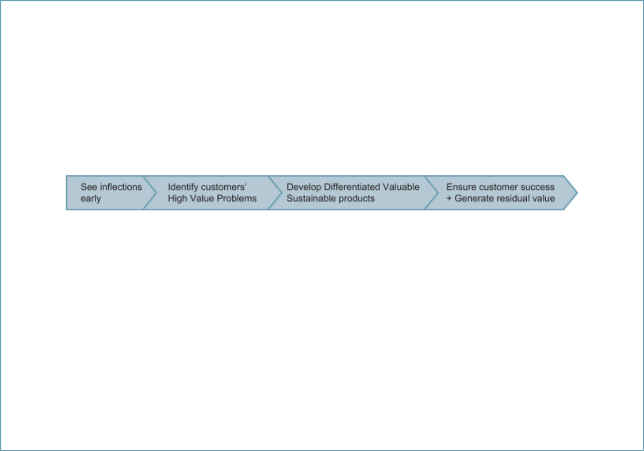

Key financial highlights for our reporting segments in fiscal 2020 include the following:

- Semiconductor Systems segment: we delivered record annual revenue of $11.4 billion with broad-based strength across products and device types.

- Applied Global Services segment: we grew revenue to a record $4.2 billion and increased the number of installed base tools covered by long-term service agreements – providing a recurring revenue stream – by 13% year-over-year.

- Display and Adjacent Markets segment: we delivered revenue of $1.6 billion and maintained profitability during an industry down cycle.

Strategic and Operational Highlights

Applied’s strategy is to deliver highly differentiated materials engineering products and services that enable major technology inflections and drive our customers’ success.

The world is relying on semiconductors more than ever as societies adapt to the challenges of COVID-19 and prepare for the post-pandemic era. Megatrends including the Internet of Things (IoT), big data and artificial intelligence (AI) are poised to transform nearly every industry in the years ahead. Applied Materials has aligned its strategy and investments around this vision for the future, and we are uniquely positioned to accelerate innovations that deliver improvements in the power, performance, area, cost and time-to-market of next-generation semiconductor devices. Key highlights for accomplishments during fiscal 2020 include:

- We continued to prioritize our operating expenses towards R&D to solve major technology challenges for our customers and drive our long-term growth strategy.

- We outperformed the wafer fabrication equipment market, growing revenues 18% and non-GAAP adjusted EPS 37%.

- Our inspection business delivered record performance as systems revenue increased 46%. Revenue for our metals deposition business grew 42% and we achieved record revenue in our packaging business. We gained share in conductor etch with new applications in DRAM and foundry-logic.

- In our services business, we increased the number of tools covered by long-term service agreements by 13%. As a result, 60% of our service and spare parts business now comes from these more predictable recurring revenue streams.

- We announced our 10-year roadmap for environmental and social responsibility, and set several challenging new goals and commitments related to our own operations, how we work with customers and suppliers and how our technology can be used to advance sustainability on a global scale.

- 2021 Proxy Statement

Table of Contents

COMPENSATION DISCUSSION AND ANALYSIS
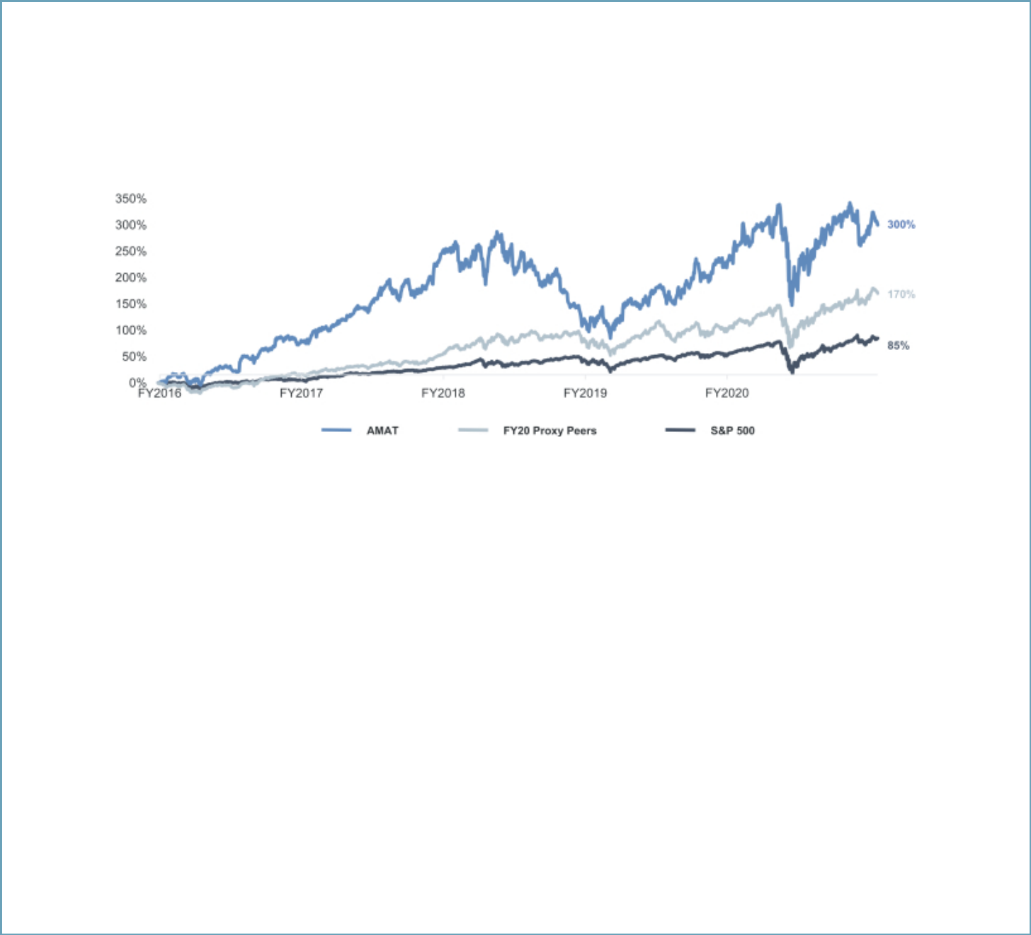

Stock Price Performance

In fiscal 2020, our stock price performance reflected increasing strength in the semiconductor markets, particularly in the second half of the year, as the industry began to adapt to the challenges created by the COVID-19 pandemic. Over the past five years, Applied has significantly outperformed the S&P 500 Index and our peer group, as shown below. In addition, from the close of market on the last trading day of fiscal 2020 through the close of market on December 31, 2020, Applied’s stock price increased by approximately 42%.

Fiscal 2016 – Fiscal 2020 Total Shareholder Return vs. S&P 500 and Proxy Peers1

- Sourced from S&P Capital IQ. Proxy peer data reflects companies set forth on page 29, weighted by market capitalization.

Key Compensation Actions

Performance-Based Compensation Decisions. The HRCC approved an aggressive set of scorecard targets for the executive officers for fiscal 2020, including financial targets above any levels that Applied had achieved in the past, as well as equally challenging operational targets. During fiscal 2020, Applied delivered very strong financial and operational performance in a challenging environment and made meaningful progress towards our long-term strategic goals that are focused on enabling strong longer-term revenue and EPS growth.

As part of our multi-year incentive program, for the period of 2018 through 2020, the HRCC approved aggressive goals for non-GAAP adjusted operating margin and wafer fabrication equipment (“WFE”) market share. The results for this three-year performance period exceeded target, resulting in above-target vesting of performance share unit awards for our executive officers.

CEO Compensation Mix Rebalance. The HRCC has consistently focused on aligning Mr. Dickerson’s compensation with Applied’s long-term results. As a result, as part of its annual review of the executive compensation program in early fiscal 2020, the HRCC reduced Mr. Dickerson’s annual incentive bonus target amount while increasing the size of his annual long-term incentive award.

Chief Legal Officer Transition. In June 2020, we welcomed a new Chief Legal Officer, Teri A. Little, who brings significant experience and knowledge of our industry and is leading our legal organization to further accelerate the execution of our strategy. In connection with hiring Ms. Little, the HRCC approved a new-hire compensation package that was appropriate in the context of providing appropriate incentives for Ms. Little to join Applied but is not intended to represent ongoing compensation for her role.

Value Creation Awards. In early fiscal 2021, and after a number of months of careful deliberation of award design, the HRCC approved long-term value creation awards for Mr. Dickerson, Mr. Durn and Dr. Raja (the “Value Creation Awards”). These awards are entirely performance-based, have a longer vesting requirement than the annual long-term incentive awards, and will only deliver value to the recipients if Applied’s stock price significantly exceeds the Company’s all-time high on the grant date. The HRCC does not expect to grant similar awards to these executives in the coming years. For additional information regarding the Value Creation Awards, please see page 37.

Applied Materials, Inc. 23

Table of Contents
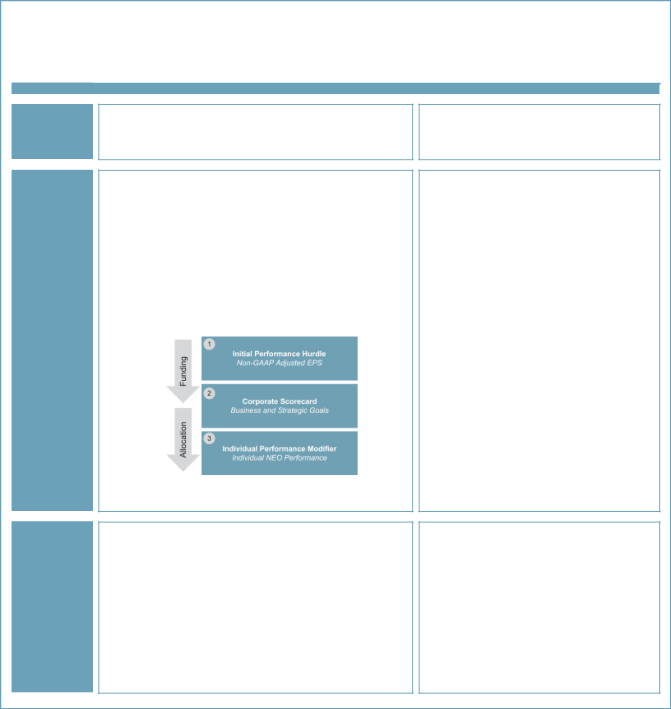

Primary Compensation Elements and Executive Compensation Highlights for Fiscal 2020

The primary elements of our compensation program consist of base salary, annual incentive bonuses and long-term incentive awards. Other elements of compensation include a 401(k) savings plan, deferred compensation benefits and other benefits programs that are generally available to all employees. Primary elements and highlights of our fiscal 2020 compensation program were as follows:

Element of Pay

Base Salary

(see page 29)

Annual Incentive Bonuses (see page 29)

Long-Term Incentives (see page 35)

Structure

- Fixed cash compensation for expected day-to-day responsibilities

- Reviewed annually and adjusted when appropriate, based on scope of responsibility, performance, time in role, experience, and competitive market for executive talent

- Variable compensation paid in cash

- Based on performance against pre-established financial, operational, strategic and individual performance measures

Financial and non-financial metrics provide a comprehensive
- assessment of executive performance

Performance metrics evaluated annually for alignment with strategy
- and market trends

NEO annual incentives determined through a three-step performance
measurement process:
∎

- Performance share units (“PSUs”) to establish rigorous long-term performance alignment

- Restricted stock units (“RSUs”) to provide link to shareholder value creation and retention value

- PSUs vest based on achievement of 3-year non-GAAP adjusted operating margin and 3-year Total Shareholder Return (“TSR”) measured against the S&P 500

PSUs vests at end of 3-year performance period, based on
- achievement of performance goals; RSUs vest ratably over 3 years

Highlights

- No change in salary from fiscal 2019 to fiscal 2020 for any of the named executive officers (“NEOs”)

- No increase in target bonus as a percentage of base salary from fiscal 2019 to fiscal 2020 for any of the NEOs

- A portion of Mr. Dickerson’s target bonus opportunity was re-allocated to his annual long-

- term incentive award value

The initial performance hurdle non-GAAP adjusted EPS goal for fiscal 2020 was $3.25 – above Applied’s actual result for fiscal 2019. The Company achieved an actual result of $4.17 for
- fiscal 2020

As the initial performance hurdle was achieved, the annual bonuses were based on the performance of the Company’s objective and
- quantifiable business and strategic goals in the corporate scorecard for each NEO

Based on achievement compared to goals, fiscal 2020 actual annual bonuses ranged from 92% to 121% of target for our NEOs

— Achievement against the corporate scorecard ranged from 0.835x to 0.965x target (see corporate scorecard information on pages 32 and 33)

— Based on an assessment of individual performance results and the impact against both quantitative and strategic objectives, the NEOs received IPF ranging from 1.0x to
1.25x (see individual performance highlights on page 34)

- The target vehicle mix of the equity awards consists of 75% PSUs and 25% RSUs for the CEO and 50% PSUs and 50% RSUs for the other NEOs

- Non-GAAP adjusted operating margin is a key measure of our Company’s long-term success

- Prior to fiscal 2019, a portion of the PSU payout was based on the Company’s WFE market share. Starting in fiscal 2019, that metric was replaced with relative TSR, which better reflects our business mix, and incentivizes management to outperform the market in any business environment. The fiscal 2018 PSUs, which vested following the end of fiscal 2020, represent the last award with a portion of the performance based on the WFE market share metric.

- 2021 Proxy Statement

Table of Contents

COMPENSATION DISCUSSION AND ANALYSIS
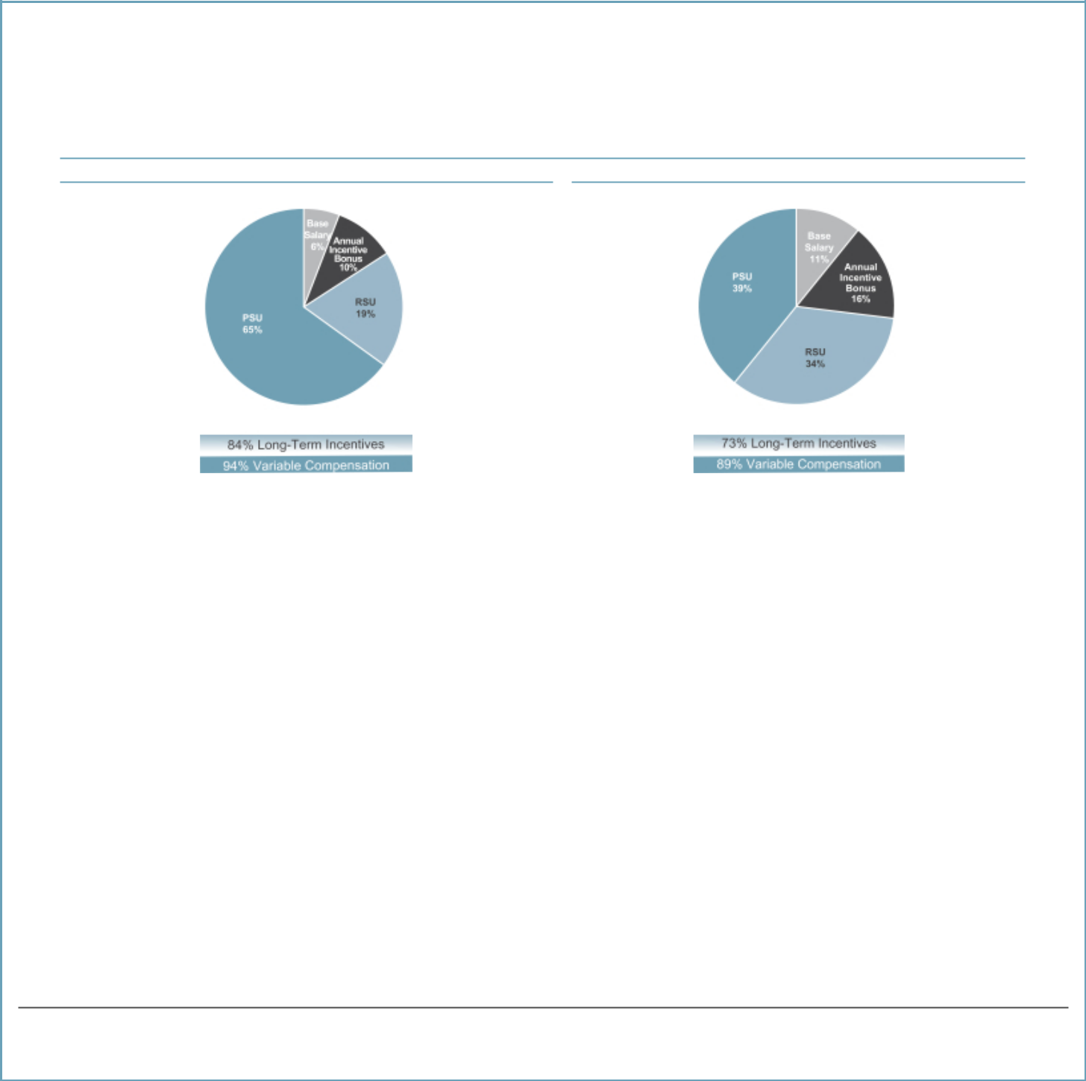

Pay Mix

In fiscal 2020, a significant portion of our executive compensation consisted of variable compensation and long-term incentives. As illustrated below, 94% of CEO compensation for fiscal 2020 consisted of variable compensation elements, and 84% of CEO compensation was delivered in equity with multi-year vesting.

Fiscal 2020 Compensation Mix1

CEO All Other NEOs2

- Represents total direct compensation for fiscal 2020, including the grant date fair value of annual equity awards. Does not include the Value Creation Awards, which were granted in fiscal 2021.
- All Other NEO chart excludes Ms. Little, whose fiscal 2020 compensation is not representative of the expected ongoing mix or level for her role.

Summary of 2020 Total Direct Compensation

The following table summarizes elements of annual total direct compensation for our NEOs for fiscal 2020, consisting of (1) base salary, (2) annual incentive bonus and (3) long-term incentive awards (the grant date fair value of stock awards). This table excludes amounts not considered by the HRCC to be annual total direct compensation, such as certain other amounts required by the SEC to be reported in the Summary Compensation Table (see page 44 of this Proxy Statement).

 |  |  |  | Annual
 |  |  | Annual | Long-Term
 |  |  | Incentive | Incentive
 |  | Salary | Bonus | Award | Total
Name and Principal Position |  | ($) | ($) | ($) | ($)
Gary E. Dickerson |  | 1,030,000 | 1,786,406 | 14,299,176 | 17,115,582
 | President and Chief Executive Officer
Daniel J. Durn |  | 625,000 | 975,586 | 4,459,552 | 6,060,138
 | Senior Vice President, Chief Financial Officer
Ali Salehpour |  | 625,000 | 774,984 | 4,247,422 | 5,647,406
 | Senior Vice President, Services, Display and Flexible Technology
Prabu G. Raja |  | 567,000 | 923,324 | 3,359,304 | 4,849,628
 | Senior Vice President, Semiconductor Products Group
 | Teri A. Little¹ | 198,077 | 200,655 | — | 398,732
 | Senior Vice President, Chief Legal Officer and Corporate Secretary

- Ms. Little joined Applied in June 2020. The base salary and annual incentive bonus shown for Ms. Little are prorated based on her service during fiscal 2020. Ms. Little did not receive an annual long-term incentive award in fiscal 2020. Amounts for Ms. Little exclude the value of a sign-on bonus, a stock replacement cash payment and a new-hire equity award, all of which are reported in the Summary Compensation Table.

Applied Materials, Inc. 25

Table of Contents
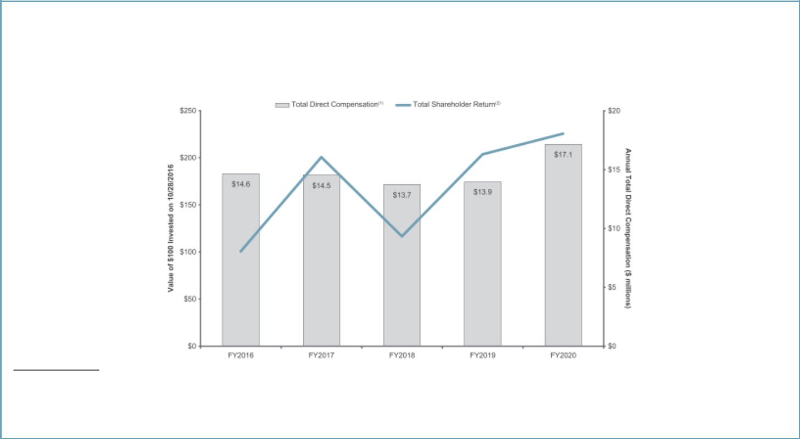

Pay and Performance

The HRCC approves aggressive performance goals for the CEO, as well as for the entire executive leadership team. As a result, despite outstanding TSR growth from fiscal 2016 through 2020, our CEO’s total direct compensation has remained within a comparable range over the same period.

- Total direct compensation consists of annual base salary, annual incentive bonus and long-term incentive award (grant date fair value of annual equity awards). Total direct compensation shown above excludes other amounts required by the SEC to be reported in the Summary Compensation Table.
- TSR line illustrates the total shareholder return on our common stock during the period from October 28, 2016 through October 23, 2020 (the last business day of fiscal 2020), assuming $100 was invested on October 28, 2016 and assuming reinvestment of dividends.

- 2021 Proxy Statement

Table of Contents

COMPENSATION DISCUSSION AND ANALYSIS


Other Key Compensation Practices

We are committed to executive compensation practices that drive performance, mitigate risk and align the interests of our leadership team with those of our shareholders. Below is a summary of best practices that we have implemented and practices that we avoid because we believe they are not in the best interests of Applied or our shareholders.

WHAT WE DO WHAT WE DO NOT DO

- Pay for Performance – Significant majority of NEO target compensation is performance-based and tied to pre-established performance goals aligned with our short-and long-term objectives.

- Mitigation of Risk – Use of varied performance measures in incentive programs mitigates risk that executives will be motivated to pursue results with respect to any one performance measure to the detriment of Applied as a whole.

- Compensation Recoupment Policy – Both our annual cash bonus plan and our stock incentive plan contain “clawback” provisions providing for reimbursement of incentive compensation from NEOs in certain circumstances.

- Stock Ownership Guidelines – All senior officers and directors are subject to stock ownership guidelines to ensure their interests are aligned with shareholders’ interests.

- Double-Trigger Change-in-Control Provisions – For vesting to accelerate, equity awards for all NEOs require a “double-trigger” of both a change-in-control and subsequent termination of employment.

- No Guaranteed Bonuses – Our annual bonus plans are performance-based and do not include any guaranteed minimum payment levels.

- No Hedging or Pledging – Our insider trading policy prohibits all directors, NEOs and other employees from engaging in hedging or other speculative trading, and prohibits directors and NEOs from pledging their shares.

- No Perquisites – We do not provide material perquisites or other personal benefits to our NEOs or directors, except in connection with business-related relocation.

- No Dividends on Unvested Equity Awards – We do not pay dividends or dividend equivalents on unvested equity awards.

- No Executive Pensions – We do not offer any executive pension plans.

- Annual Say-On-Pay Vote – We seek annual shareholder feedback on our executive compensation program.

- No Tax Gross-Ups – We do not pay tax gross-ups, except in connection with business-related relocation or expatriate assignments.

Applied Materials, Inc. 27

Table of Contents

Compensation Governance and Decision-Making Framework

Overview of Compensation Program Philosophy and Governance Framework

Our executive compensation program has three principal objectives:

- To attract, reward and retain highly-talented executive officers and other key employees;

- To motivate these individuals to achieve short-term and long-term goals that enhance shareholder value; and

- To support our core values and culture.

We seek to achieve these objectives by:

- Providing compensation that is competitive with the practices of other leading, high-technology companies; and

- Linking rewards to Company and individual performance by:

  - Setting challenging performance goals for executive officers and other key employees;

  - Balancing retention needs with performance objectives; and

  - Providing a high proportion of total target compensation in the form of equity incentives to motivate executive officers and key employees to increase long-term value in alignment with shareholders’ interests.

The HRCC uses these principles to determine base salaries and to design and determine annual incentive bonuses and long-term incentive awards. The HRCC also considers Applied’s business objectives, external factors such as the geopolitical and economic environment, competitive practices and trends, and corporate considerations, including the overall cost of the compensation program.

The HRCC further considers the results of the annual advisory “say-on-pay” vote and shareholder feedback. At our

Annual Meeting in 2020, our “say-on-pay” proposal received a substantial majority (96%) of votes cast. In consideration of this vote and feedback from our shareholders gathered through our outreach efforts, the HRCC approved an executive compensation program structure for fiscal 2020 that is unchanged from the fiscal 2019 program.

Fiscal 2020 Peer Group Companies

The HRCC regularly reviews compensation paid by our peer group, which consists of a broad range of high-technology companies whose businesses are similar to ours and with whom we typically compete for executive talent, as a reference point for evaluating our compensation program.

For the composition of the fiscal 2020 peer group, we considered companies that met the following criteria: (1) technology companies with manufacturing operations, (2) companies whose revenues or market capitalization were approximately one-third to five times that of Applied,

- U.S. based publicly-traded companies with global operations that disclose executive compensation pursuant to SEC rules, (4) companies that compete with us for key talent, and (5) companies that devote significant resources to research and development as a percentage of revenue or have approximately one-half to two times market capitalization to revenue multiple as that of Applied. Based on this assessment, the HRCC determined not to make any changes to the fiscal 2019 peer group. Each of the companies in the peer group listed below meet most or all of the five screening criteria; in addition, several of the companies were among our principal U.S. competitors or top U.S. customers.

Data gathered on the peer group include base salary, bonus, targeted cash compensation, long-term incentive awards and total direct compensation. The HRCC uses this information as a reference point in informing its decision making, rather than targeting a specific percentile of the peer data for our NEOs. The peer group data is gathered from the sources described in “Role of Compensation Consultant” below.

- 2021 Proxy Statement

Table of Contents

 |  |  | COMPENSATION DISCUSSION AND ANALYSIS
Our fiscal 2020 peer group and related information are set forth below.
 |  |  | Applied Materials Positioning Relative to Peers1
Fiscal 2020 Peer Group |  |  | Applied Materials Positioning Relative to Peers1
Advanced Micro Devices, Inc. | Micron Technology, Inc.
Analog Devices, Inc. | Motorola Solutions, Inc.
Broadcom, Inc. | NetApp, Inc.
Cisco Systems, Inc. | NVIDIA Corp.
Corning Inc. | QUALCOMM, Inc.
Intel Corp. | Seagate Technology plc
KLA Corp. | Texas Instruments, Inc.
Lam Research Corp. | Western Digital Corp.
 | 1 |  | As of the HRCC’s review in 2020.
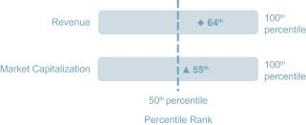

Components of Total Direct Compensation

Determining Annual Total Direct Compensation

At the beginning of fiscal 2020, the HRCC evaluated annual total direct compensation – consisting of annual base salary, target annual incentive opportunity for the fiscal year and long-term incentive award value – for each NEO (other than Ms. Little who joined Applied in June 2020). As part of this annual evaluation, the HRCC considered the NEO’s scope of responsibility, performance, skill set, prior experience and achievements, advancement potential, impact on results and expected future contribution to our business. The HRCC also considered the compensation levels of an executive officer relative to other Applied officers, the need to attract and retain talent, business conditions, and compensation levels at our peer companies for comparable positions; however, no individual element of compensation is targeted to a peer percentile range. The HRCC used peer group data as a tool to assess how our executives’ compensation compares to the market rather than as a means to establish specific target compensation levels. Actual pay results vary based on the overall performance of the Company and individual NEO performance, as the largest portion of NEO compensation is performance-based.

Base Salaries

Base salaries and bonus opportunities are designed to attract, motivate, reward and retain executive talent, as well as to align pay with performance. Base salaries represent an annual fixed level of cash compensation. Applied continues to focus the weighting of cash compensation more heavily toward performance-based incentives. At the beginning of each fiscal year, the HRCC determines each NEO’s targeted total cash compensation (salary and target bonus).

Based on its review in early fiscal 2020, the HRCC determined not to make any changes to the NEOs’ base salary levels in effect for fiscal 2019. The HRCC believed that the existing salary levels sufficiently reflected competitive pay positioning levels of similar roles, and provided adequate retention value. Ms. Little’s base salary was established as part of recruiting her to join Applied and reflects a number of considerations, including compensation practices for the Chief Legal Officer role among peer companies and survey data for a broader group of technology companies.

Annual Incentive Bonus Opportunities

Bonus Plan Overview. In fiscal 2020, all of our NEOs participated in the Senior Executive Bonus Plan (the “Bonus Plan”). The Bonus Plan is a shareholder-approved bonus program designed to motivate and reward achievement of Applied’s business goals aligned with delivering shareholder value and to attract and retain highly-talented individuals. The annual incentive bonus opportunity for each NEO under the Bonus Plan is directly linked to Applied’s achievement of financial and market performance, operational performance and strategic objectives, in addition to individual performance. Company and individual goals are designed to incentivize management to drive strong operating performance, invest in innovation to drive future growth and create shareholder value. Our Bonus Plan is performance-based and does not include any guaranteed minimum payment levels.

Determining Target Bonus Amounts. Target bonus amounts for the NEOs

are expressed as a percentage of base salary. The HRCC approves the

annual target bonus amount for each NEO, taking into consideration

Mr. Dickerson’s recommendations regarding the annual target bonus

amounts for each of the NEOs other than himself. In early fiscal 2020,

Mr. Dickerson recommended that, for each NEO then employed at Applied,

the target bonus amounts remain unchanged from fiscal 2019.

Applied Materials, Inc. 29

Table of Contents

In evaluating Mr. Dickerson’s target bonus, the HRCC – with input from its independent compensation consultant – considered a number of factors, including publicly available data and market survey data, as well as an assessment of overall economic and business conditions in evaluating Mr. Dickerson’s target bonus. Consistent with that analysis and reflecting a desire to further align Mr. Dickerson’s compensation with Applied’s long-term performance, the HRCC decided to re-allocate a portion of the target bonus opportunity to a larger long-term incentive award for

Mr. Dickerson, reducing his target bonus from 200% to 150% of his salary.

Ms. Little’s target bonus opportunity was established as part of recruiting her to join Applied and reflects a number of considerations, including compensation practices for the Chief Legal Officer role among peer companies and survey data for a broader group of technology companies. As Ms. Little joined Applied during the fiscal year, her fiscal 2020 bonus opportunity was prorated.

Assessing Performance and Payout. The determination of fiscal 2020 performance and annual incentive bonuses for our NEOs consisted of three key steps, as illustrated in the diagram below and explained in more detail in the subsequent discussion.
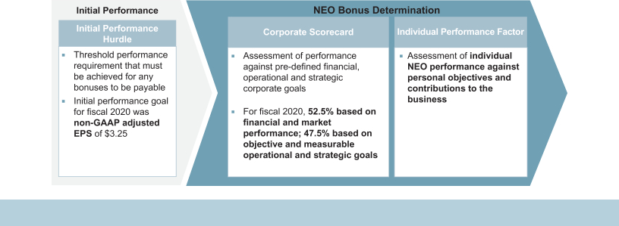

The HRCC believes that this multi-step performance framework appropriately emphasizes financial performance, while also providing a mechanism to assess achievement of key business imperatives by individual NEOs.

Initial Performance Hurdle. For fiscal 2020, the HRCC chose non-GAAP adjusted EPS as the initial performance hurdle. EPS, an indicator of overall Company financial performance, is a measure of profits generated on a per-share basis that are available either to reinvest in the business or distribute to shareholders, and has a strong link to share price valuation.

If Applied does not achieve a threshold non-GAAP adjusted EPS of $3.25 for the fiscal year, no bonus is payable. If this threshold is achieved, the maximum bonus that becomes payable for each NEO is the lowest of:

- $5 million, (b) 3x a corporate bonus pool funding modifier, multiplied by the target bonus, and (c) 3x the target bonus, as a percentage of base salary.

In fiscal 2020, Applied’s non-GAAP adjusted EPS was $4.17, resulting in achievement of the initial performance hurdle under the Bonus Plan. Adjusted EPS is a non-GAAP measure that excludes certain items from EPS determined in accordance with GAAP (see Appendix A for a reconciliation of non-GAAP adjusted EPS).

Non-GAAP adjusted EPS includes the impact of share-based compensation expenses.

Balanced Corporate Scorecard. If the initial performance hurdle is achieved, the HRCC then uses the corporate scorecard to evaluate achievement of pre-defined corporate objectives and goals for each NEO and as a primary mechanism to exercise negative discretion from the maximum bonus amount. The scorecard is designed to measure financial and non-financial objectives that are considered by the HRCC to be key drivers of the Company’s near-term financial and operational success that will create shareholder value over the longer-term. The fiscal 2020 scorecard measured corporate performance in four broad categories:

- Financial and Market Performance and Execution, (2) Products and Growth, (3) Customers and Field and (4) People and Organization. These categories align with and support the Company’s strategy of strengthening our materials engineering capabilities to enable major technology inflections for our customers and positioning Applied for sustainable growth to support long-term value creation for our shareholders.

- 2021 Proxy Statement

Table of Contents

 |  |  | COMPENSATION DISCUSSION AND ANALYSIS
 |  | Weighting
 |  | for CEO,
 |  | CFO
 | Scorecard Category | and CLO | Link to Company Strategy and Performance
 | Financial and Market | 52.5% | Financial, market share and TSR goals align with a focus on delivering sustainable performance that
Performance and Execution |  |  | increases shareholder value
 |  |  | Incentivizes increased efficiency in operational process, product development success and quality and
 |  |  | safety performance
 | Products and Growth | 27.5% | Reinforces strategy of developing new and differentiated products and services and positioning Applied
 |  |  | and its products for future revenue and market share growth
 | Customers and Field | 12.5% | Promotes focus on customer service by improving growth and efficiency at key accounts and applications
People and Organization |  | 7.5% | Drives focus on greater employee engagement to promote hiring, retention and development of key
 |  |  | talent, with a particular focus on diversity and inclusion

NEO Objectives and Weightings. Each NEO was assigned individualized weightings for all measures to reflect the relative impact and contributions of that NEO and his or her business or organizational unit to Applied’s overall performance with respect to a particular measure. The corporate scorecard objectives and weightings for each NEO are set forth in the table below.

Goal Setting and Measurement. At the beginning of the fiscal year, the HRCC reviewed objectives, goals and weightings initially proposed by management, and provided input to the final corporate scorecard and individual weightings for each NEO (other than Ms. Little, whose weightings were determined at the time of her hire). Scorecard objectives are intended to be very challenging to incentivize our NEOs to achieve performance levels that are higher than our

externally communicated financial targets. Consequently, delivering results below the 100% target level can still represent very meaningful progress towards our long-term strategic goals. Progress towards achieving the corporate scorecard objectives was evaluated and tracked quarterly during the fiscal year. Scores were awarded for each metric under the scorecard based on the degree to which the pre-determined goals for that metric were achieved. Performance hurdles were set to measure achievement at 0, 0.5, 1.0, 1.5 and 2.0 levels, with a score of 1.0 indicating performance that met very high expectations and scores over 1.0 indicating extraordinary achievement. At the end of the fiscal year, scores were calculated based on actual performance against objectives and were presented to the HRCC to review, adjust and approve.

Applied Materials, Inc. 31

Table of Contents

The following table shows fiscal 2020 corporate scorecard objectives, their relative weightings for each NEO, the achievements based on performance against rigorous objectives and the resulting scores, as approved by the HRCC (see Appendix A for non-GAAP reconciliations). The HRCC approved an aggressive set of scorecard targets for the executive officers for fiscal 2020, including financial targets above any levels that Applied had achieved in the past, as well as equally challenging operational targets. During fiscal 2020, Applied delivered strong financial and operational performance in the context of a global pandemic and made meaningful progress towards our long-term strategic goals focused on enabling strong longer-term revenue and EPS growth.

For the fiscal 2021 Corporate scorecard, we have added an ESG objective to demonstrate Applied’s commitment to driving sustainability throughout our business and to provide a discrete incentive for management to execute on our new ESG strategy.

 |  | Dickerson, | Weightings
 |  | Durn and |  |  | Achievements | Score
 | Objectives | Little | Salehpour | Raja | Achievements | Score
Financial and Market Performance
and Execution |  | 52.5% | 52.0% | 52.0%
● Grow wafer fabrication equipment |  |  |  |  | ● Forecasting growth in wafer fabrication equipment market share for
 | (measured by VLSI Research) market |  |  |  | calendar 2020
 | share |  |  |  |  | 1.0
 | ● Achieve targeted Service revenue |  |  |  | ● Delivered record Service revenue for the year
 | growth |  |  |  |  | 1.0
 | ● Reduce average order-to-cash cycle |  |  |  | ● Despite the impact of COVID-19 maintained strong order-to-cash
 | time for semiconductor businesses |  |  |  | performance | 1.0
 | ● Achieve adjusted gross margin targets |  |  |  | ● Delivered 45.1% non-GAAP adjusted gross margin, 1.1% higher than fiscal
 | (gross margin reported externally) |  |  |  | 2019 but at the low end of aggressive targets set for the year | 0.5
 | ● Achieve adjusted operating margin |  |  |  | ● Achieved 26.3% non-GAAP adjusted operating margin, 2.8% higher than
 | goal (operating margin reported |  |  |  | fiscal 2019 and within range of targets for the year
 | externally) |  |  |  |  | 1.0
 | ● Achieve TSR target relative to peers |  |  |  | ● While delivering strong absolute TSR and outperforming the broader
 |  |  |  |  | market over FY2020, did not achieve targeted performance relative to
 |  |  |  |  | peers | 0.0
 | ● Improve operational, quality and |  |  |  | ● Successfully drove improvements in delivery times, materials costs, quality
 | safety performance |  |  |  | and safety | 1.0
 | Products and Growth | 27.5% | 30.5% | 28.0%
● Demonstrate progress towards ability |  |  |  |  | ● Exceeded aggressive milestones towards delivering 2023 revenue target
 | to deliver targeted fiscal 2023 results |  |  |  | for semiconductor businesses
 | for semiconductor businesses |  |  |  |  | 1.5
 | ● Demonstrate progress towards ability |  |  |  | ● Made significant progress towards delivering 2023 targets for Display
 | to deliver targeted fiscal 2023 results |  |  |  | business but some results were below the aggressive goals set for the year
 | for Display business |  |  |  |  | 0.5
 | ● Demonstrate progress towards ability |  |  |  | ● Delivered record Service revenue but results on some metrics were below
 | to deliver targeted fiscal 2023 results |  |  |  | the aggressive goals set for the year
 | for Service business |  |  |  |  | 0.5
 | ● Demonstrate progress towards ability |  |  |  | ● Developed strong pipeline of opportunities to drive significant future growth
 | to deliver targeted fiscal 2023 results
 | for Chief Technology Officer
 | organization, Alliances and New
 | Markets |  |  |  |  | 1.0
 | Customers and Field | 12.5% | 10% | 12.5%
● Achieve growth and efficiency metrics |  |  |  |  | ● Exceeded aggressive field management goals at key accounts
 | at key accounts |  |  |  |  | 1.5
 | ● Win development tool of record and |  |  |  | ● Achieved aggressive tool of record goals, as well as milestones for
 | production tool of record positions at |  |  |  | application growth for systems and service
 | key customers; grow target
 | applications for systems and service |  |  |  |  | 1.0
 | ● Validate Preferred Strategic Partner |  |  |  | ● The Preferred Strategic Partner goal is a multiple year objective. In 2020,
 | customer engagements that create |  |  |  | we achieved or exceeded milestones for Preferred Strategic Partner
 | value for customers and meaningfully |  |  |  | engagements
 | expand systems and service business |  |  |  |  | 1.5

- 2021 Proxy Statement

Table of Contents

COMPENSATION DISCUSSION AND ANALYSIS

 |  | Dickerson, | Weightings
 |  | Durn and |  |  | Achievements | Score
 | Objectives | Little | Salehpour | Raja | Achievements | Score
People and Organization |  | 7.5% | 7.5% | 7.5%
● Continue to improve overall |  |  |  |  | ● Developed action plan and delivered on fiscal 2020 goals despite
 | organizational health |  |  |  | challenges posed by COVID-19 | 1.5
 | ● Demonstrate targeted progress |  |  |  | ● Made progress toward achieving our longer-term objectives, including by
 | towards increasing representation of |  |  |  | closing gaps across all categories
 | women and underrepresented
 | minorities, to close gap vs. market
 | availability |  |  |  |  | 1.5
 | ● Drive organizational development |  |  |  | ● Drove organizational development by ensuring that 86% of regular full-time
 |  |  |  |  | employees had development objectives in Workday by target date and
 |  |  |  |  | targeted employees completed 91% of all assigned training by end of fiscal
 |  |  |  |  | 2020 | 1.5

Goals tied to objective and quantifiable metrics aligned with Company strategy

Individual Performance Factor. The HRCC also considered the individual performance of each NEO as indicated by that NEO’s individual performance factor (“IPF”). The IPF applied only if the initial performance hurdle and at least some of the corporate scorecard objectives were achieved. The IPF modified the initial bonus amount as determined based on achievement against the corporate scorecard objectives. The IPF modifier ranges from 0 to 1.5.

The HRCC determined the IPFs for all NEOs. In determining the IPFs, the HRCC took into consideration: (i) financial performance, which exceeded target performance on EPS, (ii) results of the corporate scorecard and associated goals, (iii) the leadership team’s ability to guide Applied through unprecedented disruption caused by the COVID-19 global pandemic, and (iv) each executive’s capable leadership of his or her respective business unit or function.

The HRCC determined the IPF for each NEO, other than Mr. Dickerson, by taking into consideration Mr. Dickerson’s recommendation, which included his assessment of the achievement of strategic, financial, operational and organizational performance goals specific to the business or organizational unit for which the NEO was responsible, as well as the NEO’s leadership skills and current and expected contributions to the business.

For fiscal 2020, in light of the significant accomplishments by each NEO in leading his or her respective organization, and in Mr. Dickerson’s case, Applied, and in recognition of the significant teamwork required of the leadership team to deliver strong financial results despite navigating the unprecedented challenges of a global pandemic, the HRCC determined each NEO receive an IPF ranging between 1.0 and 1.25.

Applied Materials, Inc. 33

Table of Contents

The following table shows the highlights of each NEO’s performance in fiscal 2020 that the HRCC considered in determining their respective IPFs.

NEO

Gary E. Dickerson

Fiscal 2020 Individual Performance Highlights

- Led Applied to record performance levels with Q4 revenues at an all-time record, and a $5 non-GAAP adjusted EPS run-rate for the first time in Company history

- Drove internal portfolio and spending optimization, resulting in Company investing record percentage of Operating Expense in R&D

- Launched Company’s new ESG strategy, positioning Applied as the industry’s thought-leader on sustainability and future technology roadmap

Daniel J. Durn ● Delivered annual revenue of $17.6 billion and non-GAAP adjusted EPS of $4.17

- Successfully managed external investor relationships and communications

- Drove major improvements in efficiency and effectiveness across the Company and led Applied’s response to COVID-19

Ali Salehpour | ● | Delivered record Applied Global Services revenues of $4.0 billion
 | ● Increased the number of installed base tools covered by long-term service agreements by over 45% since 2017
 | ● Delivered revenues in Display of $1.6 billion in a down market
Prabu G. Raja | ● | Delivered record annual performance with Semiconductor Systems revenue growth of 25%, while navigating significant supply
 |  | chain and customer disruptions caused by COVID-19
● Demonstrated strong momentum in key growth areas, specifically etch and packaging, while establishing Applied as a clear leader in the DRAM market and maintaining leadership in Foundry-Logic

● Showed promising technical progress with major R&D programs for next generation products
Teri A. Little ● Ensured that Ethics and Compliance program sufficiently supports the Company’s 5-year growth plans and resulting risk profile

- Ably supported ongoing and new M&A efforts, including due diligence of potential acquisitions and post-close governance, oversight and compliance
- Strengthened IP protection and governance of supply chain

Actual Bonus Payouts. The diagram below shows the results for each of the three key steps in determining the NEOs’ fiscal 2020 annual incentive bonuses. As a result of our strong financial performance, achievement of most of our fiscal 2020 corporate scorecard objectives, and significant individual contributions, bonus payouts for our NEOs were, on average, modestly above target bonus amounts.

Fiscal 2020 Annual Incentive Calculation

Performance Measures
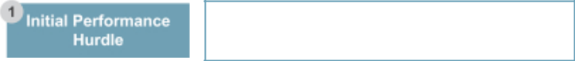

∎ Fiscal 2020 non-GAAP adjusted EPS of $3.25


∎ Strong performance on core objectives:

– Financial and Market Performance and

Execution

– Products and Growth

– Customers and Field

– People and Organization
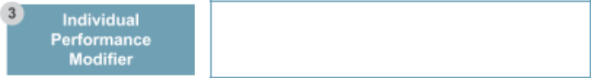

∎ NEO performance against personal objectives and individual contribution to business performance

- 2021 Proxy Statement

Fiscal 2020 Achievement

- Achieved non-GAAP adjusted EPS of $4.17

- NEO scorecard results achieved in a range from 0.835 to 0.965 based on individual weightings

- IPF achieved in a range from 1.0 to 1.25


Average NEO bonus, as

multiple of target: 1.07

Table of Contents

COMPENSATION DISCUSSION AND ANALYSIS

The following table shows for each NEO: (1) the bonus-eligible base salary, (2) the target bonus amount expressed as a percentage of base salary, (3) the target bonus expressed as a dollar amount and (4) the actual fiscal 2020 bonus amount approved by the HRCC and paid to the NEO.

 |  |  | (2)
 |  |  | Target
 |  |  | Bonus as a
 |  |  | Percentage |  | (3) |  | (4)
 |  | (1) | of Base |  | Target |  | Actual
 | Base Salary |  | Salary |  | Bonus |  | Bonus
NEO |  | ($) | (%) |  | ($) |  | ($)
Gary E. Dickerson | $ | 1,030,000 | 150% | $ | 1,545,000 | $ | 1,786,406
Daniel J. Durn | $ | 625,000 | 135% | $ | 843,750 | $ | 975,586
Ali Salehpour | $ | 625,000 | 135% | $ | 843,750 | $ | 774,984
Prabu G. Raja | $ | 567,000 | 135% | $ | 765,450 | $ | 923,324
Teri A. Little¹ | $ | 198,077 | 110% | $ | 216,924 | $ | 200,655
- Ms. Little joined Applied in June 2020. Her target bonus opportunity and actual bonus have been prorated for her service during fiscal 2020.

Pay Driven by Operating Performance. Our process for determining annual bonus awards has resulted in strong pay and performance alignment. The chart below shows the actual annual bonus awards to our CEO as a percentage of his target bonus opportunity and our non-GAAP adjusted EPS achievements over the last five fiscal years.

CEO Actual Annual Bonus vs. Earnings Per Share
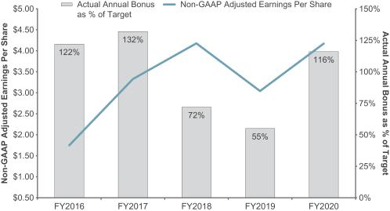

Non-GAAP adjusted EPS is a performance target under our bonus plan. See Appendix A for non-GAAP reconciliations.

Long-Term Incentives

Overview. Applied’s long-term incentive compensation program is intended to help (1) focus participants on achieving our business objectives, (2) attract, retain and motivate key talent, and (3) align our executives’ interests with shareholders’ interests to maximize long-term shareholder value.

Timing of Awards. The HRCC grants long-term incentive awards to NEOs under our shareholder-approved Employee

Stock Incentive Plan (the “Stock Plan”). The HRCC has not granted, nor does it intend to grant, equity awards in anticipation of the release of material, nonpublic information that is likely to result in changes to the price of our common stock, such as a significant positive or negative earnings announcement. Similarly, Applied has not timed, nor does it intend to time, the release of material, nonpublic information based on equity award grant dates.

Applied Materials, Inc. 35

Table of Contents

Fiscal 2020 Equity Awards

The HRCC believes that a meaningful portion of NEOs’ target compensation should be in the form of long-term incentives. These awards are intended to reward performance over a multi-year period, align the interests of executives with those of shareholders, instill an ownership culture, enhance the personal stake of executive officers in the growth and success of the Company, and provide an incentive for continued service at the Company.

Given the strong support received from our shareholders on our incentive programs last year, we continued our approach to make performance-based equity awards a substantial portion of the overall value of equity awards granted to our NEOs.

Ms. Little joined Applied in June 2020. All of the long-term incentive compensation awarded to Ms. Little in fiscal 2020, as reported in the Summary Compensation Table, pertains to her new-hire award. Her first annual long-term incentive award was made in fiscal 2021 on the same terms as awards for the other NEOs.

The fiscal 2020 long-term incentive awards for NEOs (excluding Ms. Little) consist of two forms of equity vehicles: performance share units (“PSUs”) and restricted stock units (“RSUs”). The target vehicle mix of the awards for the fiscal 2020 grant remains unchanged from the previous year’s grants and consists of 75% PSUs and 25% RSUs for the CEO and 50% PSUs and 50% RSUs for the other NEOs.

CEO LTI Vehicle Mix All Other NEO LTI

Vehicle Mix
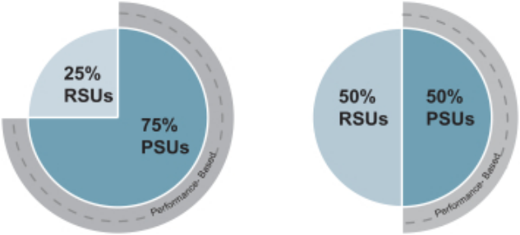

For fiscal 2020, in December 2019, the HRCC granted the number of PSUs and RSUs listed in the below table to our NEOs, except for Ms. Little, who was not an employee of Applied at the time.

- 2021 Proxy Statement

 |  | Target Value | Equivalent
 |  | Target Value | Target | Equivalent
 |  | of Awards⁽¹⁾ | Number of | Number of
NEO |  | ($) | PSUs⁽²⁾ | RSUs⁽²⁾
Dickerson | $ | 13,025,000 | 174,942 | 58,314
Durn | $ | 4,226,000 | 37,841 | 37,841
Salehpour | $ | 4,025,000 | 36,041 | 36,041
Raja | $ | 3,183,344 | 28,505 | 28,505

- Reflects value of awards based on Applied’s stock price on the date of grant. Amounts shown in the “Stock Awards” column of the Summary Compensation Table represent grant date fair value determined pursuant to Accounting Standards Codification 718.
- Number of units calculated by dividing value of awards by $55.84, the closing price of Applied stock on December 5, 2019, the grant date.

Size of Performance-Based Equity Awards. In determining the size of the awards, the HRCC considered each NEO’s award as a component of his total direct compensation. Target fiscal 2020 long-term equity awards were determined in light of each NEO’s scope of responsibility, performance, impact on results and expected future contributions to our business, compensation levels relative to other Applied officers, the need to attract and retain talent, and business conditions. In addition, the fiscal 2020 target award sizes provided sufficient performance-based equity incentives to align compensation with the long-term interests of our shareholders, were in line with market norms for the NEOs’ respective roles and were sufficient to provide incentive for them to achieve Applied’s performance goals over a multi-year period.

Performance Share Units. The long-term incentive program is designed to align performance metrics with our strategic goals over a three-year performance period. The two metrics of the PSU portion of the long-term incentive program remain unchanged from the prior year’s grants. The fiscal 2020 PSUs, granted in December 2019, will vest three years from the grant date based on achievement of average non-GAAP adjusted operating margin for fiscal 2020 through fiscal 2022 and TSR relative to the S&P 500 over the performance period of the first day of fiscal 2020 through the last day of fiscal 2022, with equal weighting given to each metric. The HRCC selected the S&P 500 as the peer set for the relative TSR metric because enough differences exist between Applied and other companies in the technology and/or semiconductor space to make identifying a comparable industry-specific peer group impractical and because the HRCC believes the S&P 500 represents an appropriate proxy for the investment alternatives available to the Company’s shareholders.

Table of Contents

COMPENSATION DISCUSSION AND ANALYSIS
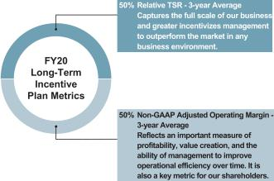

The number of PSUs that will vest will be based on the achievement of threshold (minimum required for a payout), target or maximum levels of each metric and can range from 50% to 200% of the target number of shares, as set forth below.

 | Percentage
 | of Shares
 | That May
Achievement Level | Vest
Threshold | 50%
Target | 100%
Maximum | 200%

A TSR payout factor will be determined by calculating the Company’s TSR percentile rank within the S&P 500, with threshold, target and maximum levels based on Applied’s TSR ranking of above the 25th, 50th and 75th percentile, respectively, of the S&P 500. The TSR calculation uses a 60-day trailing average stock price at the beginning and end of the performance period for measurement purposes. This approach minimizes the impact of a single beginning and ending point stock price for each performance cycle.

If the threshold level is not achieved, then no shares will vest. If achievement falls between threshold and target or target and maximum levels, the portion of the award that may vest will be determined based on straight-line interpolation.

In setting goals for the PSUs, the HRCC considered Applied’s historical results and relative performance, and established goals that are aligned with Applied’s financial and strategic objectives and will require significant effort to achieve the maximum level.

The fiscal 2020 PSU and RSU awards are subject to retirement provisions which provide for a partial payout of the PSU awards based on actual performance at the conclusion of the three-year performance period and partial accelerated vesting of RSU awards in the event of a qualifying retirement based on age and years of service. The provisions are designed to maintain engagement and focus, as well as

provide retention incentive, for our executive officers when they approach potential retirement decisions.

Restricted Stock Units. The RSU awards are scheduled to vest ratably over three years, providing a link to shareholder value creation and maintaining retention value.

Payout of Fiscal 2018 Performance Share Unit Awards

The PSUs granted to our NEOs in fiscal 2018 were scheduled to vest three years from the grant date based on achievement of average non-GAAP adjusted operating margin for fiscal 2018 through fiscal 2020 and average WFE market share for calendar years 2017 through 2019, with equal weighting given to each metric. The 2018 PSUs represented the last award with a WFE performance metric. In setting targets for the PSUs, the HRCC considered a number of factors, including the Company’s past performance, analyst expectations, current and expected macro-economic forces, the spectrum of potential outcomes, and competitor positioning. The number of PSUs that could vest was based on the achievement of threshold (minimum required for a payout), target or maximum levels of each metric and could range from 50% to 200% of the target number of shares. The threshold, target and maximum levels and actual achievement for each metric, as well as overall payout for the fiscal 2018 PSUs, are shown below.

 |  | Three-Year Average
Metric | Threshold | Target | Maximum | Result | Payout
Operating
Margin⁽¹⁾ | 22.1% | 24.1% | 29.6% | 26.3% | 139.4%
WFE Share | 19.2% | 21.2% | 26.5% | 20.2% | 75.0%
Total |  |  |  |  | 107.2%

- See Appendix A for a reconciliation of non-GAAP adjusted operating margin.

The payout of the fiscal 2018 PSUs for each NEO (with the exception of Ms. Little, who was not an employee of Applied in fiscal 2018) is shown below.

 | Target | Number of
 | Number of | PSUs
NEO | PSUs | Earned
Dickerson | 168,096 | 180,199
Durn | 29,235 | 31,340
Salehpour | 35,861 | 38,443
Raja | 28,016 | 30,034

Value Creation Awards

During fiscal 2020, the HRCC conducted a comprehensive review of the compensation for the Company’s senior executives, including the NEOs. As a result of that review, the

Applied Materials, Inc. 37

Table of Contents

HRCC determined that an incremental award of performance-based long-term incentives to certain key executives would be appropriate, prudent and in the best interests of the Company and its shareholders. Consequently, in December 2020, the HRCC approved a non-recurring long-term PSU award (“Value Creation Award”) for Mr. Dickerson of a target number of 116,145 PSUs with a value of $10 million based on Applied’s closing stock price on the grant date. The HRCC also approved Value Creation Awards for Mr. Durn and Dr. Raja, each with a target number of 33,769 PSUs and a grant value of $3 million. The Value Creation Awards will only deliver value to the executive officers if total stockholder return milestones are met during the five-year performance period ending on October 26, 2025 (“Performance Period”) and are scheduled to vest at the end of the Performance Period.

Rationale. The decision to grant the Value Creation Awards reflects the Applied Board’s confidence in the Company’s strategy and leadership team. The Board believes that the current inflection point in the technology industry presents a range of unprecedented opportunities for our Company and our industry, and that Messrs. Dickerson and Durn are the right executives to guide Applied, and Dr. Raja, the Semiconductor Products Group, for the foreseeable future. The Value Creation Awards were also made in acknowledgement of the extremely competitive market for proven executive talent among our direct peers as well as broader technology companies. The HRCC believed that the awards were an appropriate step to mitigate the potential risks to Applied posed by having to replace any of these leaders over the next several years. Finally, the HRCC designed the Value Creation Awards to align the officers’ interests with the long-term interests of our shareholders by delivering value only if Applied’s stock price growth – having achieved the highest stock price in the Company’s history on the grant date – and dividends paid exceed challenging hurdles.

Award Design. With input from its independent compensation consultant, the HRCC considered a number of potential award designs and performance measures before ultimately approving the Value Creation Awards. The HRCC designed the Value Creation Awards to:

- Motivate the officers to deliver ambitious EPS growth – far above expected overall semiconductor industry growth;

- Strive for price-to-earnings multiple expansion – by demonstrating Applied’s superior long-term growth potential;

- Tie payouts to stock price growth and dividend payout – a replica of the shareholder experience; and

- 2021 Proxy Statement

- Support the long-term retention of key executives – with a longer performance/vesting period as compared to the annual RSU and PSU awards.

The HRCC also acknowledged that while the Value Creation Awards provide incentive and retention value, they represent only one component of the compensation for Messrs. Dickerson and Durn and Dr. Raja. As a result, the HRCC believed that it was appropriate to tie the Value Creation Awards solely to Applied’s TSR performance, rather than relative TSR results or operational metrics, as these important measures are already incorporated into the ongoing executive compensation program.

Potential payout under the Value Creation Awards is based on achievement of specified levels of total shareholder return (“TSR Hurdle”) during the five-year Performance Period. The TSR Hurdle is calculated as Applied’s average closing stock price for any consecutive 20 trading days during the Performance Period, plus dividends paid during the Performance Period. The Value Creation Awards will only be earned if Applied achieves a significant increase in TSR during the five-year Performance Period. In addition, the awards require the recipients to remain employed with the Company through the end of the five-year Performance Period, except in the event of involuntary termination of employment without cause, death or following a change of control.

In determining the magnitude of the Value Creation Awards, the HRCC considered the value of the target number of PSUs at the time of grant, including when prorated over the Performance Period, as well as the potential future value of the PSUs assuming achievement at various performance levels. The HRCC evaluated the awards in the context of the executives’ overall compensation levels among their counterparts at peer companies, award values for similar non-recurring LTI awards among executives at other large technology companies, and annual award values approved by the HRCC for the officers.

Performance Goals. The actual number of PSUs that may be earned by each officer ranges from 0% to 200% of the target number of PSUs based on achievement of the TSR Hurdles shown below. If the threshold TSR Hurdle of $104.40 is not achieved, then no PSUs will vest. If the actual TSR achievement measured at the end of the Performance Period falls between the pre-defined levels, the portion of the award that may vest will be determined based on straight-line interpolation. Any PSUs earned shall vest in full at the end of the Performance Period, subject to continued employment through the vesting date. The vesting requirement would be modified in the event of involuntary termination of employment without cause, death or following a change of control, prior to the end of the Performance Period.

Table of Contents

COMPENSATION DISCUSSION AND ANALYSIS

For purposes of the Value Creation Awards, TSR is measured as the increase in the market price of our common stock plus cash dividends paid on a per share basis as compared to the base price of $76.94 (the “Baseline Price”), which represents the average closing price of Applied’s common stock during the 20-trading day period ending on December 3, 2020.

 |  | TSR % vs.
Performance |  | Baseline
Modifier | TSR Hurdle | Price
50% | $104.40 | 36%
100% | $119.40 | 55%
150% | $129.40 | 68%
200% | $144.40 | 88%

The HRCC believes that the TSR Hurdles are set at challenging levels, that require successful execution of our long-term strategy and the creation of significant incremental shareholder value. As additional context, compared to Applied’s closing share price of $60.95 on October 23, 2020, the last trading day of fiscal 2020, and assuming a constant number of shares outstanding:

- The 100% performance modifier requires Applied to achieve 96% TSR and would result in a $53 billion increase in market capitalization.

- The 200% performance modifier requires Applied to achieve 137% TSR and would result in a $76 billion increase in market capitalization.

The chart below illustrates the TSR Hurdles corresponding to the 100% and 200% modifiers, compared to Applied’s stock trading history during the previous ten years.

Value Creation Awards TSR Hurdles vs. Applied’s Stock Trading History
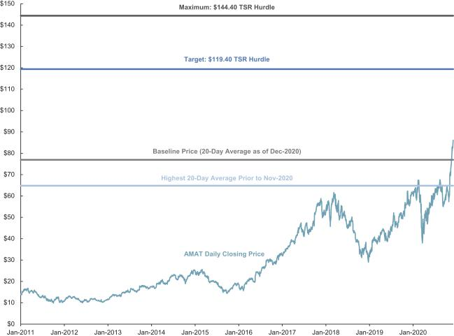

The HRCC views the Value Creation Awards as an important, non-recurring supplement to the ongoing compensation program and does not expect to grant any similar awards to these officers in the coming years.

Applied Materials, Inc. 39

Table of Contents

New-Hire Compensation Package

In June 2020, we welcomed Ms. Little as our new Chief Legal Officer. In determining Ms. Little’s new-hire compensation package, the HRCC considered a number of factors, including: the competitive market for senior legal talent; the magnitude, form and timing of her forgone compensation at her prior employer – including the need to replace substantial lost compensation in the near term; and the risk she incurred to leave her prior employer after a long and successful career.

After considering these factors, the HRCC approved a new-hire compensation package for Ms. Little consisting of: an initial annual base salary of $515,000; a target bonus of 110% of her base salary under the Bonus Plan beginning in fiscal year 2020; a sign-on bonus of $500,000 (“Sign-On Bonus”); a $1,800,000 cash payment (“Make-Whole Payment”) to partially compensate for vesting of equity awards that Ms. Little forfeited by leaving her previous employer; an RSU award with a grant date value of $7,200,000, vesting over a three-year period; and a commitment by Applied to recommend that the HRCC grant Ms. Little equity awards with an aggregate value of no less than $2,000,000 in each of the next three regular annual equity grant cycles, reflecting the competitive market for Chief Legal Officer roles. In the event Ms. Little resigns from Applied, or her employment is terminated for “cause”, prior to the completion of 24 months of service, Ms. Little is obligated to repay the full amount of the Sign-On Bonus and Make-Whole Payment, less any amounts withheld by Applied for taxes. Together, the Make-Whole Payment and the RSU award approximate the value of previously awarded long-term compensation Ms. Little forfeited to join Applied. These amounts are not intended to represent ongoing compensation for Ms. Little’s role.

Role and Authority of the Human Resources and Compensation Committee

The HRCC has a written charter approved by the Board that specifies the HRCC’s duties and responsibilities, which is available on our website at: http://www.appliedmaterials.com/files/hrcc_charter.pdf. In accordance with its charter, the HRCC oversees our programs that foster executive and employee development and retention, with an emphasis on leadership development, management capabilities, succession plans and human capital management. The HRCC also determines executive and director compensation, and oversees significant employee benefits programs, policies and plans.

Each member of the HRCC has been determined to be independent under Nasdaq and SEC rules. The HRCC may delegate any of its responsibilities to subcommittees. See “Board Meetings and Committees” on page 14 for more information about the HRCC.

- 2021 Proxy Statement

Role of Compensation Consultant

The HRCC has the authority to engage independent advisors to assist it in carrying out its responsibilities. For fiscal 2020, the HRCC engaged Semler Brossy Consulting Group (“Semler Brossy”) as its independent executive compensation consultant. Semler Brossy, who reports directly to the HRCC and not to management, is independent from Applied, has not provided any services to Applied other than to the HRCC, and receives compensation from Applied only for services provided to the HRCC. The HRCC assessed the independence of Semler Brossy pursuant to SEC rules and concluded that the work of Semler Brossy for the HRCC has not raised any conflict of interest.

Semler Brossy reviews and advises on all principal aspects of the executive compensation program. Its main responsibilities are as follows:

- Advise on alignment of pay and performance;

- Review and advise on executive total compensation, including base salaries, short- and long-term incentives, associated performance goals, and retention and severance arrangements;

- Advise on trends in executive compensation;

- Provide recommendations regarding the composition of our peer group;

- Analyze market compensation practices based on peer group proxy statements, compensation survey data and other publicly available data; and

- Perform any special projects requested by the HRCC.

The HRCC typically asks Semler Brossy to attend the HRCC’s meetings, including executive sessions at which management is not present. Semler Brossy communicates regularly with the HRCC Chair outside of committee meetings and also meets with management to gather information and review proposals.

Role of Executive Officers and Management in Compensation Decisions

In fiscal 2020, the HRCC invited Mr. Dickerson (as CEO) and other executives, including the heads of Global Human Resources and Global Rewards, to attend its meetings. The HRCC also regularly held executive sessions without management present. The CEO, together with the HRCC, assesses the performance of our NEOs and other executive officers. The CEO presents to the HRCC his evaluation of each executive officer’s performance over the past year and makes recommendations to the HRCC regarding base salaries, bonus targets and actual payments, performance goals and weightings, and long-term incentive awards for executive officers. The HRCC considers these recommendations in making its final determinations, in

Table of Contents

COMPENSATION DISCUSSION AND ANALYSIS

addition to considering input from Semler Brossy. The HRCC discusses the CEO’s compensation and makes final

decisions regarding the CEO’s compensation when he is not present.

Additional Compensation Programs and Policies

Non-Qualified Deferred Compensation Plan

Our 2016 Deferred Compensation Plan (the “DCP”) allows our NEOs and other eligible employees to voluntarily defer on a pre-tax basis a portion of their eligible earnings. We do not provide matching or other employer contributions to our executive officers under this plan. Deferrals made prior to October 2015 under the DCP are credited with deemed interest and are subject to the distribution rules in place prior to the plan amendment in October 2015. Beginning in fiscal 2016, participants are permitted to notionally invest new deferrals in certain investment options available under the plan. Additionally, for new deferrals, the DCP provides distribution rules for in-service distributions and upon a qualifying separation from service, disability and change in control.

See “Nonqualified Deferred Compensation” below for more information about the DCP.

Retirement Benefits under the 401(k) Plan and Generally Available Benefits Programs

During fiscal 2020, all full-time and part-time (working 20 or more hours a week) U.S. employees, including the NEOs, were eligible to participate in Applied’s 401(k) plan, a tax-qualified retirement plan. Eligible Applied 401(k) plan participants receive matching contributions from Applied. Other than the 401(k) plan, we do not provide defined benefit pension plans or defined contribution retirement plans to the NEOs or other employees, except as required in certain countries outside the U.S. for legal or competitive reasons. Applied offers a number of other benefits programs to a broad base of eligible employees, including a tax-qualified employee stock purchase plan, medical, dental and vision insurance, long-term and short-term disability plans, life and accidental death and dismemberment plans, health and dependent care flexible spending accounts, business travel insurance, wellness programs, educational assistance, employee assistance program and certain other country-specific benefits.

Applied annually benchmarks its overall benefits programs, including the 401(k) plan, against those of our peers. Applied’s overall broad-based benefits programs are consistent with market practice, which the HRCC believes allows us to remain competitive in attracting and retaining talent.

The value of the benefits provided under the programs discussed above are not considered by the HRCC in determining an individual NEO’s total compensation.

Relocation Program

Applied maintains a relocation program available to all eligible employees that is consistent with current practices among global companies. Applied provides competitive relocation benefits to ensure it can fill positions critical to its business needs and provide career development opportunities for high-potential employees. Benefits for employees on international assignment include reimbursement on an after-tax basis for housing and transportation allowances and living and travel expense reimbursements. Benefits also include tax equalization that is intended to put employees who relocate in service to Applied in the same position, from a tax-liability perspective, that they would be in if they were still located in the U.S.

In 2014, at the Board’s request, Mr. Dickerson relocated with his family to Japan to continue leading critical efforts toward the then-anticipated completion of a proposed business combination with Tokyo Electron Limited.

Board Rationale for Relocation. Recognizing the complexity of a U.S.-Japanese merger, including both geographic and cultural differences, the Board felt it was critical to have senior leadership presence from Applied on the ground in Japan to work closely with Tokyo Electron during the regulatory review period and to effect a smooth business combination and increase the likelihood of achieving forecasted business benefits of the merger. The Board considered and determined that the anticipated cost savings that would be generated from the merger would significantly outweigh the expenses of relocating Mr. Dickerson and his family to Japan.

Relocation Benefits. In accordance with our relocation program, as available to all employees on global assignment, the HRCC approved relocation benefits for Mr. Dickerson, which included payment for taxes incurred in connection with the relocation, as well as tax equalization for the incremental tax-liability resulting from his relocation to Japan in service of Applied.

Tax equalization ensures that the tax costs incurred by Mr. Dickerson on the international assignment be equivalent to what the tax costs would have been had he remained in the U.S. Tax payments were not paid to Mr. Dickerson, but directly to the appropriate tax authorities. While the amounts of the relocation benefits are attributed to Mr. Dickerson in the Summary Compensation Table, they did not provide any additional compensation to him and are not part of his ongoing pay.

Applied Materials, Inc. 41

Table of Contents

Disclosure and Payment Timing. Although Mr. Dickerson relocated to Japan for part of 2014 and 2015, the timing and disclosure of relocation payments extend beyond this period. Mr. Dickerson is subject to income taxes in Japan on income earned for the period of time of his international assignment, including continuing Japanese tax liabilities related to his equity awards. Japan assesses income tax on compensation earned while an individual is resident in Japan. Performance shares are deemed earned over the period during which they vest and stock options are deemed earned from grant to exercise. Applied, in connection with providing tax equalization benefits to Mr. Dickerson under the relocation program, is responsible for incremental taxes in connection with the vesting of performance shares and the stock option award upon its exercise. We expect that fiscal 2020 will be the last year in which Mr. Dickerson is subject to Japanese tax liabilities.

Stock Ownership Guidelines

We have stock ownership guidelines to help align the interests of our Section 16 officers on the CEO Executive Staff with those of our shareholders. The guidelines provide that officers should meet the following ownership levels in Applied common stock:

Position | Ownership Level
CEO | 6x base salary
Other Officers | 3x base salary

As of December 31, 2020, each officer was in compliance with the stock ownership guidelines.

Hedging and Pledging Prohibitions

Applied has an insider trading policy that, among other things, prohibits all of our employees (including officers) and directors from engaging in hedging or other speculative transactions relating to Applied shares.

Prohibited transactions include short sales, derivative securities (such as put and call options, or other similar instruments) and other hedging transactions (such as equity swaps, prepaid variable

- 2021 Proxy Statement

forwards, or similar instruments), or any transactions that have, or are designed to have, the effect of hedging or offsetting any decrease in the market value of Applied securities. In addition, Section 16 officers and directors are prohibited from holding Applied securities in a margin account or otherwise pledging Applied securities as collateral for a loan.

Clawback Policy

We have a “clawback” policy that allows the Board to require reimbursement of incentive compensation from an executive officer in the event that intentional misconduct by the officer is determined to be the primary cause of a material negative restatement of Applied’s financial results. The compensation that may be recovered is the after-tax portion of any bonus paid to, and any performance-based equity awards earned by, the NEO within the 12 months after filing of the financial statements, if the compensation would not have been paid to the NEO had Applied’s financial results been reported properly. The policy applies to financial statements filed in a rolling three-year, look-back period. This clawback policy is in addition to any policies or recovery rights that are required under applicable laws, including the Sarbanes-Oxley Act and the Dodd-Frank Act.

Tax Deductibility

Section 162(m) of the Internal Revenue Code, as amended by the Tax

Cuts and Jobs Act of 2017, restricts deductibility for federal income tax

purposes of annual individual compensation in excess of $1 million to each

NEO, effective for tax years beginning after 2017, subject to a transition

rule for certain written binding contracts which were in effect on

November 2, 2017, and which were not modified in any material respect on

or after such date. While the HRCC considers the deductibility of

compensation as a factor in making compensation decisions, it retains the

flexibility to provide compensation that is consistent with the Company’s

goals for its executive compensation program, even if such compensation

is not tax-deductible.

Table of Contents

COMPENSATION DISCUSSION AND ANALYSIS

HUMAN RESOURCES AND COMPENSATION COMMITTEE REPORT

The information contained in this report shall not be deemed to be “soliciting material” or “filed” with the SEC or subject to the liabilities of Section 18 of the Exchange Act, except to the extent that Applied specifically incorporates it by reference into a document filed under the Securities Act of 1933, as amended (the “Securities Act”), or the Exchange Act.

The Human Resources and Compensation Committee has reviewed and discussed with management the Compensation Discussion and Analysis for fiscal 2020. Based on the review and discussions, the Human Resources and Compensation

Committee recommended to the Board that the Compensation Discussion and Analysis be included in Applied’s Proxy Statement for its 2021 Annual Meeting of Shareholders.

This report is submitted by the Human Resources and Compensation Committee.

Thomas J. Iannotti (Chair)

Xun (Eric) Chen

Alexander A. Karsner

Applied Materials, Inc. 43

Table of Contents

EXECUTIVE COMPENSATION

Summary Compensation Table for Fiscal 2020, 2019 and 2018

The following table shows compensation information for fiscal 2020, 2019 and 2018 for our NEOs.

 |  |  |  |  | Non-Equity
 |  |  |  | Stock | Incentive Plan | All Other | Total
 |  | Salary | Bonus | Awards | Compensation | Compensation | Total
Name and Principal Position | Year | ($) | ($)⁽¹⁾ | ($)⁽²⁾ | ($)⁽³⁾ | ($) | ($)
Gary E. Dickerson | 2020 | 1,030,000 | — | 14,299,176 | 1,786,406 | 179,405⁽⁴⁾ | 17,294,987
President and Chief Executive Officer | 2019 | 1,024,808 | — | 11,696,506 | 1,133,000 | 218,081 | 14,072,395
 | 2018 | 1,000,000 | — | 11,261,311 | 1,430,000 | 373,229 | 14,064,540
Daniel J. Durn | 2020 | 625,000 | — | 4,459,552 | 975,586 | 13,893⁽⁵⁾ | 6,074,031
Senior Vice President, Chief Financial Officer | 2019 | 620,673 | — | 3,931,029 | 580,078 | 13,620 | 5,145,400
 | 2018 | 600,000 | 250,000 | 5,329,659 | 471,900 | 23,252 | 6,674,811
Ali Salehpour | 2020 | 625,000 | — | 4,247,422 | 774,984 | 16,194⁽⁶⁾ | 5,663,600
Senior Vice President, Services, Display | 2019 | 620,673 | — | 3,931,029 | 411,750 | 12,730 | 4,976,182
and Flexible Technology | 2018 | 600,000 | — | 3,610,485 | 588,060 | 15,824 | 4,814,369
Prabu G. Raja | 2020 | 567,000 | — | 3,359,304 | 923,324 | 17,842⁽⁷⁾ | 4,867,470
Senior Vice President, Semiconductor Products Group | 2019 | 564,058 | — | 2,892,132 | 430,948 | 16,464 | 3,903,602
 | 2018 | 549,039 | — | 4,784,842 | 522,720 | 13,923 | 5,870,524
Teri A. Little⁽⁸⁾ | 2020 | 198,077 | 2,300,000 | 6,983,678 | 200,655 | ₄₄₅(9) | 9,682,855
Senior Vice President, Chief Legal Officer | 2019 | — | — | — | — | — | —
and Corporate Secretary | 2018 | — | — | — | — | — | —

- Amount shown for Mr. Durn is a special bonus, which was paid six months following Mr. Durn’s hire date. This bonus was awarded to Mr. Durn in lieu of a fiscal 2017 bonus, as his employment occurred after the eligibility date for a 2017 bonus award under the Senior Executive Bonus Plan. Amount shown for Ms. Little is a new-hire bonus, which is subject to repayment by Ms. Little if she resigns or her employment is terminated by Applied for cause within two years of her hire date.
- Amounts shown do not reflect compensation actually received by the executive officer. Instead, the amounts reported represent the aggregate grant date fair value of target stock awards granted in the respective fiscal years, as determined pursuant to ASC 718 (but excluding the effect of estimated forfeitures for performance-based awards). For fiscal 2020, the grant date fair value of the maximum number of stock awards that may be earned by each NEO is as follows: Mr. Dickerson: $25,439,483; Mr. Durn: $6,869,256; Mr. Salehpour: $6,542,502; Dr. Raja: $5,174,492; and Ms. Little: $6,983,678. See “Fiscal 2020 Equity Awards” on page 36 for more information regarding the stock awards. The assumptions used to calculate the value of awards are set forth in Note 13 of the Notes to Consolidated Financial Statements included in Applied’s Annual Report on Form 10-K for fiscal 2020 filed with the SEC on December 11, 2020.

- Amounts consist of bonuses earned under the Senior Executive Bonus Plan for services rendered in the respective fiscal years.
- Amount includes (a) Applied’s matching contribution of $12,825 under the tax-qualified 401(k) Plan, (b) Applied’s payment on behalf of Mr. Dickerson of $1,068 in term life insurance premiums and (c) Applied’s matching contribution of $2,500 pursuant to a program under the Applied Materials, Inc. Political Action Committee to an eligible non-profit organization. Amount also includes $10,214 paid by Applied on behalf of Mr. Dickerson for tax consultation, $84,397 for taxes incurred and $68,401 of tax equalization payments for Japanese tax liabilities and taxes incurred as a result of these payments made under Applied’s relocation program in connection with Mr. Dickerson’s international assignment in Japan in contemplation of the closing of a proposed business combination with Tokyo Electron. Tax equalization ensures that the tax costs incurred by Mr. Dickerson on the international assignment are equivalent to what the tax costs would have been had he remained in the U.S. The tax equalization amounts were not paid to Mr. Dickerson but were paid directly to the appropriate tax authorities. See “Relocation Program” on page 41 for more information regarding Mr. Dickerson’s international assignment.

- Amount consists of (a) Applied’s matching contribution of $12,825 under the tax-qualified 401(k) Plan and (b) Applied’s payment on behalf of Mr. Durn of $1,068 in term life insurance premiums.
- Amount consists of (a) Applied’s matching contribution of $12,626 under the tax-qualified 401(k) Plan, (b) Applied’s payment on behalf of Mr. Salehpour of $1,068 in term life insurance premiums and (c) Applied’s matching contribution of $2,500 pursuant to a program under the Applied Materials, Inc. Political Action Committee to an eligible non-profit organization.
- Amount consists of (a) Applied’s matching contribution of $12,024 under the tax-qualified 401(k) Plan, (b) Applied’s payment on behalf of Dr. Raja of $1,068 in term life insurance premiums, (c) a payment of $2,250 under Applied’s Patent Incentive Award Program and (d) Applied’s matching contribution of $2,500 pursuant to a program under the Applied Materials, Inc. Political Action Committee to an eligible non-profit organization.
- Ms. Little was appointed Senior Vice President, Chief Legal Officer effective June 8, 2020.
- Amount consists of Applied’s payment on behalf of Ms. Little of $445 in term life insurance premiums.

- 2021 Proxy Statement

Table of Contents

EXECUTIVE COMPENSATION

Grants of Plan-Based Awards for Fiscal 2020

The following table shows all plan-based awards granted to the NEOs during fiscal 2020.

 |  |  |  |  |  |  |  |  |  | All Other
 |  |  |  |  |  |  |  |  |  | Stock | Grant
 |  | Estimated Possible Payouts |  |  |  | Estimated Future Payouts |  |  |  | Awards: | Date Fair
 |  |  |  |  |  |  |  |  |  | Number of | Value of
 |  | Under Non-Equity |  |  |  |  | Under Equity |  |  | Number of | Value of
 |  |  |  |  |  |  | Under Equity |  |  | Shares of | Stock and
 |  | Incentive Plan Awards(1) |  |  |  | Incentive Plan Awards(2) |  |  |  | Shares of | Stock and
 |  |  |  |  |  |  |  |  |  | Stock or | Option
 | Grant | Threshold | Target | Maximum |  | Threshold | Target | Maximum |  | Units | Awards
Name | Date | ($) | ($) | ($) |  | (#) | (#) | (#) |  | (#) | ($)(3)
Gary E. Dickerson | 12/5/2019 | — | — | — |  | 87,471 | 174,942 | 349,884 |  | — | 11,140,307
 | 12/5/2019 | — | — | — |  | — | — | — |  | 58,314 | 3,158,869
 | — | 0 | 1,545,000 | 4,635,000 |  | — | — | — |  | — | —
Daniel J. Durn | 12/5/2019 | — | — | — |  | 18,921 | 37,841 | 75,682 |  | — | 2,409,705
 | 12/5/2019 | — | — | — |  | — | — | — |  | 37,841 | 2,049,847
 | — | 0 | 843,750 | 2,531,250 |  | — | — | — |  | — | —
Ali Salehpour | 12/5/2019 | — | — | — |  | 18,021 | 36,041 | 72,082 |  | — | 2,295,081
 | 12/5/2019 | — | — | — |  | — | — | — |  | 36,041 | 1,952,341
 | — | 0 | 843,750 | 2,531,250 |  | — | — | — |  | — | —
Prabu G. Raja | 12/5/2019 | — | — | — |  | 14,253 | 28,505 | 57,010 |  | — | 1,815,188
 | 12/5/2019 | — | — | — |  | — | — | — |  | 28,505 | 1,544,116
 | — | 0 | 765,450 | 2,296,350 |  | — | — | — |  | — | —
Teri A. Little | 6/8/2020 | — | — | — |  | — | — | — |  | 120,201 | 6,983,678
 | — | 0 | 216,913 | 1,699,500 |  | — | — | — |  | — | —

- Amounts shown were estimated possible payouts for fiscal 2020 under the Senior Executive Bonus Plan (additional information on the annual bonus plan can be found on page 29 under “Annual Incentive Bonus Opportunities.”). These amounts were based on the individual NEO’s fiscal 2020 base salary and position. The maximum amount shown is three times the target amount for the NEO. Actual bonuses received by the NEOs for fiscal 2020 under the Senior Executive Bonus Plan are reported in the Summary Compensation Table under the column titled “Non-Equity Incentive Plan Compensation.”

- Additional information on the equity awards can be found on page 35 under “Long-Term Incentives.”
- Amounts shown do not reflect compensation actually received by the NEOs. Instead, the amounts represent the aggregate grant date fair value of the awards as determined pursuant to ASC 718 (but excluding the effect of estimated forfeitures for performance-based awards). The assumptions used to calculate the awards’ value are set forth in Note 13 of the Notes to Consolidated Financial Statements included in Applied’s Annual Report on Form 10-K for fiscal 2020 filed with the SEC on December 11, 2020.

Applied Materials, Inc. 45

Table of Contents

Outstanding Equity Awards at Fiscal 2020 Year-End

The following table shows all outstanding equity awards held by the NEOs at the end of fiscal 2020.

 |  | Stock Awards(1)
 |  |  | Equity | Equity
 |  |  | Incentive | Incentive
 |  |  | Plan | Plan Awards:
 |  |  | Awards: | Market or
 |  |  | Number of | Payout
 | Number | Market | Unearned | Value of
 | of Shares | Value of | Shares, | Unearned
 | or Units | Shares or | Units or | Shares,
 | of Stock | Units of | Other | Units or
 | That | Stock That | Rights | Other Rights
 | Have Not | Have Not | That Have | That Have
 | Vested | Vested | Not Vested | Not Vested
Name | (#) | ($)(2) | (#) | ($)(2)
Gary E. Dickerson | 18,678⁽³⁾ | 1,138,424 | — | —
 | 56,910⁽⁴⁾ | 3,468,665 | — | —
 | 58,314⁽⁵⁾ | 3,554,238 | — | —
 | — | — | 168,096⁽⁶⁾ | 10,245,451
 | — | — | 256,090⁽⁷⁾ | 15,608,686
 | — | — | 174,942⁽⁸⁾ | 10,662,715
Daniel J. Durn | 9,745⁽³⁾ | 593,958 | — | —
 | 48,606⁽⁹⁾ | 2,962,536 | — | —
 | 38,676⁽¹⁰⁾ | 2,357,302 | — | —
 | 37,841⁽¹¹⁾ | 2,306,409 | — | —
 | — | — | 29,235⁽¹²⁾ | 1,781,873
 | — | — | 58,014⁽⁷⁾ | 3,535,953
 |  |  | 37,841⁽⁸⁾ | 2,306,409
Ali Salehpour | 11,954⁽³⁾ | 728,596 | — | —
 | 38,676⁽¹⁰⁾ | 2,357,302 | — | —
 | 36,041⁽¹³⁾ | 2,196,699 | — | —
 | — | — | 35,861⁽¹⁴⁾ | 2,185,728
 | — | — | 58,014⁽⁷⁾ | 3,535,953
 | — | — | 36,041⁽⁸⁾ | 2,196,699
Prabu G. Raja | 17,753⁽¹⁵⁾ | 1,082,045 | — | —
 | 9,339⁽³⁾ | 569,212 | — | —
 | 28,455⁽¹⁶⁾ | 1,734,332 | — | —
 | 28,505⁽¹⁷⁾ | 1,737,380 | — | —
 | — | — | 28,016⁽¹⁸⁾ | 1,707,575
 | — | — | 42,682⁽⁷⁾ | 2,601,468
 |  |  | 28,505⁽⁸⁾ | 1,737,380
Teri A. Little | 120,201⁽¹⁹⁾ | 7,326,251 | — | —

- Stock awards consist of time-vesting restricted stock units (“RSUs”) and performance shares (“PSUs”), all of which will be converted into Applied common stock on a one-to-one basis upon vesting. All future vesting of shares is subject to the NEO’s continued employment with Applied through each applicable vest date. See “Long-Term Incentives” on page 35 for more information regarding these awards.
- Market value was determined by multiplying the number of such shares by the closing price of Applied common stock of $60.95 on October 23, 2020, the last trading day of fiscal 2020, as reported on the Nasdaq Global Select Market.
- RSUs were granted on December 14, 2017. These shares vested in full on December 19, 2020.
- RSUs were granted on December 6, 2018. Of these, 28,455 shares vested on December 19, 2020 and 28,455 shares are scheduled to vest on December 19, 2021.
- RSUs were granted on December 5, 2019. Of these, 19,438 shares vested on December 19, 2020 and 19,438 shares are scheduled to vest on December 19 of each of 2021 and 2022.
- PSUs were granted on December 14, 2017. These shares vested on December 19, 2020. On December 3, 2020, an additional 12,103 shares became eligible to vest due to achievement of performance goals related to the grant. These additional shares also vested on December 19, 2020.
- PSUs were granted on December 6, 2018. The shares are scheduled to vest on December 19, 2021, depending on the achievement of specified performance goals. The number of shares shown is the target amount, and the actual number of shares that may vest ranges from 0% to 200% of the target amount, depending on the achievement of specified performance goals.
- PSUs were granted on December 5, 2019. The shares are scheduled to vest on December 19, 2022, depending on the achievement of specified performance goals. The number of shares shown is the target amount, and the actual number of shares that may vest ranges from 0% to 200% of the target amount, depending on the achievement of specified performance goals.
- RSUs were granted on October 19, 2018. Of these, 24,303 shares vested on November 1, 2020 and 24,303 shares are scheduled to vest on November 1, 2021.

- 2021 Proxy Statement

Table of Contents

EXECUTIVE COMPENSATION

- RSUs were granted on December 6, 2018. Of these, 19,338 shares vested on December 19, 2020 and 19,338 shares are scheduled to vest on December 19, 2021.

- RSUs were granted on December 5, 2019. Of these, 12,613 shares vested on December 19, 2020 and 12,614 shares are scheduled to vest on December 19 of each of 2021 and 2022.
- PSUs were granted on December 14, 2017. These shares vested on December 19, 2020. On December 3, 2020, an additional 2,105 shares became eligible to vest due to achievement of performance goals related to the grant. These additional shares also vested on December 19, 2020.

- RSUs were granted on December 5, 2019. Of these, 12,013 shares vested on December 19, 2020 and 12,014 shares are scheduled to vest on December 19 of each of 2021 and 2022.
- PSUs were granted on December 14, 2017. These shares vested on December 19, 2020. On December 3, 2020, an additional 2,582 shares became eligible to vest due to achievement of performance goals related to the grant. These additional shares also vested on December 19, 2020.
- RSUs were granted on November 6, 2017. Of these, 8,876 shares vested on December 19, 2020 and 8,877 shares are scheduled to vest on December 19, 2021.
- RSUs were granted on December 6, 2018. Of these, 14,227 shares vested on December 19, 2020 and 14,228 shares are scheduled to vest on December 19, 2021.

- RSUs were granted on December 5, 2019. Of these, 9,501 shares vested on December 19, 2020 and 9,502 shares are scheduled to vest on December 19 of each of 2021 and 2022.
- PSUs were granted on December 14, 2017. These shares vested on December 19, 2020. On December 3, 2020, an additional 2,018 shares became eligible to vest due to achievement of performance goals related to the grant. These additional shares also vested on December 19, 2020.
- RSUs were granted on June 8, 2020. Of these, 40,067 shares are scheduled to vest on July 1 of each of 2021, 2022 and 2023.

Option Exercises and Stock Vested for Fiscal 2020

The following table shows all stock awards that vested and the value realized upon vesting for each NEO during fiscal 2020.

 | Option Awards |  |  | Stock Awards
 | Number of Shares |  |  | Number of Shares
 | Acquired on | Value Realized |  | Acquired on | Value Realized
 | Exercise | on Exercise |  | Vesting | on Vesting
Name | (#) | ($) |  | (#)⁽¹⁾ | ($)⁽²⁾
Gary E. Dickerson | 1,000,000 | 46,045,400 |  | 692,648 | 42,022,954
Daniel J. Durn | — | — |  | 135,340 | 8,034,536
Ali Salehpour | — | — |  | 206,343 | 12,518,830
Prabu G. Raja | — | — |  | 165,173 | 10,021,046
Teri A. Little | — | — |  | — | —

- Of the amounts shown in this column, Applied withheld the following number of shares to cover tax withholding obligations: 364,683 shares for Mr. Dickerson; 71,354 shares for Mr. Durn; 99,848 shares for Mr. Salehpour; and 79,439 shares for Dr. Raja.
- Value realized equals the fair market value of Applied common stock on the vesting date, multiplied by the number of shares that vested.

Non-Qualified Deferred Compensation

Applied’s 2016 Deferred Compensation Plan (the “DCP”), restated effective October 12, 2015 (the “Restatement Date”), is a non-qualified deferred compensation plan that allows eligible employees, including executive officers, to voluntarily defer receipt of up to 40% of their base salaries and all or a portion of their eligible sales incentive and annual bonus payments, if any.

Deferrals made prior to the Restatement Date are retained as separate “rollover” accounts under the DCP. These deferrals continue to be credited with deemed interest in the sum of (a) the yield-to-maturity of five-year U.S. Treasury notes, plus (b) 1.50%. Deferred amounts in the rollover accounts, plus deemed interest thereon, are generally payable on the same

date selected by the participants or specified prior to the Restatement Date under the terms of the DCP. Beginning in fiscal 2016, deferrals under the DCP are credited with deemed investment returns, gains or losses based upon investment crediting options available under the DCP. Applied does not make any matching or other employer contributions to the plan for our executive officers.

Under the DCP, a change in control (as defined prior to the Restatement Date), would trigger the distribution of all deferred balances in the rollover accounts. For account balances after the Restatement Date, the DCP provides distribution rules for in-service distribution options and upon a qualifying separation from service, disability and change in

Applied Materials, Inc. 47

Table of Contents

control, including the option to change the time and form of payment within three (3) months following a change in control, as such term is defined in the DCP. Distributions are payable from the general assets of Applied or from the assets

of a grantor trust (known as a rabbi trust) established by Applied for distributions made from accounts established after the Restatement Date and existing as of December 31, 2019.

Non-Qualified Deferred Compensation for Fiscal 2020

 | Executive | Registrant | Aggregate | Aggregate | Aggregate
 | Contributions in | Contributions in | Earnings in | Withdrawals/ | Balance at Last
 | Last Fiscal Year | Last Fiscal Year | Last Fiscal Year | Distributions | Fiscal Year End
Name | ($) | ($) | ($)⁽¹⁾ | ($) | ($)
Gary E. Dickerson | — | — | — | — | —
Daniel J. Durn | — | — | — | — | —
Ali Salehpour | 647,972 | — | 601,561 | — | 5,589,369
Prabu G. Raja | 586,104 | — | 300,443 | — | 5,371,774
Teri A. Little | — | — | — | — | —
- There were no above-market or preferential earnings for fiscal 2020.

Employment Agreement

Applied does not have employment agreements with any of its NEOs, other than an agreement with Mr. Dickerson. The agreement with Mr. Dickerson was entered into in connection with his appointment as President and CEO.

Mr. Dickerson’s employment agreement, dated August 14, 2013, provides that if Applied terminates his employment other than for cause and other than due to death or disability, he would be entitled to receive a lump sum payment equal to 275% of his base salary, provided that he executes an agreement containing a release of claims and non-solicitation and non-disparagement provisions in favor of Applied.

For purposes of Mr. Dickerson’s agreement, “cause” generally means the willful failure to perform his duties after written notice and an opportunity to cure; the willful commission of a wrongful act that caused, or was reasonably likely to cause, substantial damage to Applied, or an act of fraud in the performance of his duties; conviction for the commission of a felony in connection with the performance of his duties; or the order of a federal or state regulatory authority requiring the termination of his employment.

- 2021 Proxy Statement

Table of Contents

EXECUTIVE COMPENSATION

Potential Payments Upon Termination or Change of Control

Applied does not currently have change of control agreements or arrangements with any of its NEOs.

Potential Payments Upon Termination. Under Mr. Dickerson’s employment agreement described above, he would have been entitled to receive $2,832,500 (275% of his annual base salary at the end of fiscal 2020) had Applied terminated his employment without cause on October 23, 2020, the last business day of fiscal 2020. No other NEO was entitled to receive severance payment under an employment agreement in effect on October 23, 2020.

Qualified Retirement - Employee Stock Incentive Plan. Effective January 2020, PSU and RSU awards granted beginning in fiscal 2019 to certain of our executives, including the NEOs, are subject to retirement provisions which provide for partial accelerated vesting of RSU awards and a partial payout of the PSU awards based on actual performance at the conclusion of the three-year performance period, in the event of a qualifying retirement. In order to qualify, an executive is required to have reached age 60 and have completed at least five years of service with Applied, at the time of his or her retirement. As of the end of fiscal 2020, Mr. Dickerson was the only NEO who would have met the conditions for a qualifying requirement under these provisions. If Mr. Dickerson had incurred a qualifying retirement on October 23, 2020, the last business day of fiscal 2020, the equity awards that would have been accelerated would have a value of $23,352,424 (assuming that the number of his PSUs for which vesting would have been accelerated is the target number and that the price per share of Applied common stock is $60.95, the closing price on October 23, 2020).

Change of Control - Employee Stock Incentive Plan. Our Stock Plan provides that the vesting of equity awards granted

under the plan to employees, including the NEOs, will be accelerated in full upon a change of control of Applied if the successor corporation (or its parent or subsidiary) does not assume or provide a substitute for the outstanding awards. Separately, equity awards will be accelerated in full if the award holder is terminated without cause or resigns employment with Applied for good reason, in each case, within 12 months following a change of control of Applied. This double-trigger accelerated vesting does not apply if the applicable award agreement specifically states that it will not apply or if the participant’s employment is terminated due to his or her death or disability, resignation without good reason or termination for cause.

The following table shows the amounts attributable to the accelerated vesting of equity awards under the Stock Plan following a change of control in which the awards are not assumed or substituted, or within 12 months following a change of control in which the NEO is terminated without cause or resigns for good reason, in each case assuming the change of control and termination or resignation occurred on October 23, 2020, the last business day of fiscal 2020.

 | Value of Vesting Acceleration
Named Executive Officer |  | ($)⁽¹⁾
Gary E. Dickerson | $ | 44,678,179
Daniel J. Durn | $ | 15,844,440
Ali Salehpour | $ | 13,200,978
Prabu G. Raja | $ | 11,169,392
Teri A. Little | $ | 7,326,251

- Amount based on the number of restricted stock units and target number of PSUs for which vesting would have been accelerated, multiplied by $60.95, the closing price of Applied common stock on October 23, 2020.

CEO Pay Ratio

In accordance with SEC rules, we are providing the ratio of the annual total compensation of our CEO, to the median of the annual total compensation of our employees (other than the CEO). The fiscal 2020 annual total compensation of our CEO, Mr. Dickerson, was $17,294,987, the fiscal 2020 annual total compensation of our median compensated employee (other than the CEO) was $84,918, and the ratio of these amounts was 204 to 1.

This pay ratio is a reasonable estimate calculated in a manner consistent with SEC rules based on our human resources system of record and the methodology described below. Because the SEC rules for identifying the median compensated employee and calculating the pay ratio based on that employee’s annual total compensation allow companies to adopt a variety of methodologies, to apply

certain exclusions, and to make reasonable estimates and assumptions that reflect their compensation practices, the pay ratio reported by other companies may not be comparable to the pay ratio reported above, as other companies may have different employment and compensation practices and may utilize different methodologies, exclusions, estimates, and assumptions in calculating their own pay ratios.

For purposes of identifying our median compensated employee, we used our global employee population as of October 25, 2020, the last day of fiscal 2020, identified based on our human resources system of record. We used total direct compensation as our consistently applied compensation measure for such population. In this context, total direct compensation means the sum of the applicable

Applied Materials, Inc. 49

Table of Contents

base salary determined as of October 25, 2020, the annual incentive earned for service in fiscal 2020, and the approved value of the annual equity awards granted during fiscal 2020, not including off-cycle grants in the case of new hires, promotions or similar circumstances. Given the Company’s global population, we used the foreign currency exchange

rates in effect at the end of fiscal 2020 for the salary and the annual incentive. After identifying our median compensated employee, we then calculated the annual total compensation for our median compensated employee using the same methodology used for our CEO as set forth in the Summary Compensation Table of this proxy statement.

Equity Compensation Plan Information

The following table summarizes information with respect to equity awards under Applied’s equity compensation plans as of October 25, 2020:

 |  |  |  | (c)
 | (a) |  |  | Number of Securities
 | Number of |  | (b) | Available for Future
 | Securities to be |  | Weighted Average | Issuance Under Equity
 | Issued Upon Exercise |  | Exercise Price of | Compensation Plans
 | of Outstanding Options, | Outstanding Options, |  | (Excluding Securities
 | Warrants and |  | Warrants and | Reflected in
Plan Category | Rights(1) |  | Rights | Column(a))
Equity compensation plans approved by |  | (In millions, except prices)
Equity compensation plans approved by |  |  |  | 63(2)
security holders | 15 | $ | — | 63(2)
Equity compensation plans not approved by |  |  |  | 3(3)
security holders | — | $ | — | 3(3)
Total | 15 | $ | — | 66
- Includes only restricted stock units and performance shares outstanding under Applied’s equity compensation plans, as no stock options, warrants or other rights were outstanding as of October 25, 2020.
- Includes 7 million shares of Applied common stock available for future issuance under the Applied Materials, Inc. Employees’ Stock Purchase Plan. Of these 7 million shares, 1 million are subject to purchase during the purchase period in effect as of October 25, 2020.
- Includes 3 million shares of Applied common stock available for future issuance under the Applied Materials, Inc. Stock Purchase Plan for Offshore Employees. Of these 3 million shares, 1 million are subject to purchase during the purchase period in effect as of October 25, 2020.

Applied currently has the following equity compensation plans that have not been approved by shareholders:

Stock Purchase Plan for Offshore Employees. The Stock Purchase Plan for Offshore Employees (the “Offshore ESPP”) was adopted effective as of October 16, 1995 for the benefit of employees of Applied’s participating affiliates. The Offshore ESPP provides for the grant of options to purchase shares of Applied common stock through payroll deductions pursuant to one or more offerings. The administrator of the Offshore ESPP (the Board of Directors of Applied or a committee appointed by the Board) determines the terms and conditions of all options prior to the start of an offering, including the purchase price of shares, the number of shares covered by the option and when the option may be exercised. All options granted as part of an offering must be granted on the same date. As of October 25, 2020, a total of 39 million shares have been authorized for issuance under the Offshore ESPP, and 3 million shares remain available for issuance. If shareholders vote to approve Proposal 5, Approval of

Omnibus Employees’ Stock Purchase Plan, in this Proxy Statement then the Offshore ESPP will be incorporated as a sub-plan of our Applied Materials, Inc. Employees’ Stock Purchase Plan, which will be renamed the Omnibus Employees’ Stock Purchase Plan.

Applied Materials Profit Sharing Scheme. The Applied Materials Profit Sharing Scheme was adopted effective July 3, 1996 to enable employees of Applied Materials Ireland Limited and its participating subsidiaries to purchase Applied common stock at 100% of fair market value on the purchase date. Under this plan, eligible employees may elect to forgo a certain portion of their base salary and certain bonuses they have earned, and that otherwise would be payable in cash, to purchase shares of Applied common stock at full fair market value. Since the eligible employees pay full fair market value for the shares, there is no reserved amount of shares under this plan and, accordingly, the table above does not include any set number of shares available for future issuance under the plan.

- 2021 Proxy Statement

Table of Contents

EXECUTIVE COMPENSATION

Certain Relationships and Related Transactions

Applied’s Audit Committee is responsible for the review, approval, or ratification of “related person transactions” involving Applied or its subsidiaries and related persons. Under SEC rules, a related person is a director, officer, nominee for director, or 5% shareholder of a company since the beginning of the previous fiscal year, and his or her immediate family members. Applied has adopted written policies and procedures that apply to any transaction or series of transactions in which (1) Applied or a subsidiary is a participant, (2) the amount involved exceeds $120,000 and (3) a related person has a direct or indirect material interest.

In accordance with these policies and procedures, the Audit Committee determines whether the related person has a material interest in a transaction and may, in its discretion, approve, ratify or take other action with respect to the transaction. The Audit Committee reviews all material facts related to the transaction and takes into account, among other factors it deems appropriate, whether the transaction is on terms no less favorable than terms generally available to an unaffiliated third party under the same or similar circumstances, the extent of the related person’s interest in the transaction, and the purpose and the potential benefits to Applied of the transaction.

In addition, the Audit Committee has delegated authority to the Chair of the Audit Committee to review and approve transactions in accordance with specified criteria, if advance review by the Audit Committee is not feasible. Any transactions approved by the Chair must be reported to the Audit Committee at its next regularly-scheduled meeting.

The Audit Committee has adopted standing pre-approvals for limited transactions with related persons. Pre-approved transactions are as follows:

- Any transaction with another company with which a related person’s only relationship is as an employee, director, or beneficial owner of less than 10% of that company’s shares, if the aggregate amount involved does not exceed the greater of $1 million or 2% of that company’s total annual revenues;

- Any charitable contribution, grant, or endowment by Applied or The Applied Foundation to a charitable organization, foundation, or university with which a related person’s only relationship is as an employee (other than an executive officer) or a director, if the amount involved does not exceed the lesser of $1 million or 2% of the charitable organization’s total annual receipts;

- Compensation to executive officers or directors that has been approved by the Human Resources and Compensation Committee;

- Transactions in which all shareholders receive proportional benefits or where the rates or charges involved are determined by competitive bids; and

- Banking-related services involving a bank depository of funds, transfer agent, registrar, trustee under a trust indenture, or similar service.

Applied Materials, Inc. 51

Table of Contents

PROPOSAL 3—RATIFICATION OF THE APPOINTMENT OF INDEPENDENT REGISTERED PUBLIC ACCOUNTING FIRM

We are asking shareholders to ratify the appointment of KPMG LLP (“KPMG”) as Applied’s independent registered public accounting firm for fiscal 2021, which began on October 26, 2020 and will end on October 31, 2021. The Audit Committee and the Board believe that the retention of KPMG to serve as the Company’s independent registered public accounting firm is in the best interests of the Company and its shareholders. Although ratification is not legally required, Applied is submitting the appointment of KPMG to its shareholders for ratification as a matter of good corporate governance. In the event that this appointment is not ratified, the Audit Committee of the Board will reconsider the appointment. Even if the selection is ratified, the Audit Committee, in its discretion, may change the appointment at any time during the fiscal year if it determines that such a change would be in the best interest of the Company and its shareholders.

The Audit Committee is directly responsible for the appointment, compensation, retention, oversight, evaluation and, when appropriate, replacement of the independent registered public accounting firm that serves as the Company’s independent accountants. KPMG has served as

our independent registered public accounting firm since 2004. In selecting the independent auditor, the Audit Committee annually considers many factors, including its qualifications and performance during fiscal 2020 and 2019, its independence and tenure as the Company’s auditor; KPMG’s capability and expertise in handling the breadth and complexity of the Company’s global operations, including the expertise and capability of the lead audit partner; historical and recent performance, including the extent and quality of KPMG’s communications with the Audit Committee; Public Company Accounting Oversight Board inspection reports, and the appropriateness of KPMG’s fees for audit and non-audit services. Further, in conjunction with ensuring the rotation of KPMG’s lead engagement partner, the Audit Committee and its Chair are directly involved with the selection of KPMG’s lead engagement partner. The next mandatory rotation for KPMG’s lead engagement partner is scheduled to occur in fiscal year 2024.

Representatives of KPMG will be present at the Annual Meeting. They will be given an opportunity to make a statement if they wish and will be available to respond to appropriate questions.

Fees Paid to KPMG LLP

The following table shows fees paid by Applied for professional services rendered by KPMG for fiscal 2020 and 2019, which ended on October 25, 2020 and October 27, 2019, respectively. All of the fees shown in the table were approved by the Audit Committee in accordance with its pre-approval process.

Fee Category | Fiscal 2020 |  | Fiscal 2019
 |  | (In thousands)
Audit Fees | $ | 6,839 | $ | 6,530
Audit-Related Fees |  | 111 |  | 57
Tax Fees:
Tax Compliance and Review |  | 601 |  | 585
Tax Planning and Advice |  | 275 |  | 187
All Other Fees |  | 75 |  | —
Total Fees | $ | 7,901 | $ | 7,359

Audit Fees consisted of fees for (a) professional services rendered for the annual audit of Applied’s consolidated financial statements, (b) review of the interim consolidated financial statements included in quarterly reports and (c) services that are typically provided by an independent registered public accounting firm in connection with statutory and regulatory filings or engagements.

Audit-Related Fees included fees for assurance and related services that were reasonably related to the performance of the audit or review of Applied’s consolidated financial statements and are not reported under “Audit Fees.” Audit-related fees also included fees incurred for services in connection with compliance with government-funded grant requirements, audits of financial statements of certain employee benefit plans and accounting consultations related to proposed new accounting standards.

Tax Fees consisted of fees for professional services for tax compliance and review, and tax planning and advice. Tax compliance and review services consisted of federal, state and international tax compliance, assistance with tax audits and appeals, and assistance with customs and duties audits. Tax planning and advice services consisted of consultations related to tax compliance matters and certain international operations.

All Other Fees for fiscal 2020 consisted of fees for services in connection with a contract compliance audit.

The Audit Committee has concluded that the provision of the non-audit services described above was compatible with maintaining the independence of KPMG.

- THE BOARD RECOMMENDS THAT YOU VOTE FOR THE RATIFICATION OF THE APPOINTMENT OF KPMG AS APPLIED’S INDEPENDENT REGISTERED PUBLIC ACCOUNTING FIRM FOR FISCAL 2021

- 2021 Proxy Statement

Table of Contents

PROPOSAL 3—RATIFICATION OF THE APPOINTMENT OF INDEPENDENT REGISTERED PUBLIC ACCOUNTING FIRM

Policy on Audit Committee’s Pre-Approval of Audit and Permissible Non-Audit Services of Independent Registered Public Accounting Firm

The Audit Committee reviews and, as appropriate, pre-approves all audit and permissible non-audit services provided by the independent registered public accounting firm. These services may include audit services, audit-related services and tax services, as well as specifically designated non-audit services which, in the opinion of the Audit Committee, will not impair the independence of the independent registered public accounting firm. Pre-approval generally is provided for up to one year, and any pre-approval is detailed as to the particular service or category of services

and generally is subject to a specific budget. The independent registered public accounting firm and Applied’s management are required to periodically report to the Audit Committee regarding the extent of services provided by the independent registered public accounting firm in accordance with this pre-approval, including the fees for the services performed to date. In addition, the Audit Committee also may pre-approve particular services on a case-by-case basis, as necessary or appropriate.

Audit Committee Report

The information contained in this report shall not be deemed to be “soliciting material” or “filed” with the SEC, or subject to the liabilities of Section 18 of the Exchange Act, except to the extent that Applied specifically incorporates it by reference into a document filed under the Securities Act or the Exchange Act.

Composition. The Audit Committee of the Board is composed of the directors named below. Each member of the Audit Committee meets the independence and financial experience requirements under applicable SEC rules and Nasdaq listing standards. In addition, the Board has determined that each of Judy Bruner, Adrianna C. Ma, Yvonne McGill, and Scott A. McGregor is an “audit committee financial expert” as defined by SEC rules.

Responsibilities. The Audit Committee operates under a written charter that has been adopted by the Board. The charter is reviewed annually for changes, as appropriate. The Audit Committee is responsible for general oversight of Applied’s auditing, accounting and financial reporting processes, system of internal control over financial reporting, and tax, legal, regulatory and ethical compliance. Applied’s management is responsible for: (a) maintaining Applied’s books of account and preparing periodic financial statements based thereon; and (b) maintaining the system of internal control over financial reporting. The independent registered public accounting firm is responsible for auditing Applied’s annual consolidated financial statements.

Review with Management and Independent Registered Public Accounting Firm. The Audit Committee hereby reports as follows:

- The Audit Committee has reviewed and discussed with management and the independent registered public accounting firm, KPMG LLP, together and separately, Applied’s audited consolidated financial statements contained in Applied’s Annual Report on Form 10-K for fiscal year 2020.

- The Audit Committee has discussed with KPMG matters required to be discussed by applicable standards of the Public Company Accounting Oversight Board.

- The Audit Committee has received from KPMG the written disclosures and the letter required by applicable requirements of the Public Company Accounting Oversight Board regarding KPMG’s communications with the Audit Committee concerning independence, and has discussed with KPMG its independence.

Based on the review and discussions referred to in paragraphs 1-3 above, the Audit Committee recommended to the Board, and the Board has approved, that the audited consolidated financial statements be included in Applied’s Annual Report on Form 10-K for fiscal year 2020 for filing with the SEC.

The Audit Committee appointed KPMG as Applied’s independent registered public accounting firm for fiscal year 2021 and recommends to shareholders that they ratify the appointment of KPMG as Applied’s independent registered public accounting firm for fiscal year 2021.

This report is submitted by the Audit Committee.

Judy Bruner (Chair)

Stephen R. Forrest

Adrianna C. Ma

Yvonne McGill

Scott A. McGregor

Applied Materials, Inc. 53

Table of Contents

PROPOSAL 4—APPROVAL OF AMENDED AND RESTATED EMPLOYEE STOCK INCENTIVE PLAN

Reason for the Amendment and Restatement

We are asking shareholders to approve the amended and restated Employee Stock Incentive Plan (the “Stock Plan”), effective as of March 11, 2021, so that we may continue to achieve our goals of attracting, motivating and retaining our employees through grants of equity awards. Our Board of Directors has approved the amended and restated Stock Plan, subject to the approval of our shareholders at the Annual Meeting.

We strongly believe that the approval of the amended and restated Stock Plan is essential to our continued success. We use equity awards to motivate high levels of performance and to align the interests of our employees and shareholders by giving employees the perspective of an owner with an equity stake in the Company. We believe that equity awards are a competitive necessity in the high-technology industry and are essential to recruiting and retaining the highly qualified technical and other key employees who help the Company meet its goals, as well as rewarding and motivating current employees. Our number of employees continues to grow, and we believe that the ability to grant equity awards is important to Applied’s future success.

Changes in the Amended and Restated Stock Plan

The Stock Plan was last approved by shareholders at our 2017 Annual Meeting of Shareholders. The changes to the Stock Plan approved by shareholders that year did not include an increase in the number of shares authorized for issuance under the Stock Plan. The last shareholders’ approval of an increase in the number of shares authorized for issuance under the Stock Plan was at our 2012 Annual Meeting of Shareholders.

The following is a summary of the material changes included in the amended and restated Stock Plan as compared to the existing Stock Plan. Please also read the summary of the principal features of the amended and restated Stock Plan below.

- Shareholders are being asked to approve changing the number of shares authorized for issuance under the amended and restated Stock Plan by adding 10 million shares and removing the Stock Plan’s fungible share provision. Currently, under the fungible share provision, restricted stock, performance share units and restricted stock units (collectively, “Full Value Awards”) reduce the share reserve on a 2-for-1 basis and options and stock appreciation rights (“SARs”) reduce the share reserve on a 1-for-1 basis. With the proposed change, all awards will reduce the share reserve on a 1-for-1 basis. As of January 14, 2021, 47.8 million shares remained available

for grant under the existing Stock Plan. With the removal of the fungible ratio (which would reduce the remaining shares available to 23.9 million), and a proposed addition of 10 million shares, the total number of shares that would be available for grant under the amended and restated Stock Plan, pending shareholder approval, would be approximately 33.9 million.

- The maximum term for stock options is increased from seven to ten years.

- The existing Stock Plan provides for minimum vesting periods for employee and consultant Awards (as defined below under “Summary of the Stock Plan—Background and Purpose”), other than for (i) stock options and SARs and (ii) Awards other than stock options and SARs covering up to five percent of the shares reserved for issuance under the Plan. The amended and restated Stock Plan deletes the blanket exception for stock options and SARs and extends the five percent exception to all employee and consultant Awards, including stock options and SARs.

- The existing Stock Plan contains provisions designed to allow us to take a federal income tax deduction under Internal Revenue Code Section 162(m) (“Section 162(m)”) for qualified performance-based compensation. Because the portion of Section 162(m) governing qualified performance-based compensation has been eliminated, the Stock Plan provisions to comply with the prior Section 162(m) have been deleted with the exception of the limits on awards that may be granted to any one individual in a fiscal year.

If shareholders do not approve this proposal, the Stock Plan will not be amended and restated, no additional shares will be made available and the Stock Plan will continue as currently written.

Why You Should Vote for the Amended and Restated Stock Plan

We Manage Our Equity Award Use Carefully and Our Dilution and Burn Rate Are Reasonable

While we recognize that equity awards may have a dilutive impact on existing shareholders, we believe that we have demonstrated our ability to carefully manage the growth of our equity compensation program. In particular, we believe that our current level of dilution and the pace at which we grant equity awards (referred to as the “burn rate”) is reasonable and in line with those of our peer companies as demonstrated in the tables below. We are committed to effectively monitoring our equity compensation share reserve,

- 2021 Proxy Statement

Table of Contents

PROPOSAL 4—APPROVAL OF AMENDED AND RESTATED EMPLOYEE STOCK INCENTIVE PLAN

including our burn rate, to ensure that we maximize shareholder value by granting the appropriate number of equity awards necessary to attract, reward and retain employees.

The following tables provide certain information regarding our equity incentive program.

 | As of the
 | Record Date
Total number of shares subject to
outstanding stock options | 0
Total number of shares subject to
outstanding Full Value Awards | 14,178,027
Total number of shares available under
Stock Plan before proposed
restatement⁽¹⁾ | 47,849,887 (23,924,944)
Number of shares added to Stock Plan
under proposed restatement | 10,000,000
Total number of shares of common stock
outstanding | 917,660,832
Per-share closing price as reported on
Nasdaq Global Select Market | $105.80

- The number of shares enclosed by parentheses reflects the share count assuming the deletion of the fungible share provision requiring counting each share of Full Value Award granted or forfeited as two shares deducted from or returning to (as applicable) the shares available for issuance under the amended and restated Stock Plan.

The following table shows our responsible historical dilution and burn rate percentages.

 | Fiscal | Fiscal | Fiscal
 | Year | Year | Year
 | 2018 | 2019 | 2020
Full Dilution⁽¹⁾ | 10.43% | 9.47% | 8.65%
Gross Burn Rate (as discussed in greater
detail below)⁽²⁾ | 0.54% | 0.83% | 0.65%

- Full Dilution is calculated as: (shares available for grant + shares subject to outstanding equity awards)/(weighted average common stock outstanding + shares available for grant + shares subject to outstanding equity awards).
- Gross Burn Rate is calculated as: (shares subject to options granted + shares subject to other equity awards granted)/weighted average common stock outstanding.

The following table provides detailed information regarding the activity related to the Stock Plan for fiscal years 2018, 2019 and 2020.

 | Fiscal | Fiscal | Fiscal
 | Year | Year | Year
 | 2018 | 2019 | 2020
Total number of shares
subject to stock
options granted | 0 | 0 | 0
Total number of shares
subject to Full Value
Awards granted | 5,520,741 | 7,803,601 | 5,921,525
Weighted-average
number of shares
outstanding | 1,013,000,000 | 937,000,000 | 916,000,000
ISS Burn Rate (weights
Full Value Awards
2-for-1) | 1.09% | 1.67% | 1.29%

Summary of the Stock Plan

The following is a summary of the principal features of the amended and restated Stock Plan. However, this summary is not a complete description of all of the provisions of the amended and restated Stock Plan, and is qualified in its entirety by reference to the terms of the amended and restated Stock Plan, which is attached as Appendix B to this Proxy Statement, and a copy of which is available upon request to the Corporate Secretary, Applied Materials, Inc., 3225 Oakmead Village Drive, M/S 1268, P.O. Box 58039, Santa Clara, CA 95052, or by e-mail at corporatesecretary@amat.com. The closing per-share price on Nasdaq of a share of our common stock on January 14, 2021 was $105.80.

Background and Purpose. The amended and restated Stock Plan permits the grant of the following types of incentive awards: (1) stock options,

- stock appreciation rights, (3) restricted stock, (4) performance units,

- performance share units, and (6) restricted stock units (each, an “Award”). The Stock Plan is intended to attract, motivate, and retain
(a) employees of Applied and its subsidiaries, (b) consultants who provide significant services to Applied and its subsidiaries, and (c) directors of Applied who are employees of neither Applied nor any subsidiary. The Stock Plan also is designed to encourage stock ownership by employees, directors and consultants, thereby aligning their interests with those of Applied’s shareholders.

Applied Materials, Inc. 55

Table of Contents

Administration. The Stock Plan is administered by the Human Resources and Compensation Committee (the “HRCC”), which is appointed by the Board. The Stock Plan requires that the HRCC be comprised of at least two directors who qualify as “non-employee directors” under Rule 16b-3 of the Securities Exchange Act of 1934. Under the amended and restated Stock Plan, the HRCC is not required to have any director who qualifies as an “outside director” under Section 162(m).

Subject to the terms of the Stock Plan, the HRCC has the sole discretion to select the employees, consultants and directors who will receive Awards; determine the terms and conditions of Awards; and interpret the provisions of the Stock Plan and outstanding Awards. The HRCC may delegate any part of its authority and powers under the Stock Plan to one or more directors and/or officers of Applied; provided, however, that the HRCC may not delegate its authority and powers with respect to Awards granted to our executive officers and members of the Board.

Shares Authorized for Issuance. Taking into account the currently outstanding Full Value Awards, the number of shares available for grant (as adjusted for the removal of the fungible ratio), and a proposed addition of 10 million shares, the total number of shares that would be authorized for issuance under the amended and restated Stock Plan on and after March 11, 2021, is 62,280,998 shares (of which a total of approximately 33.9 million would have been available for grant as of January 14, 2021).

If an Award expires or becomes unexercisable without having been exercised in full, or, with respect to Full Value Awards, is forfeited to or repurchased by the Company, the unpurchased (or forfeited or repurchased, as applicable) shares that were subject to the Award will become available for future grant or sale under the Stock Plan in the same proportion by which the Award reduced the share reserve when the Award was granted. Upon exercise of a stock appreciation right settled in shares, the gross number of shares covered by the portion of the Award that is exercised will cease to be available under the Stock Plan. Shares that actually have been issued under the Stock Plan under any Award will not be returned to or become available for future distribution under the Stock Plan; provided, however, that if unvested shares of any Full Value Awards are repurchased by the Company or are forfeited, then those shares will become available for future grant under the Stock Plan. Shares used to pay the exercise or purchase price of an Award or to satisfy the tax withholding obligations related to an Award will not become available for future grant or sale under the Stock Plan. To the extent an Award is paid out in cash rather than shares, such cash payments will not reduce the number of shares available for issuance under the Stock Plan. Shares issued pursuant to Awards transferred under any exchange program to reprice options or stock appreciation rights will not become available for grant under

- 2021 Proxy Statement

the Stock Plan. Subject to adjustment as described below, the maximum number of shares that may be issued upon the exercise of Incentive Stock Options will equal the aggregate number of shares authorized for issuance, plus, to the extent allowable under Section 422 of the Internal Revenue Code, any shares that become available for reissuance under the terms of the Stock Plan.

In the event of a payment of any extraordinary dividend, reorganization or other change in capital structure, the HRCC will, in such manner as it determines is equitable, adjust the number, class and price of shares available for issuance under the Stock Plan; the outstanding Awards; and the per-person limits on Awards, as appropriate to prevent dilution or enlargement of the benefits or potential benefits intended to be made available under the Plan.

No Repricing. The Stock Plan prohibits the repricing of Awards and the exchanging of Awards for cash or for another Award, unless we obtain shareholder approval.

Eligibility. The HRCC selects the employees, consultants and non-employee directors who will be granted Awards under the Stock Plan. The actual number of individuals who will receive Awards cannot be determined in advance because the HRCC has the discretion to select the participants. As of January 14, 2021, 10 non-employee directors and approximately 24,000 of our employees were eligible to participate in the Stock Plan. While consultants to the Company are eligible to participate in the Stock Plan, the Company has historically only granted equity awards to consultants in very limited circumstances. In fiscal 2020, seven consultants received equity awards under the Stock Plan.

Stock Options. A stock option is the right to acquire shares of our common stock at a fixed exercise price for a fixed period of time. Under the Stock Plan, the HRCC may grant nonqualified stock options and/or incentive stock options (which entitle employees, but not Applied, to more favorable tax treatment). The HRCC will determine the number of shares of Applied common stock covered by each option, but during any fiscal year no participant may be granted options (and/or stock appreciation rights) covering more than 4,500,000 shares. Notwithstanding the foregoing, during the fiscal year in which the participant first becomes an employee of Applied or its affiliate, the participant may be granted options (and/or stock appreciation rights) covering up to an additional 4,500,000 shares.

The exercise price of the shares subject to each option is set by the HRCC but cannot be less than 100% of the fair market value of the shares covered by the option on the date of grant. An exception may be made for any options that the HRCC grants in substitution for options held by employees of companies that Applied acquires, in which case the exercise price may preserve the economic value of the employee’s cancelled option from his or her former employer. In addition,

Table of Contents

PROPOSAL 4—APPROVAL OF AMENDED AND RESTATED EMPLOYEE STOCK INCENTIVE PLAN

the exercise price of an incentive stock option must be at least 110% of fair market value if, on the grant date, the participant owns stock constituting more than 10% of the total combined voting power of all classes of stock of Applied or any of its subsidiaries. The aggregate fair market value of the shares, as determined on the grant date, covered by incentive stock options that first become exercisable by any participant during any calendar year also may not exceed $100,000. The exercise price of each option must be paid in full in cash or cash equivalent at the time of exercise. The HRCC also may permit payment through the tender of shares that are already owned by the participant, or by any other means that the HRCC determines to be consistent with the purpose of the Stock Plan.

Options become exercisable at the times and on the terms established by the HRCC. The HRCC also establishes the time at which options expire, but the expiration may not be later than ten years after the grant date. Upon the death of a participant, the HRCC may, in its discretion, provide that such participant’s unexpired options may remain exercisable for three years after the date of death or, if earlier, the expiration of the maximum term of the option as set forth in the award agreement. In addition, a participant who owns stock constituting more than 10% of the total combined voting power of all classes of stock of Applied or any of its subsidiaries may not be granted an Incentive Stock Option that is exercisable for more than five years after the option’s grant date.

Without further shareholder approval, no incentive stock options may be granted under the Stock Plan after December 4, 2030.

Stock Appreciation Rights. Stock appreciation rights are Awards that grant the participant the right to receive an amount equal to (1) the number of SARs exercised, multiplied by (2) the amount by which Applied’s stock price exceeds the exercise price. Applied may pay the appreciation amount in cash, in shares or in a combination of both, as determined by the HRCC. The exercise price is set by the HRCC but cannot be less than 100% of the fair market value of the covered shares on the grant date. A SAR may be exercised only if it has vested based on the vesting schedule established by the HRCC. SARs expire under the same rules that apply to options, meaning that the expiration may not be later than ten years after the grant date. Upon the death of a participant, the HRCC may, in its discretion, provide that such participant’s unexpired SARs may remain exercisable for three years after the date of death, such date not to exceed the ten-year maximum from the grant date. SARs also are subject to the same per-person limits as for stock options (4,500,000 covered shares for SARs and/or options in any fiscal year plus an additional 4,500,000 shares for SARs and/or options in the fiscal year in which the participant first becomes an employee of Applied or its affiliate).

Restricted Stock. Awards of restricted stock are shares of Applied common stock that vest in accordance with the terms and conditions established by the HRCC. The HRCC determines the number of shares of restricted stock granted to any participant; however, during any one of Applied’s fiscal years, no participant may be granted more than: (a) 1,500,000 shares of Full Value Awards (in the aggregate and taking into account the maximum number of shares issuable under each Award) and (b) an additional 1,500,000 shares of Full Value Awards (in the aggregate and taking into account the maximum number of shares issuable under each Award) in the fiscal year in which a participant first becomes an employee of Applied or its affiliate.

In determining whether an Award of restricted stock should be made, and/or the vesting schedule for any such Award, the HRCC may impose whatever conditions to vesting it determines to be appropriate.

A holder of restricted stock will have full voting rights, unless determined otherwise by the HRCC. A holder of restricted stock also generally may be entitled to receive all dividends and other distributions paid with respect to shares, as determined by the HRCC. For example, dividends and distributions may be made subject to the same vesting criteria and transferability restrictions as the shares upon which the dividend or distribution was paid.

Performance Units and Performance Share Units. Performance units and performance share units are Awards that result in a payment to a participant, in the form of cash, shares of our common stock of equal value or a combination thereof, as determined by the HRCC, only if performance objectives and/or other vesting criteria established by the HRCC are achieved or the Awards otherwise vest. Each performance unit has an initial dollar value that is established by the HRCC on the grant date. Each performance share unit represents the right to receive the value of a share of our common stock. The applicable performance objectives, which may consist solely of continued employment, will be determined by the HRCC, and may be applied based on company-wide, business unit or individual goals, applicable federal or securities laws or any other basis determined by the HRCC in its discretion.

During any fiscal year of Applied, no participant may receive performance units having an initial value greater than $15,000,000. Grants of performance share units are subject to the same per-person limits as restricted stock and restricted stock units (1,500,000 shares of Full Value Awards, in the aggregate and taking into account the maximum number of shares issuable under each Award, in any fiscal year; plus an additional 1,500,000 shares of Full Value Awards, in the aggregate and taking into account the maximum number of shares issuable under each Award, in the fiscal year in which the participant first becomes an employee of Applied or its affiliate).

Applied Materials, Inc. 57

Table of Contents

Restricted Stock Units. Restricted stock units represent a right to receive shares of our common stock at a future date determined in accordance with the participant’s award agreement, although they also may be paid in the form of cash, or a combination of cash and shares, as determined by the HRCC. No monetary payment is required for receipt of restricted stock units or the shares issued in settlement of the Award, the consideration for which is furnished in the form of the participant’s service to Applied. In determining whether an Award of restricted stock units should be made, and/or the vesting schedule for any such Award, the HRCC may impose whatever conditions to vesting it has determined to be appropriate.

The initial value of each restricted stock unit on the date of grant will be equal to the fair market value of a share of Applied common stock on such date. Grants of restricted stock units are subject to the same per-person limits as restricted stock and performance share units (1,500,000 shares of Full Value Awards, in the aggregate and taking into account the maximum number of shares issuable under each Award, in any fiscal year; plus an additional 1,500,000 shares of Full Value Awards, in the aggregate and taking into account the maximum number of shares issuable under each Award, in the fiscal year in which the participant first becomes an employee of Applied or its affiliate).

Non-Employee Director Awards. Each non-employee director receives automatic, non-discretionary Awards of restricted stock units under the Stock Plan. On the date of each Annual Meeting of Shareholders, each individual who is re-elected to serve as a non-employee director of Applied automatically is granted an Award of restricted stock units (an “Annual Grant”). The number of restricted stock units granted will equal an amount as determined by the HRCC from time to time prior to such Annual Meeting, divided by the fair market value of a share of Applied common stock on the grant date. Each non-employee director of Applied who is first appointed or elected to the Board on or after the Annual Meeting automatically receives, as of the date of such appointment or election, an Award of a number of restricted stock units equal to an amount as determined by the HRCC from time to time prior to such appointment or election, divided by the fair market value of a share of Applied common stock on the grant date, pro-rated to reflect the time remaining until the next Annual Meeting of Shareholders (an “Initial Grant”).

In no event may a non-employee director receive Award(s) in any fiscal year (including an Initial Grant, an Annual Grant or both) for a total number of shares that is greater than $400,000, divided by the fair market value of a share of Applied common stock on the grant date of the applicable Award(s).

Each Initial Grant and Annual Grant will vest in full on the earlier of: March 1 of the year following the year of grant and the date immediately before the date of the next annual meeting, generally only if the non-employee director remains

- 2021 Proxy Statement

on the Board through the scheduled vesting date. The Awards may vest sooner if the director terminates service as a non-employee director in connection with a change of control of Applied, or due to his or her death or disability, as defined in the Stock Plan. The HRCC may change the terms of future non-employee director grants, including the number of restricted stock units subject to Initial and Annual Grants, and may also grant Awards to non-employee directors outside of the automatic, non-discretionary Award program, subject to the previously noted $400,000 annual limit.

Performance Objectives. The HRCC, in its discretion, may grant Awards subject to achievement of performance objectives. Pursuant to the terms of the Stock Plan, the HRCC may determine whether any element(s) or item(s) will be included in or excluded from the determination of any performance objective with respect to any participant(s). Performance objectives applicable to an award may be based on measures that include, but are not limited to: cash flow; customer satisfaction; earnings per share; margin; market share; operating profit; product development and quality; profit; return on capital; return on equity; revenue; total shareholder return; and environmental, human capital or other sustainability-related factors. The HRCC may choose a performance period that is a fiscal year (or period of four consecutive fiscal quarters) or a longer period. However, the HRCC may choose a shorter performance period with respect to any person at the time such person first becomes eligible to participate in the Plan.

Minimum Vesting Period. The Stock Plan contains minimum vesting periods for Awards. If the vesting period is based solely on continued employment or service, the total vesting period must be at least three years (for example, but not by way of limitation, the shares could be scheduled to vest as to one-third of the shares on each of the first three anniversaries of the grant date of the Award). If the vesting period requires the achievement of performance objectives, the total vesting period must be at least one year. If so determined by the HRCC, these minimum vesting periods do not apply if the participant terminates employment or service due to death, disability, retirement or if there is a major capital change affecting Applied. The minimum vesting periods also do not apply to the automatic, non-discretionary Awards granted to non-employee directors as described above nor, if determined by the HRCC, to Awards covering, in the aggregate, no more than five percent of the shares reserved for issuance under the Stock Plan.

Limited Transferability of Awards. Awards granted under the Stock Plan generally may not be sold, transferred, pledged, assigned or otherwise alienated or hypothecated, other than by will or by the applicable laws of descent and distribution. Notwithstanding the foregoing, the HRCC may permit an individual to transfer an Award as a gift (i.e., without consideration) to an individual or entity other than Applied for estate planning or charitable purposes. Any transfer will be

Table of Contents

PROPOSAL 4—APPROVAL OF AMENDED AND RESTATED EMPLOYEE STOCK INCENTIVE PLAN

made in accordance with procedures established by the HRCC.

Double-Trigger upon Change of Control. Upon a change of control of Applied, as defined in the Stock Plan, participants (including our executive officers) holding Awards will be entitled to a payment with respect to each outstanding Award then held, whether or not such Award is vested at the time of such change of control, if the successor corporation (or its parent or subsidiary) does not assume or substitute for the outstanding Awards. If the successor corporation (or its parent or subsidiary) assumes or substitutes the outstanding Awards, and thereafter a participant (including our executive officers) is terminated without “cause” or resigns employment with Applied for “good reason” (as such terms are defined in the Stock Plan), in each case, within the

12-month period following a change of control of Applied, such participant will similarly be entitled to a payment with respect to each outstanding Award then held that was granted before the change of control of Applied. A non-employee director will also be entitled to a similar payment with respect to each outstanding Award then held if such non-employee director ceases to serve as a non-employee director as of the date of a change of control of Applied (and does not become a member of the board of directors of the successor corporation or its parent). The treatment described in the prior two sentences will not apply if the applicable Award agreement specifically states that it will not apply or if the participant’s employment or service on the Board is terminated due to such participant’s death or disability.

Amendment and Termination of the Stock Plan. The Board generally may amend or terminate the Stock Plan at any time and for any reason. However, no amendment, suspension or termination may impair the rights or obligations under any Award granted to a participant without such participant’s consent.

Summary of U.S. Federal Income Tax Consequences. The following paragraphs are a summary of the general federal income tax consequences to U.S. taxpayers and Applied of Awards granted under the Stock Plan. Tax consequences for any particular individual may be different.

Nonqualified Stock Options. No taxable income is reportable when a nonqualified stock option with an exercise price equal to the fair market value of the underlying stock on the date of grant is granted to a participant. Upon exercise, the participant will recognize ordinary income in an amount equal to the excess of the fair market value on the exercise date of the shares purchased over the exercise price for exercising the option. Any taxable income recognized in connection with an option exercise by an employee of Applied is subject to tax withholding by Applied. Any additional gain or loss recognized upon any later disposition of the shares would be taxable to the participant as a capital gain or loss.

Incentive Stock Options. No taxable income is reportable when an incentive stock option is granted or exercised,

except for purposes of the alternative minimum tax, in which case taxation is the same as for nonqualified stock options. If a participant exercises the option and then later sells or otherwise disposes of the shares more than two years after the grant date and more than one year after the exercise date, the difference between the sale price and the exercise price will be taxed as a capital gain or loss. If a participant exercises the option and then later sells or otherwise disposes of the shares before the end of the two- or one-year holding periods described above, the participant generally will have ordinary income at the time of the sale equal to the fair market value of the shares on the exercise date, (or the sale price, if less) minus the exercise price of the option.

Stock Appreciation Rights. No taxable income is reportable when a stock appreciation right with an exercise price equal to the fair market value of the underlying stock on the date of grant is granted to a participant. Upon exercise, the participant will recognize ordinary income in an amount equal to the amount of cash received and/or the fair market value of any shares received. Any additional gain or loss recognized upon any later disposition of the shares would be taxable to the participant as a capital gain or loss.

Restricted Stock, Restricted Stock Units, Performance Units, Performance Share Units. A participant generally will not have taxable income at the time an Award of restricted stock, restricted stock units, performance units or performance share units is granted. Instead, the participant will recognize ordinary income in the first taxable year in which the participant’s interest in the shares underlying the Award becomes either (1) freely transferable, or (2) issued and no longer subject to a substantial risk of forfeiture. However, the recipient of an Award for restricted stock may elect to recognize income at the time the participant receives the Award in an amount equal to the fair market value of the shares underlying the Award, less any cash paid for the shares, on the date the Award is granted.

Section 409A. Section 409A of the Internal Revenue Code

(“Section 409A”) provides certain requirements for non-qualified deferred compensation arrangements with respect to an individual’s deferral and distribution elections and permissible distribution events. Awards granted under the Stock Plan with a deferral feature will be subject to the requirements of Section 409A. If an Award is subject to, and fails to satisfy the requirements of,

Section 409A, the recipient of that Award may recognize ordinary income on the amounts deferred under the award, to the extent vested, which may be prior to when the compensation is actually or constructively received. Also, if an Award that is subject to Section 409A fails to comply with Section 409A’s provisions, Section 409A imposes an additional 20% federal income tax on compensation recognized as ordinary income, as well as interest on such deferred compensation.

Tax Effect for Applied. Applied generally will be entitled to a tax deduction in connection with an Award under the Stock

Applied Materials, Inc. 59

Table of Contents

Plan in an amount equal to the ordinary income realized by a participant and at the time the participant recognizes such income (for example, the exercise of a nonqualified stock option). As described above,

Section 162(m) restricts the deductibility of compensation paid to certain of our current and former officers, including our CEO and to our three other most highly compensated named executive officers (other than our CEO and our CFO).

Participation in the Stock Plan. The grant of Awards (if any) that any individual may receive under the Stock Plan is in the discretion of the HRCC and therefore cannot be determined in advance. Our executive officers and non-employee directors have an interest in this proposal because they are eligible to receive discretionary Awards under the Stock Plan. Our non-employee directors also receive automatic, non-discretionary Awards under the Stock Plan. The following table sets forth information regarding Awards that were granted under the Stock Plan to the executive officers named in the Summary Compensation Table, to all current executive officers as a group, to all non-employee directors as a group and to all other employees as a group during fiscal 2020, our last completed fiscal year:

 | Number
 | of Stock | Number of | Number
Name of Individual or Group | Options | RSUs | of PSUs
Gary E. Dickerson
President and Chief Executive
Officer | 0 | 58,314 | 174,942
Daniel J. Durn
Senior Vice President, Chief
Financial Officer | 0 | 37,841 | 37,841
Ali Salehpour
Senior Vice President, Services,
Display and Flexible
Technology | 0 | 36,041 | 36,041
Prabu G. Raja
Senior Vice President,
Semiconductor Products
Group | 0 | 28,505 | 28,505
Teri A. Little
Senior Vice President, Chief
Legal Officer and Corporate
Secretary | 0 | 120,201 | 0

All executive officers, as a group | 0 | 330,510 | 319,325
All directors who are not
executive officers, as a group | 0 | 44,883 | 0
All employees who are not
executive officers, as a group | 0 | 5,173,316 | 40,198

- THE BOARD RECOMMENDS THAT YOU VOTE FOR THE APPROVAL OF THE AMENDED AND RESTATED EMPLOYEE STOCK INCENTIVE PLAN

- 2021 Proxy Statement

Table of Contents

PROPOSAL 5—APPROVAL OF OMNIBUS EMPLOYEES’ STOCK PURCHASE PLAN

PROPOSAL 5—APPROVAL OF OMNIBUS EMPLOYEES’ STOCK PURCHASE PLAN

Reason for the Omnibus Stock Purchase Plan

We are asking shareholders to approve an amendment and restatement of the Applied Materials, Inc. Employees’ Stock Purchase Plan (the “U.S. ESPP” and, as amended, the “Omnibus ESPP”). Our Board of Directors has approved the Omnibus ESPP, subject to the approval of our shareholders at the Annual Meeting.

Currently, we maintain the U.S. ESPP and the Applied Materials, Inc. Stock Purchase Plan for Offshore Employees (the “Offshore ESPP” and, collectively, the “Current ESPPs”). The Current ESPPs provide eligible employees of Applied and its participating subsidiaries with the opportunity to purchase shares of common stock of Applied at a discounted price through accumulated contributions from their earned compensation. The U.S. ESPP was initially approved by shareholders at the 1992 Annual Meeting of Shareholders, has been amended several times since its initial adoption and was last approved by shareholders at the 2007 Annual Meeting of Shareholders. The Offshore ESPP has not been approved by shareholders, as such approval was not required when the Offshore ESPP was initially adopted in 1995.

The Omnibus ESPP is an amendment and restatement of the U.S. ESPP to incorporate the Offshore ESPP as a sub-plan operated without being subject to the requirements of Section 423 of the Internal Revenue Code, as amended (the “Code”) and to make other clarifying changes. The Omnibus ESPP allows us to use one plan and one share pool for stock purchases by both U.S. and non-U.S. eligible employees. The Omnibus ESPP’s share pool represents an increase in the total number of shares authorized under the U.S. ESPP. The Board has determined that, in order to give the Company the ability to continue to attract and retain the talented employees necessary for the Company’s continued growth and success, the number of shares issuable under the Omnibus ESPP should be increased as proposed.

Changes in Replacing Current ESPPs with Omnibus ESPP

The proposed Omnibus ESPP will be an amendment and restatement of the U.S. ESPP and will operate as a single employee stock purchase program for both U.S. and non-U.S. eligible employees, effective as of September 1, 2021 (the “Effective Date”), with non-U.S. employees subject to the terms of both the Omnibus ESPP and any subplans that are applicable to non-U.S. employees. As of January 14, 2021, the U.S. ESPP had 6,151,018 shares remaining available for issuance, and the Offshore ESPP had 3,124,857 shares remaining available for issuance. We estimate that approximately 4.8 million shares will be remaining in the U.S. ESPP immediately prior to its amendment and restatement into the Omnibus ESPP. We also estimate that approximately

1.3 million shares will remain in the Offshore ESPP immediately prior to its termination as an independent plan on the Effective Date and will not be available for future issuance. Shareholders are being asked to approve adding 11.3 million shares to the number of shares of Applied common stock authorized for issuance under the U.S. ESPP. However, given the termination of the Offshore ESPP, the net increase in the number of shares available for issuance under the Omnibus ESPP will be approximately 10 million. An estimated 16.1 million total shares will be available for future issuance under the Omnibus ESPP as of the Effective Date.

Description of the Material Features of the Omnibus ESPP

The following paragraphs provide a summary of the material features of the Omnibus ESPP and its operation. However, this summary is not a complete description of all of the provisions of the Omnibus ESPP and is qualified in its entirety by the specific language of the Omnibus ESPP, which is attached as Appendix C to the Proxy Statement, and a copy of which is available upon request to the Corporate Secretary, Applied Materials, Inc., 3225 Oakmead Village Drive, M/S 1268, P.O. Box 58039, Santa Clara, CA 95052, or by e-mail at corporatesecretary@amat.com. The material economic terms of the Omnibus ESPP generally are substantially comparable to the Current ESPPs. The closing per share price on Nasdaq of a share of our common stock on January 14, 2021 was $105.80.

Purpose. The Omnibus ESPP permits employees of the Company and its designated subsidiaries to purchase Applied common stock at a discount from market value, subject to applicable limits set by the Code, relevant local law and the Omnibus ESPP. Sales of U.S. employee shares under the Omnibus ESPP are generally made pursuant to offerings that are intended to satisfy the applicable requirements of Section 423 of the Code. Subplans that do not satisfy the requirements of Section 423 can be authorized under the Omnibus ESPP.

Eligibility to Participate. All employees of the Company and its participating subsidiaries are eligible to participate in the Omnibus ESPP, unless after the grant of purchase rights under the Omnibus ESPP, the employee would own Applied common stock exceeding five percent (5%) of the total combined voting power or value of all outstanding capital stock of the Company. Members of the Board of Directors who are not employees of the Company may not participate in the Omnibus ESPP. The Board’s Human Resources and Compensation Committee (the “HRCC”) may from time to time, at its discretion, impose restrictions on eligibility and participation within the Omnibus ESPP parameters and, if applicable, to the extent permissible under Code Section 423.

Applied Materials, Inc. 61

Table of Contents

Participation in the Omnibus ESPP is voluntary and is dependent upon each eligible employee’s election to participate and such employee’s determination, subject to the Omnibus ESPP’s provisions, as to the desired level of participation. As of January 14, 2021, approximately 24,000 of our employees would have been eligible to participate in the Omnibus ESPP.

Number of Shares Available for Issuance.

The maximum aggregate number of shares of Applied common stock authorized for issuance under the Omnibus ESPP is 106.5 million, which includes 95.2 million shares previously authorized for issuance under the U.S. ESPP (of which 6,151,018 shares remain available for issuance as of January 14, 2021) plus an additional 11.3 million shares authorized for issuance subject to shareholder approval in this proposal. As of the Effective Date, if approved by shareholders, the number of shares available for future issuance will be increased by 11.3 million shares resulting in an estimated 16.1 million shares of Applied common stock available for future issuance pursuant to the Omnibus ESPP. If any purchase right under the Omnibus ESPP terminates, is cancelled or expires without having been exercised in full, the underlying shares that were not purchased will again be available under the Omnibus ESPP. Shares sold under the Omnibus ESPP may be newly issued shares or treasury shares. In the event of any stock split or other change in the capital structure of the Company, appropriate adjustments will be made in the number, kind and purchase price of the shares available for purchase under the Omnibus ESPP.

Administration, Amendment and Termination. The Board has delegated the authority to administer the Omnibus ESPP to the HRCC. The members of the HRCC serve at the pleasure of the Board. Subject to the terms of the Omnibus ESPP, the HRCC has all discretion and authority necessary or appropriate to control and manage the operation and administration of the Omnibus ESPP, including the power to designate the subsidiaries of the Company which will be permitted to participate in the Omnibus ESPP. Subject to the applicable requirements of Code Section 423, the HRCC may exclude from participation employees who do not meet the service requirements as determined by the HRCC, and may establish a waiting period before new employees may become eligible for the Omnibus ESPP. The HRCC may make rules, interpretations, and computations, and take any other actions to administer the Omnibus ESPP that it considers appropriate to promote the Company’s best interests and to ensure that the Omnibus ESPP, as applied to U.S. employees, remains qualified under Section 423 of the Code. The HRCC may delegate one or more ministerial duties in the administration of the Omnibus ESPP.

The Board, in its sole discretion, may amend or terminate the Omnibus ESPP at any time for any reason. An amendment will be subject to shareholder approval if the HRCC or the

- 2021 Proxy Statement

Board, in their sole discretion, deems such amendment to be a material amendment. The following amendments shall be deemed material amendments for purposes of the preceding sentence (i) material increases to the benefits accrued to participants under the Omnibus ESPP;
- increases to the total number of securities that may be issued under the Omnibus ESPP; (iii) material modifications to the requirements for participation in the Omnibus ESPP, and (iv) the addition of a new provision allowing the Board or the HRCC to lapse or waive restrictions at its discretion.

Enrollment and Contributions. Eligible employees voluntarily elect whether or not to enroll in each offering under the Omnibus ESPP. The HRCC determines whether offerings will be made and the beginning and ending dates of the related purchase period(s) in each offering. A purchase period may be not less than one month nor more than 27 months. The HRCC determines the purchase price at which shares may be purchased by participants, which will not be less than the lesser of 85% of the fair market value per share of Applied common stock on the first day of the purchase period or 85% of the fair market value per share on the last day of the purchase period. We anticipate initiating the Omnibus ESPP with 6-month offering periods, with each offering period having one 6-month purchase period. We intend to initially offer a 15% discount from the lesser of the closing price on the first day of the offering period and the closing price on the purchase date. The HRCC may, however, modify at its discretion the discount, purchase period, purchase date and other aspects of the Omnibus ESPP design within the terms of the Omnibus ESPP from time to time.

Participating employees contribute to the Omnibus ESPP through payroll deductions. Participating employees generally may contribute up to 25% of their eligible compensation through after-tax payroll deductions. From time to time, the HRCC may establish a different maximum permitted contribution percentage, change the definition of eligible compensation, or change the length of the enrollment periods (but in no event may any enrollment period exceed 27 months). Unless and until the HRCC determines within its discretion to increase or decrease such dollar amount, no participant may contribute more than $6,500 during any one purchase period. After an enrollment period has begun, an employee may increase or decrease the employee’s contribution percentage in accordance with, and to the extent permitted by, procedures established by the HRCC from time to time.

Purchase of Shares. At the end of each purchase period, each participating employee’s payroll deductions are used to purchase shares of Applied common stock for the employee. The price of the shares purchased will be determined on the last day of the purchase period. We intend to initially set the purchase price at a 15% discount from the lesser of the closing price on the first day of the offering period and the closing price on the purchase date. Unless and until

Table of Contents

PROPOSAL 5—APPROVAL OF OMNIBUS EMPLOYEES’ STOCK PURCHASE PLAN

otherwise determined by the HRCC, a participant may not purchase more than 1,000 shares of Applied common stock on any given purchase date. During any single year, no employee may purchase more than $25,000 of Applied common stock under the Omnibus ESPP (based on market value on the applicable offering date).

Termination of Participation. Participation in the Omnibus ESPP terminates when (i) a participating employee’s employment with the Company ceases for any reason, (ii) the employee withdraws from the Omnibus ESPP, or (iii) the Omnibus ESPP is terminated or amended such that the employee no longer is eligible to participate.

Number of Shares To Be Received By Certain Individuals or Groups. The benefits to be received by participants are not determinable because participation is voluntary, the number of purchase periods is subject to the discretion of the HRCC, and the purchase prices of shares under the Omnibus ESPP are in part a function of prevailing market prices of the Applied common stock. However, the table below sets forth certain information regarding the number of shares purchased under the Current ESPPs by the executive officers named in the Summary Compensation Table, all current executive officers as a group, all non-employee directors as a group and all other employees as a group during fiscal 2020, our last completed fiscal year:

 | Number of
 | Shares
 | Purchased
 | During Fiscal
Name of Individual or Group | 2020
Gary E. Dickerson | 287
President and Chief Executive Officer | 287
Daniel J. Durn | 0
Senior Vice President, Chief Financial Officer | 0
Ali Salehpour
Senior Vice President, Services, Display and Flexible | 287
Technology
Prabu G. Raja | 287
Senior Vice President, Semiconductor Products Group | 287
Teri A. Little
Senior Vice President, Chief Legal Officer and | 0
Corporate Secretary
All executive officers, as a group | 1,435
All directors who are not executive officers, as a group | 0
All employees who are not executive officers, as a
group | 3,442,193

- THE BOARD RECOMMENDS THAT YOU VOTE FOR THE APPROVAL OF THE OMNIBUS EMPLOYEES’ STOCK PURCHASE PLAN Applied Materials, Inc. 63

Table of Contents

PROPOSAL 6—SHAREHOLDER PROPOSAL REGARDING INDEPENDENT CHAIR POLICY

Kenneth Steiner, whose address and stockholding will be provided by us upon request, has submitted the following proposal. The shareholder proposal will be voted on at the 2021 Annual Meeting only if properly presented by or on behalf of the proponent.

Applied is not responsible for the accuracy or content of the proposal and supporting statement, which are presented below as received from the proponent.

THE BOARD RECOMMENDS A VOTE AGAINST THIS SHAREHOLDER PROPOSAL.

Shareholder Proposal

Proposal 6 – Independent Board Chairman
Shareholders request that our Board of Directors adopt a policy, and | Since management performance setbacks often result in higher
amend our governing documents as necessary to require that the | Since management performance setbacks often result in higher
 | support for this proposal topic, the mere submission of this proposal
Chairman of the Board of Directors to be an independent member of the
 | will be an incentive for the Chairman of the Board to perform better
Board whenever possible including the next Chairman of the Board
 | leading up to the 2021 annual meeting.
transition. | leading up to the 2021 annual meeting.
transition. | It is also important to have an independent board chairman to make
If the Board determines that a Chairman who was independent when
 | up for the 2020 devaluation of the shareholder right to call a special
selected is no longer independent, the Board shall select a new Chairman
 | meeting.
who satisfies the requirements of the policy within a reasonable amount of | meeting.
time. This policy is not intended to violate any employment contract but | Starting in 2020 shareholders no longer have the right to discuss
recognizes that the Board has broad power to renegotiate an employment | concerns with other shareholders and with the directors at a special
contract. | shareholder meeting which can now be an internet meeting.
Boeing is an example of a company changing course and naming an | Shareholders are also severely restricted in making their views known
independent board chairman in October 2019. Boeing did not wait for the | at a special shareholder meeting because all their questions and
next CEO succession. | comments can be arbitrarily screened out with the internet meeting
Support for proposals to appoint an independent board chair received 17% | format. For instance Goodyear management hit the mute button right
 | in the middle of a formal shareholder proposal presentation at its 2020
higher support at U.S. companies in 2020. Two such proposals received | shareholder meeting. The 2018 Applied Materials proxy highlighted
majority support due to management oversight failings. These two
 | the value of in-person special meetings which can now be precluded
companies were Boeing, which fired its CEO after two 100% fatality
 | by management.
crashes of factory fresh Boeing 737 MAX airliners which in tum grounded | by management.
the entire worldwide fleet of 737 MAX airliners for more than 18-months | Please vote yes:
and Baxter International, which had to restate its financial results in 2019. | Independent Board Chairman – Proposal 6

Board of Directors Statement in Opposition

The Board of Directors recommends that you vote AGAINST Proposal 6 for the following reasons:

The Board is committed to strong corporate governance and agrees with the importance of strong independent leadership on the Board. Following careful review and consideration, the Board has determined that support for this shareholder proposal is unwarranted and further believes that amending the Company’s governing documents to require that the Chairman be independent is not necessary to promote independent Board oversight and not in the best interest of the Company and its shareholders. Although the Board has had an independent Chairman since 2015, Applied believes

that it is in the best interests of our shareholders to retain flexibility to determine the optimal leadership structure at any given time. In addition, Applied believes that the independence of our Board committees and other strong corporate governance practices ensure and encourage independent oversight.

Applied currently has an independent Chairman

The Board has had an independent Chairman since 2015. Its current Chairman, Thomas J. Iannotti, is independent under the applicable SEC and Nasdaq standards. Mr. Iannotti has served as Chairman since 2017, has worked with two CEOs

- 2021 Proxy Statement

Table of Contents

PROPOSAL 6— SHAREHOLDER PROPOSAL REGARDING INDEPENDENT CHAIR POLICY

at Applied and has deep knowledge of the Company and the industry. The Board believes that his strong leadership and governance experience enable him to lead the Board effectively and independently. As Chairman, Mr. Iannotti presides at all meetings of shareholders and of the Board and, along with the rest of our directors, ensures that the Board’s time and attention are focused on the effective oversight of the matters most critical to the Company.

The Board believes that it should retain the flexibility to maintain a leadership structure that best serves the interests of the Company at a particular time

Applied’s governing documents provide the Board flexibility to determine the appropriate leadership structure for the Company, including whether the roles of Chairman and CEO should be separated or combined. When it evaluates the leadership structure and elects its Chairman on an annual basis, the Board considers, among other factors, the Company’s strategic direction, the Board’s assessment of its leadership needs at the time and the best interests of Applied shareholders.

While the Board believes that it is currently appropriate to have an independent Chairman, it also believes that it should retain the ability to determine a leadership structure that best serves the interests of the Company and its shareholders at a particular time in accordance with its fiduciary duties. The shareholder proposal mandates a one-size-fits-all form of Board leadership, that, if adopted, would unnecessarily limit the Board’s options in applying the leadership structure it needs to ensure appropriate alignment with the Company’s evolving business and strategic needs and selecting the most appropriate individual to lead the Board at any given time.

If the Board were to elect a non-independent Chairman in the future, the Board will designate a Lead Independent Director

Our corporate governance guidelines provide that if the role of Chairman were to be filled by a director that does not qualify as an independent director under the relevant standards, which again is not the current situation, the Board will designate a Lead Independent Director. If designated, the corporate governance guidelines provide that the Lead Independent Director would have the following roles and responsibilities:

- preside at all meetings of the Board at which the Chairman is not present, including executive sessions of the independent directors;

- have authority to call meetings of the independent directors;

- serve as liaison between the Chairman and the independent directors;

- approve information sent to the Board;

- approve meeting agendas for the Board;

- approve meeting schedules to assure that there is sufficient time for discussion of all agenda items;

- have the authority to retain outside advisors and consultants who report to the Board on board-wide issues;

- serve as a liaison for consultation and direct communication with shareholders; and

- perform such other duties as deemed necessary by the Board from time to time.

The Company’s strong corporate governance practices and policies, including regular Board evaluation and refreshment, shareholders’ right to call a special meeting and our robust shareholder outreach program, promote effective and independent Board oversight and accountability to shareholders

A policy requiring an independent Chairman is also unnecessary given the Company’s strong governance practices and policies that encourage independent Board oversight and accountability to shareholders. For example, our corporate governance guidelines require that a majority of our directors be independent, and that our Audit Committee, Human Resources and Compensation Committee, and Corporate Governance and Nominating Committee consist solely of independent directors. All of our current directors, except our CEO, are independent and all of our Board committees are comprised entirely of independent directors.

Board composition and tenure decisions are in part based on feedback from our annual Board evaluations and individual discussions between each non-employee director and our Chairman. As a result of Applied’s Board refreshment efforts, three new directors have been added since 2018, resulting in a balanced range of tenures and ensuring both continuity and fresh perspectives among our Board members.

The Board believes fresh perspectives brought by new directors are critical to a forward-looking and strategic Board when appropriately balanced by the deep understanding of Applied’s business provided by longer-serving directors.

The Board further believes that Applied’s corporate governance practices and policies provide transparency and accountability of the Board to all Applied shareholders and allow shareholders to advance their points of view:

- Right to Call Special Meeting. Since 2015, our bylaws permit shareholders holding at least 20% of our outstanding shares of common stock to call a special meeting.

- Shareholder Action by Written Consent. Our certificate of incorporation permits shareholder action by written consent.

- Proxy Access for Director Nominations. Applied has adopted a proxy access bylaw that allows any shareholder (or group of up to 20 shareholders) owning 3% or more of

Applied Materials, Inc. 65

Table of Contents

Applied’s common stock continuously for at least three years, to nominate and include in Applied’s proxy statement director nominees constituting up to 20% of the Board (or at least two director nominees).

- Shareholder Nomination Rights. Our bylaws permit shareholders to nominate directors for consideration at the annual meeting of shareholders.

- Annual Election of Board of Directors. All of Applied’s directors are elected on an annual basis and by majority vote of the shareholders in uncontested elections, and shareholders can remove directors with or without cause.

- Majority Voting for Charter and Bylaw Amendments. Applied’s charter and bylaw provisions do not have supermajority voting provisions— shareholders can approve binding charter and bylaw amendments with a majority vote.

Applied also has a robust shareholder outreach program that enables us to understand and respond to shareholder concerns and views on important issues, including corporate governance matters. In addition, our senior management team, including our CEO, CFO and members of our Investor Relations team, maintain regular contact with a broad base of investors, including through quarterly earnings calls, individual meetings and other channels for communication. In response to shareholder feedback, we have made a number of governance changes over the years, including adopting proxy access, a shareholder special meeting right and the right for shareholders to act by written consent.

In light of Applied’s strong corporate governance practices and policies, and the need to retain the flexibility to maintain a leadership structure that best serves the interests of the Company at a particular time, the Board believes that adoption of the shareholder proposal is unnecessary and is not in the best interests of Applied and its shareholders.

- THE BOARD RECOMMENDS THAT YOU VOTE AGAINST THIS PROPOSAL REQUESTING THE ADOPTION OF A POLICY TO REQUIRE THAT THE CHAIRMAN OF THE BOARD BE AN INDEPENDENT MEMBER OF THE BOARD

- 2021 Proxy Statement

Table of Contents

PROPOSAL 7—SHAREHOLDER PROPOSAL REGARDING EXECUTIVE COMPENSATION PROGRAM AND POLICY

PROPOSAL 7—SHAREHOLDER PROPOSAL REGARDING EXECUTIVE COMPENSATION PROGRAM AND POLICY

Jing Zhao, whose address and stockholding will be provided by us upon request, has submitted the following proposal. The shareholder proposal will be voted on at the 2021 Annual Meeting only if properly presented by or on behalf of the proponent.

Applied is not responsible for the accuracy or content of the proposal and supporting statement, which are presented below as received from the proponent.

THE BOARD RECOMMENDS A VOTE AGAINST THIS SHAREHOLDER PROPOSAL.

Shareholder Proposal

Stockholder Proposal on Executive Compensation Program and
Policy
Resolved: stockholders recommend that Applied Materials, Inc. (the | There is no rational methodology or program to decide the executive
Company) improve the executive compensation program and policy to | compensation. For example, Twitter’s CEO pay ratio is less than 0.001
include CEO pay ratio and other factors. | to 1 in 2018 and in 2019, Amazon’s CEO pay ratio is 58 to 1 in 2018
Supporting Statement | and in 2019. JCPenney’s alarming CEO pay ratio 1294 to 1 in 2018 is
Supporting Statement | one cause leading to its bankruptcy. The CEOs pay ratios of big
The Company’s executive compensation program/policy does not consider | Japanese and European companies are much less than of big
any social and economic factors, such as the CEO pay ratio. | American companies.
In 2019, the CEO pay ratio to the median compensated employee pay is | America’s ballooning executive compensation is not sustainable for the
 | economy, especially under the current domestic social conflicts and
135 to 1 (2020 Proxy Statement p. 46)
135 to 1 (2020 Proxy Statement p. 46) | international crisis. Time changed, so our executive compensation
 | program/policy must change too. Reducing the CEO pay ratio (closer
 | big Japanese and European companies) should be included to the
 | executive compensation program/policy. The Human Resource and
 | Compensation Committee has the flexibility to include other social and
 | economic factors.
Board of Directors Statement in Opposition

The Board of Directors recommends that you vote AGAINST Proposal 7 for the following reasons:

The Company has a deep commitment to operating its business in a sustainable and socially responsible manner, and the Board has taken steps to ensure that the executive compensation program reflects this commitment. Following careful review and consideration, the Board has determined that support for this shareholder proposal is unwarranted because the Board’s Human Resources and Compensation Committee (the “HRCC”) already takes into account social and economic factors in the Company’s executive compensation program and reviews the CEO pay ratios of the Company and its peers. Moreover, the HRCC regularly reviews and updates the executive compensation program to align the program with market trends, the Company’s business objectives, and shareholder feedback.

The principal objectives of the Company’s executive compensation program are:

- to attract, reward and retain highly-talented executive officers and other key employees;

- to motivate these individuals to achieve short-term and long-term goals that enhance shareholder value; and

- to support our core values and culture.

As described in more detail under “Compensation Discussion and Analysis,” a significant portion of the Company’s executive compensation is performance-based and dependent upon the success of the Company in driving long-term value for its shareholders, including through its key Environmental, Social and Governance (“ESG”) and sustainability initiatives. Annual bonuses are determined by the HRCC based on achievement of a set of corporate scorecard objectives in four categories— Financial and Market Performance and Execution, Products and Growth, Customers and Field, and People and Organization—as well as the Company’s earnings and individual executive performance. The scorecard objectives include those specifically tied to issues relevant to the Company’s workforce, such as employee safety, engagement, learning and career development, and diversity and inclusion.

Applied Materials, Inc. 67

Table of Contents

As a reference point for evaluating our compensation program, the HRCC regularly reviews compensation paid by our peer group. See “Compensation and Analysis—Compensation Governance and Decision-Making Framework—Fiscal 2020 Peer Group Companies”. On an annual basis, the HRCC also reviews the Company’s CEO pay ratio, changes in the ratio from year to year, as well as the ratios of certain other peer companies and companies in the S&P 500 Index.

Additionally, our Board and management team actively seek the feedback of our shareholders, including with respect to our executive compensation program and ESG matters and consider that feedback in their decision-making. During the fall of 2020, the Company contacted the holders of approximately 62% of our outstanding shares and engaged in active discussions on these topics with shareholders who requested meetings, representing approximately 39% of our shares outstanding. Feedback obtained through our robust shareholder outreach program over the last few years has

resulted in the implementation of changes to our executive compensation program, including a comprehensive redesign of our long-term incentive program in 2017 which, among other things, established new performance metrics and extended performance measurement periods from one year to three years.

Moreover, shareholders have overwhelmingly endorsed our Company’s pay practices since we began providing advisory proposals in 2011. At the 2020 Annual Meeting of Shareholders, approximately 96% of the votes cast supported our “say-on-pay” proposal to approve the Company’s executive compensation, the same level of support (96%) expressed at each of our 2019 and 2018 Annual Meetings.

For these reasons, the Board has determined that support for this shareholder proposal is unwarranted and does not believe our executive compensation program and policy should be changed as described in this proposal.

_{Ò} THE BOARD RECOMMENDS THAT YOU VOTE AGAINST THIS PROPOSAL REQUESTING OUR BOARD OF DIRECTORS TO AMEND
OUR COMPENSATION PROGRAM AND POLICY

- 2021 Proxy Statement

Table of Contents

QUESTIONS AND ANSWERS ABOUT THE PROXY STATEMENT AND OUR 2021 ANNUAL MEETING

QUESTIONS AND ANSWERS ABOUT THE PROXY STATEMENT AND OUR 2021 ANNUAL MEETING

Q: Why am I receiving these materials?

- The Board of Directors of Applied Materials is providing these materials to you in connection with its solicitation of proxies for use at Applied’s 2021 Annual Meeting of Shareholders. The 2021 Annual Meeting will be held on Thursday, March 11, 2021, online at www.virtualshareholdermeeting.com/ AMAT2021 via a live webcast. Shareholders are invited to attend the Annual Meeting via the live webcast and to vote on the proposals described in this Proxy Statement.

These proxy materials are being provided on or about January 28, 2021 to all shareholders of record of Applied as of January 14, 2021.

- What information is contained in these materials?

- This Proxy Statement contains important information regarding the 2021 Annual Meeting, the proposals on which you are being asked to vote, the voting process and procedures, and information you may find useful in determining how to vote.

If you requested to receive printed proxy materials, these materials also include an accompanying proxy card. If you received more than one proxy card, this generally means your shares are registered differently or are in more than one account. Please provide voting instructions for each proxy card or, if you vote via the Internet or by telephone, vote once for each proxy card you receive to ensure that all of your shares are voted.

Q: What proposals will be voted on at the Annual Meeting? What are the Board’s recommendations?

- The following table describes the proposals to be voted on at the Annual Meeting and the Board’s voting recommendations:

Proposal | Board Recommendation
1. Election of ten directors | ✓ FOR each Nominee
2. Approval, on an advisory basis, of the compensation of our named executive officers for fiscal year 2020 | ✓ FOR
3. Ratification of the appointment of KPMG LLP as our independent registered public accounting firm for fiscal year | ✓ FOR
2021
4. Approval of the amended and restated Employee Stock Incentive Plan | ✓ FOR
5. Approval of the Omnibus Employees’ Stock Purchase Plan | ✓ FOR
6. Shareholder proposal regarding independent chair policy | × AGAINST
7. Shareholder proposal regarding executive compensation program and policy | × AGAINST

At the time this Proxy Statement was mailed, we were not aware of any other matters to be presented at the Annual Meeting other than those set forth in this Proxy Statement and in the notice accompanying this Proxy Statement.

- What is the record date? How many shares are entitled to vote?

- Shareholders who owned Applied common stock at the close of business on January 14, 2021, the record date, are entitled to vote at the Annual Meeting. On the record date, there were 917,660,832 shares of Applied common stock outstanding. Each share of Applied common stock is entitled to one vote for each director nominee and one vote for each of the proposals to be voted on.

A complete list of these shareholders will be available for the 10 days prior to the Annual Meeting. To make arrangements to view the list, please contact our Corporate Secretary by e-mail at

corporatesecretary@amat.com. This list also will be available during

the Annual Meeting online at

www.virtualshareholdermeeting.com/AMAT2021. A shareholder may

examine the list for any legally valid purpose related to the Annual

Meeting.

- What is the difference between holding shares as a shareholder of record and as a beneficial owner?

- Most Applied shareholders hold their shares as beneficial owners (through a broker, bank, or other nominee) rather than as a shareholder of record (directly in their own name).

Applied Materials, Inc. 69

Table of Contents

Shareholders of Record. If your shares are registered directly in your name with Applied’s transfer agent, Computershare, you are considered the shareholder of record with respect to those shares, and these proxy materials are being sent directly to you. As a shareholder of record, you have the right to grant your voting proxy directly to Applied or to vote electronically at the Annual Meeting. If you requested printed proxy materials, we have enclosed an accompanying proxy card for you to use. You may also submit voting instructions via the Internet or by telephone by following the instructions on the accompanying proxy card, as described below under “How can I vote my shares?”

Beneficial Owners. If your shares are held in a brokerage account or by a broker, bank, or other nominee, you are considered the beneficial owner of shares held in street name, and these proxy materials are being forwarded to you by your broker, bank, or other nominee, which is considered the shareholder of record with respect to those shares. As a beneficial owner, you have the right to direct your broker, bank, or other nominee on how to vote the shares in your account. However, because you are not the shareholder of record, you may not vote these shares electronically at the Annual Meeting, unless you follow the instructions from your broker, bank or other nominee. Your broker, bank, or other nominee has included a voting instruction form for you to use to direct them how to vote your shares. Please instruct your broker, bank, or other nominee how to vote your shares using the voting instruction form you received from them.

Q: Can I attend the Annual Meeting?

- Applied shareholders on the record date or their legal proxy holders may attend the Annual Meeting online at www.virtualshareholdermeeting.com/AMAT2021. To participate in the Annual Meeting, you will need the 16-digit control number included on your Notice of Internet Availability of Proxy Materials, on your proxy card or on the instructions that accompanied your proxy materials.

Q: How can I vote my shares?

- You may vote over the Internet, by telephone, by mail, or electronically at the Annual Meeting. Votes submitted by telephone or over the Internet must be received by 11:59 p.m., Eastern Time, on Wednesday, March 10, 2021, unless otherwise indicated.

Voting over the Internet. To vote over the Internet, please follow either the instructions included on your proxy card or the voting instructions you receive by e-mail or that are being provided via the Internet. If you vote over the Internet, you do not need to complete and mail a proxy card.

- 2021 Proxy Statement

Voting by Telephone. If you have requested printed proxy materials, such materials will include instructions for how to vote by telephone. Please follow either the instructions included on your proxy card or voting instruction form. If you vote by telephone, you do not need to complete and mail a proxy card.

Voting by Mail. If you have requested printed proxy materials, you may vote by mail by signing the proxy card and returning it in the prepaid and addressed envelope enclosed with the proxy materials. By signing and returning the proxy card, you are authorizing the individuals named on the proxy card to vote your shares at the Annual Meeting in the manner you indicate. We encourage you to sign and return the proxy card even if you plan to attend the Annual Meeting so that your shares will be voted if you are unable to attend the Annual Meeting. If you receive more than one proxy card, it is an indication that your shares are held in multiple accounts. Please sign and return all proxy cards to ensure that all of your shares are voted. Your printed proxy materials may also indicate methods whereby you may vote by telephone or over the Internet instead of signing, dating a returning the proxy card by mail.

Voting Electronically at the Meeting. If you attend the virtual Annual Meeting and plan to vote electronically at the Annual Meeting, you can vote by following the instructions provided when you log in to the online virtual Annual Meeting platform. If you are a shareholder of record, you have the right to vote electronically at the Annual Meeting. If you are the beneficial owner of shares held in street name, you may also vote electronically at the Annual Meeting if you follow the instructions from your broker, bank or other nominee to vote those shares.

Applied Employee Plan Participants. If you own shares purchased through Applied’s Employees’ Stock Purchase Plan or Applied’s Stock Purchase Plan for Offshore Employees that are still held by the plans’ recordkeeper and you do not vote these shares, the shares may be voted in accordance with standard brokerage industry practices only on routine matters.

Q: Can I change my vote or revoke my proxy?

- If you are a shareholder of record, you may change your vote or revoke your proxy at any time before the Annual Meeting. To change your vote or revoke your proxy, you must:

  - Sign and return a later-dated proxy card, or enter a new vote over the Internet or by telephone; or

  - Provide written notice of the revocation to Applied’s Corporate Secretary at: Applied Materials, Inc., Attention: Teri A. Little, Corporate Secretary, 3225

Table of Contents

QUESTIONS AND ANSWERS ABOUT THE PROXY STATEMENT AND OUR 2021 ANNUAL MEETING

Oakmead Village Drive, M/S 1268, P.O. Box 58039, Santa Clara, CA 95052, or by e-mail at corporatesecretary@amat.com, before the proxies vote your shares at the Annual Meeting; or

- Attend the virtual Annual Meeting and vote electronically at the meeting.

Only the latest validly-executed proxy that you submit will be counted.

- What is the quorum requirement for the Annual Meeting?

- A majority of the outstanding shares entitled to vote as of the record date must be present at the Annual Meeting to constitute a quorum and in order to conduct business at the Annual Meeting. Your shares are counted as present if you vote in person at the Annual Meeting, over the Internet, by telephone, or by submitting a properly executed proxy card by mail.

Abstentions and broker non-votes are counted as present for the purpose of determining a quorum.

Q: How are votes counted?

- You may vote “FOR,” “AGAINST,” or “ABSTAIN” with respect to each of the director nominees. If you elect to abstain from voting on the election of directors, the abstention will not have any effect on the election of directors. In tabulating the voting results for the election of directors, only “FOR” and “AGAINST” votes are counted.

You may vote “FOR,” “AGAINST,” or “ABSTAIN” with respect to:

  - Proposal 2: The approval, on an advisory basis, of the compensation of our named executive officers for fiscal year 2020;

- Proposal 3: The ratification of the appointment of KPMG LLP as our independent registered public accounting firm for fiscal year 2021;

- Proposal 4: The approval of the amended and restated Employee Stock Incentive Plan;

- Proposal 5: The approval of the Omnibus Employees’ Stock Purchase Plan;

- Proposal 6: The shareholder proposal regarding independent chair policy; and

- Proposal 7: The shareholder proposal regarding executive compensation program and policy.

If you elect to abstain from voting on any of these six proposals, the abstention will have the same effect as an “AGAINST” vote with respect to such proposals.

If you are a shareholder of record and you sign and return your proxy card without giving specific voting instructions, your shares will be voted on the proposals as recommended by our Board and in accordance with the discretion of the persons named on the proxy card with respect to any other matters that may properly come before the Annual Meeting.

If your shares are held in street name and you do not instruct your broker on a timely basis on how to vote your shares, your brokerage firm, in its discretion, may either leave your shares unvoted or vote your shares on routine matters. Only the ratification of KPMG LLP as our independent registered public accounting firm is a routine matter. Without your voting instructions, your brokerage firm cannot vote your shares on any other proposal. These unvoted shares, called “broker non-votes,” refer to shares held by brokers who have not received voting instructions from their clients and who do not have discretionary authority to vote on non-routine matters. Broker non-votes are not considered entitled to vote on non-routine proposals. Broker non-votes will not have an effect on Proposals 1, 2 or 4 through 7.

Applied Materials, Inc. 71

Table of Contents

  - What is the vote requirement to approve each proposal?

- The following table describes the proposals to be considered at the Annual Meeting, the vote required to elect directors and to adopt each of the other proposals, and the manner in which votes will be counted:

 |  | Vote | Effect of | Effect of
Proposal |  | Required | Abstentions | Broker Non-Votes
1. | Election of ten directors | Majority of votes cast | No effect | No effect
2. | Approval, on an advisory basis, of the | Majority of shares present and | Same as vote against | No effect
compensation of our named executive |  | entitled to vote thereon
officers for fiscal year 2020

- Ratification of the appointment of KPMG LLP as our independent registered public accounting firm for fiscal year 2021

Majority of shares present and Same as vote against Brokers have discretion to vote

entitled to vote thereon

- Approval of the amended and restated Employee Stock Incentive Plan

Majority of shares present and Same as vote against No effect

entitled to vote thereon

5. Approval of the Omnibus Employees’ | Majority of shares present and | Same as vote against | No effect
Stock Purchase Plan | entitled to vote thereon
6. Shareholder proposal regarding | Majority of shares present and | Same as vote against | No effect
independent chair policy | entitled to vote thereon

- Shareholder proposal regarding executive compensation program and policy

Majority of shares present and Same as vote against No effect

entitled to vote thereon

- Who will count the votes? Where can I find the voting results of the Annual Meeting?

- Votes will be tabulated by an independent inspector of elections appointed for the Annual Meeting. Preliminary voting results will be announced at the Annual Meeting. Final voting results will be reported in a Current Report on Form 8-K, which will be filed with the SEC following the Annual Meeting.

- Who will bear the cost of soliciting votes for the Annual Meeting?

- Applied will bear the entire cost of proxy solicitation, including the preparation, assembly, printing, mailing and distribution of the proxy materials. We have hired Innisfree M&A Incorporated to assist in the distribution and solicitation of proxies. Solicitations may be made personally or by mail, facsimile, telephone, messenger,

or via the Internet. In addition to the estimated proxy solicitation cost of $20,000, plus reasonable out-of-pocket expenses for this service, we will reimburse brokerage firms and other custodians for their reasonable out-of-pocket expenses for forwarding the proxy materials to shareholders.

- Why did I receive a notice in the mail regarding the Internet availability of proxy materials instead of a full set of proxy materials?

- In accordance with SEC rules, we are furnishing proxy materials to our shareholders primarily via the Internet, instead of mailing printed copies of those materials to each shareholder. On January 28, 2021, we commenced mailing a Notice of Internet Availability to our shareholders (other than those who had previously requested electronic or paper delivery) containing

- 2021 Proxy Statement

Table of Contents

QUESTIONS AND ANSWERS ABOUT THE PROXY STATEMENT AND OUR 2021 ANNUAL MEETING

instructions on how to access our proxy materials, including this Proxy Statement and our Annual Report. The Notice of Internet Availability also instructs you on how to vote over the Internet.

This process is designed to expedite shareholders’ receipt of proxy materials, lower the cost of the Annual Meeting and help conserve natural resources. However, if you would prefer to receive printed proxy materials, please follow the instructions included in the Notice of Internet Availability. If you have previously elected to receive our proxy materials electronically, you will continue to receive these materials via e-mail unless you elect otherwise.

- I share an address with another shareholder and we received only one paper copy of the proxy materials. How can I obtain an additional copy of the proxy materials?

- Under a practice approved by the SEC called “householding,” shareholders who have the same

address and last name and who do not participate in electronic delivery of proxy materials will receive only one mailed copy of our proxy materials, unless one or more of these shareholders notifies us that he or she wishes to receive individual copies. Shareholders who participate in householding will continue to receive separate proxy cards.

If you share an address with another shareholder and received only one set of proxy materials and would like to request a separate paper copy of these materials, please: (1) go to www.proxyvote.com and follow the instructions provided; (2) send an e-mail message to investor_relations@amat.com with “Request for Proxy Materials” in the subject line and provide your name, address and the control number indicated on your proxy card or Notice of Internet Availability; or (3) call our Investor Relations department at (408) 748-5227.

Applied Materials, Inc. 73

Table of Contents

OTHER MATTERS

Shareholder Proposals or Nominations for 2022 Annual Meeting

If a shareholder would like us to consider including a proposal in the proxy statement for our 2022 Annual Meeting pursuant to Rule 14a-8 of the Exchange Act, the proposal must be received by our Corporate Secretary at our principal executive offices or by e-mail at corporatesecretary@amat.com on or before September 30, 2021.

For a shareholder’s notice of nomination of one or more director candidates to be included in our proxy statement and ballot pursuant to the proxy access right included in Section 2.15 of our Bylaws, it must be received by our Corporate Secretary at our principal executive offices or by e-mail at corporatesecretary@amat.com no earlier than August 31, 2021, and no later than the close of business on September 30, 2021. The notice must contain the information required by our Bylaws, and the shareholder(s) and nominee(s) must comply with the information and other requirements in our Bylaws relating to the inclusion of shareholder nominees in our proxy materials.

If a shareholder seeks to propose other business or nominate a director, but does not seek to include a proposal or director nominee in our proxy statement for our 2022 Annual Meeting, notice must be received by our Corporate Secretary at our principal executive offices no earlier than November 26, 2021, and no later than the close of business on December 26, 2021.

Our Bylaws contain specific requirements regarding a shareholder’s ability to nominate a director or to submit a proposal for consideration at an upcoming meeting. If you would like a copy of our Bylaws, please contact our Corporate Secretary by mail addressed to Teri A. Little, Corporate Secretary, Applied Materials, Inc., 3225 Oakmead Village Drive, M/S 1268, P.O. Box 58039, Santa Clara, CA 95052, or by e-mail at corporatesecretary@amat.com.

No Incorporation by Reference

In Applied’s filings with the SEC, information is sometimes “incorporated by reference.” This means that we are referring you to information that has previously been filed with the SEC and the information should be considered as part of the particular filing. As provided under SEC rules, the “Audit Committee Report” and the “Human Resources and Compensation Committee Report” contained in this Proxy Statement are not incorporated by reference into any of our other filings with the SEC, except to the extent we specifically incorporate either report by reference into a filing. In addition, this Proxy Statement includes several website addresses. These website addresses are intended to provide inactive, textual references only. The information on these websites is not part of this Proxy Statement.

YOU MAY OBTAIN A COPY OF APPLIED’S ANNUAL REPORT ON FORM 10-K FOR THE FISCAL YEAR ENDED OCTOBER 25, 2020 ON OUR WEBSITE AT www.appliedmaterials.com OR WITHOUT CHARGE BY SENDING A WRITTEN REQUEST TO APPLIED MATERIALS, INC., 3050 BOWERS AVENUE, P.O. BOX 58039, M/S 1261, SANTA CLARA, CALIFORNIA 95052-8039, ATTN: INVESTOR RELATIONS.

By Order of the Board of Directors

Santa Clara, California

January 28, 2021

- 2021 Proxy Statement

Table of Contents

APPENDIX A

UNAUDITED RECONCILIATION OF NON-GAAP ADJUSTED FINANCIAL MEASURES

 |  |  |  |  |  |  |  | Fiscal Year
 |  | 2020 |  |  | 2019 |  |  |  |  | 2018 |  |  |  | 2017 |  |  | 2016
Non-GAAP Adjusted Earnings Per Diluted Share |  |  |  |  | (In millions, except per share amounts)
Reported earnings per diluted share—GAAP basis¹ |  | $ 3.92 |  |  | $ 2.86 |  |  | $ |  | 2.96 |  | $ |  | 3.25 |  | $ | 1.54
Certain items associated with acquisitions² |  | 0.05 |  |  | 0.05 |  |  |  |  | 0.18 |  |  |  | 0.16 |  |  | 0.16
Acquisition integration and deal costs |  | 0.07 |  |  | 0.02 |  |  |  |  | — |  |  |  | — |  |  | —
Certain incremental expenses related to COVID-19³ |  | 0.03 |  |  |  | — |  |  |  | — |  |  |  | — |  |  | —
Realized loss (gain) on strategic investments, net |  |  | — |  |  | — |  |  |  | (0.02) |  |  |  | — |  |  | —
Unrealized loss (gain) on strategic investments, net |  | (0.01) |  |  | (0.03) |  |  |  |  | — |  |  |  | — |  |  | —
Loss on early extinguishment of debt |  | 0.03 |  |  |  | — |  |  |  | — |  |  |  | — |  |  | —
Other gains, losses or charges, net |  |  | — |  |  | — |  |  |  | — |  |  |  | (0.01) |  |  | 0.01
Income tax effect of changes in applicable U.S. tax laws⁴ |  |  | — |  | (0.03) |  |  |  |  | 1.08 |  |  |  | — |  |  | —
Income tax effects related to intra-entity intangible asset transfers |  | 0.12 |  |  | 0.07 |  |  |  |  | — |  |  |  | — |  |  | —
Resolution of prior years’ income tax filings and other tax items |  |  | (0.04) |  | 0.10 |  |  |  |  | (0.02) |  |  |  | (0.07) |  |  | 0.04
Non-GAAP adjusted earnings per diluted share |  | $ 4.17 |  |  | $ 3.04 |  |  | $ |  | 4.18 |  | $ |  | 3.33 |  | $ | 1.75
Weighted average number of diluted shares |  | 923 |  |  | 945 |  |  |  |  | 1,026 |  |  |  | 1,084 |  |  | 1,116

- Amount for fiscal 2017 included the recognition of the previously unrecognized foreign tax credits.
- These items are incremental charges attributable to acquisitions, consisting of amortization of purchased intangible assets.
3Temporary incremental employee compensation during the COVID-19 pandemic.
4Charges to provision for income taxes related to non-GAAP adjustments reflected in income before income taxes.

 |  | Fiscal Year
 |  | 2020
 |  | (In millions, except
Non-GAAP Adjusted Gross Profit |  | percentages)
Reported gross profit—GAAP basis |  | $7,692
Certain items associated with acquisitions¹ |  | 37
Certain incremental expenses related to COVID-19² |  |  | 23
Non-GAAP Adjusted Gross Profit |  | $7,752
Non-GAAP Adjusted Gross Margin (% of net sales) |  | 45.1%

- These items are incremental charges attributable to acquisitions, consisting of amortization of purchased intangible assets.
2Temporary incremental employee compensation during the COVID-19 pandemic.

Applied Materials, Inc. A-1

Table of Contents

 |  |  |  |  |  |  |  | Fiscal Year
 |  |  | 2020 |  |  | 2019 |  | 2018 |  |  | 2017 |  |  | 2016
 |  |  |  |  |  | (In millions, except percentages)
Non-GAAP Adjusted Operating Income
Reported operating income—GAAP basis |  |  | $4,365 |  |  | $3,350 |  | $4,491 |  |  | $3,936 |  |  | $2,152
Certain items associated with acquisitions¹ |  |  | 54 |  |  | 55 |  | 197 |  |  | 191 |  |  | 188
Acquisition integration and deal costs |  |  | 80 |  |  | 22 |  | 5 |  |  | 3 |  |  | 2
Certain incremental expenses related to COVID-19² |  |  | 30 |  |  | — |  |  | — |  |  | — |  | —
Inventory charges (reversals) related to restructuring and asset impairments³ |  |  | — |  |  | — |  |  | — |  |  | — |  | (3)
Other gains, losses or charges, net |  |  | — |  |  | — |  |  | — |  |  | (12) |  | 8
Non-GAAP adjusted operating income |  |  | $4,529 |  |  | $3,427 |  | $4,693 |  |  | $4,118 |  |  | $2,347
Non-GAAP adjusted operating margin |  |  | 26.3% |  |  | 23.5% |  | 28.1% |  |  | 28.0% |  |  | 21.7%

- These items are incremental charges attributable to completed acquisitions, consisting of amortization of purchased intangible assets.
2Temporary incremental employee compensation during the COVID-19 pandemic.
3Results for fiscal 2016 included adjustments associated with the cost reductions in the solar business.

Use of Non-GAAP Adjusted Financial Measures

Management uses non-GAAP adjusted financial measures to evaluate the Company’s operating and financial performance and for planning purposes, and as performance measures in its executive compensation program. Applied believes these measures enhance an overall understanding of its performance and investors’ ability to review the Company’s business from the same perspective as the Company’s management and facilitate comparisons of this period’s results with prior periods on a consistent basis by excluding items that management does not believe are indicative of Applied’s ongoing operating performance.

The non-GAAP adjusted financial measures presented above are adjusted to exclude the impact of certain costs, expenses, gains and losses, including certain items related to mergers and acquisitions; restructuring charges and any associated adjustments; certain incremental expenses related to COVID-19; impairments of assets, or investments; gain or loss on sale of strategic investments; loss on early extinguishment of debt; certain income tax items and other discrete adjustments. Additionally, non-GAAP results exclude estimated discrete income tax expense items associated with U.S. tax legislation. Reconciliations of these non-GAAP measures to the most directly comparable financial measures calculated and presented in accordance with GAAP are provided in the financial tables presented above. There are limitations in using non-GAAP financial measures because the non-GAAP financial measures are not prepared in accordance with generally accepted accounting principles, may be different from non-GAAP financial measures used by other companies, and may exclude certain items that may have a material impact upon our reported financial results. The presentation of this additional information is not meant to be considered in isolation or as a substitute for the directly comparable financial measures prepared in accordance with GAAP.

A-2 2021 Proxy Statement

Table of Contents

APPENDIX B

APPLIED MATERIALS, INC.

EMPLOYEE STOCK INCENTIVE PLAN

(March 11, 2021 Amendment and Restatement)

SECTION 1

BACKGROUND AND PURPOSE

1.1 Background and Effective Date. The Plan permits the grant of Nonqualified Stock Options, Incentive Stock Options, Stock Appreciation Rights, Restricted Stock Awards, Performance Units, Performance Share Units, and Restricted Stock Units. The Plan, as amended and restated, is effective as of March 11, 2021 (the “Effective Date”), subject to approval by an affirmative vote of the holders of a majority of the Shares that are present in person or by proxy and entitled to vote at the 2021 Annual Meeting of Stockholders of the Company.

1.2 Purpose of the Plan. The Plan is intended to attract, motivate, and retain (a) Employees, (b) Consultants, and (c) Nonemployee Directors. The Plan also is designed to encourage stock ownership by Participants, thereby aligning their interests with those of the Company’s stockholders.

SECTION 2

DEFINITIONS

The following words and phrases shall have the following meanings unless a different meaning is plainly required by the context:

2.1 “1933 Act” means the Securities Act of 1933, as amended. Reference to a specific section of the 1933 Act or regulation thereunder shall include such section or regulation, any valid regulation promulgated under such section, and any comparable provision of any future legislation or regulation amending, supplementing or superseding such section or regulation.

2.2 “1934 Act” means the Securities Exchange Act of 1934, as amended. Reference to a specific section of the 1934 Act or regulation thereunder shall include such section or regulation, any valid regulation promulgated under such section, and any comparable provision of any future legislation or regulation amending, supplementing or superseding such section or regulation.

2.3 “Affiliate” means any corporation or any other entity (including, but not limited to, partnerships and joint ventures) controlling, controlled by, or under common control with the Company.

2.4 “Annual Meeting” means the Company’s annual meeting of stockholders.

2.5 “Applicable Laws” means the requirements relating to the administration of equity-based awards under U.S. federal and state corporate laws, U.S. federal and state securities laws, the Code, any stock exchange or quotation system on which the Company’s common stock is listed or quoted and the applicable laws of any foreign country or jurisdiction where Awards are, or will be, granted under the Plan.

2.6 “Award” means, individually or collectively, a grant under the Plan of Incentive Stock Options, Nonqualified Stock Options, SARs, Restricted Stock Awards, Restricted Stock Units, Performance Units or Performance Share Units.

2.7 “Award Agreement” means the written agreement (which may be in electronic form) setting forth the terms and conditions applicable to each Award granted under the Plan.

2.8 “Board” or “Board of Directors” means the Board of Directors of the Company.

2.9 “Cause” means the occurrence of any of the following:

- an act of personal dishonesty taken by the Participant in connection with the Participant’s responsibilities as an employee and intended to result in the Participant’s substantial personal enrichment;

Applied Materials, Inc. B-1

Table of Contents

  - the Participant being convicted of, or pleading no contest or guilty to, (i) a misdemeanor that the Company reasonably believes has had or will have a material detrimental effect on the Company; or (ii) any felony;

  - a willful act by the Participant that constitutes gross misconduct;

  - the Participant’s willful and continued failure to perform the reasonable duties and responsibilities of the Participant’s position after there has been delivered to the Participant a written demand for performance from the Company that describes the basis for the Company’s belief that the Participant has not substantially performed the Participant’s duties and/or responsibilities and the Participant has not corrected such failure within thirty
- calendar days of such written demand; or

  - a material violation by the Participant of any written, material Company employment policy or standard of conduct.

2.10 “Change of Control” means the occurrence of any of the following events:

- A change in the ownership of the Company that occurs on the date that any one person, or more than one person acting as a group (as defined under U.S. Department of Treasury Regulation (“Treasury Regulation”) § 1.409A-3(i)(5)(v)(B)) (“Person”), acquires ownership of the stock of the Company that, together with the stock held by such Person, constitutes more than fifty percent (50%) of the total voting power of the stock of the Company. For purposes of this subsection (a), the acquisition of additional stock by any one Person, who is considered to own more than fifty percent (50%) of the total voting power of the stock of the Company will not be considered an additional Change of Control; or

- A change in the effective control of the Company that occurs on the date that a majority of members of the Board is replaced during any twelve (12) month period by directors whose appointment or election is not endorsed by a majority of the members of the Board prior to the date of the appointment or election; for purposes of this subsection (b), once any Person is considered to be in effective control of the Company, the acquisition of additional control of the Company by the same Person will not be considered an additional Change of Control; or

- A change in the ownership of a “substantial portion of the Company’s assets,” as defined herein. For this purpose, a “substantial portion of the Company’s assets” shall mean assets of the Company having a total gross fair market value equal to or more than fifty percent (50%) of the total gross fair market value of all of the assets of the Company immediately prior to such change in ownership. For purposes of this subsection (c), a change in ownership of a substantial portion of the Company’s assets occurs on the date that any Person acquires (or has acquired during the twelve (12) month period ending on the date of the most recent acquisition by such Person or Persons) assets from the Company that constitute a “substantial portion of the Company’s assets.” For purposes of this subsection (c), the following will not constitute a change in the ownership of a substantial portion of the Company’s assets: (i) a transfer to an entity that is controlled by the Company’s stockholders immediately after the transfer, or (ii) a transfer of assets by the Company to: (1) a stockholder of the Company (immediately before the asset transfer) in exchange for or with respect to the Company’s stock, (2) an entity, fifty percent (50%) or more of the total value or voting power of which is owned, directly or indirectly, by the Company, (3) a Person, that owns, directly or indirectly, fifty percent (50%) or more of the total value or voting power of all the outstanding stock of the Company, or (4) an entity, at least fifty percent (50%) of the total value or voting power of which is owned, directly or indirectly, by a Person described in this subsection (c). For purposes of this subsection (c), gross fair market value means the value of the assets determined without regard to any liabilities associated with such assets.

For purposes of this Section 2.10, Persons will be considered to be acting as a group if they are owners of a corporation that enters into a merger, consolidation, purchase or acquisition of stock, or similar business transaction with the Company.

Notwithstanding the foregoing, if a Change of Control constitutes a payment event with respect to any Award (or portion of any Award) that provides for the deferral of compensation that is subject to Section 409A of the Code, to the extent required to avoid the imposition of additional taxes under Section 409A, the transaction or event described in subsections (a), (b) or (c) with respect to such Award (or portion thereof) shall only constitute a Change of Control for purposes of the payment timing of such Award if such transaction also constitutes a “change in control event,” as defined in Treasury Regulation § 1.409A-3(i)(5).

Further and for the avoidance of doubt, a transaction will not constitute a Change of Control if its primary purpose is to: (A) change the state of the Company’s incorporation, or (B) create a holding company that will be

B-2 2021 Proxy Statement

Table of Contents

APPENDIX B

owned in substantially the same proportions by the persons who held the Company’s securities immediately before such transaction.

2.11 “Code” means the Internal Revenue Code of 1986, as amended. Reference to a specific section of the Code or regulation thereunder shall include such section or regulation, any valid regulation promulgated under such section, and any comparable provision of any future legislation or regulation amending, supplementing or superseding such section or regulation.

2.12 “Committee” means the committee appointed by the Board (pursuant to Section 3.1) to administer the Plan.

2.13 “Company” means Applied Materials, Inc., a Delaware corporation, or any successor thereto.

2.14 “Consultant” means any consultant, independent contractor, or other person who provides significant services to the Company or its Affiliates, but who is not an Employee or a Director.

2.15 “Director” means any individual who is a member of the Board of Directors of the Company.

2.16 “Disability” means a permanent and total disability within the meaning of Section 22(e)(3) of the Code. In the case of Awards other than Incentive Stock Options, the Committee, in its discretion, may determine that a different definition of Disability shall apply in accordance with standards adopted by the Committee from time to time.

2.17 “Employee” means any employee of the Company or of an Affiliate, whether such employee is so employed at the time the Plan is adopted or becomes so employed subsequent to the adoption of the Plan. Neither service as a Director nor payment of a Director’s fee by the Company will constitute “employment” by the Company.

2.18 “Exchange Program” means a program under which outstanding Awards are amended to provide for a lower Exercise Price or surrendered or cancelled in exchange for (a) Awards with a lower Exercise Price, (b) a different type of Award, (c) cash or (d) a combination of (a), (b) and/or (c). Notwithstanding the preceding, the term Exchange Program does not include any (i) action described in Sections 4.3 or 4.4 nor (ii) transfer or other disposition permitted under Sections 12.7 and 12.8. The implementation of any Exchange Program is subject to stockholder approval as required under Section 3.2.

2.19 “Exercise Price” means the price at which a Share may be purchased by a Participant pursuant to the exercise of an Option or SAR.

2.20 “Fair Market Value” means the closing per share selling price for Shares on the relevant date, or if there were no sales on such date, the average of the closing sale prices on the immediately following and preceding trading dates, in either case as reported by the Nasdaq Global Select Market/National Market or such other source selected in the discretion of the Committee (or its delegate). Notwithstanding the preceding, for federal, state and local income tax reporting purposes, fair market value shall be determined by the Committee (or its delegate) in accordance with uniform and nondiscriminatory standards adopted by it from time to time.

2.21 “Fiscal Quarter” means a fiscal quarter within a Fiscal Year of the Company.

2.22 “Fiscal Year” means the fiscal year of the Company.

2.23 “Good Reason ” means without the Participant’s written consent: (a) a material reduction in the Participant’s level of base salary, unless such reduction is no greater (in terms of percentage) than base salary reductions imposed on all or substantially all of the Company’s employees; or (b) a material relocation of the Participant’s principal place of employment by at least fifty (50) miles. In order for a termination to be for “Good Reason,” the Participant must (i) provide notice to the Company of the Good Reason condition within ninety (90) calendar days of the initial existence of the condition,

- give the Company at least thirty (30) calendar days to remedy such condition, and (iii) actually terminate the Participant’s employment within six

(6) months following the initial existence of the condition.

2.24 “Grant Date” means, with respect to an Award, the date on which the Committee makes the determination granting such Award, or such later date as is determined by the Committee at the time it approves the grant. With respect to an Award granted under the automatic grant provisions of Section 11, “Grant Date” means the

Applied Materials, Inc. B-3

Table of Contents

applicable date of grant specified in Section 11. The Grant Date of an Award shall not be earlier than the date the Award is approved by the Committee.

2.25 “Incentive Stock Option” means an Option to purchase Shares that by its terms qualifies as and is intended to qualify as an incentive stock option within the meaning of Section 422 of the Code.

2.26 “Nonemployee Director” means a Director who is not an employee of the Company or any Affiliate.

2.27 “Nonqualified Stock Option” means an Option to purchase Shares that by its terms does not qualify or is not intended to qualify as an Incentive Stock Option.

2.28 “Option” means an Incentive Stock Option or a Nonqualified Stock Option.

2.29 “Participant” means the holder of an outstanding Award.

2.30 “Performance Objectives” means the objective(s) (or combined objective(s)) determined by the Committee (in its discretion) to be applicable to a Participant with respect to an Award. As determined by the Committee, the Performance Objectives applicable to an Award shall provide for a targeted level or levels of achievement using measures that include, but are not limited to, one or more of the following: (a) cash flow, (b) customer satisfaction,

- earnings per share, (d) margin, (e) market share, (f) operating profit, (g) product development and quality, (h) profit, (i) return on capital, (j) return on equity, (k) revenue, (l) total shareholder return and (m) environmental, human capital or other sustainability-related factors. Any Performance Objective used may be measured (i) in absolute terms, (ii) in combination with another Performance Objective or Objectives (for example, but not by way of limitation, as a ratio or matrix), (iii) in relative terms (including, but not limited to, as compared to results for other periods of time, and/or against another company, companies or an index or indices), (iv) on a per-share or per-capita basis, (v) against the performance of the Company as a whole or a specific business unit(s), business segment(s) or product(s) of the Company and/or (vi) on a pre-tax or after-tax basis. As determined in the discretion of the Committee, achievement of Performance Objectives for a particular Award may be calculated in accordance with the Company’s financial statements, prepared in accordance with generally accepted accounting principles, or as adjusted for certain costs, expenses, gains and losses to provide non-GAAP measures of operating results.

2.31 “Performance Period” means any Fiscal Year (or period of four (4) consecutive Fiscal Quarters) or such other period longer than a Fiscal Year or, with respect to any person at the time that they first become eligible to be a Participant in the Plan, a period of shorter than a Fiscal Year, as determined by the Committee in its sole discretion.

2.32 “Performance Share Unit” means an Award granted to a Participant pursuant to Section 9.

2.33 “Performance Unit” means an Award granted to a Participant pursuant to Section 8.

2.34 “Plan” means the Applied Materials, Inc. Employee Stock Incentive Plan, as set forth in this instrument and as hereafter amended from time to

time.

2.35 “Restricted Stock” means restricted Shares granted pursuant to a Restricted Stock Award.

2.36 “Restricted Stock Award” means an Award granted to a Participant pursuant to Section 7.

2.37 “Restricted Stock Unit” means an Award granted to a Participant pursuant to Section 10.

2.38 “Retirement” means, in the case of an Employee, a Termination of Service after: (a) obtaining at least sixty (60) years of age and whose age plus Years of Service with the Company is not less than seventy (70), or (b) obtaining at least sixty-five (65) years of age. With respect to a Consultant, no Termination of Service shall be deemed to be on account of “Retirement.”

2.39 “Rule 16b-3” means Rule 16b-3 promulgated under the 1934 Act, and any future regulation amending, supplementing or superseding such regulation.

2.40 “Section 16(b)” means Section 16(b) of the 1934 Act.

B-4 2021 Proxy Statement

Table of Contents

APPENDIX B

2.41 “Section 16 Person” means an individual who, with respect to Shares, is subject to Section 16 of the 1934 Act and the rules and regulations promulgated thereunder.

2.42 “Section 409A” means Section 409A of the Code and the regulations and guidance thereunder, as they may be amended or modified from time to time.

2.43 “Shares” means the shares of common stock of the Company.

2.44 “Stock Appreciation Right” or “SAR” means an Award, granted alone or in connection with a related Option, that pursuant to Section 6 is designated as an SAR.

2.45 “Subsidiary” means any corporation in an unbroken chain of corporations beginning with the Company as the corporation at the top of the chain, but only if each of the corporations below the Company (other than the last corporation in the unbroken chain) then owns stock possessing fifty percent (50%) or more of the total combined voting power of all classes of stock in one of the other corporations in such chain, or if Section 424(f) of the Code is modified after the Effective Date, a “subsidiary corporation” as defined in Section 424(f) of the Code.

2.46 “Tax Obligations” means tax and social insurance liability obligations and requirements in connection with the Awards, including, without limitation, (a) all federal, state and local taxes (including the Participant’s Federal Insurance Contributions Act (FICA) obligation) that are required to be withheld by the Company or the employing Affiliate, (b) the Participant’s and, to the extent required by the Company (or Affiliate), the Company’s (or Affiliate’s) fringe benefit tax liability, if any, associated with the grant, vesting, or exercise of an Award or sale of Shares, and (c) any other Company (or Affiliate) taxes the responsibility for which the Participant has, or has agreed to bear, with respect to such Award (or exercise thereof or issuance of Shares thereunder).

2.47 “Termination of Service” means (a) in the case of an Employee, a cessation of the employee-employer relationship between the Employee and the Company or an Affiliate for any reason, including, but not by way of limitation, a termination by resignation, discharge, death, Disability, Retirement, or the disaffiliation of an Affiliate, but excluding any such termination where there is a simultaneous reemployment by the Company or an Affiliate; (b) in the case of a Consultant, a cessation of the service relationship between the Consultant and the Company or an Affiliate for any reason, including, but not by way of limitation, a termination by resignation, discharge, death, Disability or the disaffiliation of an Affiliate, but excluding any such termination where there is a simultaneous re-engagement of the Consultant by the Company or an Affiliate; and (c) in the case of a Nonemployee Director, a cessation of the Director’s service on the Board for any reason, including, but not by way of limitation, a termination by resignation, death, Disability or non-reelection to the Board. The Committee, in its discretion, may specify in an Award Agreement whether or not a Termination of Service will be deemed to occur when a Participant changes capacities (for example, when an Employee ceases to be such but immediately thereafter becomes a Consultant).

2.48 “Years of Service” means, in the case of an Employee, the number of full months from the Employee’s latest hire date with the Company or an Affiliate to the date in question, divided by twelve (12). The Employee’s latest hire date shall be determined after giving effect to the non-401(k) Plan principles of North American Human Resources Policy No. 2-06, Re-Employment of Former Employees/Bridging of Service, as such Policy may be amended or superseded from time to time. With respect to a Nonemployee Director, “Years of Service” means the number of years of continuous service on the Board of Directors.

SECTION 3

ADMINISTRATION

3.1 The Committee. The Plan shall be administered by the Committee. The Committee shall consist of not less than two (2) Directors who shall be appointed from time to time by, and shall serve at the pleasure of, the Board of Directors. The Committee shall be comprised solely of Directors who are “non-employee directors” under Rule 16b-3. Until and unless determined otherwise by the Board, the Committee shall be the Human Resources & Compensation Committee of the Board.

3.2 Authority of the Committee. It shall be the duty of the Committee to administer the Plan in accordance with the Plan’s provisions. The Committee shall have all powers and discretion necessary or appropriate to administer the Plan and to control its operation, including, but not limited to, the power to (a) determine which Employees, Consultants and Directors shall be granted Awards, (b) prescribe the terms and conditions of the Awards,

- interpret the Plan and the Awards, (d) adopt such procedures and subplans as are necessary or appropriate for the purpose of satisfying applicable foreign laws or for qualifying for favorable tax treatment under applicable foreign laws, (e) adopt rules for the administration, interpretation and application of the Plan as are

Applied Materials, Inc. B-5

Table of Contents

consistent therewith and (f) interpret, amend or revoke any such rules. Notwithstanding the preceding, the Committee shall not implement an Exchange Program without the approval of the holders of a majority of the Shares that are present in person or by proxy and entitled to vote at any Annual or special Meeting of Stockholders of the Company.

3.3 Minimum Vesting Periods. Notwithstanding any contrary provision of the Plan (but subject to the following sentence), the vesting period for an Award shall expire in full no earlier than (a) the third (3rd) annual anniversary of the Grant Date if the vesting period expires solely as the result of continued employment or service, and (b) the first (1st) annual anniversary of the Grant Date if expiration of the vesting period is conditioned on achievement of Performance Objectives and does not expire solely as the result of continued employment or service. The preceding minimum vesting periods shall not apply with respect to Awards to Nonemployee Directors under Section 11 or to an Award if determined by the Committee (in its discretion): (a) due to death, Disability, Retirement or major capital change or (b) with respect to Awards covering, in the aggregate, no more than five percent (5%) of the shares reserved for issuance under the Plan.

3.4 Delegation by the Committee. The Committee, in its sole discretion and on such terms and conditions as it may provide, may delegate all or any part of its authority and powers under the Plan to one or more Directors or officers of the Company, except that the Committee may not delegate all or any part of its authority under the Plan with respect to Awards granted to any Section 16 Person. To the extent of any delegation by the Committee, references to the Committee in this Plan and any Award Agreement shall be deemed also to include reference to the applicable delegate(s).

3.5 Decisions Binding. All interpretations, determinations and decisions made by the Committee, the Board, and any delegate of the Committee pursuant to the provisions of the Plan shall be final, conclusive and binding on all persons, and shall be given the maximum deference permitted by law.

SECTION 4

SHARES SUBJECT TO THE PLAN

4.1 Number of Shares . Subject to adjustment as provided in Section 4.3, the total number of Shares available for issuance under the Plan shall not exceed 62,280,998. Shares granted under the Plan may be either authorized but unissued Shares or treasury Shares.

4.2 Lapsed Awards. If an Award expires without having been exercised in full, or, with respect to Restricted Stock, Restricted Stock Units, Performance Share Units or Performance Units, is forfeited to or repurchased by the Company, the unpurchased Shares (or for Awards other than Options and Stock Appreciation Rights, the forfeited or repurchased Shares) which were subject thereto will become available for future grant or sale under the Plan (unless the Plan has terminated). Upon exercise of a Stock Appreciation Right settled in Shares, the gross number of Shares covered by the portion of the Award so exercised will cease to be available under the Plan. Shares that have been issued under the Plan under any Award will not be returned to the Plan and will not become available for future distribution under the Plan; provided, however, that if unvested Shares of Restricted Stock, Restricted Stock Units, Performance Share Units or Performance Units are repurchased by the Company or are forfeited to the Company, such Shares will become available for future grant under the Plan. Shares used to pay the exercise or purchase price of an Award and/or to satisfy the Tax Obligations related to an Award will not become available for future grant or sale under the Plan. To the extent an Award under the Plan is paid out in cash rather than Shares, such cash payment will not reduce the number of Shares available for issuance under the Plan. Notwithstanding anything in the Plan or any Award Agreement to the contrary, Shares covered by Awards that are surrendered or cancelled under any Exchange Program will not again be available for grant under the Plan. Notwithstanding the foregoing provisions of this Section 4.2, subject to adjustment provided in Section 4.3, the maximum number of Shares that may be issued upon the exercise of Incentive Stock Options will equal the aggregate Share number stated in Section 4.1, plus, to the extent allowable under Section 422 of the Code, any Shares that become available for issuance under the Plan under this Section 4.2.

4.3 Adjustments in Awards and Authorized Shares. In the event that there occurs any extraordinary dividend or other distribution (whether in the form of cash, Shares, other securities or other property (other than an ordinary cash dividend)), recapitalization, stock split, reverse stock split, reorganization, merger, consolidation, split-up, spin-off, combination, repurchase, or exchange of Shares or other securities of the Company, or other change in the corporate structure of the Company affecting the Shares such that an adjustment is determined by the Committee (in its sole discretion) to be appropriate in order to prevent dilution or enlargement of the benefits or potential benefits intended to be made available under the Plan, then the Committee shall, in such manner as it may deem equitable, adjust the number and class of Shares which may be delivered under the Plan, the number, class and price of Shares subject to outstanding Awards or any other affected terms of outstanding Awards, and the numerical limits of

B-6 2021 Proxy Statement

Table of Contents

APPENDIX B

Sections 5.1, 6.1, 7.1, 8.1, 9.1 and 10.1. Notwithstanding the preceding, the number of Shares subject to any Award always shall be a whole number.

4.4 Change of Control. In the event of a Change of Control, each outstanding Award will be assumed or an equivalent option or right be substituted by the successor corporation or a parent or Subsidiary of the successor corporation. The Committee will not be required to treat all Awards similarly in the transaction.

4.4.1 Non-Assumption of Awards. If, in connection with a Change of Control, the successor corporation (or a parent or Subsidiary of the successor corporation) does not agree to assume or substitute outstanding Awards, then, with respect to such Awards and no later than immediately prior to the Change of Control: (a) each such Award that is an Option or Stock Appreciation Rights will terminate upon the Change of Control provided that either (i) before the Change of Control, the Committee notifies the Participant in writing or electronically that the Option or SAR will be exercisable for a period of time determined by the Committee in its sole discretion, or (ii) promptly after the Change of Control, the Participant receives a cash payment equal to the Fair Market Value (calculated at the time of the Change of Control) of the Shares covered by the Option or SAR, minus the Exercise Price of the Shares covered by the Option or SAR (provided that if the result is $0 or lower, the Participant will receive no payment) and (b) with respect to all other such Awards that are not Options or SARs, the Company will have the right to terminate such Award upon the Change in Control, in which case the Participant holding each such Award will have the right to receive promptly after the Change of Control a cash payment equal to the Fair Market Value (calculated at the time of the Change of Control) of the Shares covered by the Award, provided that all Performance Objectives or other vesting criteria will be deemed achieved at one hundred percent (100%) of target levels, and such payment must be made in compliance with Section 409A of the Code and all other terms and conditions of the Award must be met.

4.4.2 Assumption. For the purposes of Section 4.4, an Award will be considered assumed if, following the Change of Control, the Award confers the right to purchase or receive, for each Share subject to the Award immediately prior to the Change of Control, the consideration (whether stock, cash, or other securities or property) received in the Change of Control by holders of Shares held on the effective date of the transaction (and if holders were offered a choice of consideration, either the type of consideration chosen by the greatest number of holders of outstanding Shares or, at the Committee’s discretion, a mix of consideration based on the consideration paid to the holders in the Change of Control transaction); provided, however, that if such consideration received in the Change of Control is not solely common stock of the successor corporation or its parent, the Committee may, with the consent of the successor corporation, provide for the consideration to be received upon the exercise of an Option or SAR or upon the payout of any other Award, for each Share subject to such Award, to be solely common stock of the successor corporation or its parent equal in fair market value to the per share consideration received by holders of Shares in the Change of Control. Notwithstanding anything in this Section 4.4 to the contrary, an Award that vests, is earned or paid-out upon the satisfaction of one or more Performance Objectives will not be considered assumed if the Company or its successor modifies any of such Performance Objectives without the Participant’s consent in a manner that could reasonably be expected to have a material impact on the Participant; provided, however, a modification to such Performance Objectives only to reflect the successor corporation’s post-Change of Control corporate structure will not be deemed to invalidate an otherwise valid Award assumption.

SECTION 5

STOCK OPTIONS

5.1 Grant of Options. Options may be granted to Employees, Directors and Consultants at any time and from time to time as determined by the Committee in its sole discretion. The Committee, in its sole discretion, shall determine the number of Shares subject to each Option, provided that during any Fiscal Year, no Participant shall be granted Options (and/or SARs) covering more than a total of 4,500,000 Shares. Notwithstanding the foregoing, during the Fiscal Year in which a Participant first becomes an Employee, the Participant may be granted Options (and/or SARs) to purchase up to a total of an additional 4,500,000 Shares. The Committee may grant Incentive Stock Options, Nonqualified Stock Options, or a combination thereof.

5.2 Award Agreement. Each Option shall be evidenced by an Award Agreement that shall specify the Exercise Price, the expiration date of the Option, the number of Shares covered by the Option, any conditions to exercise the Option, and such other terms and conditions as the Committee, in its discretion, shall determine. The Award Agreement shall also specify whether the Option is intended to be an Incentive Stock Option or a Nonqualified Stock Option.

5.3 Exercise Price. Subject to the provisions of this Section 5.3, the Exercise Price for each Option shall be determined by the Committee in its sole discretion.

Applied Materials, Inc. B-7

Table of Contents

5.3.1 Nonqualified Stock Options. The Exercise Price of each Nonqualified Stock option shall be determined by the Committee in its discretion but shall be not less than one hundred percent (100%) of the Fair Market Value of a Share on the Grant Date.

5.3.2 Incentive Stock Options. In the case of an Incentive Stock Option, the Exercise Price shall be not less than one hundred percent (100%) of the Fair Market Value of a Share on the Grant Date; provided, however, that if on the Grant Date, the Employee (together with persons whose stock ownership is attributed to the Employee pursuant to Section 424(d) of the Code) owns stock possessing more than 10% of the total combined voting power of all classes of stock of the Company or any of its Subsidiaries, the Exercise Price shall be not less than one hundred and ten percent (110%) of the Fair Market Value of a Share on the Grant Date.

5.3.3 Substitute Options. Notwithstanding the other provisions of this Section 5.3, in the event that the Company or a Subsidiary consummates a transaction described in Section 424(a) of the Code (e.g., the acquisition of property or stock from an unrelated corporation), persons who become Employees, Nonemployee Directors or Consultants on account of such transaction may be granted Options in substitution for options granted by their former employer. If such substitute Options are granted, the Committee, in its sole discretion and consistent with Section 424(a) of the Code, may determine that such substitute Options shall have an Exercise Price less than one hundred percent (100%) of the Fair Market Value of the Shares on the Grant Date.

5.4 Expiration of Options.

5.4.1 Expiration Dates. Unless otherwise determined by the Committee, in its sole discretion, subject to Sections 5.4.2 and 5.4.3 hereof, each

Option shall terminate no later than the first to occur of the following events:

- The date for termination of the Option set forth in the Award Agreement; or

- The expiration of ten (10) years from the Grant Date.

5.4.2 Death of Participant. If a Participant dies prior to the expiration of the Participant’s Options, the Committee, in its discretion, may provide that such Options shall be exercisable until the earlier of (a) the third anniversary of the date of death and (b) the expiration of the date of the Option set forth in the Award Agreement.

5.4.3 Committee Discretion. Subject to the ten (10) year limit of Section 5.4.1, the Committee, in its sole discretion, (a) shall provide in each Award Agreement when each Option will become unexercisable, including its expiration date and any earlier termination events, and (b) may, after an Option is granted, extend the exercisability of the Option (subject to Section 5.8.4 regarding Incentive Stock Options) beyond the original expiration date or termination event set forth in the Award Agreement. With respect to the Committee’s authority in Section 5.4.3(b), if at the time of any such extension of exercisability, the Exercise Price of the Option is less than the Fair Market Value of the Share, the extension shall, unless otherwise determined by the Committee, be limited to original expiration date of the Option set forth in the Award Agreement. Unless otherwise determined by the Committee, any extension of the term of an Option pursuant to this Section 5.4.3 shall comply with Section 409A to the extent possible.

5.5 Exercisability of Options . Options granted under the Plan shall be exercisable at such times and be subject to such restrictions and conditions as the Committee shall determine in its sole discretion. An Option may not be exercised for a fraction of a Share. After an Option is granted, the Committee, in its sole discretion, may accelerate the exercisability of the Option.

5.6 Payment. In order to exercise an Option, the Participant shall give notice in the form specified by the Company and follow such procedures as the Company (or its designee) may specify from time to time. Exercise of an Option also requires that the Participant make arrangements satisfactory to the Company for full payment of the Exercise Price for the Shares. All exercise notices shall be given in the form and manner specified by the Company from time to time. The Exercise Price shall be payable to the Company in full in cash or its equivalent. The Committee, in its sole discretion, also may permit exercise (a) by tendering previously acquired Shares having an aggregate Fair Market Value at the time of exercise equal to the total Exercise Price, or (b) by any other means which the Committee, in its sole discretion, determines to both provide legal consideration for the Shares, and to be consistent with the purposes of the Plan. As soon as practicable after receipt of a notification of exercise satisfactory to the Company and full payment for the Shares purchased, the Company shall deliver to the Participant (or the Participant’s designated broker), Share certificates (which may be in book entry form) representing such Shares. Until

B-8 2021 Proxy Statement

Table of Contents

APPENDIX B

the Shares are issued (as evidenced by the appropriate entry on the books of the Company or of a duly authorized transfer agent of the Company), no right to vote or receive dividends or any other rights as a stockholder will exist with respect to the Shares subject to an Option, notwithstanding the exercise of the Option. The Company will issue (or cause to be issued) such Shares promptly after the Option is exercised. No adjustment will be made for a dividend or other right for which the record date is prior to the date the Shares are issued, except as provided in Section 4.3 of the Plan.

5.7 Restrictions on Share Transferability. The Committee may impose such restrictions on any Shares acquired pursuant to the exercise of an Option as it may deem advisable, including, but not limited to, restrictions related to applicable federal securities laws, the requirements of any national securities exchange or system upon which Shares are then listed or traded, or any blue sky or state securities laws.

5.8 Certain Additional Provisions for Incentive Stock Options.

5.8.1 Exercisability . The aggregate Fair Market Value (determined on the Grant Date(s)) of the Shares with respect to which Incentive Stock Options are exercisable for the first time by any Employee during any calendar year (under all plans of the Company and its Subsidiaries) shall not exceed $100,000.

5.8.2 Termination of Service. No Incentive Stock Option may be exercised more than three (3) months after the Participant’s Termination of Service for any reason other than Disability or death, unless (a) the Participant dies during such three-month period, and/or (b) the Award Agreement or the Committee permits later exercise (in which case the Option instead may be deemed to be a Nonqualified Stock Option). No Incentive Stock Option may be exercised more than one (1) year after the Participant’s Termination of Service on account of Disability, unless (i) the Participant dies during such one-year period, and/or (ii) the Award Agreement or the Committee permit later exercise (in which case the option instead may be deemed to be a Nonqualified Stock Option).

5.8.3 Employees Only. Incentive Stock Options may be granted only to Employees who are employed by the Company or a Subsidiary on the

Grant Date.

5.8.4 Expiration. No Incentive Stock Option may be exercised after the expiration of ten (10) years from the Grant Date; provided, however, that if the Option is granted to an Employee who, together with persons whose stock ownership is attributed to the Employee pursuant to Section 424(d) of the Code, owns stock possessing more than ten percent (10%) of the total combined voting power of all classes of the stock of the Company or any of its Subsidiaries, the Option may not be exercised after the expiration of five (5) years from the Grant Date.

5.8.5 Leave of Absence. For purposes of Incentive Stock Options, no leave of absence may exceed three (3) months, unless reemployment upon expiration of such leave is guaranteed by statute or contract. If reemployment upon expiration of a leave of absence approved by the Company is not so guaranteed, then six (6) months following the first (1st) day of such leave, any Incentive Stock Option held by the Participant will cease to be treated as an Incentive Stock Option and will be treated for tax purposes as a Nonqualified Stock Option.

SECTION 6

STOCK APPRECIATION RIGHTS

6.1 Grant of SARs. An SAR may be granted to Employees, Directors and Consultants at any time and from time to time as shall be determined by the Committee, in its sole discretion.

6.1.1 Number of Shares. The Committee shall have complete discretion to determine the number of SARs granted to any Participant, provided that during any Fiscal Year, no Participant shall be granted SARs (and/or Options) covering more than a total of 4,500,000 Shares. Notwithstanding the foregoing, during the Fiscal Year in which a Participant first becomes an Employee, the Participant may be granted SARs (and/or Options) covering up to a total of an additional 4,500,000 Shares.

6.1.2 Exercise Price and Other Terms. The Committee, subject to the provisions of the Plan, shall have complete discretion to determine the terms and conditions of SARs granted under the Plan. The Exercise Price of each SAR shall be determined by the Committee in its discretion but shall not be less than one hundred percent (100%) of the Fair Market Value of a Share on the Grant Date. Notwithstanding the foregoing, SARs may be granted with a per Share Exercise Price of less than one hundred percent (100%) of the Fair Market Value per Share on the Grant Date pursuant to the rules of Section 5.3.3, which also shall apply to SARs.

Applied Materials, Inc. B-9

Table of Contents

APPENDIX B

6.2 SAR Agreement. Each SAR grant shall be evidenced by an Award Agreement that shall specify the Exercise Price, the term of the SAR, the conditions of exercise and such other terms and conditions as the Committee, in its sole discretion, shall determine.

6.3 Expiration of SARs. An SAR granted under the Plan shall expire upon the date determined by the Committee, in its sole discretion, and set forth in the Award Agreement. Notwithstanding the foregoing, the rules of Section 5.4 also shall apply to SARs.

6.4 Payment of SAR Amount. Upon exercise of an SAR, a Participant shall be entitled to receive payment from the Company in an amount determined by multiplying:

- The excess of the Fair Market Value of a Share on the date of exercise over the Exercise Price; and

- The number of Shares with respect to which the SAR is exercised.

At the discretion of the Committee, the payment upon SAR exercise may be in cash, in Shares of equivalent value, or in some combination thereof.

No adjustment will be made for a dividend or other right for which the record date is prior to the date the Shares are issued under the SAR, except as provided in Section 4.3 of the Plan.

SECTION 7

RESTRICTED STOCK AWARDS

7.1 Grant of Restricted Stock Awards. The Committee, at any time and from time to time, may grant Shares of Restricted Stock to Employees, Directors and Consultants as the Committee, in its sole discretion, shall determine. The Committee, in its sole discretion, shall determine the number of Shares to be granted to each Participant, provided that during any Fiscal Year, no Participant shall receive more than a total of 1,500,000 Shares of Restricted Stock, Performance Share Units and Restricted Stock Units (in the aggregate and taking into account the maximum number of Shares issuable under each Award). Notwithstanding the foregoing, during the Fiscal Year in which a Participant first becomes an Employee, the Participant may be granted up to a total of an additional 1,500,000 Shares of Restricted Stock, Performance Share Units or Restricted Stock Units (in the aggregate and taking into account the maximum number of Shares issuable under each Award).

7.2 Restricted Stock Award Agreement. Each Restricted Stock Award shall be evidenced by an Award Agreement that shall specify any vesting conditions, the number of Shares granted and such other terms and conditions as the Committee, in its sole discretion, shall determine. Unless the Committee (or its designee(s)) determine otherwise, Shares of Restricted Stock shall be held by the Company as escrow agent until the restrictions on such Shares have lapsed.

7.3 Transferability. Except as provided in this Section 7 or Section 12.8, Shares of Restricted Stock may not be sold, transferred, pledged, assigned or otherwise alienated or hypothecated until the end of the applicable vesting period.

7.4 Other Restrictions. The Committee, in its sole discretion, may impose such other restrictions on Shares of Restricted Stock as it may deem advisable or appropriate, in accordance with this Section 7.4. The Committee, in its sole discretion, may set restrictions based upon the Participant’s continued employment or service with the Company and its Affiliates, the achievement of specific Company-wide, departmental or individual Performance Objectives, applicable federal or state securities laws, or any other basis determined by the Committee in its discretion (for example, but not by way of limitation, continuous service as an Employee, Director or Consultant).

7.4.1 Legend on Certificates. The Committee, in its discretion, may require that a legend be placed on the certificates representing Restricted Stock to give appropriate notice of the applicable restrictions.

7.5 Removal of Restrictions. Except as otherwise provided in this Section 7, Shares of Restricted Stock covered by each Restricted Stock Award shall be released from escrow as soon as practicable after the last day of the vesting period. The Committee, in its discretion, may accelerate the time at which any restrictions shall lapse or be removed. After the restrictions have lapsed, the Participant shall be entitled to have any legend(s) under Section 7.4.1 removed from such Participant’s Share certificate(s), and the Shares shall be freely transferable by the

B-10 2021 Proxy Statement

Table of Contents

APPENDIX B

Participant. The Committee (in its discretion) may establish procedures regarding the release of Shares from escrow and the removal of legends, as necessary or appropriate to minimize administrative burdens on the Company.

7.6 Voting Rights. During the vesting period, Participants holding Shares of Restricted Stock granted hereunder may exercise full voting rights with respect to those Shares, unless the Committee determines otherwise.

7.7 Dividends and Other Distributions. During the vesting period, Participants holding Shares of Restricted Stock shall be entitled to receive all dividends and other distributions paid with respect to such Shares unless otherwise provided in the Award Agreement. Any such dividends or distribution shall be subject to the same restrictions on transferability and forfeitability as the Shares of Restricted Stock with respect to which they were paid, unless otherwise provided in the Award Agreement.

7.8 Return of Restricted Stock to Company. On the date set forth in the Award Agreement, the Restricted Stock for which restrictions have not lapsed shall be forfeited to the Company and, except as otherwise determined by the Committee and subject to Section 4.2, again shall become available for grant under the Plan.

SECTION 8

PERFORMANCE UNITS

8.1 Grant of Performance Units. Performance Units may be granted to Employees, Directors and Consultants at any time and from time to time, as shall be determined by the Committee, in its sole discretion. The Committee shall have complete discretion in determining the number of Performance Units granted to each Participant provided that during any Fiscal Year, no Participant shall receive Performance Units having an initial value greater than $15,000,000.

8.2 Value of Performance Units. Each Performance Unit shall have an initial value that is established by the Committee on or before the Grant

Date.

8.3 Performance Objectives and Other Terms. The Committee, in its discretion, shall set Performance Objectives or other vesting criteria which, depending on the extent to which they are met, will determine the number or value of Performance Units that will be paid out to the Participants. Each Award of Performance Units shall be evidenced by an Award Agreement that shall specify any applicable Performance Period, and such other terms and conditions as the Committee, in its sole discretion, shall determine. The Committee may set Performance Objectives or vesting criteria based upon the achievement of specific Company-wide, departmental or individual Performance Objectives, applicable federal or state securities laws, or any other basis determined by the Committee in its discretion (for example, but not by way of limitation, continuous service as an Employee, Director or Consultant).

8.4 Earning of Performance Units . After the applicable Performance Period has ended, the holder of Performance Units shall be entitled to receive a payout of the number of Performance Units earned by the Participant over the Performance Period, to be determined as a function of the extent to which the corresponding Performance Objectives have been achieved. After the grant of a Performance Unit, the Committee, in its sole discretion, may reduce or waive any Performance Objectives for such Performance Unit and may accelerate the time at which any restrictions will lapse or be removed.

8.5 Form and Timing of Payment of Performance Units. Payment of earned Performance Units shall be made as soon as practicable after the expiration of the applicable Performance Period (subject to any deferral permitted under Section 12.1), or as otherwise provided in the applicable Award Agreement or as required by Applicable Laws. The Committee, in its sole discretion, may pay earned Performance Units in the form of cash, in Shares (which have an aggregate Fair Market Value equal to the value of the earned Performance Units at the close of the applicable Performance Period) or in a combination thereof.

8.6 Cancellation of Performance Units. On the date set forth in the Award Agreement, all unearned or unvested Performance Units shall be forfeited to the Company, and, except as otherwise determined by the Committee and subject to Section 4.2, again shall be available for grant under the Plan.

SECTION 9

PERFORMANCE SHARE UNITS

9.1 Grant of Performance Share Units. Performance Share Units may be granted to Employees, Directors and Consultants at any time and from time to time, as shall be determined by the Committee, in its sole

Applied Materials, Inc. B-11

Table of Contents

discretion. The Committee shall have complete discretion in determining the number of Performance Share Units granted to each Participant, provided that during any Fiscal Year, no Participant shall be granted more than a total of 1,500,000 Performance Share Units, Shares of Restricted Stock and Restricted Stock Units (in the aggregate and taking into account the maximum number of Shares issuable under each Award). Notwithstanding the foregoing, during the Fiscal Year in which a Participant first becomes an Employee, he or she may be granted up to a total of an additional 1,500,000 Performance Share Units, Shares of Restricted Stock or Restricted Stock Units (in the aggregate and taking into account the maximum number of Shares issuable under each Award).

9.2 Value of Performance Share Units. Each Performance Share Unit represents the right to receive the value of one (1) Share at the time the Performance Share Unit vests. Performance Share Units are granted at no cost to the Participant.

9.3 Performance Share Units Agreement. Each Award of Performance Share Units shall be evidenced by an Award Agreement that shall specify any vesting conditions, the number of Performance Share Units granted and such other terms and conditions as the Committee, in its sole discretion, shall determine.

9.4 Performance Objectives and Other Terms. The Committee, in its discretion, shall set Performance Objectives or other vesting criteria which, depending on the extent to which they are met, will determine the number or value of Performance Share Units that will be paid out to the Participants. The Committee may set Performance Objectives or vesting criteria based upon the achievement of specific Company-wide, departmental or individual Performance Objectives, applicable federal or state securities laws, or any other basis determined by the Committee in its discretion.

9.5 Earning of Performance Share Units. After the applicable Performance Period has ended, the holder of Performance Share Units shall be entitled to receive a payout of the number of Performance Share Units earned by the Participant over the Performance Period, to be determined as a function of the extent to which the corresponding Performance Objectives or other vesting provisions have been achieved. After the grant of Performance Share Units, the Committee, in its sole discretion, may reduce or waive any Performance Objectives for such Performance Share Units and may accelerate the time at which any restrictions will lapse or be removed.

9.6 Form and Timing of Payment of Performance Share Units. Payment of vested Performance Share Units shall be made as soon as practicable after the expiration of the applicable Performance Period (subject to any deferral permitted under Section 12.1), or as otherwise provided in the applicable Award Agreement or as required by Applicable Laws. The Committee, in its sole discretion, may pay earned Performance Share Units in the form of cash, in Shares or in a combination thereof.

9.7 Cancellation of Performance Share Units. On the date set forth in the Award Agreement, all unvested Performance Share Units shall be forfeited to the Company, and except as otherwise determined by the Committee and subject to Section 4.2, again shall be available for grant under the Plan.

SECTION 10

RESTRICTED STOCK UNITS

10.1 Grant of Restricted Stock Units. Restricted Stock Units may be granted to Employees, Directors and Consultants at any time and from time to time, as shall be determined by the Committee, in its sole discretion. The Committee shall have complete discretion in determining the number of Restricted Stock Units granted to each Participant, provided that during any Fiscal Year, no Participant shall be granted more than a total of 1,500,000 Restricted Stock Units, Shares of Restricted Stock and Performance Share Units (in the aggregate and taking into account the maximum number of Shares issuable under each Award). Notwithstanding the foregoing, during the Fiscal Year in which a Participant first becomes an Employee, the Participant may be granted up to a total of an additional 1,500,000 Restricted Stock Units, Shares of Restricted Stock or Performance Share Units (in the aggregate and taking into account the maximum number of Shares issuable under each Award).

10.2 Value of Restricted Stock Units. Each Restricted Stock Unit represents the right to receive the value of one (1) Share at the time the Restricted Stock Unit vests.

10.3 Restricted Stock Unit Agreement. Each Award of Restricted Stock Units shall be evidenced by an Award Agreement that shall specify any vesting conditions, the number of Restricted Stock Units granted, and such other terms and conditions as the Committee, in its sole discretion, shall determine.

B-12 2021 Proxy Statement

Table of Contents

APPENDIX B

10.4 Vesting and Other Terms. The Committee, in its discretion, shall set Performance Objectives or other vesting criteria which, depending on the extent to which they are met, will determine the number or value of Restricted Stock Units that will be paid out to the Participants. Each Award of Restricted Stock Units shall be evidenced by an Award Agreement that shall specify the Performance Period, and such other terms and conditions as the Committee, in its sole discretion, shall determine. The Committee may set Performance Objectives or vesting criteria based upon the achievement of specific Company-wide, departmental or individual Performance Objectives, applicable federal or state securities laws, or any other basis determined by the Committee in its discretion (for example, but not by way of limitation, continuous service as an Employee, Director or Consultant).

10.5 Earning of Restricted Stock Units. After the applicable vesting period has ended, the holder of Restricted Stock Units shall be entitled to receive a payout of the number of Restricted Stock Units earned by the Participant over the vesting period. After the grant of a Restricted Stock Unit, the Committee, in its sole discretion, may reduce or waive any vesting condition that must be met to receive a payout for such Restricted Stock Unit and may accelerate the time at which any restrictions will lapse or be removed.

10.6 Form and Timing of Payment of Restricted Stock Units. Payment of vested Restricted Stock Units shall be made as soon as practicable after the date(s) set forth in the Award Agreement (subject to any deferral permitted under Section 12.1) or as otherwise provided in the applicable Award Agreement or as required by Applicable Laws. The Committee, in its sole discretion, may pay Restricted Stock Units in the form of cash, in Shares or in a combination thereof.

10.7 Cancellation of Restricted Stock Units. On the date set forth in the Award Agreement, all unearned Restricted Stock Units shall be forfeited to the Company, and except as otherwise determined by the Committee and subject to Section 4.2, again shall be available for grant under the Plan.

SECTION 11

NONEMPLOYEE DIRECTOR AWARDS

11.1 General. During any Fiscal Year, each Nonemployee Director may be granted Awards covering an aggregate maximum number of Shares equal to $400,000 divided by the Fair Market Value of a Share on the Grant Date of the applicable Award. As determined in the discretion of the Committee, Nonemployee Directors will be eligible to be granted all types of Awards under this Plan (other than Incentive Stock Options), including discretionary Awards not covered under this Section 11. All grants of Restricted Stock Units to Nonemployee Directors pursuant to this Section 11 will be automatic and nondiscretionary, except as otherwise provided herein, and will be made in accordance with the following provisions:

11.2 Awards.

11.2.1 Initial Awards. Each Nonemployee Director who first becomes a Nonemployee Director automatically shall receive, as of the date that the individual first is appointed or elected as a Nonemployee Director, an Award of Restricted Stock Units (the “Initial Award”). The number of Restricted Stock Units subject to the Initial Award will be equal to (a) the value obtained by multiplying (i) an amount as determined by the Committee from time to time prior to such appointment or election and subject to the limitation set forth in Section 11.1 by (ii) a fraction, the numerator of which is the actual number of days between the date of the Nonemployee Director’s appointment or election and the scheduled date of the next following Annual Meeting, and the denominator of which is 365, which such resulting value divided by (b) the Fair Market Value of a Share on the Grant Date, rounded down to the nearest whole Share. The Nonemployee Director shall not receive an Initial Award if such individual is first appointed or elected as a Nonemployee Director on the date of an Annual Meeting and instead shall receive an Ongoing Award pursuant to Section 11.2.2 on that date.

11.2.2 Ongoing Awards. On the date of each Annual Meeting, but after any stockholder votes taken on such date, each Nonemployee Director who is appointed or elected as a Nonemployee Director on the date of the Annual Meeting automatically shall receive, as of such date, an Award of the number of Restricted Stock Units equal to an amount as determined by the Committee from time to time prior to such Annual Meeting and subject to the limitation set forth in Section 11.1 divided by the Fair Market Value of a Share on the Grant Date, rounded down to the nearest whole Share (the “Ongoing Award”). Notwithstanding the foregoing, each Nonemployee Director who is required to tender a resignation following such Annual Meeting in accordance with the Company’s majority voting policy for election of directors shall not receive an Ongoing Award, unless the Board determines not to accept such Nonemployee Director’s resignation in accordance with the Company’s policy, in which case such Nonemployee Director automatically shall receive the Ongoing Award on the date the Board makes a determination not to accept such resignation.

Applied Materials, Inc. B-13

Table of Contents

11.3 Terms of Initial Award and Ongoing Awards.

11.3.1 Award Agreement. Each Award of Restricted Stock Units granted pursuant to this Section 11 shall be evidenced by a written Award Agreement (which may be in electronic form) between the Participant and the Company.

11.3.2 Value of Restricted Stock Units. Each Restricted Stock Unit shall have an initial value equal to the Fair Market Value of a Share on the

Grant Date.

11.3.3 Vesting and Other Terms. Subject to the other provisions of Section 11.3, each Initial Award and Ongoing Award shall be earned and paid out as to one hundred percent (100%) of the Shares subject to the Initial Award or Ongoing Award, as applicable, on the next following March 1 (or, if earlier, on the date immediately before the date of the Annual Meeting of Stockholders that next follows the Grant Date). Notwithstanding the preceding, once a Nonemployee Director ceases to be a Director, such Director’s Restricted Stock Units which are not then earned shall never be earned or paid out and shall be immediately forfeited, except to the extent provided in Section 11.3.4 and Section 11.3.5.

11.3.4 Disability of Nonemployee Director. If a Nonemployee Director has a Termination of Service due to Disability prior to the vesting of Restricted Stock Units, then one hundred percent (100%) of the Restricted Stock Units shall immediately become vested and payable, subject to the terms and conditions of any deferral pursuant to Section 11.3.7.

11.3.5 Death of Nonemployee Director. If a Nonemployee Director dies while serving as a Director prior to the vesting of such Nonemployee Director’s Restricted Stock Units, then one hundred percent (100%) of the Restricted Stock Units shall immediately become vested and payable, subject to the terms and conditions of any deferral pursuant to Section 11.3.7.

11.3.6 Earning of Restricted Stock Units. After the applicable vesting period has ended, the holder of Restricted Stock Units shall be entitled to receive a payout of the number of Restricted Stock Units earned by the Nonemployee Director over the vesting period, to be determined as a function of the extent to which the corresponding vesting provisions have been achieved.

11.3.7 Form and Timing of Payment of Restricted Stock Units. Payment of earned Restricted Stock Units shall be made as soon as practicable after the expiration of the applicable vesting period. The Committee, in its sole discretion, may pay earned Restricted Stock Units in the form of cash, in Shares (which have an aggregate Fair Market Value equal to the value of the earned Restricted Stock Units at the close of the applicable vesting period) or in a combination thereof. Notwithstanding the foregoing, the Committee may, in its sole discretion, provide a Nonemployee Director with the opportunity to defer the receipt of earned Restricted Stock Units that would otherwise be delivered to such Nonemployee Director under this Section 11. Any such deferral shall be subject to such rules, conditions and procedures as shall be determined by the Committee in its sole discretion, which rules, conditions and procedures shall comply with the requirements of Section 409A, unless otherwise specifically determined by the Committee.

11.3.8 Cancellation of Restricted Stock Units. On the date set forth in the Award Agreement, all unearned or unvested Restricted Stock Units shall be forfeited to the Company, and except as otherwise determined by the Committee and subject to Section 4.2, again shall be available for grant under the Plan.

11.3.9 Other Terms. All provisions of the Plan not inconsistent with this Section 11 shall apply to Restricted Stock Units granted to Nonemployee Directors, including but not limited to the provisions of Section 10.

11.4 Amendments. The Committee, in its sole discretion, at any time may change the number of Restricted Stock Units to be granted (after the date of the amendment) as the Initial Award and Ongoing Awards.

11.5 Elections by Nonemployee Directors. Pursuant to such procedures as the Committee (in its discretion) may adopt from time to time, each Nonemployee Director may elect to forgo receipt of all or a portion of the annual retainer, committee fees and meeting fees otherwise due to the Nonemployee Director in exchange for Shares or Awards granted under the Plan. The number of Shares (or covered by Awards) received by any Nonemployee Director shall equal the amount of foregone compensation divided by the Fair Market Value of a Share (or of the Award) on the date that the compensation otherwise would have been paid to the Nonemployee Director,

B-14 2021 Proxy Statement

Table of Contents

APPENDIX B

rounded down to the nearest whole number of Shares. The procedures adopted by the Committee for elections under this Section 11.5 shall be designed to ensure that any such election by a Nonemployee Director will not disqualify him or her as a “non-employee director” under Rule 16b-3. Unless otherwise expressly determined by the Committee, the elections permitted under this Section 11.5 shall comply with Section 409A.

SECTION 12

ADDITIONAL PROVISIONS

12.1 Deferrals. The Committee, in its sole discretion, may permit a Participant to defer receipt of the payment of cash or the delivery of Shares that would otherwise be due to such Participant under an Award. Any such deferral elections shall be subject to such rules and procedures as shall be determined by the Committee in its sole discretion and, unless otherwise expressly determined by the Committee, shall comply with the requirements of Section 409A.

12.2 Compliance with Section 409A. Awards will be designed and operated in such a manner that they are either exempt from the application of, or comply with, the requirements of Section 409A such that the grant, payment, settlement or deferral will not be subject to the additional tax or interest applicable under Section 409A, except as otherwise determined in the sole discretion of the Committee. The Plan and each Award Agreement under the Plan is intended to meet the requirements of Section 409A and will be construed and interpreted in accordance with such intent, including with respect to any ambiguities or ambiguous terms, except as otherwise determined in the sole discretion of the Committee. To the extent that an Award or payment, or the settlement or deferral thereof, is subject to Section 409A the Award will be granted, paid, settled or deferred in a manner that will meet the requirements of Section 409A, such that the grant, payment, settlement or deferral will not be subject to the additional tax or interest applicable under Section 409A. Each payment or benefit under this Plan and under each Award Agreement is intended to constitute a separate payment for purposes of Section 1.409A-2(b)(2) of the Treasury Regulations.

12.3 No Effect on Employment or Service. Nothing in the Plan or any Award shall interfere with or limit in any way the right of the Company to terminate any Participant’s employment or service at any time, with or without cause. For purposes of the Plan, transfer of employment of a Participant between the Company and any one of its Affiliates (or between Affiliates) shall not be deemed a Termination of Service. Employment with the Company and its Affiliates is on an at-will basis only.

12.4 Participation. No Employee, Director or Consultant shall have the right to receive an Award under this Plan, nor, having received any Award, have the right to receive a future Award, except as otherwise provided under Section 11.

12.5 Indemnification. Each person who is or shall have been a member of the Committee, or of the Board, shall be indemnified and held harmless by the Company against and from (a) any loss, cost, liability, or expense that may be imposed upon or reasonably incurred by such member in connection with or resulting from any claim, action, suit, or proceeding to which the member may be a party or in which the member may be involved by reason of any action taken or failure to act under the Plan or any Award Agreement, and (b) from any and all amounts paid by such member in settlement thereof, with the Company’s approval, or paid by such member in satisfaction of any judgment in any such claim, action, suit, or proceeding against such member, provided that such member shall give the Company an opportunity, at its own expense, to handle and defend the same before undertaking to handle and defend it on such member’s own behalf. The foregoing right of indemnification shall not be exclusive of any other rights of indemnification to which such persons may be entitled under the Company’s Certificate of Incorporation or Bylaws, by contract, as a matter of law, or otherwise, or under any power that the Company may have to indemnify them or hold them harmless.

12.6 Successors. All obligations of the Company under the Plan, with respect to Awards granted hereunder, shall be binding on any successor to the Company, whether the existence of such successor is the result of a direct or indirect purchase, merger, consolidation, or otherwise, of all or substantially all of the business or assets of the Company.

12.7 Beneficiary Designations. If permitted by the Committee, a Participant under the Plan may name a beneficiary or beneficiaries to whom any vested but unpaid Award shall be paid in the event of the Participant’s death. Each such designation shall revoke all prior designations by the Participant and shall be effective only if given in a form and manner acceptable to the Committee. In the absence of any such designation, any vested benefits remaining unpaid at the Participant’s death shall be paid to the Participant’s estate and, subject to the terms of the

Applied Materials, Inc. B-15

Table of Contents

Plan and of the applicable Award Agreement, any unexercised vested Award may be exercised by the administrator or executor of the Participant’s estate.

12.8 Limited Transferability of Awards. No Award granted under the Plan may be sold, transferred, pledged, assigned, or otherwise alienated or hypothecated, other than by will, by the laws of descent and distribution, or to the limited extent provided in Section 12.7. All rights with respect to an Award granted to a Participant shall be available during the Participant’s lifetime only to the Participant. Notwithstanding the foregoing, a Participant may, if the Committee (in its discretion) so permits, transfer an Award (other than an Incentive Stock Option) to an individual or entity other than the Company for estate planning or charitable purposes. Any such transfer shall be made as a gift (i.e., without consideration) and in accordance with such procedures as the Committee may specify from time to time.

12.9 No Rights as Stockholder. Except to the limited extent provided in Sections 7.6 and 7.7, no Participant (nor any beneficiary) shall have any of the rights or privileges of a stockholder of the Company with respect to any Shares issuable pursuant to an Award (or exercise thereof), unless and until certificates representing such Shares (which may be in book entry form) shall have been issued, recorded on the records of the Company or its transfer agents or registrars, and delivered to the Participant (or beneficiary).

12.10 Vesting of Awards following Change of Control. If, within 12 months after a Change of Control, a Participant’s employment is terminated by the Company without Cause, or the Participant voluntarily terminates the Participant’s employment with Good Reason, the Participant shall have the right to receive a payment with respect to each outstanding Award held by such Participant at the time of such employment termination that was both granted prior to the Change of Control, whether or not such Award was vested at the time of such Change in Control, calculated in the manner described in Section 4.4.1 based on the values and other facts as of the date of such employment termination. If a Participant who is a Nonemployee Director ceases to be such as of the date of a Change of Control (and does not become a member of the board of directors of the successor corporation, or a parent of the successor corporation), each outstanding Award then held by the Participant shall be treated as described in Section 4.4.1, as if the Award was not assumed or substituted for in the Change of Control. This Section 12.10 shall not apply to an Award if: (a) the applicable Award Agreement specifically provides that the provisions of this Section 12.10 shall not apply to the Award, or (b) the Participant’s employment or service on the Board is terminated due to the Participant’s death or Disability.

SECTION 13

AMENDMENT, TERMINATION, AND DURATION

13.1 Amendment, Suspension, or Termination. The Board, in its sole discretion, may amend, suspend or terminate the Plan, or any part thereof, at any time and for any reason. The Company will obtain stockholder approval of any Plan amendment to the extent necessary and desirable to comply with applicable laws. In addition, an amendment will be subject to stockholder approval if the Committee or the Board, in their sole discretion, deems such amendment to be a material amendment, except with respect to such an amendment that will impact Awards covering, in the aggregate, no more than five percent (5%) of the shares reserved for issuance under the Plan. The following amendments shall be deemed material amendments for purposes of the preceding sentence: (a) material increases to the benefits accrued to Participants under the Plan; (b) increases to the number of securities that may be issued under the Plan; (c) material modifications to the requirements for participation in the Plan, and (d) the addition of a new provision allowing the Committee to lapse or waive restrictions at its discretion. The amendment, suspension, or termination of the Plan shall not, without the consent of the Participant, alter or impair any rights or obligations under any Award theretofore granted to such Participant. No Award may be granted during any period of suspension or after termination of the Plan. Termination of the Plan will not affect the Committee’s ability to exercise the powers granted to it hereunder with respect to Awards granted under the Plan prior to the date of such termination.

13.2 Duration of the Plan. The Plan shall be effective as of the Effective Date, and subject to Section 13.1 (regarding the Board’s right to amend or terminate the Plan), shall remain in effect thereafter. However, without further stockholder approval, no Incentive Stock Option may be granted under the Plan after December 4, 2030.

SECTION 14

TAX WITHHOLDING

14.1 Withholding Requirements. Prior to the delivery of any Shares or cash pursuant to an Award (or exercise thereof), or at such earlier time as the Tax Obligations are due, the Company shall have the power and the right to deduct or withhold, or require a Participant to remit to the Company, an amount sufficient to satisfy all Tax Obligations.

B-16 2021 Proxy Statement

Table of Contents

APPENDIX B

14.2 Withholding Arrangements. The Committee, in its sole discretion and pursuant to such procedures as it may specify from time to time, may designate the method or methods by which a Participant may satisfy such Tax Obligations. As determined by the Committee in its discretion from time to time, these methods may include one or more of the following: (a) paying cash, (b) electing to have the Company withhold otherwise deliverable cash or Shares having a Fair Market Value equal to the Tax Obligations, (c) delivering to the Company already-owned Shares having a Fair Market Value equal to the Tax Obligations, (d) selling a sufficient number of Shares otherwise deliverable to the Participant through such means as the Committee may determine in its sole discretion (whether through a broker or otherwise) equal to the Tax Obligations required to be withheld or remitted, (e) retaining from salary or other amounts payable to the Participant cash having a sufficient value to satisfy the Tax Obligations or (f) any other means which the Committee, in its sole discretion, determines to both comply with Applicable Laws, and to be consistent with the purposes of the Plan, provided any withholding or delivery of Shares will not result in any adverse accounting consequences as the Committee determines in its sole discretion. The amount of Tax Obligations will be deemed to include any amount that the Committee agrees may be withheld at the time the election is made, not to exceed the amount determined by using the maximum federal, state or local marginal income tax rates applicable to the Participant or the Company, as applicable, with respect to the Award on the date that the amount of tax or social insurance liability to be withheld or remitted is to be determined. The Fair Market Value of the Shares to be withheld or delivered shall be determined as of the date that the Tax Obligations are required to be withheld.

SECTION 15

LEGAL CONSTRUCTION

15.1 Number. Except where otherwise indicated by the context, the plural shall include the singular and the singular shall include the plural.

15.2 Severability. In the event any provision of the Plan shall be held illegal or invalid for any reason, the illegality or invalidity shall not affect the remaining parts of the Plan, and the Plan shall be construed and enforced as if the illegal or invalid provision had not been included.

15.3 Requirements of Law . Shares shall not be issued pursuant to the exercise or vesting of an Award unless the exercise or vesting of such Award and the issuance and delivery of such Shares shall comply with Applicable Laws and shall be further subject to the approval of counsel for the Company with respect to such compliance.

15.4 Securities Law Compliance. With respect to Section 16 Persons, transactions under this Plan are intended to qualify for the exemption provided by Rule 16b-3. To the extent any provision of the Plan, Award Agreement or action by the Committee fails to so comply, it shall be deemed null and void, to the extent permitted by law and deemed advisable or appropriate by the Committee.

15.5 Investment Representations. As a condition to the exercise of an Award, the Company may require the person exercising such Award to represent and warrant at the time of any such exercise that the Shares are being purchased only for investment and without any present intention to sell or distribute such Shares if, in the opinion of counsel for the Company, such a representation is required.

15.6 Inability to Obtain Authority. The Company will not be required to issue any Shares, cash or other property under the Plan unless all the following conditions are satisfied: (a) the admission of the Shares or other property to listing on all stock exchanges on which such class of stock or property then is listed; (b) the completion of any registration or other qualification or rule compliance of the Shares under any U.S. state or federal law or under the rulings or regulations of the Securities and Exchange Commission, the stock exchange on which Shares of the same class are then listed, or any other governmental regulatory body, as counsel to the Company, in its absolute discretion, deems necessary or advisable; (c) the obtaining of any approval or other clearance from any U.S. federal, state or other governmental agency, which counsel to the Company, in its absolute discretion, determines to be necessary or advisable; and (d) the lapse of such reasonable period of time following the Grant Date, vesting and/or exercise as the Company may establish from time to time for reasons of administrative convenience. If the Committee determines, in its absolute discretion, that one or more of the preceding conditions will not be satisfied, the Company automatically will be relieved of any liability with respect to the failure to issue the Shares, cash or other property as to which such requisite authority will not have been obtained.

15.7 Governing Law. The Plan and all Award Agreements shall be construed in accordance with and governed by the laws of the State of California (with the exception of its conflict of laws provisions).

15.8 Captions. Captions are provided herein for convenience only and shall not serve as a basis for interpretation or construction of the Plan.

Applied Materials, Inc. B-17

Table of Contents

APPENDIX C

APPLIED MATERIALS, INC.

OMNIBUS EMPLOYEES’ STOCK PURCHASE PLAN

(Amended and Restated Effective as of September 1, 2021)

SECTION 1

PURPOSE

1.1 Applied Materials, Inc., having established the Applied Materials, Inc. Employees’ Stock Purchase Plan (the “U.S. Plan”) in order to provide Eligible Employees of the Company and Participating Companies with the opportunity to purchase Common Stock through payroll deductions or, if payroll deductions are not permitted under local laws, through other means as specified by the Committee, hereby amends, restates and renames the U.S. Plan in its entirety. Effective as of September 1, 2021, the amended plan shall be renamed the Applied Materials, Inc. Omnibus Employees’ Stock Purchase Plan (the “Omnibus Plan”), and as amended and restated, the Omnibus Plan consists of the U.S. Plan and one or more separate sub-plans (“Non-U.S. Plans”) that may be established by the Committee. The Omnibus Plan document is an omnibus document designed to permit offerings of grants under the U.S. Plan to Employees of the Company and Subsidiaries that are Participating Companies where such offerings are intended to satisfy the requirements of Section 423 of the Code, and the U.S. Plan shall be interpreted in a manner that is consistent with that intent; however, the Company makes no undertaking nor representation to obtain or maintain qualification under Section 423 for any Subsidiary, individual, offering or grant. Additionally, the Omnibus Plan permits offerings of grants to Employees of certain Participating Companies subject to the Non-U.S. Plans, which are not intended to satisfy the requirements of Section 423 of the Code.

1.2 The U.S. Plan is a separate and independent plan from the Non-U.S. Plans, provided, however, that the total number of shares of Common Stock authorized to be issued under the Omnibus Plan in Section 3.1 hereof applies in the aggregate to both the U.S. Plan and the Non-U.S. Plans. Offerings under the Non-U.S. Plans may be made to achieve desired tax or other objectives in particular locations outside the United States of America or to comply with local laws applicable to offerings in such foreign jurisdictions. Offerings under the Non-U.S. Plans may also be made to Employees of Participating Companies that are not Subsidiaries.

1.3 All Employees who participate in the U.S. Plan shall have the same rights and privileges except for differences that may be mandated by local law and are consistent with the requirements of Section 423(b)(5) of the Code. The terms of the U.S. Plan shall be those set forth in this Omnibus Plan document to the extent such terms are consistent with the requirements for qualification under Section 423 of the Code. The Committee may adopt Non-U.S. Plans applicable to particular Participating Companies or locations that are not participating in the U.S. Plan. The terms of each Non-U.S. Plan may take precedence over other provisions herein, with the exception of Sections 3 and 11 with respect to the total number of shares available to be offered under the Omnibus Plan which includes shares available to be offered under the U.S. Plan and all Non-U.S. Plans in the aggregate. Unless otherwise superseded by the terms of such Non-U.S. Plan, the provisions of this Omnibus Plan document shall govern the operation of any Non-U.S. Plan. Except to the extent expressly set forth herein or where the context suggests otherwise, any reference herein to “Omnibus Plan” shall be construed to include a reference to the U.S. Plan and any Non-U.S. Plans that may be established by the Committee.

SECTION 2

DEFINITIONS

2.1 “1934 Act” means the Securities Exchange Act of 1934, as amended. Reference to a specific section of the 1934 Act or regulation thereunder shall include such section or regulation, any valid regulation promulgated under such section, and any comparable provision of any future legislation or regulation amending, supplementing or superseding such section or regulation.

2.2 “Affiliates” means an entity, other than a Subsidiary, in which the Company has an equity or other ownership interest whether or not such entity or interest exists now or is hereafter organized or acquired.

2.3 “Board” means the Board of Directors of the Company.

2.4 “Code” means the Internal Revenue Code of 1986, as amended. Reference to a specific Section of the Code or regulation thereunder shall include such Section or regulation, any valid regulation promulgated under

Applied Materials, Inc. C-1

Table of Contents

such Section, and any comparable provision of any future legislation or regulation amending, supplementing or superseding such Section or regulation.

2.5 “Committee” shall mean the committee appointed by the Board to administer the Omnibus Plan. Until otherwise determined by the Board, the Omnibus Plan shall be administered by the Human Resources and Compensation Committee of the Board.

2.6 “Common Stock” means the common stock of the Company, $0.01 par value per share.

2.7 “Company” means Applied Materials, Inc., a Delaware corporation.

2.8 “Compensation” means a Participant’s base salary or base hourly wages payable for standard hours, excluding any other type of compensation such as commissions, overtime, bonuses, allowances or shift differential. The Committee, in its discretion, may, on a uniform and nondiscriminatory basis or as otherwise permitted by Treasury Regulation Section 1.423-2(f), establish a different definition of Compensation prior to an Enrollment Date for all options to be granted on such Enrollment Date in an Offering.

2.9 “Eligible Employee” means every Employee of an Employer, except (a) any Employee who immediately after the grant of an option under the Omnibus Plan, would own stock and/or hold outstanding options to purchase stock possessing five percent (5%) or more of the total combined voting power or value of all classes of stock of the Company or of any Subsidiary of the Company (including stock attributed to such Employee pursuant to Section 424(d) of the Code), or (b) as provided in this Section 2.9. The Committee, in its discretion, from time to time may, prior to an Enrollment Date for all options to be granted on such Enrollment Date in an Offering under the U.S. Plan, determine on a uniform and nondiscriminatory basis or as otherwise permitted by Treasury Regulation Section 1.423-2 that an Employee shall not be an Eligible Employee if he or she: (1) has not completed the required length of service with the Company, if any, as such length may be determined by the Committee in its discretion (such length of required service not to exceed two (2) years), (2) customarily works not more than twenty (20) hours per week (or such lesser period of time as may be determined by the Committee in its discretion), (3) customarily works not more than five (5) months per calendar year (or such lesser period of time as may be determined by the Committee in its discretion), (4) is a highly compensated employee under Section 414(q) of the Code and (5) is a highly compensated employee under Section 414(q) of the Code with compensation above a certain level or who is an officer or subject to the disclosure requirements of Section 16(a) of the 1934 Act, provided any exclusion be applied with respect to an individual Offering in a manner complying with Treasury Regulation

Section 1.423-2(e)(2)(ii). The Committee may further impose restrictions on eligibility and participation of Employees who are officers and directors to facilitate compliance with federal or state securities laws or foreign laws, to extent permitted by Code Section 423, if applicable. Further, and notwithstanding the foregoing, Employees who are citizens or residents of a non-U.S. jurisdiction (without regard to whether they also are citizens or residents of the United States or resident aliens (within the meaning of Section 7701(b)(1)(A) of the Code)) may be excluded from the U.S. Plan or an Offering if the participation of such Employees is prohibited under the laws of the applicable jurisdiction or if complying with the laws of the applicable jurisdiction would cause the U. S. Plan or an Offering to violate Section 423 of the Code. An Employee who otherwise is an Eligible Employee shall be treated as continuing to be such while the Employee is on sick leave or other leave of absence approved in writing by the Employer, except that if the period of leave exceeds three (3) months and the Employee’s right to reemployment is not guaranteed by statute or contract, he or she shall cease to be an Eligible Employee on the date three (3) months and one (1) day following the start of such leave. Until and unless determined otherwise by the Committee, Eligible Employees shall exclude each Employee (other than as excluded by subsection (a) of this Section 2.9) of an Employer who is customarily employed by the Company and/or a Subsidiary to work less than or equal to twenty (20) hours per week or five (5) months per calendar year. In respect of any Non-U.S. Plan, the Committee may exclude from participation any Employees it deems necessary or advisable, including without limitation, for the purposes of achieving a desired tax treatment in a foreign jurisdiction or complying with the laws applicable to a non-U.S. Subsidiary or Affiliate.

2.10 “Employee” means an individual who is an employee of any Employer, whether such employee is so employed at the time the Omnibus Plan is adopted or becomes so employed subsequent to the adoption of the Omnibus Plan.

2.11 “Employer” or “Employers” means any one or all of the Company and those Subsidiaries or Affiliates which has been or may be designated by the Committee in writing from time to time as a Participating Company. With respect to a particular Participant, Employer means the Company or its Subsidiary or Affiliate, as the case may be, that directly employs the Participant.

C-2 2021 Proxy Statement

Table of Contents

APPENDIX C

2.12 “Enrollment Date” means such dates as may be determined by the Committee, in its discretion and on a uniform and nondiscriminatory basis, from time to time.

2.13 “Grant Date” means any date on which a Participant is granted an option under the Omnibus Plan.

2.14 “Offering” means an offer under this Omnibus Plan of an option that may be exercised during the period described in Section 5.2. For purposes of the Omnibus Plan, all Eligible Employees will be deemed to participate in the same Offering unless the Committee otherwise determines that Eligible Employees of one or more Employers will be deemed to participate in separate Offerings, in which case the Offerings will be considered separate even if the dates of each such Offering are identical and the provisions of the Omnibus Plan will separately apply to each Offering. To the extent permitted by Treasury Regulation Section 1.423-2(a)(1), the terms of each Offering need not be identical provided that the terms of the Omnibus Plan and the Offering together satisfy Treasury Regulation Sections 1.423-2(a)(2) and (a)(3).

2.15 “Omnibus Plan” means the renamed, amended and restated Applied Materials, Inc. Omnibus Employees’ Stock Purchase Plan, as set forth in this instrument and as hereafter amended from time to time.

2.16 “Participant” means an Eligible Employee who (a) has become a Participant in the Omnibus Plan pursuant to Section 4.1 and (b) has not ceased to be a Participant pursuant to Section 8 or Section 9.

2.17 “Participating Company” means the Company and any Subsidiary or Affiliate that has been designated by the Committee to participate in the Omnibus Plan. For purposes of participation in the U. S. Plan, only the Company and its Subsidiaries may be considered Participating Companies, and the Committee shall designate from time to time which Subsidiaries will be Participating Companies in the U. S. Plan. The Committee shall designate from time to time which Subsidiaries and Affiliates will be Participating Companies in particular Non-U. S. Plans, provided, however, that at any given time, a Subsidiary that is a Participating Company in the U. S. Plan will not be a Participating Company in a Non-U. S. Plan. The foregoing designations and changes in designation by the Committee shall not require shareholder approval. Notwithstanding the foregoing, the term “Participating Company” shall not include any Subsidiary or Affiliate that offers its employees the opportunity to participate in an employee stock purchase plan covering the Subsidiary’s or Affiliate’s common stock.

2.18 “Purchase Date” means such dates on which each outstanding option granted under the Omnibus Plan shall be exercised (except in such instance in which the Omnibus Plan has been terminated), as may be determined by the Committee, in its discretion and on a uniform and nondiscriminatory basis from time to time prior to an Enrollment Date for all options to be granted on such Enrollment Date.

2.19 “Purchase Period” means the period beginning on such date as may be determined by the Committee, in its discretion and on a uniform and nondiscriminatory basis and ending on a Purchase Date.

2.20 “Subsidiary” means any corporation, whether or not such corporation exists now or is hereafter organized or acquired, in an unbroken chain of corporations beginning with the Company if each of the corporations other than the last corporation in the unbroken chain then owns stock possessing fifty percent (50%) or more of the total combined voting power of all classes of stock in one of the other corporations in such chain.

2.21 “Treasury Regulations” means the Treasury regulations of the Code. Reference to a specific Treasury Regulation or Section of the Code shall include such Treasury Regulation or Section, any valid regulation promulgated under such Section, and any comparable provision of any future legislation or regulation amending, supplementing or superseding such Section or regulation.

SECTION 3

SHARES SUBJECT TO THE OMNIBUS PLAN

3.1 Number Available. A maximum of 106,500,000 shares of Common Stock shall be available for issuance pursuant to the Omnibus Plan. Shares issued under the Omnibus Plan may be newly issued shares or treasury shares.

3.2 Adjustments. In the event of any reorganization, recapitalization, stock split, reverse stock split, stock dividend, spin off, combination of shares, merger, consolidation, offering of rights or other similar change in the capital structure of the Company, the Committee shall proportionately adjust the number, kind and purchase price of the shares available for purchase under the Omnibus Plan, the per person share number limits on purchases and the

Applied Materials, Inc. C-3

Table of Contents

purchase price and number of shares subject to any option under the Omnibus Plan which has not yet been exercised.

SECTION 4

ENROLLMENT

4.1 Participation. Each Eligible Employee may elect to become a Participant by enrolling or re-enrolling in the U.S. Plan or Non-U.S. Plans, as applicable, effective as of any Enrollment Date. In order to enroll, an Eligible Employee must complete, sign and submit to the Company, or such other entity designated by the Company for this purpose, an enrollment form, which may be electronic, in such form, manner and by such deadline as may be specified by the Committee from time to time, in its discretion and on a nondiscriminatory basis or, with regard to the U.S. Plan, as otherwise permitted by Treasury Regulation Section 1.423-2. Any Participant whose option is exercised or expires and who has not withdrawn from the Omnibus Plan shall be automatically re-enrolled in the U. S. Plan or Non-U. S. Plans, as applicable, on the Enrollment Date immediately following the Purchase Date on which the Participant’s option is exercised or expires.

4.2 Payroll Withholding and Contribution. On the enrollment form, each Participant must elect to make contributions via payroll withholding from the Participant’s Compensation or, if payroll withholding is not permitted under local laws, via such other means as specified by the Committee and/or to the extent permitted by Treasury Regulation Section 1.423-2. Pursuant to such procedures as the Committee may specify from time to time (which may be in electronic form), a Participant may elect to have withholding equal to, or otherwise contribute, a whole percentage from one percent (1%) to twenty-five percent (25%) (or such greater or lesser percentage or dollar amount that the Committee may establish from time to time, in its discretion and on a uniform and nondiscriminatory basis or as otherwise permitted by Treasury Regulation Section 1.423-2, for all options to be granted on any Enrollment Date in an Offering). The Company may require current Participants to complete a new enrollment form at any time it deems necessary or desirable to facilitate Plan administration or for any other reason. Unless and until the Committee determines within its discretion to increase or decrease such dollar amount, no Participant may contribute more than $6,500 during any one Purchase Period. If permitted by the Committee, a Participant instead may elect to have a specific amount withheld or to contribute a specific amount, in dollars or in the applicable local currency, subject to such uniform and nondiscriminatory rules (or as otherwise permitted by Treasury Regulation Section 1.423-2) as the Committee in its discretion may specify. A Participant may elect to increase or decrease such Participant’s rate of payroll withholding or contribution by submitting an election (which may be in electronic form) in accordance with, and if and to the extent permitted by, procedures established by the Committee from time to time, which may, if permitted by the Committee, include a decrease to zero percent (0%), provided, however, that unless determined otherwise by the Committee, a decrease to zero percent (0%) shall be deemed a withdrawal from the Omnibus Plan. A Participant may stop such Participant’s payroll withholding or contribution by submitting an election in accordance with and to the extent permitted by procedures as may be established by the Committee from time to time. In order to be effective as of a specific date, an enrollment election must be received by the Company no later than the deadline specified by the Committee, in its discretion and on a nondiscriminatory basis, from time to time. Any Participant who is automatically re-enrolled in the Omnibus Plan shall be deemed to have elected to continue payroll withholding or contributions at the percentage last elected by the Participant. Notwithstanding the foregoing, and to the extent necessary to comply with Section 423(b)(8) of the Code and Section 5.3 of the Omnibus Plan, the Company may automatically decrease a Participant’s payroll deductions to zero percent (0%) at any time during an option period. Under such circumstances, payroll deductions shall recommence at the rate provided in such Participant’s enrollment form at the beginning of the first Purchase Period which is scheduled to begin in the following calendar year, unless terminated by the Participant as provided in Section 7 of the Omnibus Plan.

SECTION 5

OPTIONS TO PURCHASE COMMON STOCK

5.1 Grant of Option. On each Enrollment Date on which the Participant enrolls or re-enrolls in the Omnibus Plan, the Participant shall be granted an option to purchase shares of Common Stock.

5.2 Duration of Option. Each option granted under the Omnibus Plan shall expire on the earliest to occur of (a) the completion of the purchase of shares on the last Purchase Date occurring within twenty-seven (27) months of the Grant Date of such option, (b) such shorter option period as may be established by the Committee from time to time, in its discretion and on a uniform and nondiscriminatory basis or as otherwise permitted by Treasury Regulation Section 1.423-2, prior to an Enrollment Date for all options to be granted on such Enrollment Date, or (c) the date on which the Participant ceases to be such for any reason.

C-4 2021 Proxy Statement

Table of Contents

APPENDIX C

5.3 Number of Shares Subject to Option. The maximum number of shares available for purchase by each Participant under the option or on any given Purchase Date shall be established by the Committee from time to time prior to an Enrollment Date for all options to be granted on such Enrollment Date, subject to this Section 5.3. Unless and until otherwise determined by the Committee, a Participant may not purchase more than 1,000 shares of Common Stock (subject to adjustment in accordance with Section 3.2) on any given Purchase Date. Notwithstanding any contrary provision of the Omnibus Plan, to the extent required under Section 423(b) of the Code, an option (taken together with all other options then outstanding under this Omnibus Plan and under all other similar employee stock purchase plans of the Employers) shall not give the Participant the right to purchase stock of the Company or any Subsidiary at a rate which accrues in excess of $25,000 worth of stock (determined using the fair market value of a share of the stock on the Grant Date of each such option) for each calendar year in which such option is outstanding, in accordance with Treasury Regulation Section 1.423-2(a)(3)(vi).

5.4 Other Terms and Conditions. Each option shall be subject to the following additional terms and conditions:

- payment for shares purchased under the option shall be made only through payroll withholding under Section 4.2, unless payroll withholding is not permitted under local laws as determined by the Committee, in which case the Participant may contribute by such other means as specified by the Committee to the extent permitted by Treasury Regulation Section 1.423-2 ;

- purchase of shares upon exercise of the option shall be accomplished only in accordance with Section 6.1;

- the price per share under the option shall be determined as provided in Section 6.1, subject to adjustment pursuant to Section 3.2;

- the option in all respects shall be subject to such other terms and conditions as the Committee shall determine from time to time in its discretion (applied on a uniform and nondiscriminatory basis or as otherwise permitted by Treasury Regulation Section 1.423-2); and

- each option will be granted under the same Offering unless the Committee otherwise designates separate Offerings for the Eligible Employees of one or more Participating Companies, in which case, each Participant’s option will be granted under the Offering designated for the Eligible Employees of the Participant’s Employer.

SECTION 6

PURCHASE OF SHARES

6.1 Exercise of Option. Subject to Section 6.2 and the limits established under Section 5.3, on each Purchase Date, the funds then credited to each Participant’s account shall be used to purchase whole shares of Common Stock. Any cash remaining after whole shares of Common Stock have been purchased or that exceed the $25,000 cap described in Section 5.3 above, shall be refunded to the Participant without interest (except as otherwise required under local laws, in which case the Committee may determine that interest must be paid to all Participants in the relevant Offering in order to comply with Section 423 of the Code, if applicable. The price per share of Common Stock of the shares purchased under any option granted under the Omnibus Plan shall be determined by the Committee from time to time, in its discretion and on a uniform and nondiscriminatory basis or as otherwise permitted by Treasury Regulation Section 1.423-2, for all options to be granted on an Enrollment Date in an Offering. However, in no event shall the price be less than eighty-five percent (85%) of the lower of:

- the closing price per share of Common Stock on the Grant Date for such option on the Nasdaq Global Select Market; or

- the closing price per share of Common Stock on the Purchase Date on the Nasdaq Global Select Market.

If a closing price is not available on the Grant Date or Purchase Date, then the closing price per share of Common Stock referred to in 6.1(a) and

- above shall refer to the closing price per share of Common Stock on the first Nasdaq Global Select Market trading day immediately following the Grant Date or preceding the Purchase Date, respectively.

Applied Materials, Inc. C-5

Table of Contents

6.2 Delivery of Shares. As directed by the Committee in its sole discretion, shares purchased on any Purchase Date shall be delivered to the Participant by means of book entry system through a broker, including a broker, if any, designated by the Committee to hold shares for the benefit of the Participants.

6.3 Exhaustion of Shares. If at any time the shares available under the Omnibus Plan are over-enrolled, enrollments shall be reduced to eliminate the over-enrollment, as the Committee determines, which determination shall be on a uniform and nondiscriminatory manner. For example, the Committee may determine that such reduction method shall be “bottom up,” with the result that all option exercises for one share shall be satisfied first, followed by all exercises for two shares, and so on, until all available shares have been exhausted. Any funds that, due to over-enrollment, cannot be applied to the purchase of whole shares shall be refunded to the Participants without interest thereon, except as otherwise required under local laws (in which case the Committee may determine that interest must be paid to all Participants in the relevant Offering in order to comply with Section 423 of the Code, if applicable).

6.4 Tax Withholding. Prior to the delivery of any shares purchased under the Omnibus Plan (or at any other time that a taxable event related to the Omnibus Plan occurs), the Company shall have the power and the right to deduct or withhold, or require a Participant to remit to the Company, an amount sufficient to satisfy all tax and social insurance liability obligations and requirements in connection with the options and shares purchased thereunder, if any, including, without limitation, all federal, state, and local taxes (including the Participant’s FICA obligation, if any), and any other taxes imposed by any non-U.S. jurisdiction, that are required to be withheld by the Company or the Employer, the Participant’s and, to the extent required by the Company (or the Employer), the Company’s (or the Employer’s) fringe benefit tax liability, if any, associated with the grant, vesting, or sale of shares and any other Company (or Employer) taxes the responsibility for which the Participant has agreed to bear with respect to such shares.

SECTION 7

WITHDRAWAL

A Participant may withdraw from the Omnibus Plan by submitting a withdrawal form to the Company, or such other entity designated by the Company for this purpose, in such form and manner as the Committee may specify (which may be in electronic form). A withdrawal shall be effective only if it is received by the deadline specified from time to time by the Committee, in its discretion and on a uniform and nondiscriminatory basis or as otherwise permitted by Treasury Regulation Section 1.423-2. Unless otherwise determined by the Committee, when a withdrawal becomes effective, the Participant’s payroll contributions shall cease and all amounts then credited to the Participant’s account shall be distributed to such Participant, without interest thereon, except as otherwise required under local laws (in which case the Committee may determine that interest must be paid to all Participants in the relevant Offering in order to comply with Section 423 of the Code, if applicable).

SECTION 8

CESSATION OF PARTICIPATION

A Participant shall cease to be a Participant immediately upon the cessation of the Participant’s status as an Eligible Employee, except that the Committee, in its discretion and on a uniform and nondiscriminatory basis, may permit an individual who has ceased to be an Eligible Employee to exercise that individual’s option on the next Purchase Date to the extent permitted by Section 423 of the Code, if applicable. As soon as practicable after such cessation, the Participant’s payroll contributions shall cease and all amounts then credited to the Participant’s account shall be distributed to the Participant without interest thereon, except as otherwise required under local laws (in which case the Committee may determine that interest must be paid to all Participants in the relevant Offering in order to comply with Section 423 of the Code, if applicable).

SECTION 9

DESIGNATION OF BENEFICIARY

9.1 Designation. Each Participant may, pursuant to such uniform and nondiscriminatory procedures (or as otherwise permitted by Treasury Regulation Section 1.423-2) as the Committee may specify in its discretion from time to time, designate one or more individuals to receive any amounts credited to the Participant’s account at the time of the Participant’s death (“Beneficiaries”). Notwithstanding any contrary provision of this Section 9, Sections 9.1 and 9.2 shall be operative only after, and for so long as, the Committee determines on a uniform and nondiscriminatory basis (or as otherwise permitted by Treasury Regulation Section 1.423-2) to permit the designation of Beneficiaries.

C-6 2021 Proxy Statement

Table of Contents

APPENDIX C

9.2 Changes. A Participant may designate different Beneficiaries or may revoke a prior Beneficiary designation at any time by delivering a new designation or revocation of a prior designation, as applicable, in like manner. Any designation or revocation shall be effective only if it is received by the Committee. However, when so received, the designation or revocation shall be effective as of the date the designation or revocation is executed, whether or not the Participant still is living, but without prejudice to the Committee on account of any payment made before the change is recorded. The last effective designation received by the Committee shall supersede all prior designations.

9.3 Failed Designations . If a Participant dies without having effectively designated a Beneficiary, or if no Beneficiary survives the Participant, the Participant’s account shall be payable to the Participant’s estate.

SECTION 10

ADMINISTRATION

10.1 Plan Administrator. The Omnibus Plan shall be administered by the Committee. The Committee shall have the authority to control and manage the operation and administration of the Omnibus Plan.

10.2 Actions by Committee. Each decision of a majority of the members of the Committee then in office shall constitute the final and binding act of the Committee. The Committee may act with or without a meeting being called or held and shall keep minutes of all meetings held and a record of all actions taken by written consent.

10.3 Powers of Committee. The Committee shall have all powers and discretion necessary or appropriate to administer the Omnibus Plan and to control its operation in accordance with its terms, including, but not by way of limitation, the following discretionary powers:

- To interpret and determine the meaning and validity of the provisions of the Omnibus Plan and the options and to determine any question arising under, or in connection with, the administration, operation or validity of the Omnibus Plan or the options;

- To determine the form and manner for Participants to make elections under the Omnibus Plan;

- To determine any and all considerations affecting the eligibility of any Employee to become a Participant or to remain a Participant in the Omnibus Plan;

- To cause an account or accounts to be maintained for each Participant and establish rules for the crediting of contributions and/or shares to the account(s);

- To determine the time or times when, and the number of shares for which, options shall be granted;

- To establish and revise an accounting method or formula for the Omnibus Plan;

- To designate a custodian or broker to receive shares purchased under the Omnibus Plan and to determine the manner and form in which shares are to be delivered to the designated custodian or broker;

- To determine the status and rights of Participants and their Beneficiaries or estates;

- To employ such brokers, counsel, agents and advisers, and to obtain such broker, legal, clerical and other services, as it may deem necessary or appropriate in carrying out the provisions of the Omnibus Plan;

- To establish, from time to time, rules for the performance of its powers and duties and for the administration of the Omnibus Plan;

- To designate from time to time which Subsidiaries will participate in the U.S. Plan and which Subsidiaries or Affiliates will participate in a

Non-U.S. Plan. In respect of a Non-U.S. Plan, the Committee may exclude from participation any Subsidiary or Affiliate it deems necessary or advisable, including without limitation, for the purposes of achieving a desired tax treatment in a foreign jurisdiction or complying with the laws applicable to a non-U.S. Subsidiary or Affiliate.

Applied Materials, Inc. C-7

Table of Contents

- To establish Non-U. S. Plans and determine the terms of such sub-plans, including without limitation, modifications to eligibility criteria, maximum number or value of shares that may be purchased in a given period, currency flow for the purchase of shares of Common Stock, Participant ability to hold or sell purchased shares of Common Stock, or other requirements set forth herein, and procedural or administrative modifications, provided any modification relating to Offering under a Non-U. S. Plan of a particular Participating Company will apply only to that Participating Company and will apply equally to all similarly situated Employees of that Participating Company.

- To determine procedures for Eligible Employees to enroll in or withdraw from a sub-plan, setting or changing payroll deduction percentages, and obtaining necessary tax withholdings;

- To allocate the available shares of Common Stock under the Omnibus Plan to the sub-plans for particular offerings;

- To determine that, to the extent permitted by Treasury Regulation Section 1.423-2(f), the terms of an option granted under the Omnibus Plan or an Offering to citizens or residents of a non-U.S. jurisdiction (without regard to whether they also are citizens or residents of the United States or resident aliens (within the meaning of Section 7701(b)(1)(A) of the Code)) will be less favorable than the terms of options granted under the Omnibus Plan or the same Offering to Employees resident in the United States;

- To designate separate Offerings for the Eligible Employees of one or more Employers, in which case the Offerings will be considered separate even if the dates of each such Offering are identical and the provisions of the Omnibus Plan will separately apply to each Offering; and

- To delegate to any one or more of its members or to any other person including, but not limited to, employees of any Employer, severally or jointly, the authority to perform for and on behalf of the Committee one or more of the functions of the Committee under the Omnibus Plan.

10.4 Decisions of Committee. All actions, interpretations, and decisions of the Committee shall be made in the sole discretion of the Committee and shall be conclusive and binding on all persons and shall be given the maximum deference permitted by law.

10.5 Administrative Expenses. All expenses incurred in the administration of the Omnibus Plan by the Committee, or otherwise, including legal fees and expenses, shall be paid and borne by the Employers, except any stamp duties or transfer taxes applicable to the purchase of shares may be charged to the account of each Participant. Any brokerage fees for the purchase of shares by a Participant shall be paid by the Company, but fees and taxes (including brokerage fees) for the transfer, sale or resale of shares by a Participant, or the electronic delivery of shares, shall be borne solely by the Participant.

10.6 Eligibility to Participate. No member of the Committee who is also an Employee of an Employer shall be excluded from participating in the Omnibus Plan if otherwise eligible, but such person shall not be entitled, as a member of the Committee, to act or pass upon any matters pertaining specifically to the Committee member’s own account under the Omnibus Plan.

10.7 Indemnification. Each of the Employers shall, and hereby does, indemnify and hold harmless the members of the Committee and the Board, from and against any and all losses, claims, damages or liabilities, including attorneys’ fees and amounts paid, with the approval of the Board or the Committee, in settlement of any claim, arising out of or resulting from the implementation of a duty, act or decision with respect to the Omnibus Plan, so long as such duty, act or decision does not involve gross negligence or willful misconduct on the part of any such individual.

10.8 Participant’s Rights as a Shareholder; Unfunded Plan. No Participant shall have any right as a shareholder with respect to any shares of Common Stock until the shares have been purchased in accordance with Section 6 above and have been issued by the Company. The Omnibus Plan shall be unfunded, and the Company shall not be required to segregate any assets that may at any time be represented by options granted under the Omnibus Plan. Any liability of the Company to any person with respect to any option granted under the Omnibus Plan shall be based solely upon any contractual obligations that may be created pursuant to this Omnibus Plan. No such obligation of the Company shall be deemed to be secured by any pledge of, or other encumbrance on, any property of the Company.

C-8 2021 Proxy Statement

Table of Contents

APPENDIX C

SECTION 11

AMENDMENT, TERMINATION, AND DURATION

11.1 Amendment, Suspension, or Termination. The Board or the Committee, in its sole discretion, may amend, suspend or terminate the Omnibus Plan, or any part thereof, at any time and for any reason. If the Omnibus Plan is amended, suspended or terminated, the Board or the Committee, in its discretion, may elect to terminate all outstanding options either immediately or upon completion of the purchase of shares on the next Purchase Date (which, notwithstanding Section 2.18, may be sooner than originally scheduled, if determined by the Board or the Committee in its discretion), or may elect to permit options to expire in accordance with their terms (and participation to continue through such expiration dates). If the options are terminated prior to exercise or expiration, all amounts then credited to Participants’ accounts that have not been used to purchase shares shall be returned to the Participants (without interest thereon, except as otherwise required under local laws, in which case the Committee may determine that interest must be paid to all Participants in the relevant Offering in order to comply with Section 423 of the Code, if applicable) as soon as administratively practicable. Except as provided in Section 3.2 and this Section 11, no amendment may make any change in any option theretofore granted which adversely affects the rights of any Participant unless his or her consent is obtained. To the extent necessary to comply with Section 423 of the Code (or any successor rule or provision or any other applicable law, regulation or stock exchange rule), the Company shall obtain stockholder approval of any amendment in such a manner and to such a degree as required. No option may be granted during any period of suspension or after termination of the Omnibus Plan. Without stockholder approval and without regard to whether any Participant rights may be considered to have been “adversely affected,” the Committee shall be entitled to change the duration of an option, limit the frequency and/or number of changes in the amount withheld during the duration of an option, establish the exchange ratio applicable to amounts withheld in a currency other than U.S. dollars, permit payroll withholding in excess of the amount designated by a Participant in order to adjust for delays or mistakes in the Company’s processing of properly completed withholding elections, establish reasonable waiting and adjustment periods and/or accounting and crediting procedures to ensure that amounts applied toward the purchase of Common Stock for each Participant properly correspond with amounts withheld from the Participant’s Compensation, and establish such other limitations or procedures as the Committee determines in its sole discretion advisable which are consistent with the Omnibus Plan.

11.2 Stockholder Approval for Amendments. An amendment will be subject to stockholder approval if the Committee or the Board, in their sole discretion, deems such amendment to be a material amendment. The following amendments shall be deemed material amendments for purposes of the preceding sentence (i) material increases to the benefits accrued to Participants under the Omnibus Plan; (ii) increases to the total number of securities that may be issued under the Omnibus Plan; (iii) material modifications to the requirements for participation in the Omnibus Plan, and (iv) the addition of a new provision allowing the Board or the Committee to lapse or waive restrictions at its discretion.

11.3 Committee’s Rights to Amend the Omnibus Plan. Without regard to whether any Participant’s rights may be considered to have been “adversely affected,” in the event the Committee determines that the ongoing operation of the Omnibus Plan may result in unfavorable financial accounting consequences, the Committee may, in its discretion and, to the extent necessary or desirable, modify or amend the Omnibus Plan to reduce or eliminate such accounting consequence including, but not limited to:

- Amending the Omnibus Plan to conform with the safe harbor definition under ASC Topic 718, including with respect to an option issued at the time of the amendment;

- Increasing or otherwise altering the exercise price for any option including an option issued at the time of the change in exercise price;

- Reducing the maximum percentage of Compensation that a Participant may elect to set aside as payroll deductions;

- Shortening the duration of any option so that the option ends on a new Purchase Date, including an option issued at the time of the Committee action; and

- Reducing the number of shares that may be purchased upon exercise of outstanding options.

Such modifications or amendments shall not require stockholder approval or the consent of any Participants.

Applied Materials, Inc. C-9

Table of Contents

11.4 Duration of the Omnibus Plan. The Omnibus Plan shall commence on the date specified herein, and subject to Section 11.1 (regarding the Board’s and the Committee’s right to amend or terminate the Omnibus Plan), shall remain in effect thereafter.

SECTION 12

GENERAL PROVISIONS

12.1 Participation by Subsidiaries. One or more Subsidiaries or Affiliates of the Company may become participating Employers by adopting the Omnibus Plan and obtaining approval for such adoption from the Board or the Committee. By adopting the Omnibus Plan, a Subsidiary or Affiliate shall be deemed to agree to all of its terms, including, but not limited to, the provisions granting exclusive authority (a) to the Board and the Committee to amend the Omnibus Plan and (b) to the Committee to administer and interpret the Omnibus Plan. An Employer may terminate its participation in the Omnibus Plan at any time. The liabilities incurred under the Omnibus Plan to the Participants employed by each Employer shall be solely the liabilities of that Employer, and no other Employer shall be liable for benefits accrued by a Participant during any period when such Participant was not employed by such Employer.

12.2 Inalienability. In no event may either a Participant, a former Participant or a Participant’s Beneficiary, spouse or estate sell, transfer, anticipate, assign, pledge, hypothecate, or otherwise dispose of any right or interest under the Omnibus Plan; and such rights and interests shall not at any time be subject to the claims of creditors nor be liable to attachment, execution or other legal process. Accordingly, for example, a Participant’s interest in the Omnibus Plan is not transferable pursuant to a domestic relations order.

12.3 Severability. In the event any provision of the Omnibus Plan shall be held illegal or invalid for any reason, the illegality or invalidity shall not affect the remaining parts of the Omnibus Plan, and the Omnibus Plan shall be construed and enforced as if the illegal or invalid provision had not been included.

12.4 Requirements of Law. The granting of options and the issuance of shares shall be subject to all applicable laws, rules and regulations, and to such approvals by any governmental agencies or securities exchanges as the Committee may determine are necessary or appropriate.

12.5 Compliance with Rule 16b-3. Any transactions under this Omnibus Plan with respect to officers, as defined in Rule 16a-1 promulgated under the 1934 Act, are intended to comply with all applicable conditions of Rule 16b-3. To the extent any provision of the Omnibus Plan or action by the Committee fails to so comply, it shall be deemed null and void to the extent permitted by law and deemed advisable by the Committee. Notwithstanding any contrary provision of the Omnibus Plan, if the Committee specifically determines that compliance with Rule 16b-3 no longer is required, all references in the Omnibus Plan to Rule 16b-3 shall be null and void.

12.6 No Enlargement of Employment Rights. Neither the establishment or maintenance of the Omnibus Plan, the granting of options, the purchase of shares, nor any action of any Employer or the Committee, shall be held or construed to confer upon any individual any right to be continued as an employee of the Employer nor, upon dismissal, any right or interest in any specific assets of the Employers other than as provided in the Omnibus Plan. Each Employer expressly reserves the right to discharge any employee at any time, with or without cause.

12.7 Apportionment of Costs and Duties. All acts required of the Employers under the Omnibus Plan may be performed by the Company for itself and its Subsidiaries or Affiliates, and the costs of the Omnibus Plan may be equitably apportioned by the Committee among the Company and the other Employers. Whenever an Employer is permitted or required under the terms of the Omnibus Plan to do or perform any act, matter or thing, it shall be done and performed by any officer or employee of the Employers who is thereunto duly authorized by the Employers.

12.8 Construction and Applicable Law. The Omnibus Plan (other than any Non-U.S. Plan that may be established by the Committee) is intended to qualify as an “employee stock purchase plan” within the meaning of Section 423(b) of the Code, and the Omnibus Plan shall be interpreted in a manner that is consistent with that intent; however, the Company makes no undertaking nor representation to obtain or maintain qualification under Section 423 for any Subsidiary, individual, offering or grant. Any provision of the Omnibus Plan (other than any Non-U.S. Plan that may be established by the Committee) which is inconsistent with Section 423(b) of the Code shall, without further act or amendment by the Company or the Committee, be reformed to comply with the requirements of Section 423(b). The provisions of the Omnibus Plan shall be construed, administered and enforced in accordance with such Section and with the laws of the State of California, excluding California’s conflict of laws’ provisions.

C-10 2021 Proxy Statement

Table of Contents

APPENDIX C

12.9 Captions. The captions contained in and the table of contents prefixed to the Omnibus Plan are inserted only as a matter of convenience, and in no way define, limit, enlarge or describe the scope or intent of the Omnibus Plan nor in any way shall affect the construction of any provision of the Omnibus Plan.

12.10 Use of Funds. Payroll withholdings and other contributions received or held by the Company under the Omnibus Plan may be used by the Company for any corporate purpose, and the Company will not be obligated to segregate such payroll withholdings or other contributions except under Offerings in which applicable local law requires that such payroll withholdings or other contributions be segregated from the Company’s general corporate funds and/or deposited with an independent third party for Participants in non-U.S. jurisdictions.

12.11 Automatic Transfer to Low Price Option Period. To the extent permitted by applicable laws and specified by the Committee in advance for particular option periods, if the fair market value of the Common Stock on any Enrollment Date is higher than the fair market value of the Common Stock on the first day of any later Purchase Period during the same option period, then all Participants in such option period shall be automatically withdrawn from such option period and automatically re-enrolled in the immediately following new option period.

Applied Materials, Inc. C-11

Table of Contents


Table of Contents
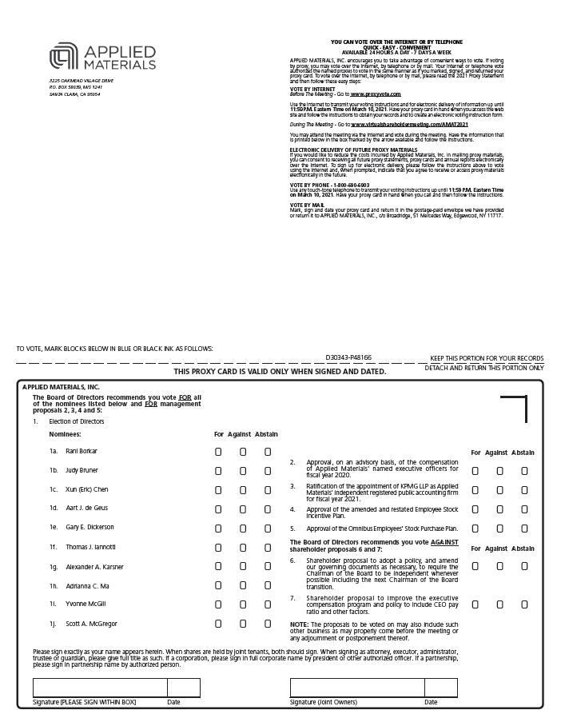

Table of Contents


